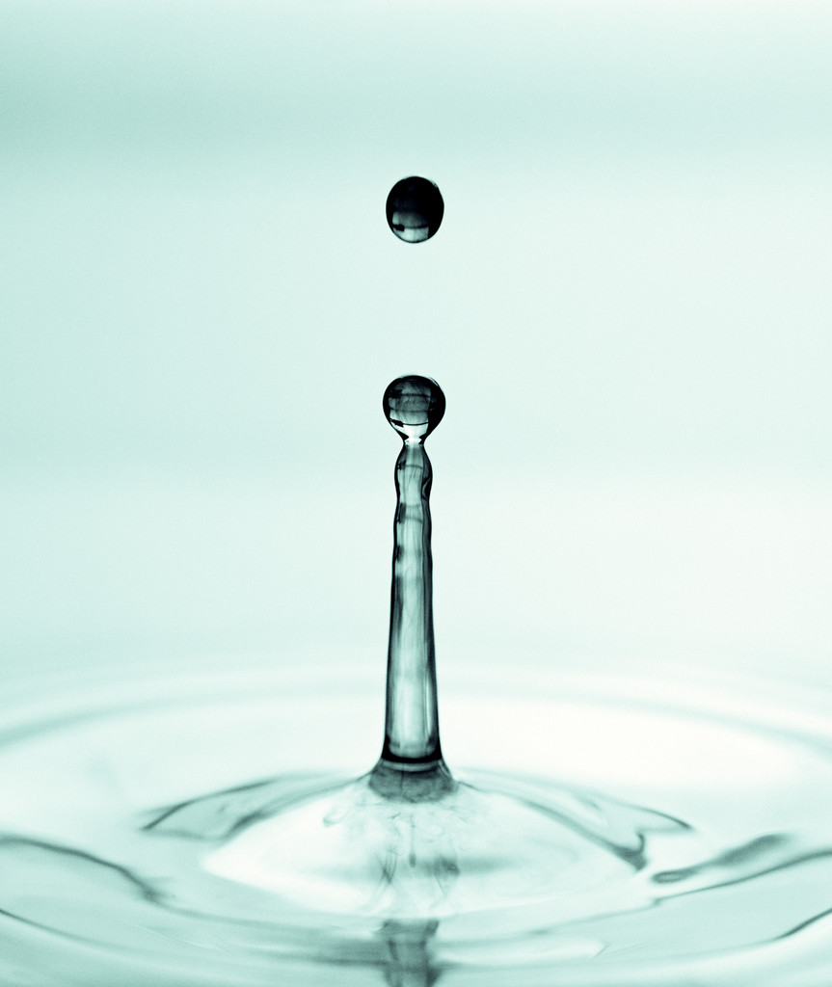
2016 Annual Drinking Water Quality Report

SAN LEON MUNICIPAL UTILITY DISTRICT
(CONSUMER CONFIDENCE REPORT)

Public Board MEETINGS - Date: Third Tuesday of Every Month
Time: 6:30 p. m. Location: 443 24th Street in San Leon
EPA’S SAFE DRINKING WATER HOTLINE 1-800-426-4761

Annual Water Quality Report for the period of January 1, 2016 to December 31, 2016.

This report is intended to provide you with important information about your drinking water and the efforts made by the water system to provide safe drinking water. For more information regarding this contact: San Leon Municipal Utility District Customer Service (281)339-1586

En Español

Este informe contiene información muy importante sobre el agua que usted bebe. Tradúzcalo o hable con alguien que lo entienda bien.

Sources of Drinking Water

The source of drinking water used by San Leon Municipal Utility District is Purchased Surface Water from Gulf Coast Water Authority in Texas City, Texas.

The sources of drinking water (both tap water and bottled water) include rivers, lakes, streams, ponds, reservoirs, springs and wells. As water travels over the surface of the land or through the ground, it dissolves naturally-occurring minerals, and in some cases, radioactive material, and can pick up substances resulting from the presence of animals or human activity.

Drinking water, including bottled water, may reasonably be expected to contain at least small amounts of some contaminants. The presence of contaminants does not necessarily indicate that water poses a health risk. More information about contaminants and potential health effects can be obtained by calling the EPA’s Safe Drinking Water Hotline at (800)426-4791.

Contaminants that may be present in source water include:

- Microbial contaminants, such as virus and bacteria, which may come from sewage treatment plants, septic systems, agricultural livestock operations and wildlife.
- Inorganic contaminants, such as salts and metals, which can be naturally-occurring or result from urban storm water runoff, industrial or domestic wastewater discharges, oil and gas production, mining, or farming
- Pesticides and herbicides, which may come from a variety of sources such as agriculture, urban storm water runoff and residential uses.
- Organic chemical contaminants, including synthetic and volatile organic chemicals, which are by-products of industrial processes and petroleum production, and can also come from gas stations, urban storm water runoff and septic systems.
- Radioactive contaminants, which can be naturally-occurring or be the result of oil and gas production and mining activities.

In order to ensure that tap water is safe to drink, EPA prescribes regulations which limit the amount of certain contaminants in water provided by public water systems. FDA regulations establish limits for contaminants in bottled water which must provide the same protection for public health.

2016 ANNUAL DRINKING WATER QUALITY REPORT

Contaminants may be found in drinking water that may cause taste, color or odor problems. These types of problems are not necessarily causes for health concerns. For more information on taste, odor of color of drinking water, please contact the system’s business office.

You may be more vulnerable that the general population to certain microbial contaminants, such as Cryptosporidium, in drinking water. Infants, some elderly, or immunocompromised persons such as those undergoing chemotherapy for cancer; persons who have undergone organ transplants; those who are undergoing treatment with steroids; and people with HIV/AIDS or other immune system disorders, can be particularly at risk from infections. You should seek advice about drinking water from your physician or health care providers. Additional guidelines on appropriate means to lessen the risk of infection by Cryptosporidium are available from the Safe Drinking Water Hotline at (800) 426-4791.

If present, elevated levels of lead can cause serious health problems, especially for pregnant women and young children. Lead in drinking water is primarily from materials and components associated with service lines and home plumbing. We are responsible for providing high quality drinking water, but we cannot control the variety of materials used in plumbing components. When your water has been sitting for several hours, you can minimize the potential for lead exposure by flushing your tap for 30 seconds to 2 minutes before using water for drinking or cooking. If you are concerned about lead in your water, you may wish to have your water tested. Information on lead in drinking water, testing methods and steps you can take to minimize exposure is available from the Safe Drinking Water Hotline or at http://www.epa.gov/safewater/lead.

Information about Source Water Assessments

The TCEQ completed an assessment of your source water and results indicate that some of your sources are susceptible to certain contaminants. The sampling requirements for your water system are based on this susceptibility and previous sample data. Any detections of these contaminants may be found in this Consumer Confident Report. For more information on source water assessments and protection efforts at our system, contact San Leon Municipal Utility District, 281-339-1586 located at 443 24th Street, San Leon, Texas 77539.

For more information about your sources of water, please refer to the Source Water Assessment Viewer available at the following URL: http://www.tceq.texas.gov/gis/swaview

Further details about sources and source-water assessments are available in Drinking Water Watch at the following URL: http://dww2.tceq.texas.gov/DWW/

Source Water Name TYPE OF WATER REPORT STATUS LOCATION
SW FROM GULF COAST SW ACTIVE TEXAS CITY, TEXAS/BRAZO RIVER
WATER AUTHORITY COUNTY OF GALVESTON
CC FROM TX0840153 GULF

Definitions: The following tables contain scientific terms and measures, some of which may require explanation.
Action Level Goal (ALG): The level of a contaminant in drinking water below which there is no known or expected risk to health. ALG’s allow for a margin of safety.
Action Level: The concentration of a contaminant which, if exceeded, triggers treatment or other requirements which a water system must follow.
Avg.: Regulatory compliance with some MCLs are based on running annual average of monthly samples.
Maximum Contaminant Level or MCL: The highest level of a contaminant that is allowed in drinking water. MCL’s are set as close to the MCLG’s as feasible using the best available treatment technology.
Level 1 Assessment: A Level 1 assessment is a study of the water system to identify potential problems and determine (if possible) why total coliform bacteria have been found in our water system.
Maximum Contaminant Level Goal (MCLG): The level of a contaminant in drinking water below which there is no known or expected risk to health. MCLG’s allow for a margin of safety.
Level 2 Assessment: A Level 2 assessment is a very detailed study of the water system to identify potential problems and determine (if possible) why an E. coli MCL violation has occurred and/or why total coliform bacteria have been found in our water system on multiple occasions.
Maximum Residual Disinfectant Level (MRDL): The highest level of disinfectant allowed in drinking water. There is convincing evidence that addition of a disinfectant is necessary for control of microbial contaminants.

2016 ANNUAL DRINKING WATER QUALITY REPORT
Maximum Residual Disinfectant Level Goal (MRDLG): The level of a drinking water disinfectant below which there is no known or expected risk to health. MRDLGs do not reflect the benefits of the use of disinfectants to control microbial contaminations.
MFL: Million fibers per liter (a measure of asbestos).
na: Not applicable.
mrem: millirems per year (a measure of radiation absorbed by the body).
NTU: Nephelometric turbidity units (a measure of turbidity).
pCi/L: Picocuries per liter (a measure of radioactivity).
ppb: Micrograms per liter or parts per million - or one ounce in 7,350,000 gallons of water.
ppm: Milligrams per liter or parts per million - or one ounce in 7,350 gallons of water.
ppt: Parts per trillion, or monograms per liter(ng/L).
ppq: Parts per quadrillion, or pictograms per liter (pg/L).

Water Quality Test Results

Lead and Copper | Date Sampled | MCLG | Action Level (AL) | 90th Percentile | # Sites Over All | Units | Violation | Likely Source Of Contamination
Copper | 2014 | 1.3 | 1.3 | 0.1 | 0 | ppm | N | Erosion of natural deposit; Leaching from wood preservatives; Corrosion of household plumbing systems.
Lead | 2014 | 0 | 15 | 1.2 | 0 | ppb | N | Corrosive of household plumbing systems; Erosion of natural deposits.
Regulated Contaminants
Disinfectants and Disinfection By-Products | Collection Date | Highest Level Detected | Range of Levels Detected | MCLG | MCL | Units | Violation | Likely Source of Contamination
Haloacetic Acids (HAA5)* | 2016 | 22 | 4.4 - 21.7 | No goal for the total | 60 | ppb | N | By-Products of drinking water disinfection.
Total Trihalomethanes (TTHM)* | 2016 | 48 | 29.2 - 50.7 | No goal for the total | 80 | ppb | N | By-Products of drinking water disinfection.

Inorganic Contaminants | Collection Date | Highest Level Detected | Range of Levels Detected | MCLG | MCL | Units | Violation | Likely Source of Contamination
Arsenic | 05/18/2011 | 2.4 | 2.4 - 2.4 | 0 | 10 | ppm | N | Erosion of natural deposits; Runoff from orchards; Runoff from glass and electronics production wastes.
Barium | 05/18/2011 | 0.13 | 0.13 - 0.13 | 2 | 2 | ppm | N | Discharge of drilling wastes; Discharge from metal refineries; Erosion of natural deposits.
Fluoride | 05/18/2011 | 0.77 | 0.77 - 0.77 | 4 | 4.0 | ppm | N | Erosion of natural deposits; Water additive which promotes strong teeth; Discharge from fertilizes and aluminum factories.
Nitrate (measured as Nitrogen) | 2016 | 1 | 0.89 - 0.89 | 10 | 10 | ppm | N | Runoff from fertilizer use; Leaching from septic tanks, sewage; Erosion of natural deposits.
Selenium | 5/18/2011 | 6.8 | 6.8 - 6.8 | 50 | 50 | ppm | N | Discharge from petroleum and metal refineries; Erosion of natural deposits; Discharge from mines.

2016 ANNUAL DRINKING WATER QUALITY REPORT

Radioactive Contaminants | Collection Date | Highest Level Detected | Range of Levels Detected | MCLG | MCL | Units | Violation | Likely Source of Contamination
Beta/photon emitters | 5/18/2011 | 4.3 | 4.3 - 4.3 | 0 | 50 | pCi/L* | N | Decay of natural and man-made deposits
Combined Radium 226/228 | 5/28/2011 | 1 | 1 - 1 | 0 | 5 | pCi/L | N | Erosion of natural deposits.
*EPA considers 50 pCi/L to be the level of concern for the beta particles.
Synthetic organic contaminants including pesticides | Collection Date | Highest Level Detected | Range of Levels Detected | MCLG | MCL | Units | Violation | Likely Source of Contamination
Atrazine | 7/18/2013 | 0.17 | 0.17 – 0.17 | 3 | 3 | ppb | N | Runoff from herbicide used on row crops.

Violations Table

Public Notification Rule
The Public Notification Rule helps to ensure that consumers will always know if there is a problem with their drinking water. These notices immediately alert consumers if there is a serious problem with their drinking water (e.g., a boil water emergency).
Violation Type | Violation Begin | Violation End | Violation Explanation
PUBLIC NOTICE RULE LINKED TO VIOLATION | 01/08/2016 | 05/31/2016 | We failed to provide to you, our drinking water consumers, about a violation of the drinking water regulations
PUBLIC NOTICE RULE LINKED TO VIOLATION | 04/20/2016 | 05/31/2016 | We failed to provide to you, our drinking water consumers, about a violation of the drinking water regulations

SAN LEON MUNICIPAL UTILITY DISTRICT
443 24TH STREET
SAN LEON, TEXAS 77539

2016 ANNUAL DRINKING WATER QUALITY REPORT

