**Key elements of your meter**

**Flow Finder:** because the meter measures thousands of gallons, the needles and dials move very slowly. If all your faucets were closed and there was a small leak, you would not be able to see the needles or dials move. The Flow Finder, however, turns rapidly when water passes through the meter. So if there is a leak, you will see this needle spinning thus indicating there is a leak. If this happens you should contact the MUD and you may need to contact a plumber to find and repair the leak.

**Meter Dial:** The dark background dials record hundreds of gallons while the light background dials record thousands.

**Serial Number:** This allows us to track the individual meter from the manufacturer (for warranty purposes) to your specific building for accurate recordkeeping.

The MUD’s water supply is distributed to the District through underground pipes to each home or business; this is the “service line”. Your water meter is located between the service line and your building. The meter measures, or “counts” the number of gallons of water delivered to your building. The meter is cumulative, that is, it starts at “0” and continues to increase whenever water passes through it; it is never reset to 0.

PLEASE NOTE: if the water meter were to fail, it might restrict or block the water from getting to your building. But it **CANNOT** register more water than passes through it. In other words, if the measuring mechanism fails, it will just stop measuring - it will not count more water than you receive!

ABOUT MY WATER METER

This picture is the electronic meters

that is installed at residents and

commercial accounts.

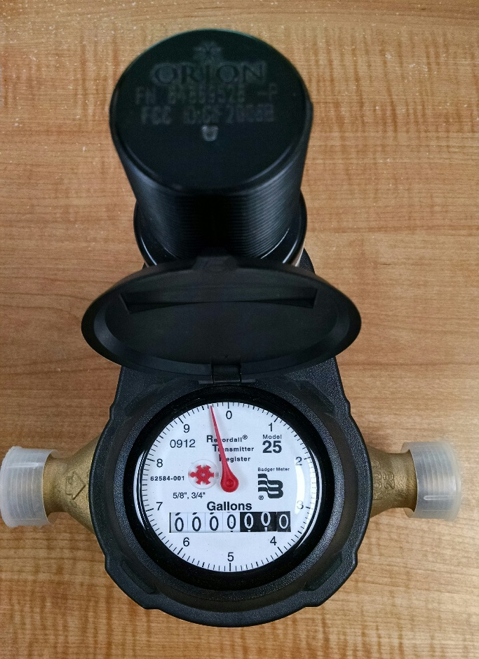

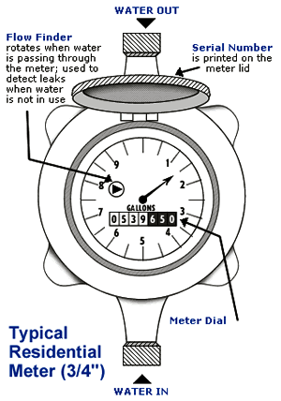

Registers total gallons of water used and is billed in increments of thousands of gallons.

WATER OUT TO YOUR BUILDING