As mentioned on the water meter page, your water meter is “cumulative”, that is, it is never reset; it continues to register the amount of water that has passed through it since it was first installed. So to determine how much water you used in the current cycle, we must subtract the previous reading from the current reading; the difference is how much you used in the current cycle. These readings are printed on the right side of your bill as shown below.

The meter measures “thousands” of gallons; we charge a certain amount for each thousand gallons you use. The cost to process waste water (the water that goes into the sewer) is a fraction of the cost of the water you purchase. So we apply that fraction to your water usage to determine how much to charge for sewer service.

The cost of installation, operation and maintenance of the street lights in San Leon is paid for by the residents of the District. Likewise, the cost of operating the San Leon Volunteer Fire Department is also paid for by the District. These costs are identified and collected by the MUD on your monthly bill. There is also a service fee collected for the Texas Commission on Environmental Quality (TCEQ), the agency that enforces the standards of quality of the water and sewer services the MUD provides. The amounts we collect are turned over to the electric company, fire department and TCEQ respectively.

For more detailed information on the basis for calculating the cost of water and sewer services, see the “Rate Order” available from the Forms page. Also please visit our Billing Cycle Timeline page to find out how we process bills.

HOW TO READ MY BILL . . .

PLEASE NOTE WE HAVE NEW **BILL CARDS!!** Your water bill is perforated horizontally in the middle of the card. Please make sure to tear off the top portion of the card and include it with your payment. If you would like a receipt bring the entire card to the Water Office. This will ensure you get proper credit for the amount you pay. Without the remittance it takes our staff longer to process your payment - and that costs ***you*** money!

Back of the Bill Card

Front of the Bill Card

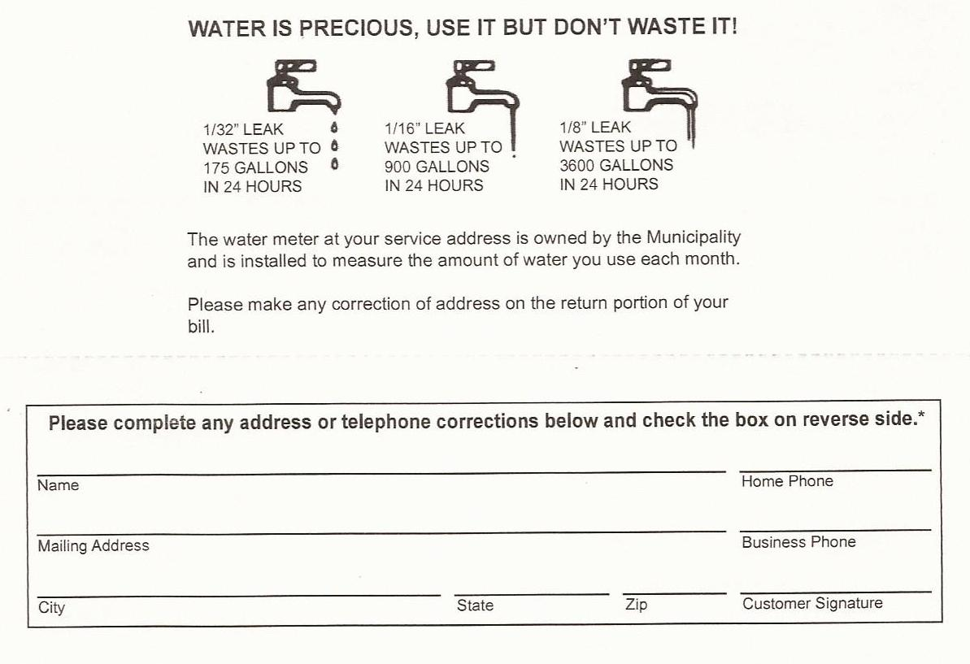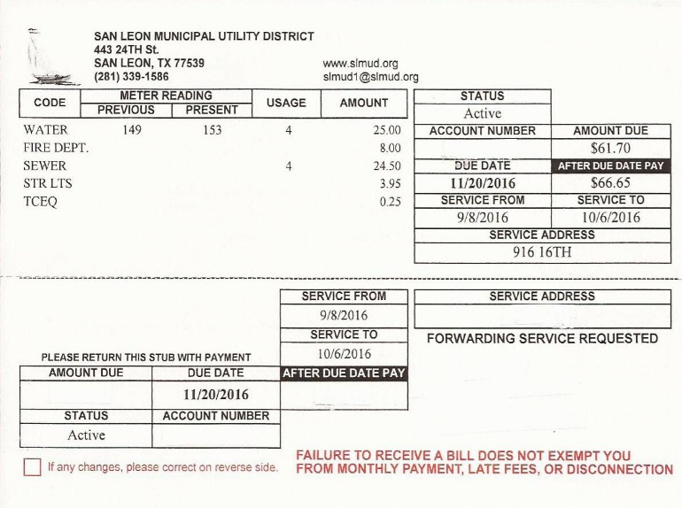

BOARD MEETING TUESDAY JANUARY 16, 2012 6:30 PM HOURS 8:00—5:00 M - F STREET LIGHT OUT/REPAIR,

CALL 1-800-332-7143

1-50015-05

CUSTOMER NAME

123 THAT ST.

SAN LEON, TEXAS 77539

$66.66

1-50015-05

$61.70

**Bills are due on the 20th of every month. Cutoff is after the 27th and there is a $25 re-connect fee added to your bill if you are disconnected for non-pay!!**