**HQL Application Instructions**

**\*Before applying for the HQL, you are going to need to wait until you receive your CCW in the mail from Maryland State Police.\***

1. Go to the [Maryland Department of State Police Online Services Login Page](https://emdsp.mdsp.org/egov/Login.aspx) and log in. If you do not already have an account, create a log in. You can also type into google search engine “HQL Log-in” and click the first link to get to the HQL portal.

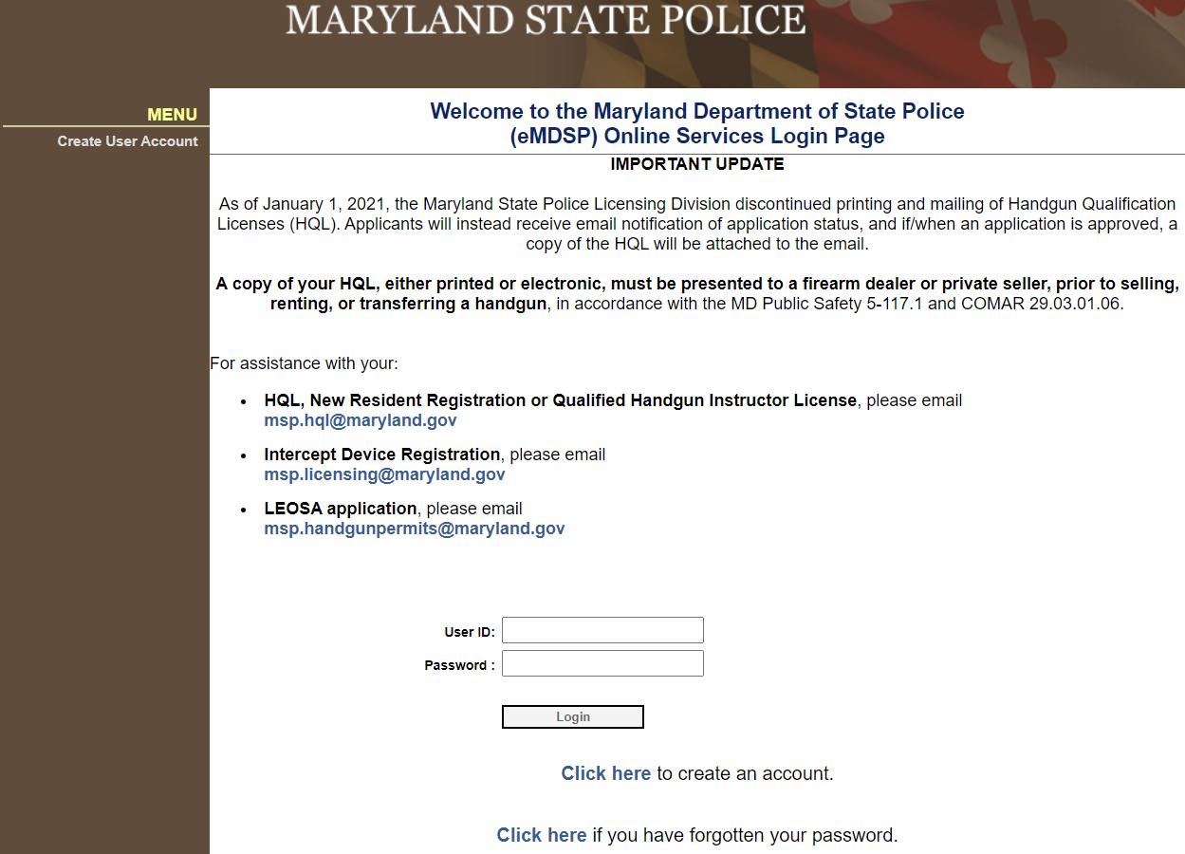

1. Once on the Home Page, you are going to click “initial application.”

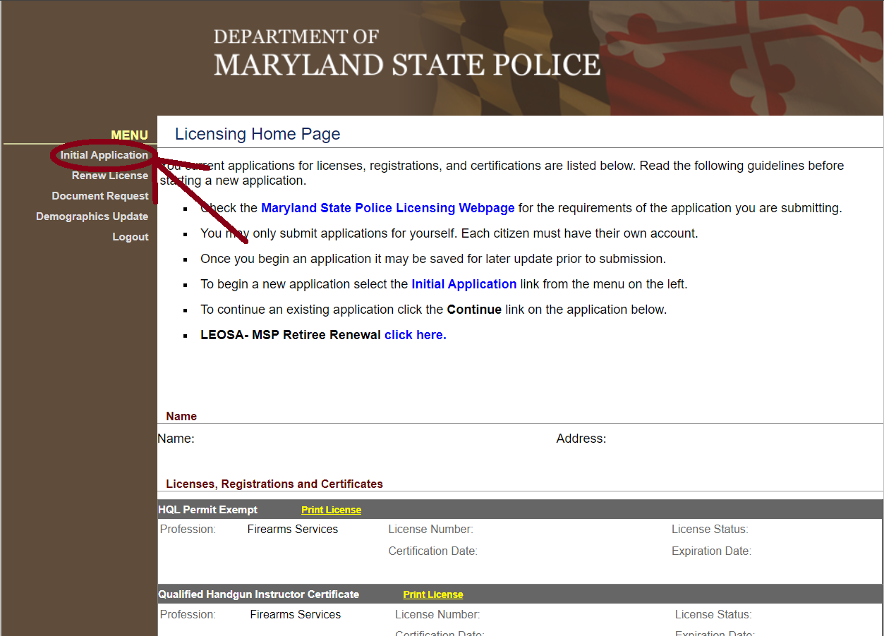

1. Next you will see the scroll down options. For Profession you are going to select “firearm services.” For licensing type, you are going to select “HQL Permit Exempt.” For Obtained by method, you are going to select “Application.” After filling out the three criteria’s, you are going to click on Start Application.

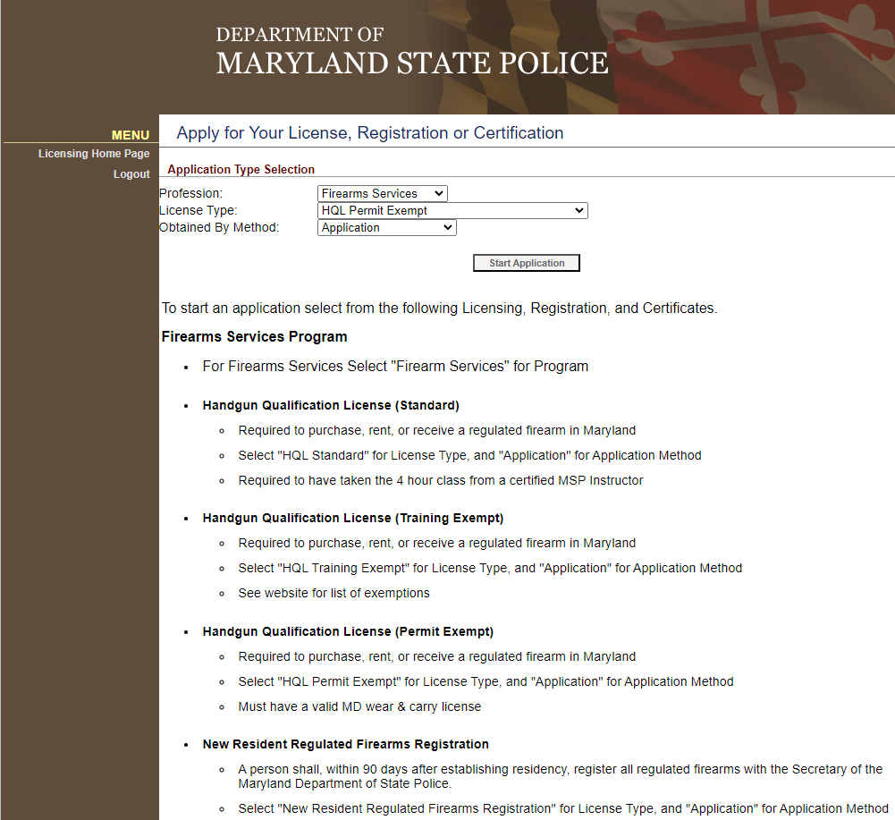

1. You will be taken to the application start screen. Next you will click on Demographics to begin filling out the application.
2. On the demographics screen, ensure you fill out all the required information. At the bottom of the demographics screen, notice where it says “Maryland Carry Permit Information.” There you will input your Maryland CCW license number and expiration date. Once all required fields have been filled out and completed, you will click on “Update” at the bottom of the screen.

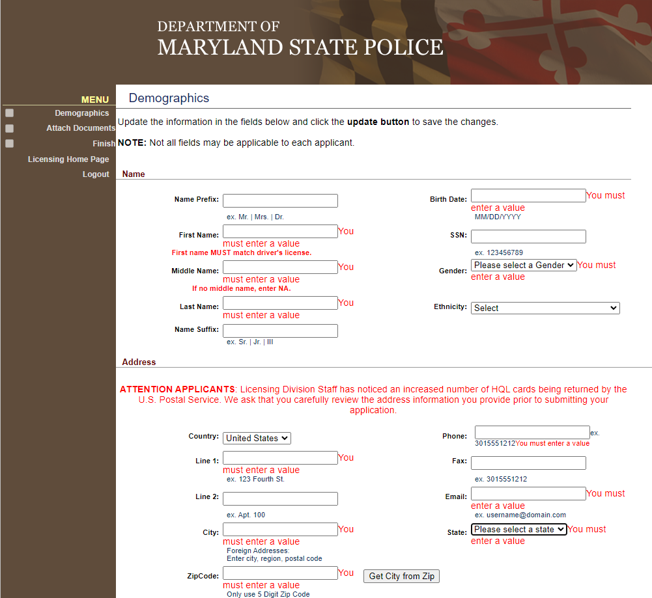

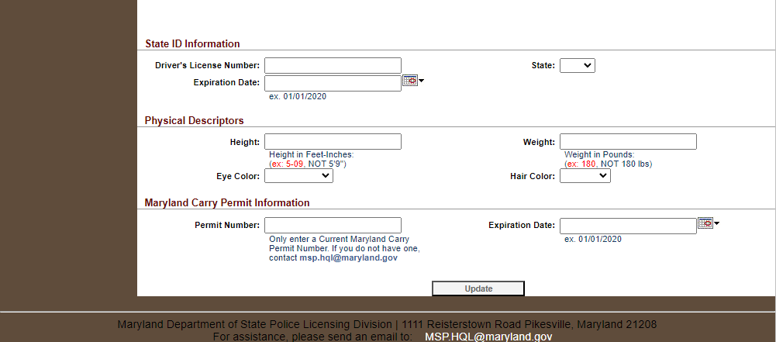

1. After clicking on update on the demographics section. You can click on “Finish” in the top left-hand corner of the screen to proceed to the part of the application where you will submit it.
2. On the “Finish” section, ensure all information is correct before clicking on the “Submit Application” button on the bottom of the screen.

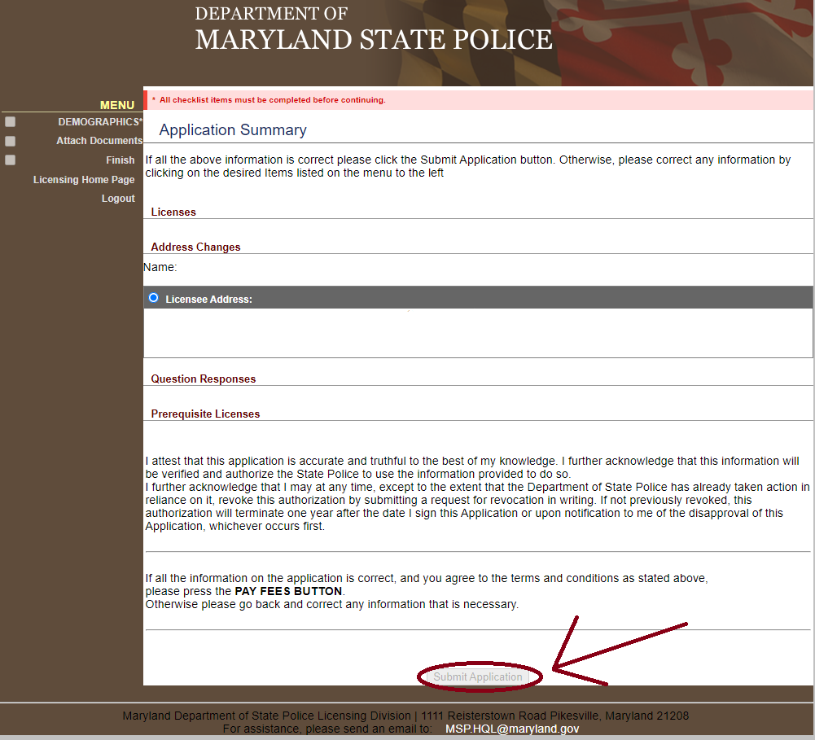

1. Once your application is submitted, you will receive an email from Maryland State Police within roughly a week stating you were approved for the HQL. You can access and view your HQL permit number on this website, so ensure not to lose or forget your username and/or password.

