

**How To Purchase A Handgun In D.C**

**Things you will need!**

1. Fees
   1. $120 Transfer Fee (FFL Transfer)
2. Garage Fee: $14

**Step 1**: Go to Nova Armory, located at 2607 Wilson Blvd, Arlington, VA 22201. After purchasing your firearm of choice from them, inform them you want your firearm transferred to D.C Security Associates FFL in D.C. These two agencies have a business agreement, and will waive the shipping costs. However, if you wish to purchase your firearm from another firearm dealer, ensure to have it transferred to D.C Security Associates FFL so they can do your firearm processing.

**Step 2:** D.C Security Associates will contact you as soon as they receive your handgun. If you do not hear from them within a week of you purchasing the firearm, then you need to contact them at (202) 964-2010. After they contact you or you contact them, you will then go to their office located at 1413 K St NW, Washington, DC 20005, 10th floor to do the transfer paperwork, to fill out and complete the Application For Firearms Registration Certificate, and pay the $120 transfer fee.

**Step 3:** After purchasing your firearm of choice and completing the paperwork with D.C Security Associates FFL, make an appointment at <https://mpdc.dc.gov/book/commonly-requested-telephone-numbers/i-need-fingerprints> to register the firearm you purchased. **BE ADVISED, IF YOU HAVE ALREADY MADE AN APPOINTMENT WITH METROPOLICATN PD, PLEASE SKIP TO STEP 12!**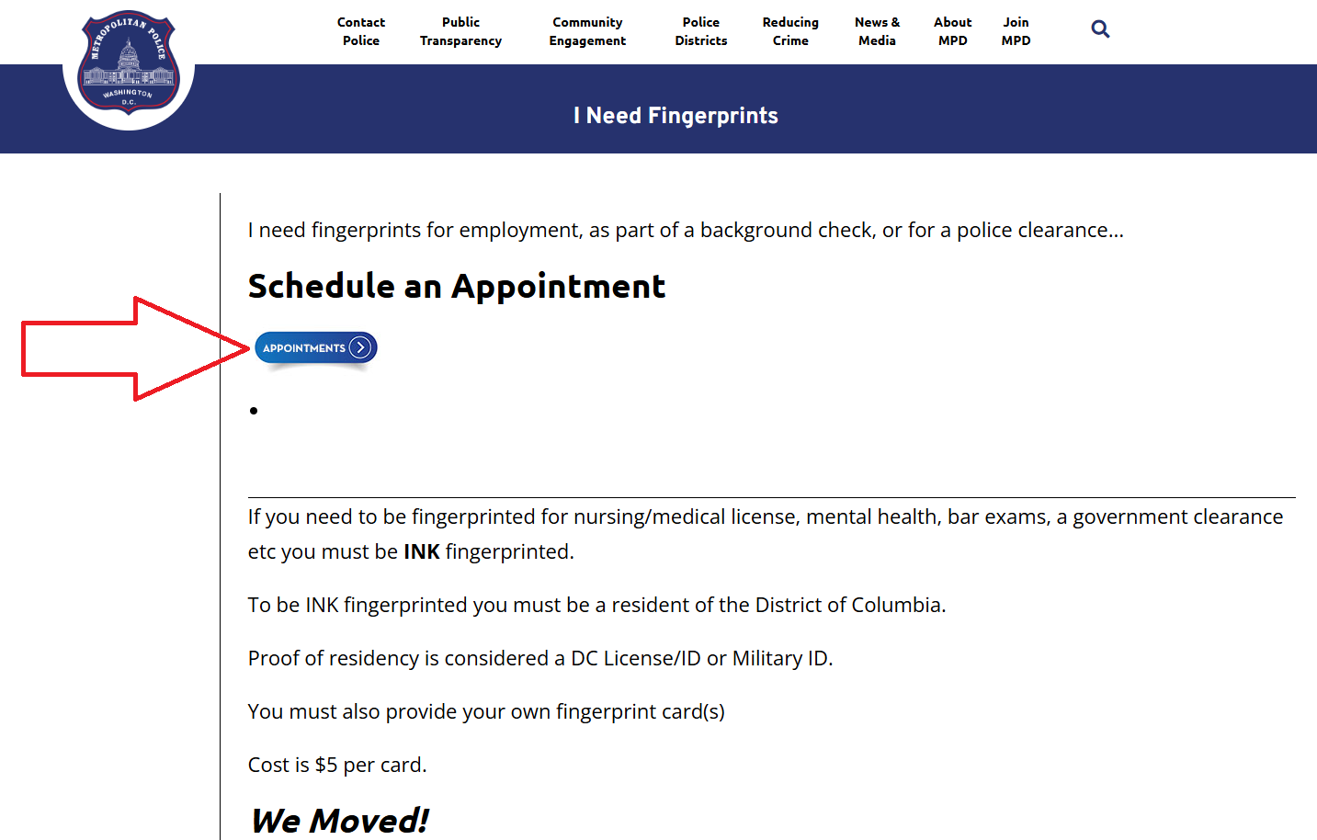

**Step 4:** On this screen, for “New Appointments: Service,” you will select “Firearms – Registration Application” in the drop-down option. After selecting “Firearms – Registration Application” click “Make an Appointment.”

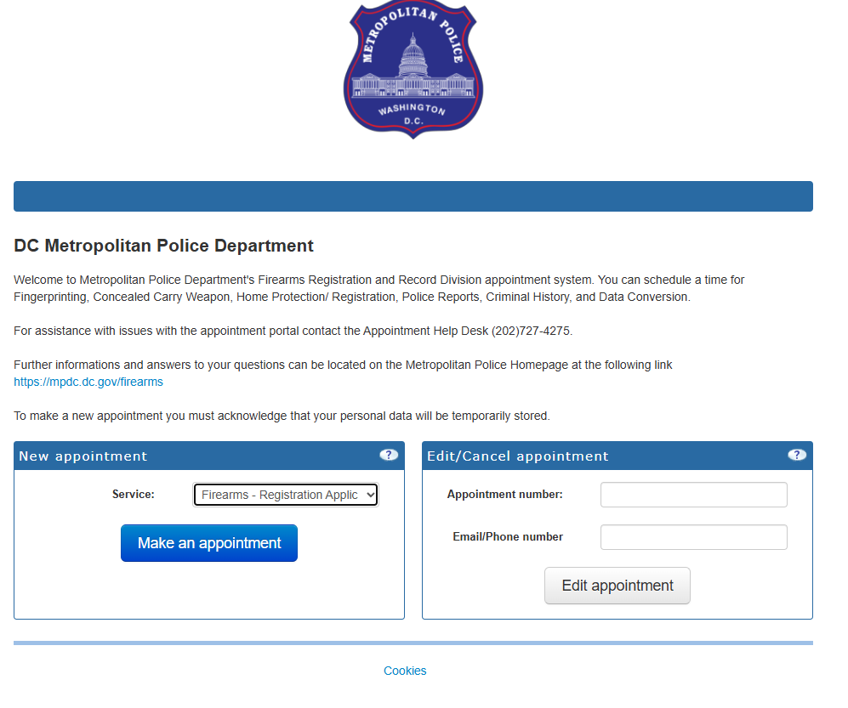

**Step 5**: On this screen, Accept the terms of agreement then click “Next” at the bottom of the right-hand screen

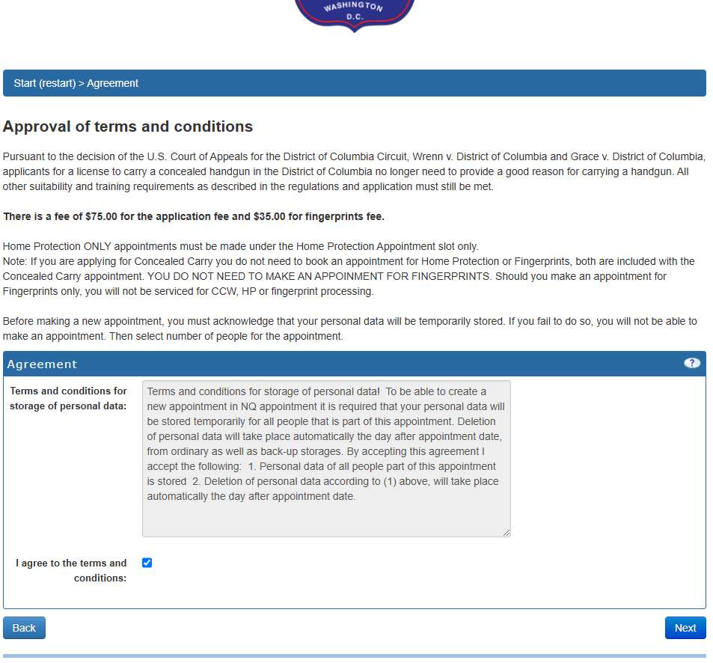

**Step 6**: On this screen, the “First Available Time” button

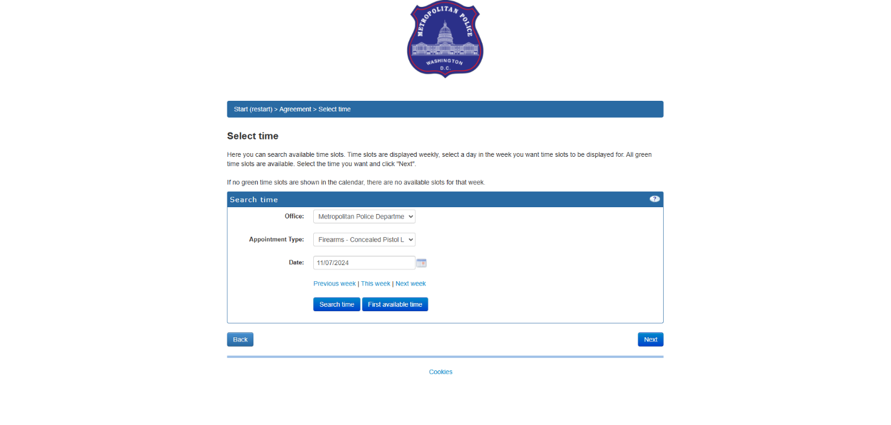

**Step 7**: You will then see the first available date and time you can schedule your appointment with Metropolitan PD to do the firearm registration.

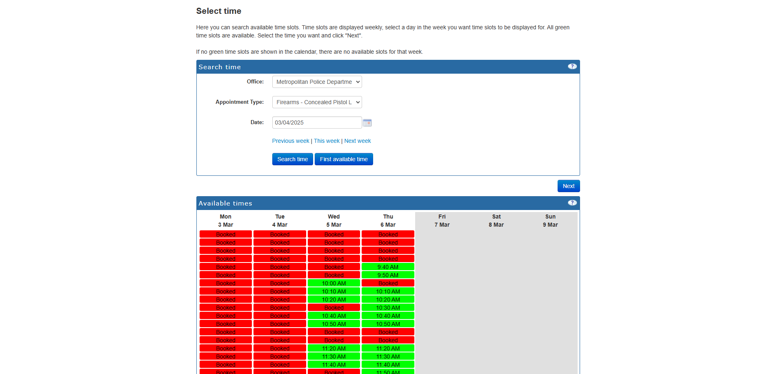

**Step 8**: Once you have selected the date and time of your choice, click “Next” at the bottom right-hand corner of the screen

**Step 9**: On this screen, enter your name, then click “Next” at the bottom right-hand corner of the screen

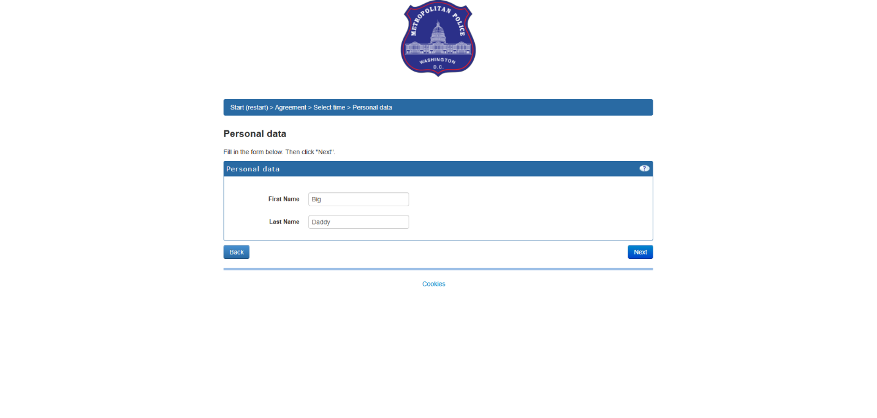

**Step 10**: On this screen, enter your personal information then choose your reminder type between text or email, then choose when you will receive this reminder text or email. Once you have completed this task, click “Next” at the bottom right-hand corner of the screen

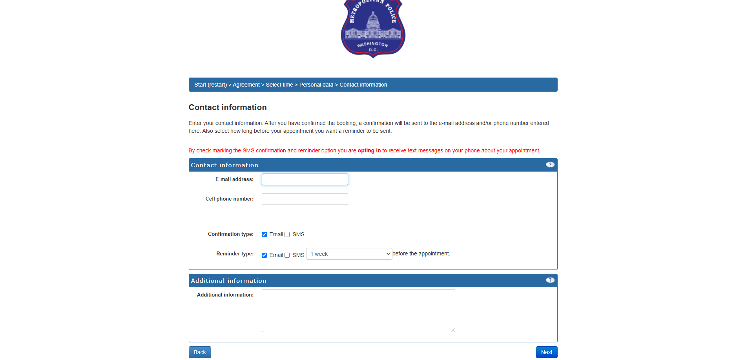

**Step 11**: On this screen, double check everything by reading over the appointment information. Once you have verified all information provided, click “Confirm Appointment” at the bottom right-hand corner of the screen.

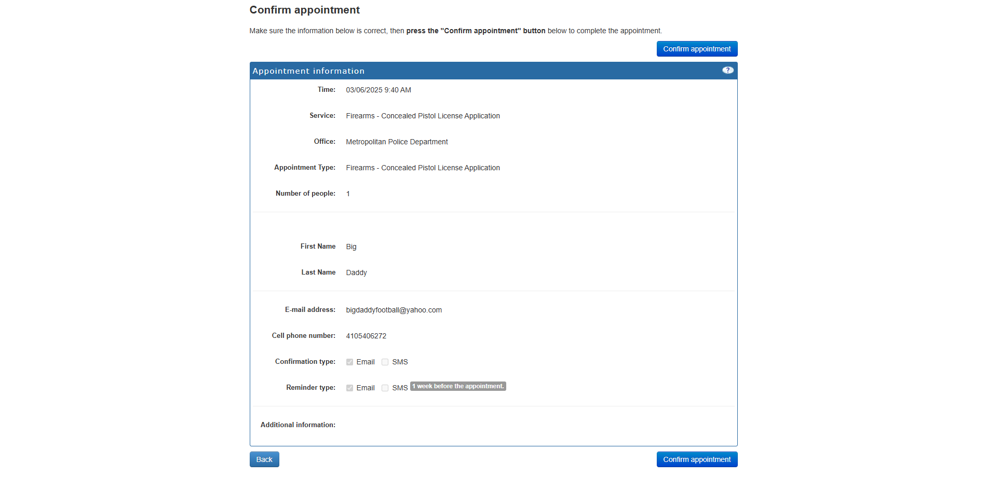

**Step 12:** On the date of your fingerprinting appointment, you will GPS to “501 3rd St Garage.” This is the nearest garage to the fingerprinting location. Make sure you bring your filled out and completed “Application for Firearms Registration Certificate” form.

**Step 12.5**: If you use or wish to use the metro station as your form of transportation, I was advised by a few of your peers that Judiciary Square Metro Station is the closest metro station to DC Metropolitan police department headquarters. I have not verified this myself as I am not familiar with the metro system, so **THIS IS AT YOUR OWN RISK!**

**Step 13:** Once you park in the garage or get off the train station, you will then proceed to the firearms registration division location which is located at

DC MPD

441 4th Street, NW South Washington, DC 20001. Suite 550

*\*It is one block away from the garage\**

**Front of the Fingerprinting Building**

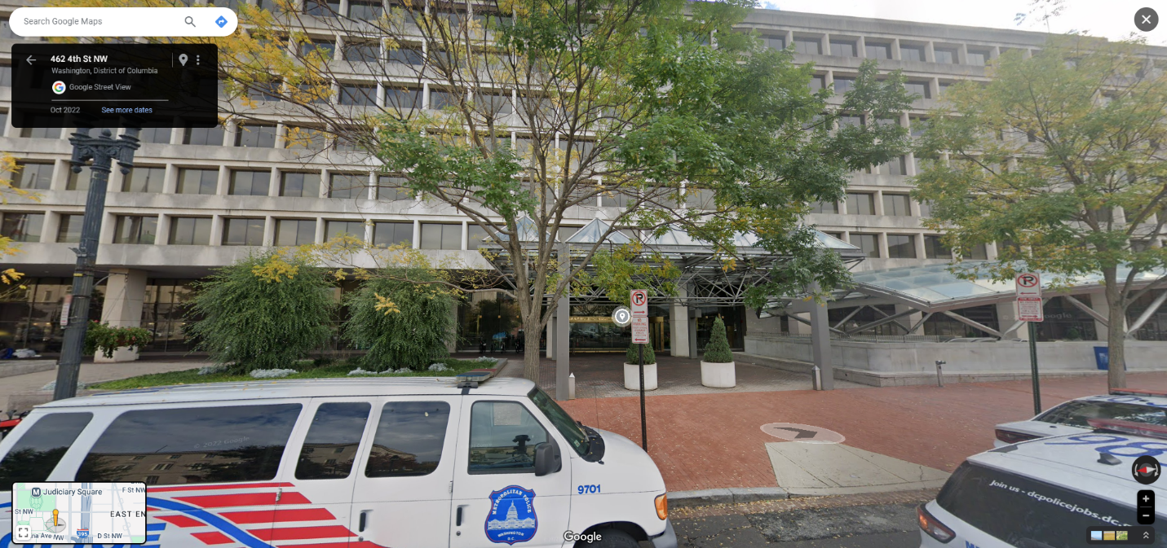

**Step 14:** Once you arrive at the building, you will be greeted at the front entrance by Security Officers. Be ready to walk through metal detectors, and have your driver’s license or passport out ready to give to the Security Officers. After being cleared, inform the Security Officers you are going to suite 550 to be fingerprinted. They will direct you to the elevator. Click number 5 in the elevator to go to the 5th floor.

**Step 15:** Once you get to the 5th Floor, go into the suite and immediately proceed to either one of the two payment kiosks located next to the windows at the other end of the suite.

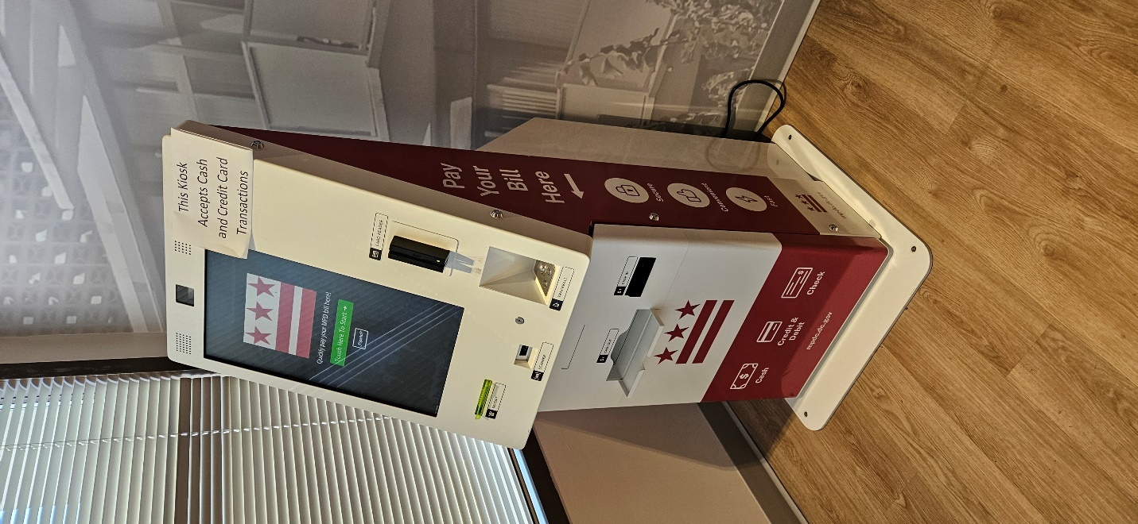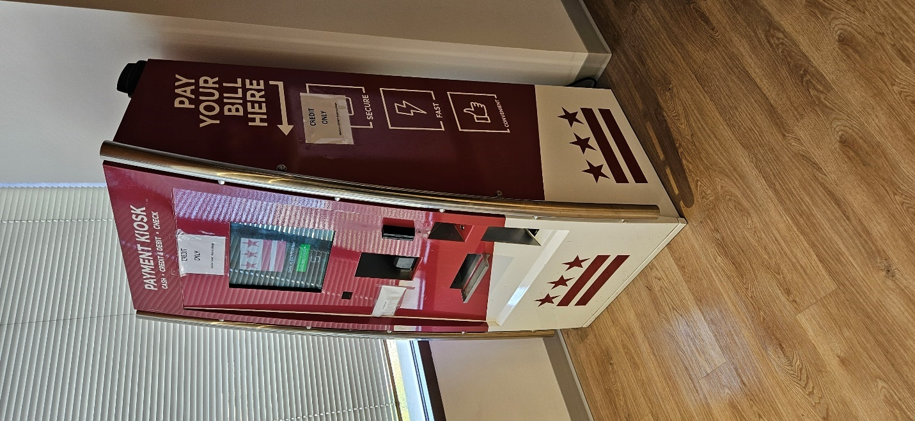

**Step 16:** Once you are at the payment kiosk. You will select “Firearms Registration” on the kiosk. The kiosk takes debit/credit. Once the payment is processed, ensure you secure your receipt of the transaction.

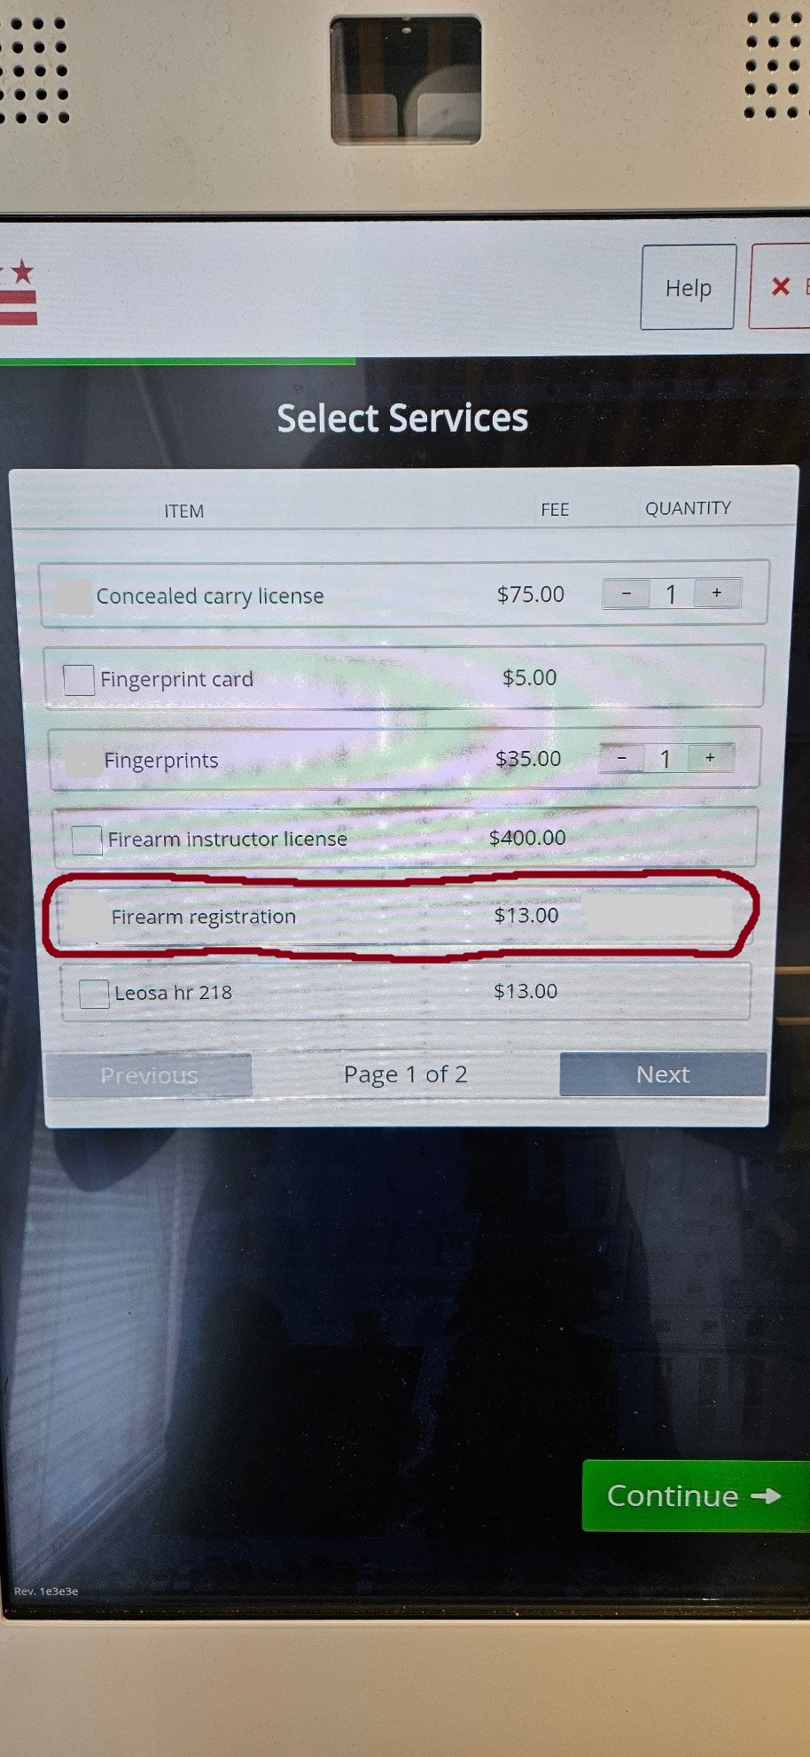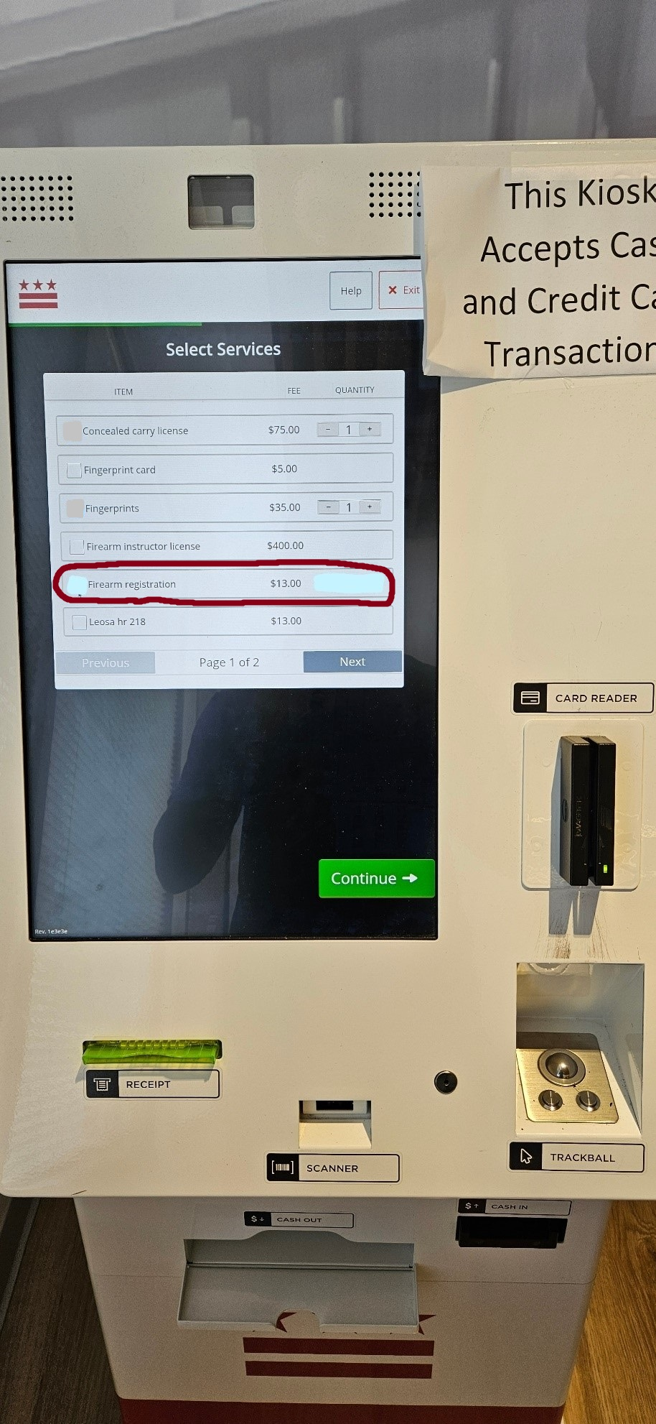

**Step 17:** After you finish the transaction and secure the receipt of the transaction, proceed to one of the three firearms registrations desks (desk numbers 4 through 6). Once you are at the desk, inform them are there to submit your Application for Firearms Registration Certificate, and you did the firearms registration payment. They will then ask for the receipt of the transaction. After this point, I am not sure what they will or will not do, but follow all their instructions.

**Step 18:** After completing all documents and procedures for the firearms registration, you will be free to leave the facility.

**Step 19:** At some point after completing and submitting all required documents to Metropolitan Police Department, you will receive an email from [firearms.adminbox@dc.gov](mailto:firearms.adminbox@dc.gov) titled “Approved CPL and/or firearms registration.” In that email will be a PDF of your Firearms Registration Certificate for the firearm you purchased. After receiving this email, proceed to D.C Security Associates located at 1413 K St NW, Washington, DC 20005, 10th floor. Once you arrive at D.C Security Associates, you will show them the PDF of your firearms registration certificate. They will then give you your firearm. Congratulations on becoming a firearm owner!