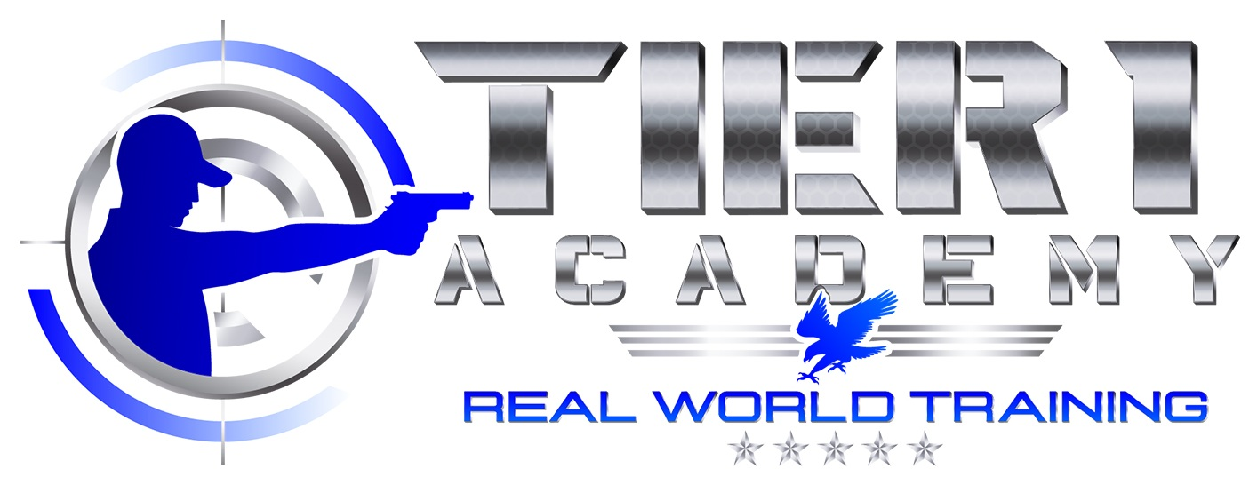

De-Lead Strategies

Thank you for choosing Tier 1 Academy for your firearm training and certifications. Below is information and suggestions pertaining to lead levels.

Youtube video we made on Instructor Hines’s elevated lead levels experience: https://www.youtube.com/watch?v=Bnn8S9ean_k

You can order a lead test online using the link provided - https://www.questhealth.com/product/lead-test/599M.html

Consumables To Remove Lead In The Body
- Vitamin B1 (Thiamine) Supplement - Excretes lead from the brain.
- Vitamin C - Consistently linked to lower blood lead levels
- Chlorella vulgaris - Helps reduce lead accumulation in the body.
- Ashwagandha – Helps with the symptoms of elevated lead levels.

