Liability Waiver for Critter RnR
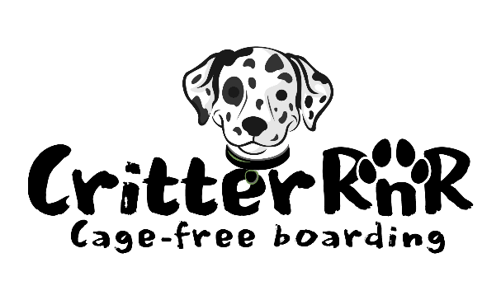
This agreement is entered into by and between Critter RnR and dog owner.

(Owner)__________________________________________________________
(Dog’s Name/Breed) _______________________________________________
- Disclosures: The owner agrees to disclose all information regarding the animal’s health, temperament, and issues (aggression, digging, barking, or escaping) to Critter RnR for a safe boarding experience. The owner understands that there is not a veterinarian on site and thus no medical condition can be diagnosed or detected.

- Food &Medications: When boarding your dog, the owner is responsible for leaving enough food and medication needed for the duration of the stay. Should food or medication run out, the owner will reimburse Critter RnR for incurred expenses.

- Release of liability: Owner accepts potential risks involved in run and playtime; a dog can sustain minor injuries. Owner further agrees that Critter RnR is not liable for injury, death, illness or escape of the dog, provided that all precautions are followed.

- The owner is solely responsible for any harm and damage to property, animals and/or people caused by their dog(s).

 My dog is not a digger and would not dig out of the enclosure
My dog is not a jumper and would not jump a 6 ft fence enclosure

I have toured the facility, and it is suitable for my dog and his/her temperament

By signing below, I acknowledge that I have read and fully understand this Agreement/Liability Waiver.

Owner Signature and date: __________________________________________

