Andover Glen Gazette
www.andoverglen.org
“Communication is the key to a strong community”
September 2009, volume 7, issue 8

Andover Glen Summer Picnic was the Best Attended in Years
By Randy Simpson

If you were there you know how wonderful the Annual Andover Glen Summer Picnic was on August 29th. There was abundant and delicious food (the chicken was my favorite) and of course lots of great conversation among friends catching up on summer activities and maybe even meeting some new neighbors. The pictures below tell the story. It was the best attended picnic in years, with a crowd approaching 60 in attendance. Thanks to all those who contributed, especially to Debra Jones for her organizing skills and Derrick Laughlin and others for setting up the shelter, etc. ~

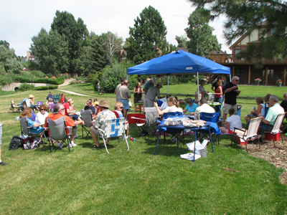
A picture perfect day for a picnic
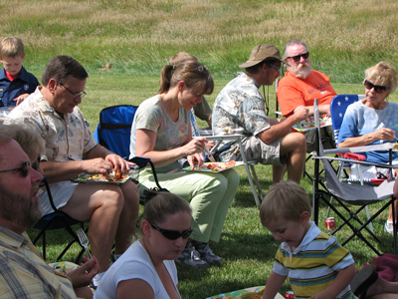
Great food & conversation were abundant
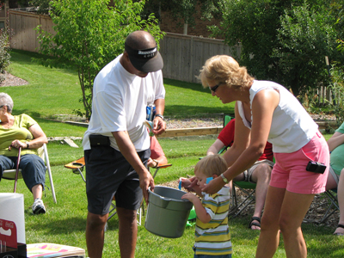
A big helper drawing a raffle ticket

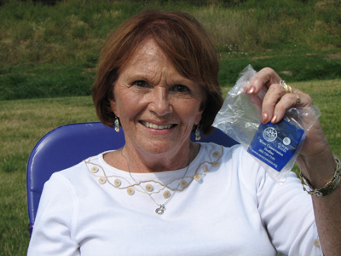
Marian Shields is a lucky raffle winner!


A picnic wouldn’t be complete without games
Election of New Board Members and a Covenant Restatement update on tap for AG Annual Meeting September 21st
By Randy Simpson


Make sure you’ve marked your calendar for Monday, September 21st for the Andover Glen Annual Meeting. It will be held once again at Shalom Park. The meeting officially begins at 7 p.m. but there will be light snacks and beverages served beginning at 6:30 p.m. There are some very important items on the agenda, including the election of new Board Members and a progress report on the important project to create a restatement our AG covenants (see separate article in this Gazette). I hope to see many of you on the 21st! ~


WE NEED YOU!

Your Andover Glen Board is still looking for several neighbors to serve on your Andover Glen Board. Please contact any board member if you’re interested. Remember, volunteering is the best way to give back to your neighborhood. The typical time commitment is only a few hours a month.

Call 303-627-3100 to report suspicious activity (APD Dispatch)
www.aurorapolice.com

Update on the Covenant Restatement Process
By Anne Stellmon

Over the course of the last two years, by dialoguing with the AG community, the Board has determined that it is imperative for the future of our community to have a complete review, update and restatement of our governing documents. The dialogue with the community has led us to take action to make this process possible. The Board believes that our governing documents should reflect the current personality and culture of our community and provide the flexibility for change for the next generation of homeowner’s. The modernizing of covenants is aimed at updating language, readability and bringing the document in line with current state and federal law. Modernizing our governing documents is not intended to change the standards that our community has adopted but rather to strengthen our community’s ability to maintain and defend those standards.

At the July 15, 2009 the AGHA Board took under consideration bids from three local law firms to assist us with the update and restatement of our HOA’s covenants. The Board made the decision to hire the firm of Rothgerber Johnson & Lyons LLP for this project. The attorneys who will be responsible for the project are Robert Hoehn and Gary LaPlante. Each attorney has extensive knowledge and experience regarding HOA law and include some of the largest HOA’s in Colorado as their clients. A complete copy of the our agreement with Rothgerber Johnson, & Lyons is available as an attachment to the July board minutes at www.andoverglen.org.

Our covenants were reviewed last year by a committee of homeowners that included Dave Kline, Randy Simpson, Anne Stellmon, Lynn Walton and Michael Zabinski. The committee’s concerns, questions and suggestions have been presented to the

Covenant Restatement continues on page 3
Covenant Restatement form page 2

attorneys to be taken under advisement as they prepare their recommendation and suggestions for our homeowners.

The covenant restatement process will be part of the agenda at the Annual Homeowner’s Meeting on Monday, September 21, 2009. It is the Boards’ hope that we will be able to present at that time the attorneys suggestions and recommendations for discussion but there will be no formal presentation from the attorneys at that meeting.

The next step in the covenant restatement process will be a community education and information plan presented by the Board later this fall. The Board will present the attorney’s draft for restatement of covenants at the education/information meetings that will give you a forum to ask questions and express your concerns. As part of the Board’s education plan, our attorneys will be available later on in the process to meet with the AGHA to answer your questions before the new document is finally presented to the AGHA for a vote of approval in 2010.

Dumpster Days and Document Shredding – October 4th & 5th
By Debra Jones

Once more, a large 40ft roll-off dumpster will be available on Saturday and Sunday, October 4th & 5th, near the AG Park. This dumpster is for general debris from around your house and yard. Just a few reminders, if you have any large branches or bushes, please cut them down to smaller pieces. The following items are NOT ALLOWED in the dumpster:
- No toxic wastes like old paint and oil
- No batteries
- No old tires
- No electronic waste like televisions &old Computers, etc.
Also, please remember that once the dumpster is full -IT’S FULL! If we overfill it, we all pay for another dumpster! The dumpster is for Andover Glen Homeowners only, paid for by your Association Dues. Thanks for everyone’s efforts so we can deep offering this service to our community.

We are also offering “Document Shredding” on Saturday, October 4th from 11:00 a.m.–1:00 p.m. This is a safe, fast and easy way to destroy your unwanted documents and protect your identity. It destroys all paper, paper clips, staples, film, CD’s, checks, checkbook registers and old tax forms. No card board please. There is no charge for this service this year. The truck will be located next to the dumpster. ~

Community Garden Grows into a Great Success
By Randy Simpson

The Andover Glen Community Garden has blossomed into a great success this year. Some of us took the time on the day of the summer picnic to stroll on over and take a tour. From eggplant to pumpkins, everything was looking quite tasty! Congratulations to all those green thumbs who participated and thanks to Lynn Walton and others for their organizing efforts in this worthwhile community asset. A few plots may be available for the 2010 season, so for you green thumbs interested, please contact Lynn at 720-379-4616. ~

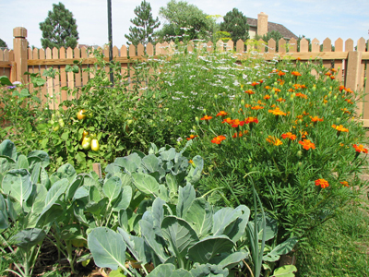The community garden is both beautiful and nutritious!


Hidden under a leaf—eggplant surprise!


A pumpkin just in time for Halloween

Drip Irrigation Class on September 13
Interested in learning about drip irrigation? Here’s a chance to learn from a pro. On September 13th at 2:30 p.m. Norm Arlt will be giving some tips on drip irrigation at his house.


Next Common Grounds on September 25th
Hello Neighbors! The next Common Grounds Coffee club will take place:
September 25th
Lynn Walton and Derrick Laughlin’s
14307 E. Layton Drive

Reminder: The Annual Andover Glen HOA meeting will be held on Monday, September 21st at 7 p.m. at Shalom Park. (coffee and snacks at 6:30). All AG residents are welcome and encouraged to attend this important meeting.

Neighbor to Neighbor
Services and stuff for sale, cheap!
Baby Sitting: Experienced, Red Cross Certified, 11th Grade, neighborhood Babysitter. Loves Kids! Kristin Guerra, 303-766-0464.
Baby Sitting& Odd Jobs: Red Cross Certified, 9th Grade, neighborhood Babysitter. Will also do odd jobs like house sitting, dog sitting, watering plants. Very Responsible. Shannon Guerra, 303-766-0464.
Baby Sitting: Red Cross Certified, thoughtful and loves kids. Call Sophia, 303-693-9356 or 303-668-6058.

We are always looking for informative and interesting articles for the Gazette. If you have one you’d like to share, please contact Randy Simpson at rgatess@yahoo.com

Andover Glen Homeowner’s Association Board Members
Randy Simpson, President 693-0546
Dave Estes, Vice President 766-9166
Anne Stellmon, Secretary 699-8567
Dick Moore, Treasurer 400-8987
Carl Miller, Welcoming 693-1899
Debra Jones, Social 690-9459
Derrick Laughlin, N. Watch 720-379-4616

