Andover Glen Gazette
www.andoverglen.org
“Communication is the key to a strong community”
February 2010, volume 8, issue 1

Andover Glen Holiday Party Was A Blast…
By Randy Simpson
I personally am of the opinion that writing about the details of a party that has long since past is a bit like kissing your sister…it goes seriously lacking in many ways. If you made it out to this year’s Andover Glen Party (or should I say Parties) then you know what a great time you had. I saw no one complaining for lack of food, drink, and laughter. I include a few photographs below just to remind those of you who attended of some of the moments from the great time you had. To those of you who could not, or simply did not attend, well…sorry you couldn’t make it this year, and perhaps we’ll see you the next time. Special thanks go out to Tom & Nannette Almon, Royal & Mim Shields, and Mike Zabinski and M.L. Hanson for hosting, and to Debra Jones for her great organization of this event…and a final congrats to Cindy Wagner for winning the “best drink” contest. Can’t wait for next year!~

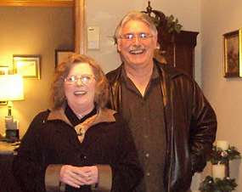
Always the gracious hosts, Mike Zabinski & M.L. Hanson hosted the dessert party

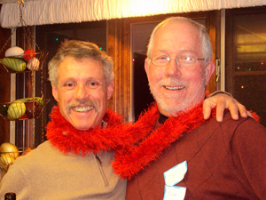
Dave & Bob with Furry Boa
(Last names withheld to protect the Boa’s reputation)

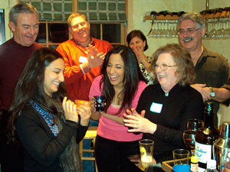
As the Holiday Cheer flowed, the Best Drink Contest brought lots of smiles


Common Grounds Coffee Scheduled on February 26th

Here’s a chance to meet some new neighbors or just connect with old friends. Open to everyone in AG and held this month on Friday, Feb. 26th at 10 a.m. at the home of:

Michael Zabinski & M. L. Hanson
14205 E. Layton Drive!
Covenant Restatement information on AG website and feedback process started
By Randy Simpson

In December, the AG Board introduced the first draft of the Restated AG Covenant and By-laws on the web. They are available at www.andoverglen.org or you can call any of the board members and they’ll get you a copy. The board dedicated a large portion of its January meeting to discussing the new documents. Several AG residents attended and gave some very helpful feedback.

Early feedback on the restatement has given the Board excellent input on areas that still need some work, and the board is grateful to those who took the time to come to the last meeting and then take the additional time to email some of their concerns and recommendations. It is this kind of feedback and interaction that will only make the restated covenants that much better and truly represent the neighborhood. Based on this feedback, the board spent much of Saturday, Feb. 6th, going over the documents and amending them to accommodate many of the issues raised. Later this year, some open forums or discussion groups will be held to gain even more feedback and begin to focus on a final set of restated documents to be voted on by the full AG Membership. Some issues these new restated documents will address over our current documents are:

- Outdated and obsolete language
- Clarify many unclear requirements
- Update sections incompatible with new laws
- Bring amendments into the main body of the covenants.
- Provide a solid document that can more easily be modified as Colorado State Laws change.

If you get the chance, we hope you’ll download these restatements and look at them, or ask a board member for a copy. Your feedback is wanted! ~
Reminder: The next Andover Glen HOA Board Meeting will be held on Wednesday, February 17th, 2010 at 7:00 p.m. at Shalom Park. All AG residents are welcome and encouraged to attend.
Neighbor to Neighbor

Services and stuff for sale, cheap!
Baby Sitting: Experienced, Red Cross Certified, 12th Grade, neighborhood Babysitter. Loves Kids! Kristin Guerra, 303-766-0464.
Baby Sitting& Odd Jobs: Red Cross Certified, 10th Grade, neighborhood Babysitter. Will also do odd jobs like house sitting, dog sitting, watering plants. Very Responsible. Shannon Guerra, 303-766-0464.
Baby Sitting: Red Cross Certified, thoughtful and loves kids. Call Sophia, 303-693-9356 or 303-668-6058.
For Sale –Burton Snowboard Boots, Ladies size 7, perfect condition, $20, and old fashioned wooden sled, $10 call Linda at 303-248-6213.
Editors Note: Items for the Neighbor to Neighbor section should be sent to Randy Simpson at rgatess@yahoo.com.

Call 303-627-3100 to report suspicious activity (APD Dispatch)
www.aurorapolice.com

Andover Glen Homeowner’s Association Board Members
Randy Simpson, President 693-0546
Nanette Almon, Vice President 720-479-8072
Anne Stellmon, Secretary 699-8567
Dick Moore, Treasurer 400-8987
Carl Miller, Welcoming 693-1899
Debra Jones, Social 690-9459
Derrick Laughlin, N. Watch 720-379-4616
Dave Estes, Architectural 766-9166

