Andover Glen Gazette
www.andoverglen.org
“Communication is the key to a strong community”
August 2010, volume 8, issue 7

Final AG Covenant Restatement Ready—Vote set to begin in September.

Provision for Storage Sheds Removed After a Straw Poll Shows Residents Split
By Randy Simpson

A final draft the proposed Andover Glen Covenant Restatement is now available at www.andoverglen.org. After much discussion and a straw poll of a sizable number of residents, the provision for allowing storage sheds under certain restrictions was removed. The poll showed that residents were fairly even split on this issue. Since the covenant restatement must pass by a 2/3 majority of AG residents (67 households), the Board felt that the overall passage of the updated and restated covenants was far more important than any single issue and so the language to allow sheds was removed. Also removed was language that would allow the Board the ability of waiving dues for residents in cases of financial hardship. A straw poll showed that this item was also too controversial and might be a reason that some would vote against the overall covenant restatement. On the other side, there were some other items that were amended and put into the final version of the restatement. The addition of new wood shingles to homes will no longer be allowed. No one has added new wood shingles in many years, and those replacing their roofs have chosen either the high definition tri-laminate, or tile roofs. The reason new wood shingles were removed is that they pose a very high fire risk. Of course, current wood-shingled homes in AG would NOT be affected by this change.

The voting process for the new covenant restatements is set to begin at the Annual meeting, scheduled for Monday, September 13th, at 7 p.m. at Shalom Park. To be in attendance at the meeting will be the attorney hired by the association to assist in the preparation of the restatements. The attorney will give a brief presentation and be available to answer questions. While the vote will begin at the September meeting, it will take place over a period of months, and if you are not in attendance at the annual meeting, you can anticipate being contacted by one of the AG Board members to gather your vote.

In addition to the proposed restated covenants, on the website you’ll also find the proposed updated Bylaws, as well as summaries that give the details of the changes between the new and older documents. In general, the new covenants will modernize the language of our covenants as well as clarify certain provisions. They will continue to provide a strong basis for a high quality neighborhood. If you have any questions related to the covenant restatement, feel free to contact any board member. ~

Save the Date!
AG Annual Meeting

Monday, September 13th, 7 p.m. at Shalom Park
AG Covenant Restatement Vote will Commence that Evening!

Andover Glen Summer Picnic, Sat., August 28th

By Debra Jones

“Meet the Neighbors” at the Summer Picnic in the Andover Glen Park by the Gazebo. The food, fun and festivities will begin at High Noon and end when the last person leaves the park.

The Association will be providing a great BBQ along with (non-alcoholic) drinks and paper goods. We would like the homeowners with odd house numbers to bring your favorite dessert and the homeowners with even house numbers to bring your favorite salad. We are unable to offer alcoholic beverages, but you are allowed to bring your favorite alcoholic drink.

If you have a favorite drink, enter the “Best Darn Drink Contest.” The “Best Darn Drink Contest” is usually offered at the Andover Glen Holiday Party, but by popular demand we are going to have it at the Picnic. To enter the drink contest, you bring enough of your “Best Darn Drink” to share with the Judges and let the fun begin! (see separate article in this Gazette)

The “Spiff Awards” will be presented at the Picnic along with other fun prizes. “Spiff Awards” are awarded to the neighbors with the Best Darn Homes.

We will be having a “Big Air Jumper” for the kids from Noon – 6:00 p.m. Parents must watch their children while in the jumper. We will also offer other lawn games to play in the park for adults and kids.
So grab your lawn chairs, umbrellas, sunscreen, tennis racket and plan on spending a fun filled afternoon for the whole family.

If it just happens to “rain” on our picnic, we will have the picnic on the back-up date of Saturday, September 4th, same time – same place. If you have any questions or concerns, contact Debra at debsew79@msn.com. ~

Adult Beverage Contest at the Andover Glen Summer Picnic
By M.L. Hanson

Dig out those little paper drink umbrellas and start your blender engines.
We are in search of the official Andover Glen Summer Sipper! The winter drink winner was Cindy Wagner with her Fabulous and 50 entry, although all the entries were delicious, my favorite was Larry Stellmon’s. If you missed out on that contest at the end of the Holiday Party, now is your chance to excel at the AG summer picnic and with something extra to add to your resume or a “dear diary entry.”

The Ground Rules

1.Judges are not permitted to submit entries, but may accept “tokens of appreciation.”
2.Participants must bring their own ingredients.
3.Beverages maybe mixed on the premises of the Summer Picnic on August 28th or prepared in advance (but please don’t bring a pre-bottled cocktail, where is the fun in that.)
4.The beverage can be any theme, tropical, domestic, out of this world...use your imagination!
5.The winning entry will become the official AG Beverage until the next contest is conducted.
6. Responsible Drinking is Always Encouraged!

There will be PRIZES for every entry, but no guarantee they are tasteful. We need judges, so if you want to volunteer contact M. L. Hanson at mlhanson-consultant@comcast.net. 303-627-4044. (I think the judges had the best time of everyone, just ask Dave Estes.) ~
A special “Thank You” to Bob Stracy
From the Andover Glen Board

We would like to extend a special thank you to a man who has helped out our neighborhood in several occasions without reservation. Last summer Bob Stracy built the fence for the Community Garden and recently he built a new sign for our community that announces our events. Finally, and mostly he is a great friend and best neighbor anyone could have. Bob, thanks you for all you do and mean to our neighborhood! ~

Remember, the Gazette is Going Electronic Only Delivery this Fall
By Randy Simpson


Beginning with the October 2010 edition, the Gazette will be Electronic deliver only. This change will save the Association over $400 a year in printing and distribution costs. Please send an email rgatess@yahoo.com if you’d like to be added to the distribution list to be automatically emailed the Gazette each month.

We highly respect your individual privacy, and your email will be only used for official Andover Glen business, and not shared with any outside individual or organization of any kind.

If you have any questions or concerns about the upcoming electronic delivery of the Gazette, please contact Randy Simpson at 303-693-0546.~


WE NEED YOU!

Your Andover Glen Board is looking for a few neighbors to serve on your Andover Glen Board. Please contact any board member if you’re interested. Remember, volunteering is the best way to give back to your neighborhood. The typical time commitment is only a few hours a month.
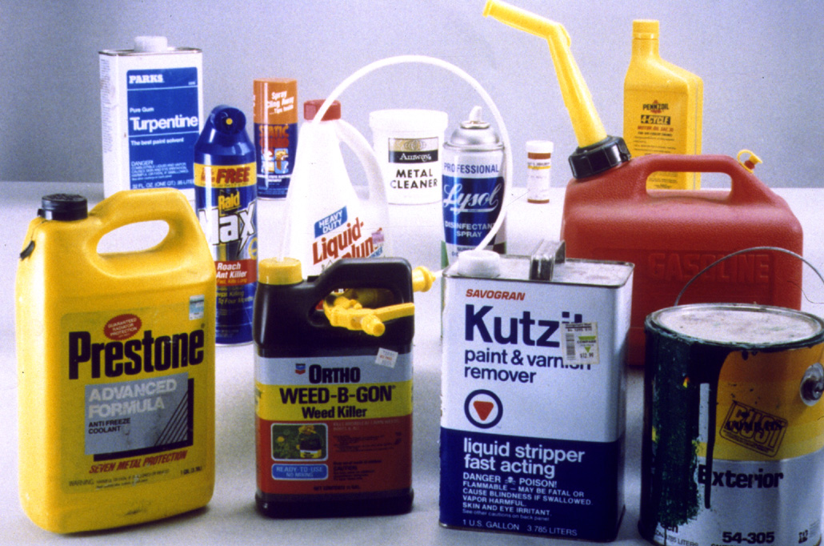
Hazardous household chemicals recycled at free City of Aurora Event

“One great, strong, unselfish soul in every community could actually redeem the world.”
- Elbert Hubbard
Drop off your household chemicals for free during this important pollution prevention event. The 18th annual Household Chemical Roundup will take place Saturday, Sept. 11, 2010 from 9 a.m. to 4 p.m. at 13645 E. Ellsworth Ave. (Just two block north of the intersection of Alameda & Potomac).
This event is open to Aurora residents only, so please bring a driver’s license, voter registration or water bill as proof of residency.
Only household items, no business waste.
For information, call 303-739-7372. ~
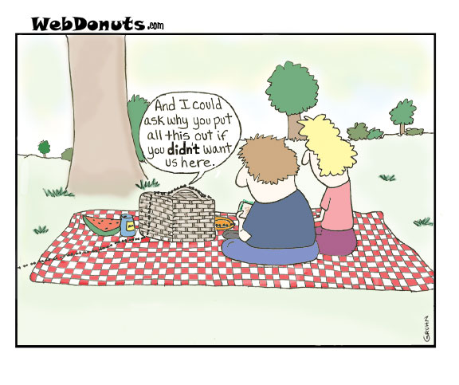
Neighbor to Neighbor

Services and stuff for sale, cheap!
Baby Sitting: Experienced, Red Cross Certified, 12th Grade, neighborhood Babysitter. Loves Kids! Kristin Guerra, 303-766-0464.
Baby Sitting& Odd Jobs: Red Cross Certified, 10th Grade, neighborhood Babysitter. Will also do odd jobs like house sitting, dog sitting, watering plants. Very Responsible. Shannon Guerra, 303-766-0464.
Baby Sitting: Red Cross Certified, thoughtful and loves kids. Call Sophia, 303-693-9356 or 303-668-6058.

Editors Note: Items for the Neighbor to Neighbor section should be sent to Randy Simpson at rgatess@yahoo.com.

Call 303-627-3100 to report suspicious activity (APD Dispatch)
www.aurorapolice.com

Andover Glen Homeowner’s Association Board Members
Randy Simpson, President 693-0546
Nannette Almon, Vice President 7-479-8072
Anne Stellmon, Secretary 699-8567
Dick Moore, Treasurer 400-8987
Carl Miller, Welcoming 693-1899
Debra Jones, Social 690-9459
Derrick Laughlin, N. Watch 720-379-4616
Dave Estes, Architectural 766-9166

