Website Administration

* General
  + The AGHA domain and website is hosted through [GoDaddy.com](http://godaddy.com)
  + The site should be updated monthly with board meeting minutes and as needed for other information
  + Expense reports must be submitted before the end of the calendar year (6/30).
  + Submit expense reports using the form under the documents > board resources section of the AGHA website.
  + The ‘Business Website Builder’ is what the legacy website was constructed in and where we can manage the forwarding addresses for board members.
  + The ‘Websites + Marketing Basic’ is the current website builder that the updated AGHA site is constructed with. It is limited in many aspects but allows for someone with basic computer skills to update the website.
* Billing / Expenses (7/2024 prices)
  + Annual domain registration
    - $22.99/yr
    - Renews in October
  + Monthly hosting expenses
    - $15.55
* Transferring billing information
  + Contact [GoDaddy support](https://www.godaddy.com/help/contact-us) to transfer ownership of maintenance to a new individual.

Items to Update

* Getting to the website editor
  + Login to [GoDaddy](https://www.godaddy.com/) with the AGHA account
  + Goto the Account menu > My Products
    - 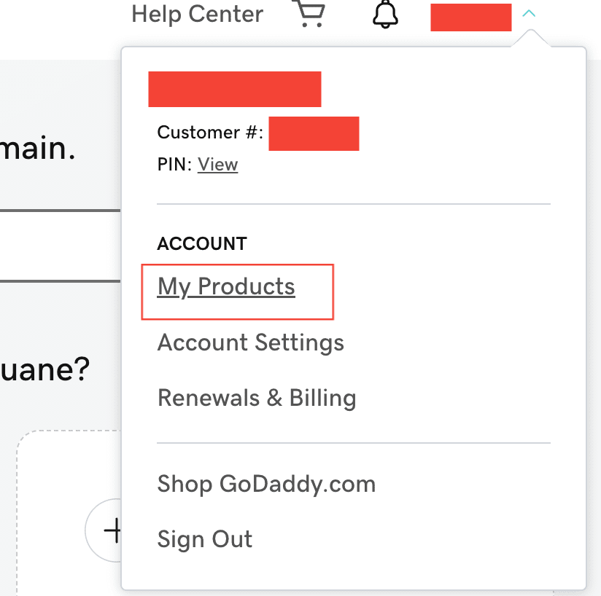
  + Choose Websites + Marketing > Websites + Marketing Basic > Manage
    - 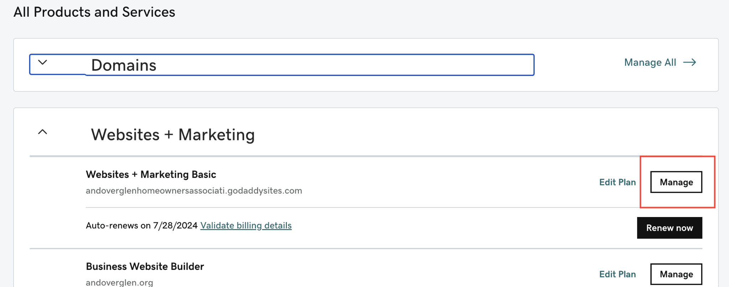
  + Choose Edit Website
    - 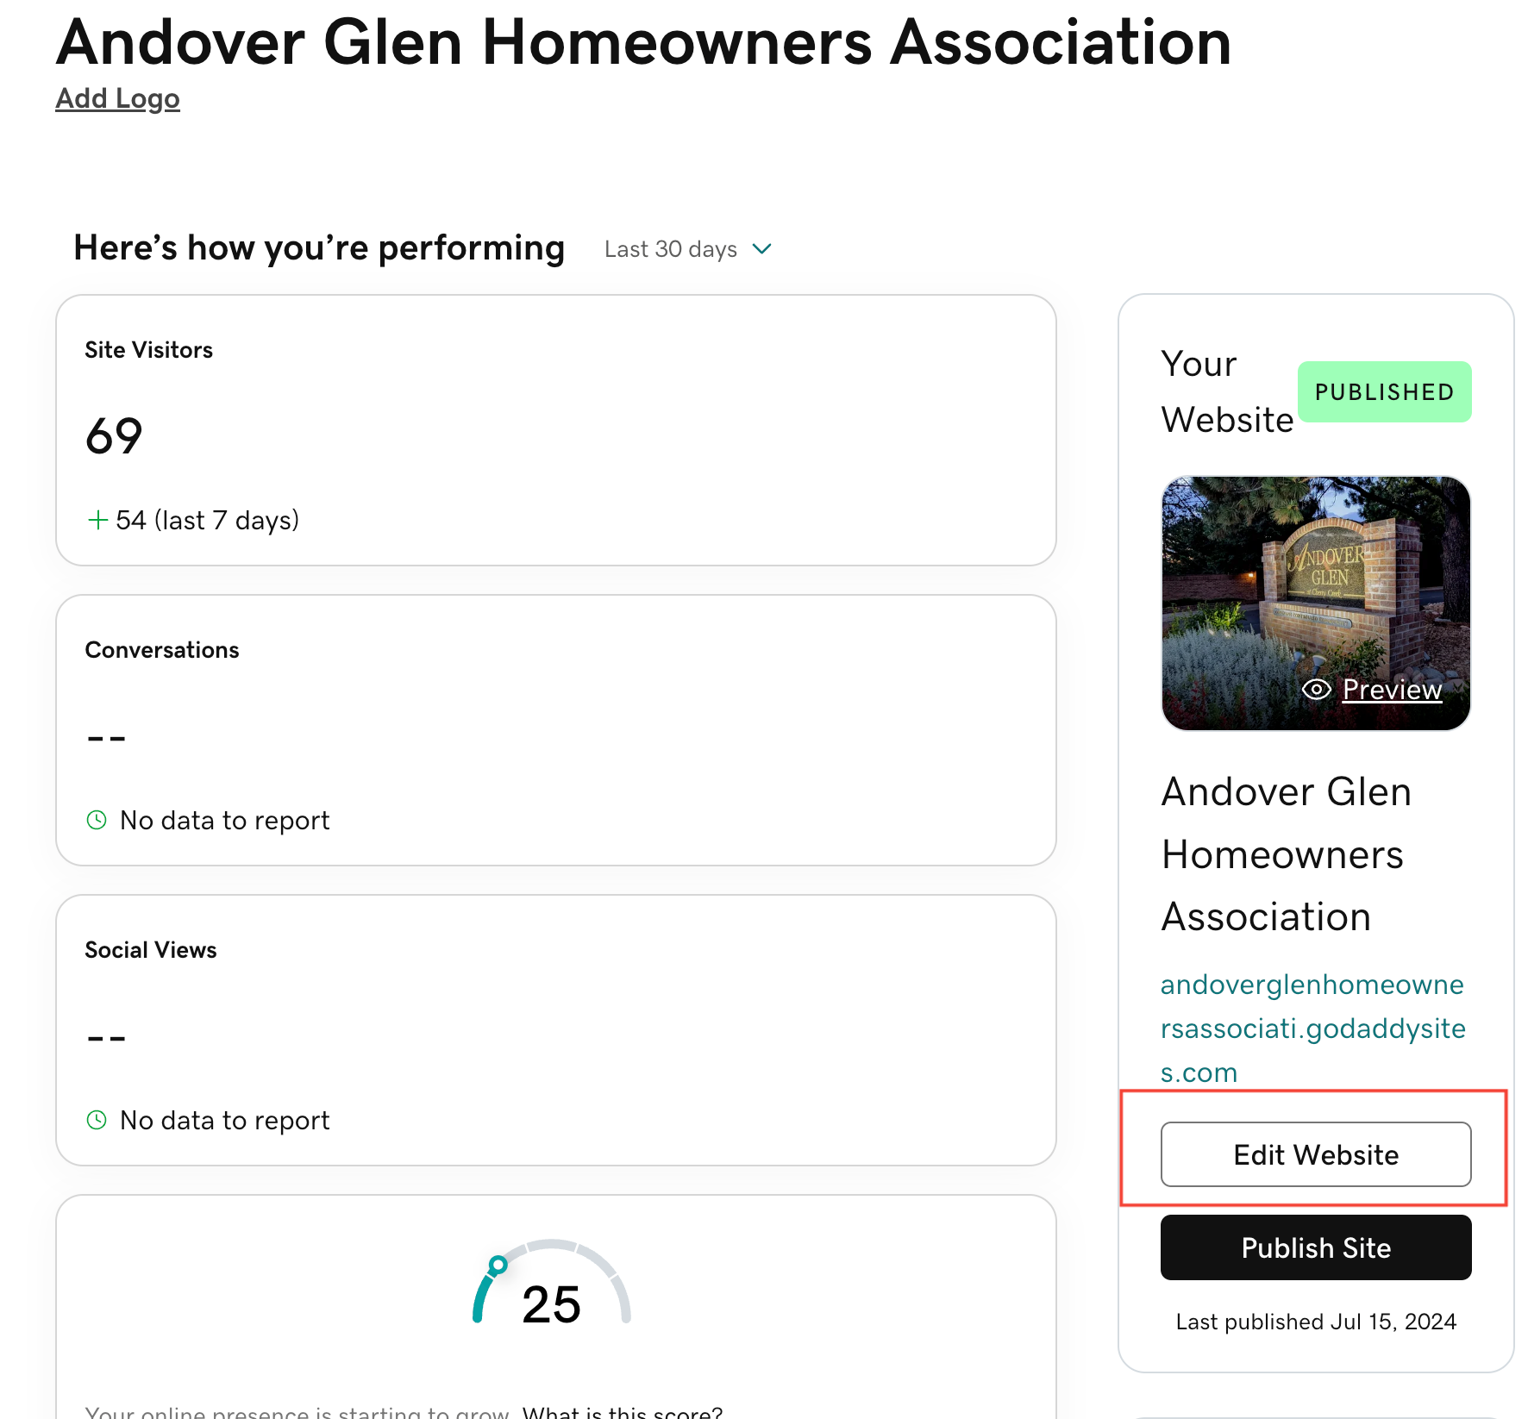
  + Notes:
    - Each ‘File’ section can only contain 15 files. Add a new ‘File’ section as needed
    - Each page can only contain 22 sections. Split content across pages as needed *(see Newletters pages)*.
* Meeting Minutes (monthly)
  + Navigate to Archives > Meeting Minutes
  + Click into the most recent Minutes section
  + Click ‘Add’ in the right-hand panel to upload a new file
    - *It is strongly recommended to name new files consistently with existing files*
    - 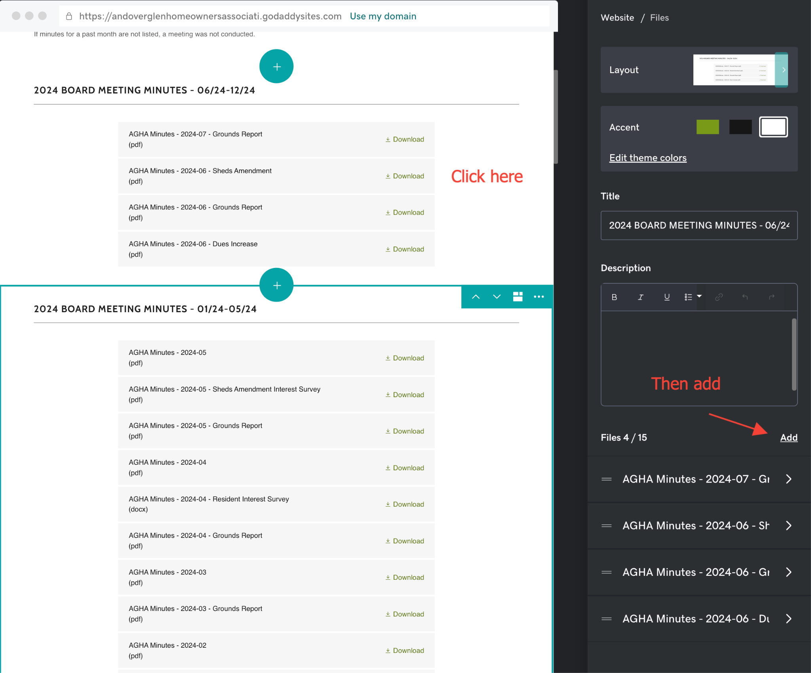
  + Click ‘Publish’ to make the changes visible to site visitors
* Newsletters (quarterly/floating)
  + Follow the guidelines for Meeting Minutes, but navigate to Archives > Newsletters to begin
* Board Member information (annually / as needed)
  + Navigate to Contact > Board Members and update information as needed
* Forwarding emails for board members
  + The AGHA Office account IS NOT through GoDaddy, therefore forwarding emails must be maintained separately.
  + The email forwarding service offered through GoDaddy does not function properly when receiving emails from GMail users.
  + [ImprovMX](https://improvmx.com/) offers a [free service](https://improvmx.com/pricing/) for low-volume users, such as AGHA.Getting to the website editor
    - Login to [ImprovMX](https://improvmx.com/) with the AGHA account
    - Delete, Add or Test up to 25 forwarding aliases.
      * 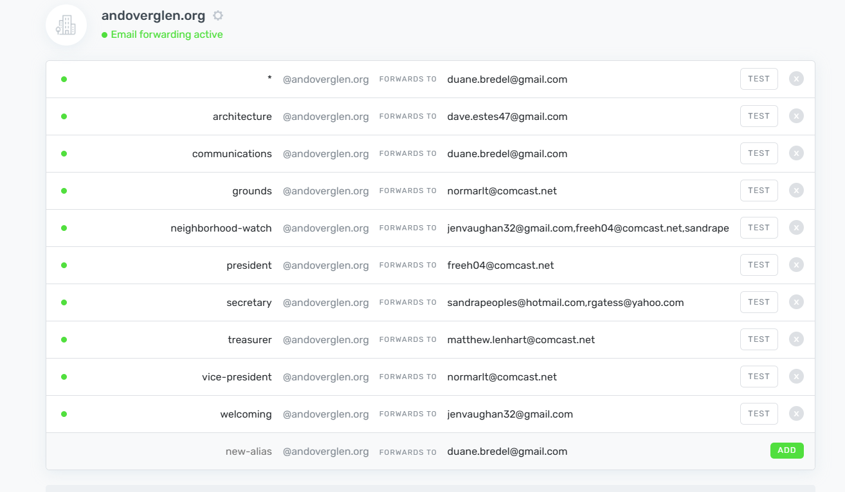
    - NOTE: This is a FREE service, not a fully-fledged email provider. Once someone emails a board member, further communication is via their personal email account / service. They can, however, setup email filters to make sure that board related emails sent to these addresses are sorted into a separate location.
    - To transfer, the account should be updated with the new owner’s email address by the old owner in account info.
      * 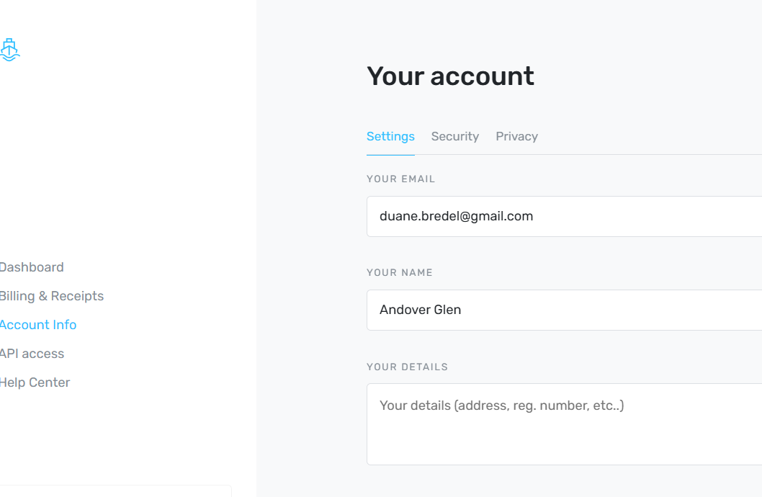
* Miscellaneous information (as needed)
  + Add new items the board calls out to pages such as Safety Information or Landscaping Resources as needed.