beE - Application Form
* Required
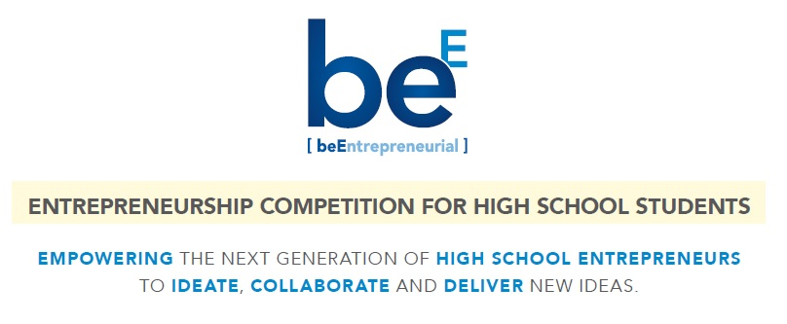
Team Member Name 1 (First, Last): *
Your answer
Team Member Name 2 (First, Last): *
Your answer
Team Member Name 3 (First, Last):
Your answer
Team Member Name 4 (First, Last):
Your answer
Team Member Name 5 (First, Last):
Your answer
Email (one point of contact for your team): *
Your answer
Phone (one point of contact for your team): *
Your answer
School Name: *
Your answer
Name of School Representative:
Your answer
Email of School Representative:
Your answer
Phone # of School Representative:
Your answer
What's the name / title of the idea your presenting? *
Your answer
What's your idea about? Give us some details in no more than 50 words. *
Your answer
What need does your idea satisfy? What problem are you trying to solve? Give us some details in no more than 50 words. *
Your answer
Who are your primary customers? Who is going to use the product / service that you have proposed above? Give us some details in no more than 50 words. *
Your answer
How is your idea unique, different or better than what's available in the market today? Give us some details in no more than 50 words.
Your answer

Anything else you want to share or upload in reference to your idea above? Eg: short 1 min video describing your idea, logo, pictures, graphics, presentation etc. Be creative and go for it! Send your material along with this application to VALENTINA ISCARO / vi0004@uah.edu.

Acknowledgement

By emailing this form, I acknowledge that the above information is provided for the purpose of applying for the beE competition and is accurate to the best of my knowledge. I understand that UAH, I2C and related staff, advisers or parties retain sole decision whether this application is approved, disapproved or modified.
I understand that as a student participating in beE, any support I receive in the course of the mentoring relationship is solely for the purpose of guiding my student team in the field of enterprise. I understand this relationship is an educational resource to discuss issues confronted in building and scaling the idea proposed above.
I agree to hold harmless The University of Alabama in Huntsville, the University of Alabama System, The Trustees of the Alabama System, I2C, its’ staff, employees, agents, volunteers, officers and related boards from any and all claims, injury, cause of action whatsoever, whether previously, now or hereafter incurred, from any acts or omissions by these entities, as a result of my participation in beE. I agree that these offices assume no responsibility for the success or failure of the proposed idea. The role of these entities is educational and consultative in nature and any advice or information offered may or may not be used per my discretion.
----------
Thanks for your interest. Please email this form to VALENTINA ISCARO / vi0004@uah.edu.

