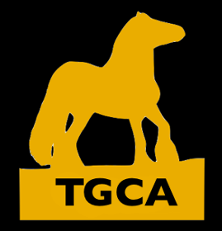
TGCA Assured Breeders Scheme

Name________________________________
Email_________________________________
Telephone_____________________________
Address__________________________________________________________
________________________________________________________________
Country_____________
Number of horses in Herd_________

Will require TGCA assessors to travel outside the UK? Yes No

Please complete and email to tgcaheadoffice@gmail.com for a full quote

By signing below, you agree to let TGCA contact you with products and services on offer

Signed________________________________________
Date_______________
TGCA processes your personal data in accordance with the GDPR. Your personal details will be kept confidential and safe on the secure information server. As part of your membership contract signed above, your data will be processed by the TGCA for the following purposes: administration of membership, contacting you about TGCA activities and fulfilling legal requirements set by DEFRA. TGCA will not disclose your personal data to third party controllers other than the above, or without your permission.

