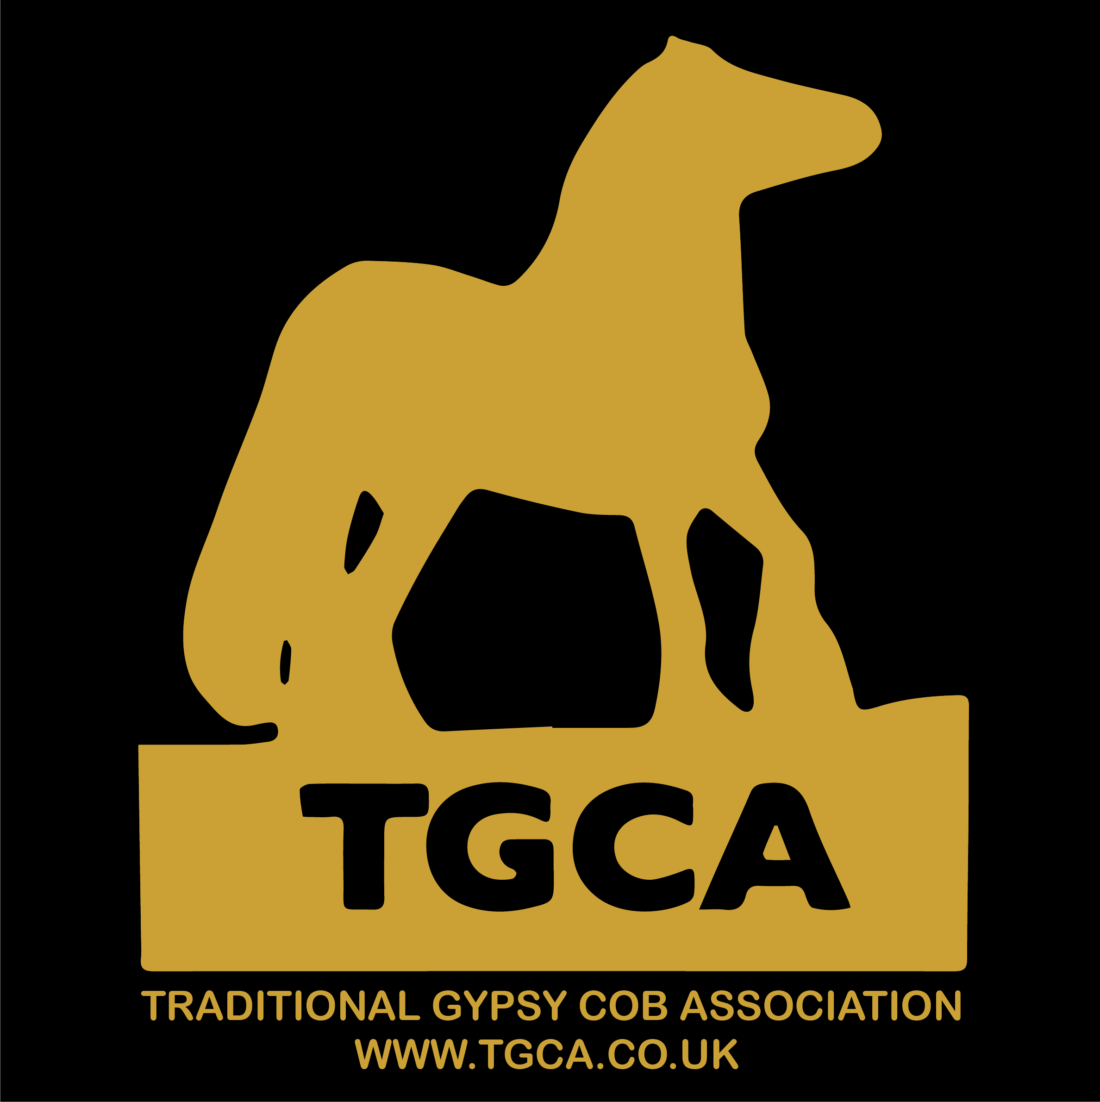
TGCA Horse Registration Form
Passport application
COMPLETE FOR:  A PART BRED Horse With Known/ Unknown Breeding

  Send to: Send to: PO Box TGCA, PO Box 1120, CT1 9UL

PLEASE COMPLETE SECTIONS 1 - 5 (IN BLOCK CAPITALS)and clearly
 |  | 1 EQUINE DETAILS
Name of Horse:
Date of Birth:
Country of Birth:
Breeder Name & Address: |  | (if known)
Indicate: |  | Mare     Filly      Stallion     Colt    Gelding 
Colour: |  |  |  | Height at maturity:
Microchip No: |  | (Please enclose any spare bar code stickers for inclusion into the passport. Please do not stick them to this form.)
Passport ULEN Number: |  | (not required if you are applying for a new TGCA passport)
Section applied for  SEE DETAILS PAGE 2 |  | DRUM SPORT NATIVE SHOW COB PONY
2 HORSE OWNER DETAILS

Name: |  |  | Telephone No:
Address:
Email: |  |  | TGCA Membership Number:
Please complete a) or b)
- I DO NOT intend the equine known as ………………………………..….. to enter the human food chain and I agree to sign the page marked Section IX when appropriate. I understand this decision cannot be reversed.
- I DO wish the equine known as………………………………...…….……. to enter the human food chain and I agree to sign the page marked Section IX when appropriate. I understand this decision may be reversed. I understand certain drugs will be denied to my horse if I make the decision for my horse to enter the human food chain.
I understand the above and have taken steps to expand my knowledge if I deem it necessary before signing this form.
3 NEW PASSPORT DECLARATION
4 REGISTRATION DECLARATION
I HEREBY CERTIFY THAT ALL INFORMATION BOTH ENTERED ONTO THIS FORM AND SUPPLIED IN SUPPORT OF MY HORSE REGISTRATION APPLICATION ARE CORRECT AND THAT THE HORSE DETAILED IN THIS REGISTRATION FORM IS NOT ALREADY REGISTERED OR ELIGIBLE FOR REGISTRATION WITH ANY OTHER BREED SOCIETY.
Date: |  | Signature:

UK inc postage:- NON MEMBERS - £50 * TGCA MEMBERS - £40 * for EU add £5 extra for postage

5 PAYMENT - COST OF AN OFFICIAL TGCA BREED PASSPORT WITH NO KNOWN BREEDING : -

Turnaround From receipt of ALL required paperwork and payment:
General 15 working days
FAST TRACK * 2 working days
NB working days exclude Weekends and Bank Holidays.
Refund policy: All refunds will be subject to a £10 administration fee.
Payment method (please tick)
ONLINE: at http://www.tgca.co.uk/guidesrates.htm
CHEQUE: made out to ‘TGCA Ltd’
and MUST HAVE bank card details on the reverse side
CASH: Please send using recorded delivery
NB for FAST TRACK * payment must be online or by cash

PLEASE ENSURE YOU HAVE: YOU HAVE , COMPLETED THIS FORM IN FULL

- SENT PAYMENT IN FULL Either online or enclosed

- SENT 4 IMAGES ( ONE OF EACH SIDE 2 will be included in passport ) Either emailed or photos enclosed

- ATTACHED YOUR IDENTITY FORM (completed by the vet , who has completed all sections that can be easily read )

FOR GUIDANCE: Please refer to ‘Passport Overview’ - https://www.tgca.co.uk/passport-overview

(1)(a) Species:  Espèce |  |  |  | (4) Unique Life Number: (15 digits):  Numéro unique d'identification valable à vie (15 chiffres)  826-089-
(1)(b) Sex
Sexe
(2)(a) Date of birth:  Date de naissance |  |  |  | (5) Transponder code (where available):  Code du transpondeur (si disponible)  Reading system (if not ISO 11784):  Système de lecture (si différent de ISO 11784)  Bar-Code (optional):  Code-barres (optionnel)
(2)(b) Country of birth:
Pays de naissance
(3) Description/Signalement
(3)(a) Colour:
Robe
(3)(b) Head:  Tête |  |  |  | (6) Alternative method of identity verification (if applicable):  Méthode alternative de vérification d'identité (si applicable)
(3)(c) Foreleg L:  Ant. G |  |  |  | (7) Information on any other appropriate method providing guarantees to verify the identity of the animal (blood group/DNA code) (optional):  Informations sur toute autre méthode appropriée donnant des garanties pour vérifier l'identité de l'animal (groupe sanguin/code ADN) (optionnel)
(3)(d) Foreleg R:
Ant. D
(3)(e) Hindleg L:
Post G
(8) Name and address of person to whom document is issued:
Nom et adresse du destinataire du document

(3)(f) Hindleg R:
Post D
(3)(g) Body:
Corps
(3)(h) Markings: Marques |  |  |  | (11) Signature of qualified person (name in capital letters):  Signature de la personne qualifiée (nom en lettres capitales)
(9) Date:  Date |  |  | A Betteridge (TGCA DIRECTOR)
(10) Place  Lieu |  |  | Stamp of issuing body or competent authority:  Cachet de l'organisme émetteur ou de l'autorité compétente
VET NOTES : These Forms are to be used on behalf of the Traditional Gypsy Cob Association ( TGCA Ltd ) All writing must be clear and easy to read, each section must be completed between section 1-10, Spare bar codes must be returned with this completed form. The Above Silhouette must be fully completed, with the transponder (microchip) clearly marked where inserted, with a cross. All whorls and markings must be clearly defined. If the Equine does not have the required 3 Whorls and is without markings , then an outline of each chestnut must
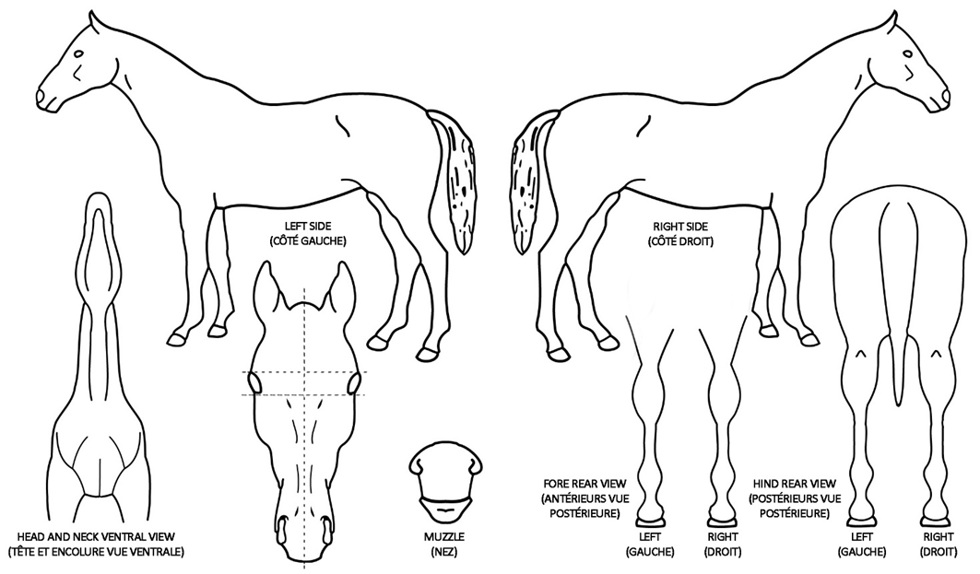
Signature and stamp of the veterinarian or qualified person or place bar code label here/or code if already implanted
competent authority (name in capital letters)

Signature and stamp of the veterinarian or qualified person or place bar code label here/or code if already implanted
competent authority (name in capital letters)

