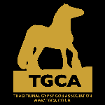
TGCA Horse Registration Form
COMPLETE FOR: A New HORSE PASSPORT for equines with TGCA Registered Parents (Sire must be TGCA Breed Evaluated) – a TGCA covering certificate must be submitted with this form
 

Send to: Send to: PO Box TGCA, PO Box 1120, CT1 9UL

PLEASE COMPLETE SECTIONS 1 AND 6 (IN BLOCK CAPITALS)
 |  | 1 EQUINE DETAILS
Name of Horse:
Date of Birth:
Country of Birth:
Breeder Name & Address: |  | (if known)
Indicate: |  | Mare     Filly      Stallion     Colt    Gelding 
Colour: |  |  |  | Height at maturity:
Microchip No: |  | (Please enclose any spare bar code stickers for inclusion into the passport. Please do not stick them to this form.)
Passport ULEN Number: |  | (not required if you are applying for a new TGCA passport)
2 HORSE OWNER DETAILS

Name: |  |  | Telephone No:
Address:
Email: |  |  | TGCA Membership Number:

APPLICATION FOR :- SUPPLEMENTARY STUD BOOK 2 :
If you are requesting SSB2 passport : then please submit hairs for a DNA profile to be done.
APPLICATION FOR : -SUPPLEMENTARY STUD BOOK 1 :
Please complete section 4 , and if your pedigree can be proven please send in DNA profile samples with your application.
More information regarding stud book levels can be found in TGCA stud book reference guide on the web site

3
P
EDIGREE CHART-for SSB1 application
Sire:
Grand Sire:
Great Grand Sire:
DOB
Great Grand Dam:
UELN
Breed
Grand Dam:
Great Grand Sire:
Society No:
Great Grand Dam:
Name of Your
Horse:
Grand Sire:
Great Grand Sire:
Dam:
DOB
Great Grand Dam:
UELN
Breed
Grand Dam:
Great Grand Sire:
Society No:
Great Grand dam:
4 NEW PASSPORT DECLARATION
Please complete a) or b)
- I DO NOT intend the equine known as ………………………………..….. to enter the human food chain and I agree to sign the page marked Section IX when appropriate. I understand this decision cannot be reversed.
- I DO wish the equine known as………………………………...…….……. to enter the human food chain and I agree to sign the page marked Section IX when appropriate. I understand this decision may be reversed. I understand certain drugs will be denied to my horse if I make the decision for my horse to enter the human food chain.
I understand the above and have taken steps to expand my knowledge if I deem it necessary before signing this form.
PLEASE COMPLETE SECTION 6
5 REGISTRATION DECLARATION
I HEREBY CERTIFY THAT ALL INFORMATION BOTH ENTERED ONTO THIS FORM AND SUPPLIED IN SUPPORT OF MY HORSE REGISTRATION APPLICATION ARE CORRECT AND THAT THE HORSE DETAILED IN THIS REGISTRATION FORM IS NOT ALREADY REGISTERED OR ELIGIBLE FOR REGISTRATION WITH ANY OTHER BREED SOCIETY.
Date: |  | Signature*:

www.tgca.co.uk
TGCA SSB Registration Application Form 2023
TGCA Ltd Company No. 7415438
6 PAYMENT CALCULATION
Service |  | Please tick | Rate | Amount Enclosed £
Studbook  SSB2:  Entry Fee  SSB1: |  |  | Member £55  NON Member £65  Member £55  NON Member £65
DNA Profiling Fee  (required for SSB1 and SSB2) |  |  | members per profile £50  non-members per profile £65
FAST TRACK*  Please check the website BEFORE opting for fast track to ensure the office is currently open and available.  Do not take this option if you require DNA processing. |  |  | ADD £40  Outside UK postage - £5
If outside UK, please add an EXTRA £5 postage |  |  | Total Payable
 | Payment method (please tick)  ONLINE: at http://www.tgca.co.uk/guidesrates.htm  CHEQUE: made out to ‘TGCA Ltd’ and MUST HAVE bank card details on the reverse side  CASH: Please send using recorded delivery  NB for FAST TRACK * payment must be online or by cash |  | Turnaround From receipt of ALL required paperwork and payment:  General 15 working days  FAST TRACK * 2 working days  NB working days exclude Weekends and Bank Holidays.  Refund policy: All refunds will be subject to a £10 administration fee.

PLEASE ENSURE YOU HAVE: COMPLETED THIS FORM IN FULL

- SENT PAYMENT IN FULL Either online or enclosed

- SENT IMAGES Either emailed or photos enclosed

- SENT PROOF OF BREEDING if applicable OR DNA sample

- SENT YOUR IDENTITY FORM (completed by the vet ,who has completed all sections that can be easily read)

SEND TO : TGCA Ltd , PO BOX 1120 CT1 9UL
FOR GUIDANCE: Please refer to 'How to PASSPORT or Register Your Horse’ at http://www.tgca.co.uk/registeryourhorse.htm

*

TGCA SSB Registration Application Form 2023
www.tgca.co.uk
TGCA Ltd Company No. 7415438

(1)(a) Species:  Espèce |  |  |  | (4) Unique Life Number: (15 digits):  Numéro unique d'identification valable à vie (15 chiffres)  826-089-
(1)(b) Sex
Sexe
(2)(a) Date of birth:  Date de naissance |  |  |  | (5) Transponder code (where available):  Code du transpondeur (si disponible)  Reading system (if not ISO 11784):  Système de lecture (si différent de ISO 11784)  Bar-Code (optional):  Code-barres (optionnel)
(2)(b) Country of birth:
Pays de naissance
(3) Description/Signalement
(3)(a) Colour:
Robe
(3)(b) Head:  Tête |  |  |  | (6) Alternative method of identity verification (if applicable):  Méthode alternative de vérification d'identité (si applicable)
(3)(c) Foreleg L:  Ant. G |  |  |  | (7) Information on any other appropriate method providing guarantees to verify the identity of the animal (blood group/DNA code) (optional):  Informations sur toute autre méthode appropriée donnant des garanties pour vérifier l'identité de l'animal (groupe sanguin/code ADN) (optionnel)
(3)(d) Foreleg R:
Ant. D
(3)(e) Hindleg L:
Post G
(8) Name and address of person to whom document is issued:
Nom et adresse du destinataire du document

(3)(f) Hindleg R:
Post D
(3)(g) Body:
Corps
(3)(h) Markings: Marques |  |  |  | (11) Signature of qualified person (name in capital letters):  Signature de la personne qualifiée (nom en lettres capitales)
(9) Date:  Date |  |  | A Betteridge (TGCA DIRECTOR)
(10) Place  Lieu |  |  | Stamp of issuing body or competent authority:  Cachet de l'organisme émetteur ou de l'autorité compétente
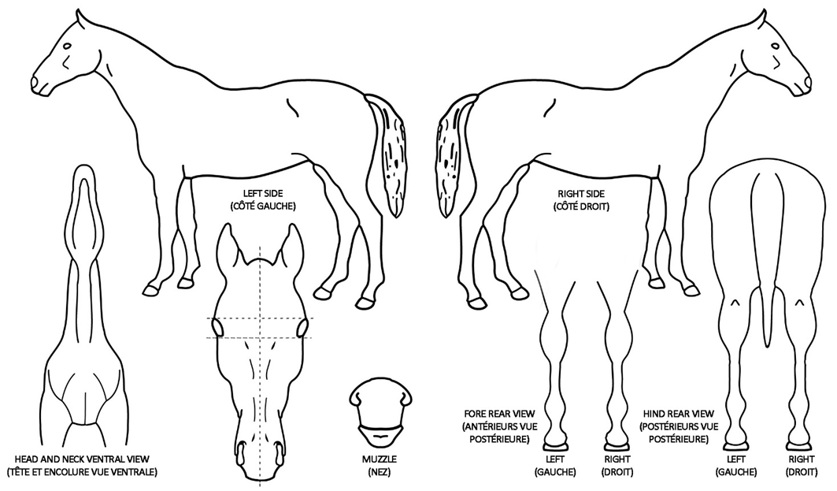
www.tgca.co.uk
TGCA SSB Registration Application Form 2023
TGCA Ltd Company No. 7415438
Signature and stamp of the veterinarian or qualified person or place bar code here or transponder code if already implanted
competent authority (name in capital letters)

Signature et cachet du vétérinaire ou de la personne qualifiée ou
Signature and stamp of the veterinarian or qualified person or place bar code here or transponder code if already implanted
competent authority (name in capital letters)

Signature et cachet du vétérinaire ou de la personne qualifiée ou

