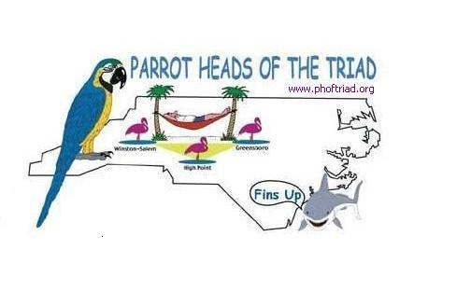
Parrot Heads of the Triad 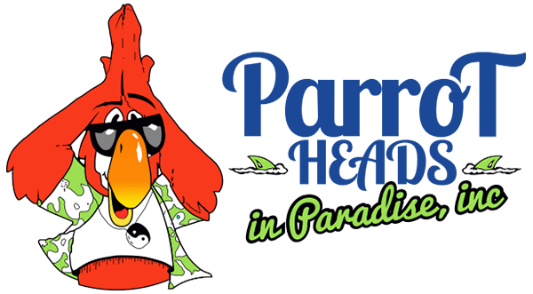
Membership Application

Date:____________

Name:_________________________________Spouse:_____________________________

Street Address:_____________________________________________________________

City, State, Zip: _____________________________________________________________

Phone: ____________________________ Other Phone: ___________________________

Email(s):___________________________________________________________________

Birthday:________________________ Spouse Birthday:____________________________

Occupation: ________________________ Spouse’s Occupation:______________________

Favorite Charity:_____________________________________________________________

I would like to volunteer with club administration and/or events___________
It is okay to include my phone number & addres on the club directory for members only
Yes______ No_______
I have read and understand the guidelines of the Parrot Heads of the Triad __________
How did you hear about the club?_____________________________________________
Occasionally we post photos on our website..it is okay to post my picture if applicable
Yes______ No______

If you require special services or handicap access check here __________

Please see DUES Schedule on reverse side of application. Make checks payable to Parrot Heads of the Triad and return to: Treasurer, Parrot Heads of the Triad, 3750 Squirewood Drive, Clemmons, NC 27012.

Club hotline: (336) 766-9638 Club website: www.phoftriad.com Club email: TriadPHNews@yahoo.com

The Parrot Head Club of the Triad is an officially chartered club sanctioned by the Parrot Heads in Paradise. The Parrot Head Club of the Triad embraces the following statement of purpose: “The local Parrot Head clubs are not for profit organizations whose purposes are to provide a variety of social activities for people with similar taste and interests and to assist in local community and environmental concerns.” Any money or items given to the club for charitable or membership reasons are not deductible as a charitable contribution for federal income tax purposes.

Schedule of Dues
Annual membership begins on January, 1st and continues through December, 31st of the following year. Renewals are every January and to remain a member in good standing membership dues must be paid by January 31 of each year.

Household Individual

January $ 36.00 $ 25.00
February $ 33.00 $ 23.00
March $ 30.00 $ 21.00
April $ 27.00 $ 19.00
May $ 24.00 $ 17.00
June $ 21.00 $ 15.00
July $ 18.00 $ 13.00
August $ 15.00 $ 11.00
September $ 12.00 $ 9.00
October $ 9.00 $ 7.00
November $ 6.00 $ 5.00
December $ 3.00 $ 3.00

New members will receive a New Member Packet consisting of a lanyard and membership badge plus

- Welcome Letter
- Brochures – Parrot Heads of the Triad and Parrot Head in Paradise

