Bible science?

Ancient Hebrew Cosmology
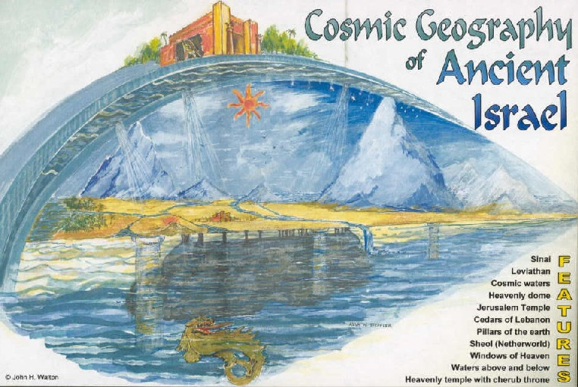

This is written about the scientifically inaccurate correlation between the mind and heart that was common in the ancient world. To reiterate, ancient cultures believed that our emotions, and in many cases our intellect, came from within our heart, and that the heart was ethereally connected (if not itself the) immaterial soul. The biblical authors, writing in the Ancient Near East, used this type of language to discuss issues of personhood and being. If we try to read their phrases, such as “thinking in your heart” with our scientific mindset, we would read them erroneously for the biblical authors wrote in a local context that was lacking much scientific knowledge about the world. Yet, it turns out that ancient neurology was not the only field lacking scientific accuracy. The whole understanding of the universe by ancient people was immensely shortsighted. It was literally shortsighted, because most of our knowledge about the cosmos is very recent and was only discovered after the invention of the telescope in the 17th century!

What do we know about the cosmos?
Very little. But compared to the people of Antiquity, significantly more. For example: if we know 5 percent of what there is to know about the universe, the ancient people only know 0.0000001 percent about it. And 99 percent of what they “knew” was wrong.
We know that the earth is an ellipsoid sphere, rotating on an axis, hurling around the sun, being held in orbit around the center of our galaxy, and moving out in an expanding universe. We are on a spherical rock madly spinning, soaring, and moving at speeds we cannot fathom.
We know that the stars are not little lights but that they are in fact suns, just like our own sun, vast distances away from us. Our sun is one out of 300,000,000,000 stars in our galaxy, and we estimate there are between 200,000,000,000 to 500,000,000,000 such galaxies, each with infinities of stars.
We also know that all of these stars have planets, whole worlds, of their own. Each of these planets have their own rocky terrain, caverns, caves, plains, mountains, their own weather patterns, storms, solar cycles, and perhaps many other things we cannot even imagine.
We estimate that there are around 4,000,000,000,000 planets in our galaxy alone. If we take multiply that by the estimated number of galaxies, we get 12,000,000,000,000,000,000,000,000 planets. Can you even imagine what that means? That means our planet represents only 0.000000000000000000000000083 percent of the worlds out there.
In the last two centuries, astronomers have discovered and learned so many things about this cosmos, many being so complicated most of us don’t even grasp them completely.

What did they know about the cosmos?
If we look at the recorded writings left to us by our forebears, what did they believe about the earth? Generally, this is a very difficult question to answer because of the huge diversity of early beliefs and progressive evolution of knowledge that spread from Greece to the other parts of the ancient world. Different philosophies and ideologies spread in waves throughout different parts of the planet, some like Hindu thought, stayed contained within their borders, whereas Greek thinking eventually prevailed throughout the western world.
Also consider that today conceptions of the universe widely vary. Almost everyone in academia accepts the theory of biological evolution, the old age of the earth, and the cosmological theory of the big bang. Yet, the public, in large droves, doesn’t believe in any of these and imagines a very different world. And this is in a time when most people are literate! Historians say only 1 percent of people in the ancient world knew how to read or had access to education. Our views are diverse even though education is mandated. So, you can see why it’s difficult. That said, we can study many ancient documents and see what the 1 percent who were usually intellectual elites believed.

The sky above
The people of the Ancient Near East, often called the “cradle of civilization” because it included Mesopotamia, Babylon, Egypt, and of course, the Hebrews, left many writings depicting their belief that the sky above was “firm,” like a canvass or a tent, stretched over the disc shaped earth below.
The Hebrew bible speaks of a “firmament” which is translated so because it comes from the word “firm.” In the Ancient Near East the stars were seen as the representations of gods, spirits, or small lights suspended on the firmament/dome celling.
The early Greeks believed a magical ether was above the earth, but a few centuries before the turn of the millennium, they developed a belief that the earth and other heavenly bodies rotated around an invisible flame in a small circular universe. This was evolved more clearly into a belief that the universe is composed of a few concentric spheres (like a ball inside of a ball, inside of a ball) and outside of these spheres was the realm of heaven.
This cosmology was adopted by Christians who drew heavily on Greek philosophers like Plato, and thus it was the dominant cosmology throughout the Middle Ages, until the Copernican revolution. If you would have asked a Middle Ages person what the universe was like, they would have drawn concentric circles, and stated that God literally lived in the realm outside of these circles.

The earth below
What did the earth look like? “For thousands of years the earth was thought to be anything but a sphere by ancient people. The Mesopotamians and Egyptians saw the earth as being flat, as did the earliest Greeks. It was the Greeks, however, that changed the view of the earth and set forth a series of theories that proved the earth was round.” (1) What is interesting is that, contrary popular opinion in Elementary school, the scholars of the Middle Ages did not believe in a flat earth, certainly many of the villagers might have, but the academics did not. Most educated people of the Middle Ages inherited Greek philosophy and cosmology, which as far back as the 3rd century BC established that the word was spherical. However, in ancient Mesopotamia, Sumer, and other lands bordering the Hebrews, the people unilaterally believed that the earth was flat, it was conceived as a flat circle or disk. Below is an illustration produced by Christian biblical scholars of the Old Testament. (2)

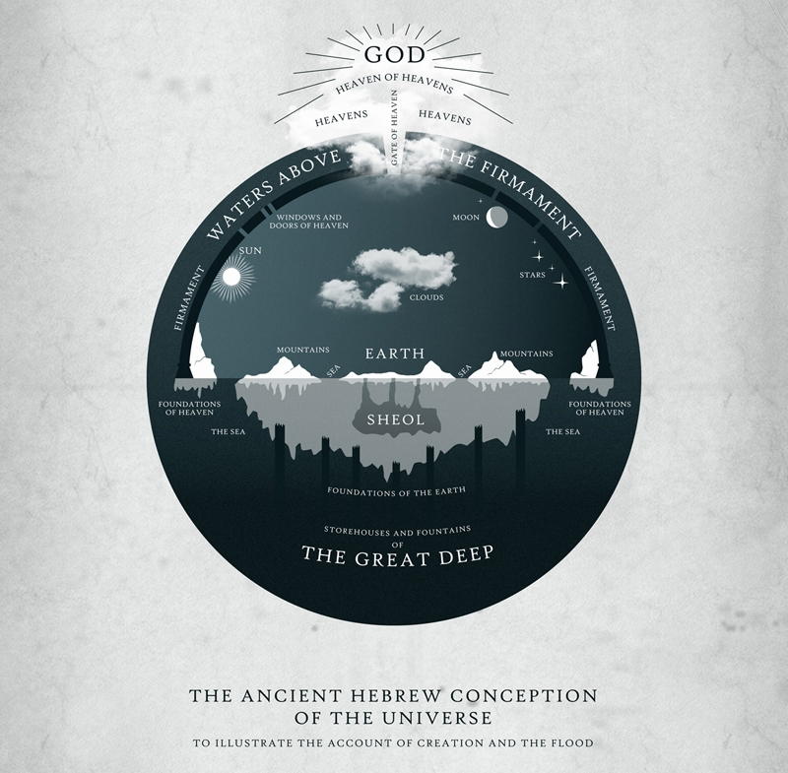

The center of it all
The ancient Greeks believed the center of the universe was an invisible flame. Yet other groups, especially in the Ancient Near East, firmly believed that the earth was the center of it all. The last two thousand years saw the advent of the Christian church and Islamic theology, both of which served as the backdrop for most of the cosmological ideas of the Middle Ages. Both of these religions have texts that are very geocentric or present the earth as the center of the universe. This is why Galileo was denounced by the church. There has been plenty of attempts by conservative apologists redefine this story, but the papal decree issued against Galileo says otherwise: “The proposition that the Sun is the center of the world and does not move from its place is absurd and false philosophically and formally heretical, because it is expressly contrary to Holy Scripture.“ (3) Fortunately a recent Pope has apologized and recognized this was indeed a fatal error by the church.

A blue speck in the infinite ocean of space
Yet, Galileo himself did not get the whole picture, for he only considered that the sun replaced the earth as the center of the universe. In reality, it was only the center of one small solar system, one out of 300,000,000,000 in our galaxy, out of perhaps 300,000,000,000 galaxies! While a few visionary thinkers in ancient era suggested that our sun was a star, and other stars were suns, this was only accepted a few hundred years ago. It was only in the early 1800’s that astronomer Herschel theorized the sun was not the center of the universe. A few years before, Kant proposed that there was other “Island universes.” Then in 1918 it was proven that sun was not in the center of the universe, but off on a distant arm. Astronomers only agreed that there are other galaxies in the early 1920’s. Think about that for a second, people who lived before my grandfather was born, did not know there were other galaxies! (Though to be honest, at the time most of the public didn’t even know there were other planets with mountains and valleys.)

What does the Bible depict about cosmology?
There is no indication that the Biblical text depicts anything different than the accepted theories of its day. The Hebrew Bible unabashedly describes the earth as a flat disk, covered by a physical dome, at the center of the universe, without trillions of galaxies, stars, and planets outside. Many of these ancient Hebrew phrases and ideas were borrowed by the New Testament authors, although the era of the New Testament did include many scholars influenced by the Greeks who that believed the earth was spherical.

1. The sun moves
The Bible never mentions the earth moving, but always speaks of the sun moving. To an observer standing on the earth, the sun indeed appears to move, and perhaps some people even use phenomenological language today, for example, we speak of “sunsets” and “sunrises.” Yet we must note that these very words were invented by our predecessors, who taught that the sun literally orbited around an immobile earth. Had they believed otherwise, we would have inherited different terminology.
The difference is, any modern scientifically inclined person knows “sun moved” really means “earth rotated,” yet, from the cultures of the Ancient Near East all the way up to the 16th century, people did not know this but actually believed the sun moved around a stationary earth. The Catholic church and reformers like Martin Luther and John Calvin firmly believed this based on their interpretation of the Bible.
Joshua 10:12-13
“Then Joshua spoke… ‘sun, stand still at Gibeon, and moon in the valley of Aijalon.’ So, the sun stood still, and the moon stopped”
Habakkuk 3:11
“The sun and moon stood still in their habitation”
Ecclesiastes 1:5
“The sun rises, and the sun goes down, and hastens to the place where it rises.”
Psalm 19:5
“He has set a tent for the sun, which comes out like a bridegroom leaving his chamber, and, like a strong man, runs its course with joy.”

Psalm 19:6
“It’s rising is from the end of the heavens, and its circuit to the end of them.”
Psalm 104:19
“The sun knows when to go down.”
(Not the earth knows when to rotate)

Malachi 1:11
“From where the sun rises to where it sets.”

2. The earth does not move
The Bible never mentions that the earth is moving in an orbit around the sun, while rotating. We know the earth is in perpetual motion, yet the Biblical authors described it from their perspective, completely motionless.
This was interpreted literally
John Calvin wrote
“Those who assert that ‘the earth moves and turns’…are motivated by ‘a spirit of bitterness, contradiction, and faultfinding;’ possessed by the devil, they aimed ‘to pervert the order of nature.”
1 Chronicles 16:30
“Indeed, the world is firmly established, it will not be moved.”
Psalm 93:1
“Yes, the world is established; it shall never be moved.”
Psalm 96:10
“Indeed, the world is firmly established, it will not be moved”
Psalm 104:5
“He set the earth on its foundations, so that it should never be moved.”

3. The earth has foundations

2 Samuel 22:16
“The channels of the sea appeared; the foundations of the world were laid bare”
Psalms 18:15
“Channels of the sea were seen, and the foundations of the world were laid bare”
Psalm 82:5
“All the foundations of the earth are shaken.”
Psalms 102:25
“Of old you laid the foundation of the earth, and the heavens are the work of your hands.”
Psalm 104:5
“He set the earth on its foundations, so that it should never be moved.”
Proverbs 8:27-29
“When He marked out the foundations of the earth”
Isaiah 24:48
“For the windows above are opened, and the foundations of the earth shake.”
Isaiah 48:13
“Laid the foundation of the earth”
Isaiah 51:13
“Stretched out the heavens and laid the foundations of the earth”
Jeremiah 31:37
“The foundations of the earth searched out below”

Zechariah 12:1
“Stretches out the heavens, lays the foundation of the earth”
Job 38:4-6
“Laid the foundation of the earth? On what were its bases sunk, or who laid its cornerstone?”

4. The earth has a foundation of pillars

Job 9:6
“Who shakes the earth out of its place, And its pillars tremble”
Psalm 75:3
“When the earth and all its people quake, it is I who hold its pillars firm.”
1 Sam 2:8
“For the pillars of the earth are the LORD’S, And He set the world on them.”
Psalm 75:3
The earth and all who dwell in it melt; It is I who have firmly set its pillars”

5. The sky has foundations and windows

2 Samuel 22:8
“Then the earth shook and quaked, the foundations of heaven were trembling”

Job 26:11
“The pillars of heaven tremble and are amazed at His rebuke:
Genesis 7:11
“The great deep burst forth and the windows of the heavens were opened.”
Genesis 8:2
“The fountains of the deep and the windows of the heavens were closed, the rain from the heavens was restrained”
Isaiah 24:18
“For the windows of heaven are opened, and the foundations of the earth tremble.”
Malachi 3:10
“Not open the windows of heaven for you”

6. The heaven is a hard physical “firmament” (dome)

Even recent interpreters of the Bible believed that heaven was a physically “hard thing” which was called the “firmament” in the Old Testament. For example, Martin Luther said: “Indeed, it is more likely that the bodies of the stars, like that of the sun, are round, and that they are fastened to the firmament like globes of fire, to shed light at night, each according to its endowment and its creation.” (5)
The Jewish Encyclopedia says
“The Hebrews regarded the earth as a plain or a hill figured like a hemisphere, swimming on water. Over this is arched the solid vault of heaven. To this vault are fastened the lights, the stars. So slight is this elevation that birds may rise to it and fly along its expanse” There are also “upper waters… shut up in heaven.”(6) This explains why early Hebrews believed heaven had windows, for there was water above the firmament of heaven.
Saint Augustine wrote about the firmament that “We may understand this name as given to indicate not that it is motionless but that it is solid.” (7)
In Genesis 11:4-7 we see the ancient people saying “Come, let us build ourselves a city, and a tower with its top in the heavens” clearly showing their cosmological views. They did not know that heaven was an infinite vastness of trillions of stars and galaxies, but the top of dome that one could physically reach.
Firmament is the English for the Hebrew Raqia (Firmament)which means “something hammered out.” Its Greek equivalent in the Septuagint, used by New Testament Christians, is stereoma or “something solid.”
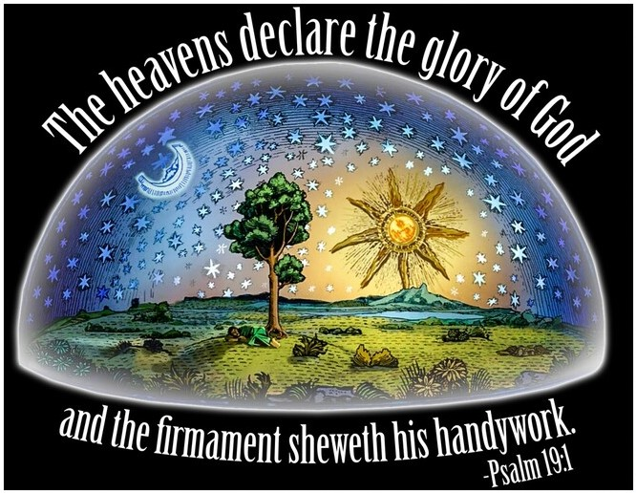
Genesis 17-8
“And AHAYA made the firmament and divided the waters which were under the firmament from the waters which were above the firmament: and it was so. And AHAYA called the firmament Heaven. AHAYA said let the waters under the heavens be gathered together unto one place, and let the dry land appear.”
Job 37:18
“Can you, like him, spread out the skies, hard as a cast metal mirror?”
Proverbs 8:27-29
“When he made firm the skies above when he established the fountains of the deep “
Isaiah 40:22
“Who stretches out the heavens like a curtain and spreads them out like a tent to dwell in.”
Isaiah 48:13
“My right hand spread out the heavens; When I call to them, they stand together.”
Psalm 104:2
“He stretches out the heavens like a tent”
Isaiah 34:4
“And the sky will be rolled up like a scroll; all their hosts will also wither away as a leaf withers from the vine”
Job 22:14
“Clouds are a hiding place for Him, so that He cannot see; and He walks on the vault of heaven.”
Job 26:8
“He wraps up the waters in His clouds, and the cloud does not burst under them”
Job 22:12
“Is not AHAYA in the height of heaven? Look also at the distant stars, how high they are!”
Isaiah 40:22
stars connected to heaven/dome because the author imagined AHAYA lived just beyond the stars.

7. The earth is a flat circle not a ball
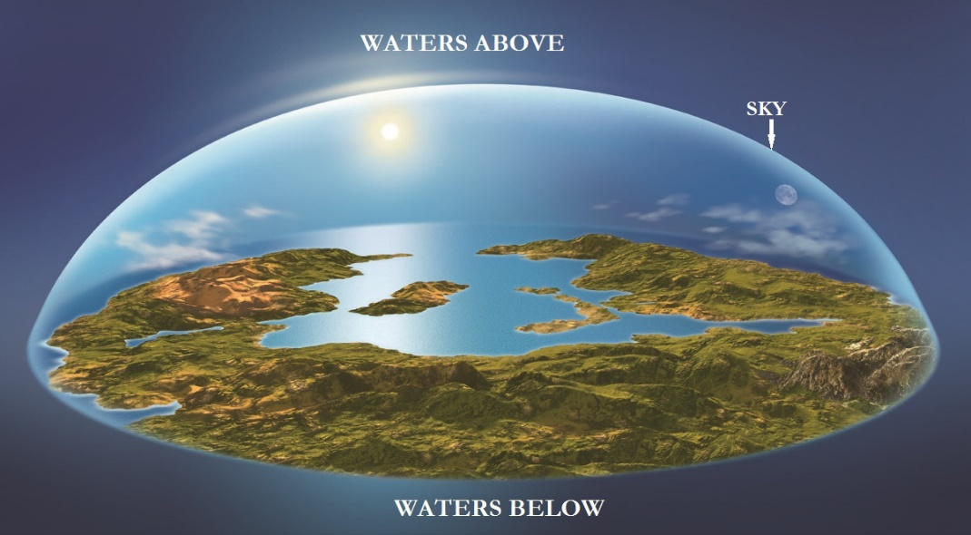
“Above the circle of the earth… the heavens like a curtain... spread…out like a tent to dwell in.”
Proverbs 8:27-29
“When he established the heavens, I was there, when he drew a circle on the face of the deep waters, when he made firm the skies above”
Job 26:10
“He has inscribed a circle on the surface of the waters”

Psalms 136:6
“Who spread out the earth upon the waters”
Isaiah 22:18
The Biblical authors called the earth a “circle” (chug). This word is used in nominal forms four times in the Old Testament to refer to “circle instrument” a device used to draw a circle on paper. The ancient people, standing on a tall mountain, could look all around them, and phenomenologically see the earth appearing as a flat disc or a circle and because of this believed it was circular. (1)
There is Hebrew language that distinguishes a 2D circle with a 3D shape, something “round” or a “ball,” but this language is not used in reference to the earth, though it is used for other things. Elsewhere Isaiah does use imagery for a 3D object: “and throw you like a ball into a wide land. There you shall die”
(Definition of Circle: cir·​cle ˈserk el noun: RING, HALO
a closed plane (see PLANE definition adjective
1: having no elevations or depressions: FLAT)
curve every point of which is equidistant (see EQUIDISTANT sense 1)
from a fixed point within the curve
: the plane surface bounded by such a curve)
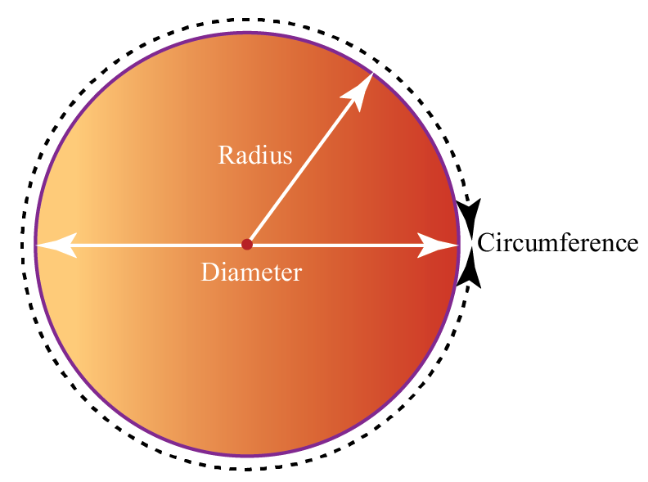

8. The earth has “edges” or “corners”

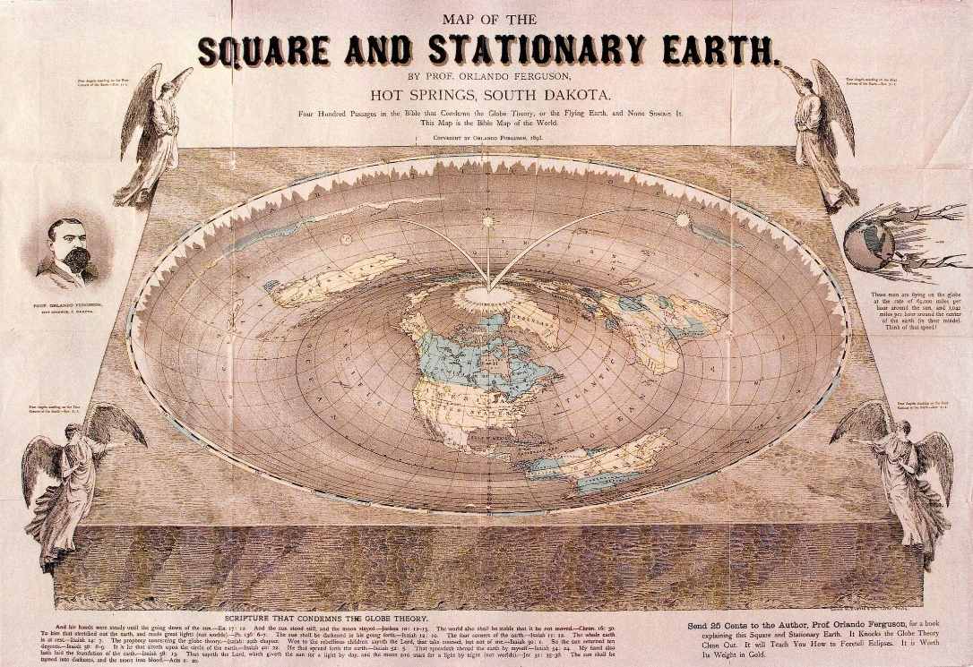
There are hundreds of passages that speak of “the ends of the earth” and the “corners of the earth” (ex: Jeremiah 51:16, Isaiah 41:9, Psalms 65:5, Ezekiel 7:2, Mark 13:27). The translation of “corners” does not mean the Hebrews believed the earth was square with 90-degree geometric corners, but the Hebrew qatsah is often translated as “ends” or “edges.” For example, in the descriptions of the temple, derivatives of qatsah are used to describe the edges of the curtains, not geometric corners.
Today it’s common to reinterpret “ends of the earth” figuratively instead of literally. Yet there is nothing in the text to tell us this is metaphor, the only reason we say these are not literal “ends,” is because we have circumvented the globe, we know it doesn’t really have ends. The reason such terminology was invented by the ancients, is because they sincerely believed the earth had ends.
Deuteronomy 28:64
Common usage of “ends” of earth: “And AHAYAH will scatter you among all peoples, from one end of the earth to the other”

Job 28:24
“For he looks to the ends of the earth and sees everything under the heavens.”
Job 38:13
That it might take hold of the ends of the earth, And the wicked be shaken out of it?
Daniel 4:10-11
“The tree grew and became strong, and its top reached to heaven, and it was visible to the end of the whole earth.”
Psalms 103:12
“As far as the east is from the west” [there is a distance from one to the other, not that they are directions on our globe that come back into each other]

9. The stars are small “accessories” to the earth, not giant suns much larger than the earth

Gen 1:16
“And God made the two great lights—the greater light to rule the day and the lesser light to rule the night—and the stars.”
Job 38:7
“When the morning stars sang together, and all the sons of God shouted for joy”
Isaiah 14:13
“I will ascend to heaven, above the stars”
Daniel 8:10
It grew great, even to the host of heaven; and some of the host of the stars it cast down to the ground and trampled upon them.

Obadiah 1:4
“The sun and the moon are darkened, and the stars withdraw their shining.” (Joel 2:10)
“Though your nest is set among the stars, from there I will bring you down”
Ezekiel 32:7
“I will cover the heavens and make their stars dark”
Matthew 24:29
“The sun will be darkened, and the moon will not give its light, and the stars will fall from heaven”
Mark 13:24-25
“The sun will be darkened, and the moon will not give its light, and the stars will be falling from heaven”
1 Corinthians 15:41
“There is one glory of the sun, and another glory of the moon, and another glory of the stars; for star differs from star in glory.”
Revelation 6:12-13
“and the sun became black as sackcloth, the full moon became like blood, and the stars of the sky fell to the earth as the fig tree sheds its winter fruit when shaken by a gale”
Revelation 8:10
“The third angel blew his trumpet, and a great star fell from heaven, blazing like a torch, and it fell on a third of the rivers and on the springs of water.” [a great star is 10,000 times larger than the earth]

Revelation 8:12
The fourth angel blew his trumpet, and a third of the sun was struck, and a third of the moon, and a third of the stars, so that a third of their light might be darkened, and a third of the day might be kept from shining, and likewise a third of the night.
Revelation 12:4
“His tail swept down a third of the stars of heaven and cast them to the earth “

10. There are thousands of stars, not trillions

There are estimates that with the naked eye (without telescopes), humans can see from 5,000 to 10,000 stars. With powerful telescopes we have discovered many orders of magnitude more individual stars and clusters of stars called galaxies than are not visible with the human eye. There are some be 300 billion stars in our galaxy, and perhaps 300 billion galaxies with hundreds of billions of stars each.
Genesis 22:17
“Make your descendants as numerous as the stars in the sky and as the sand on the seashore”
Deuteronomy 1:10
“AHAYA your God has multiplied you, and behold, you are today as numerous as the stars of heaven”
Deuteronomy 10:22
“Your ancestors who went down into Egypt were seventy in all, and now the AHAYA your God has made you as numerous as the stars in the sky. “

Deuteronomy 28:62
“You who were as numerous as the stars in the sky will be left but few in number”
Nehemiah 9:23
“You multiplied their children as the stars of heaven”

What does this mean for theology?

The Bible is not a science book and should not be used as such. It is not written with the intention of portraying accurate descriptions of natural processes. Certainly, there are some things that are mentioned with an accurate understanding, like the hydrologic cycle, yet these are usually things what were more or less understood by other ancient people. For example,
the idea of the hydrologic cycle was documented by ancient Indians almost a millennium before the birth of YASHA. Other things, like the cosmological understanding of the world, whether in India or in Jerusalem, was different from our contemporary understanding because written through the cultural, conceptual, and linguistic limits of the human authors
Some might argue that all of these descriptions of the earth with foundations and pillars are metaphors. I would ask these people to find one cosmological reference that is not a metaphor and explain to me how an ancient person without telescopes was supposed to know which one was a metaphor, and which one was not.
Certainly, we know, because we put a man on the moon, yet what about an ancient Mesopotamian farmer? In any case, we still have to concede that every single cosmological reference in the Bible is a metaphor, which yet again would show that the Bible is not written to give scientific facts, but to speak about a spiritual journey.
Leading evangelical scholar, Dr. John Walton, who is a specialist in Old Testament and the Book of Genesis, writes: “in the Bible there is no scientific revelation, That’s such an important point. Israel is not getting any new understanding of the material world, its mechanisms, its operations, or anything of that sort. No new information. Now they can observe the world, and they might make some of the same observations we make when we observe the world in our modern times. But they didn’t get that by revelation. In other words, anything that is in the Bible about the workings of the material world were things that Israel already believed and that all the nations around them already believed. Like I mentioned with the waters, the waters above and the waters below in Genesis One. Everyone in the ancient world believed that. That’s not kind of a breakthrough revelation. And that is true all the way through the Old Testament.”

Study to shew thyself approved unto AHAYAH
All Praises to the most High
AHAYAH ASHAR AHAYAH BAHASHEM YASHAYAH WA RuWACH
SHAWALAM
ALL RIGHTS RESERVED
THE TRUTH SHALL SET YOU FREE
