
Sleep, Sleep, Sleep, Sleep, Sleep …

“A good laugh and a long sleep are the best cures in the doctor’s book.”
-Irish Proverb
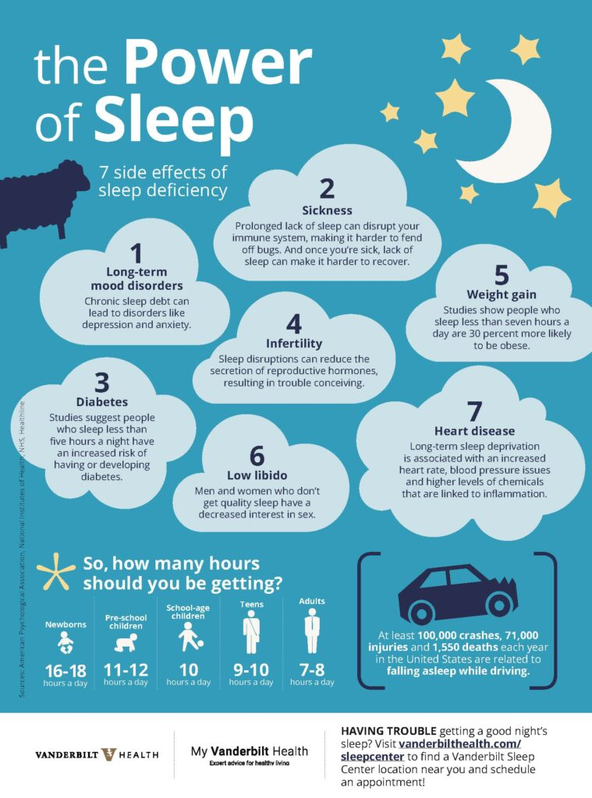

What Ideal Sleep and Circadian Rhythms Look Like
dana.org/resources/understanding-sleep/
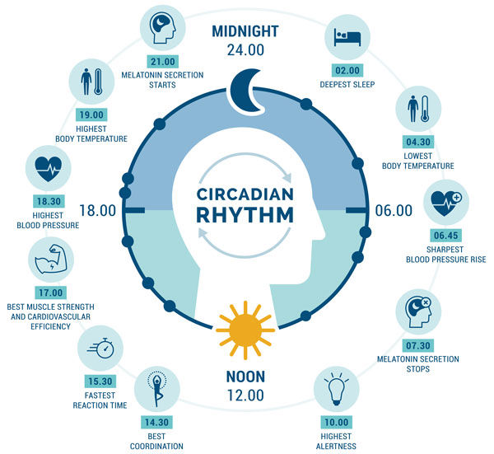

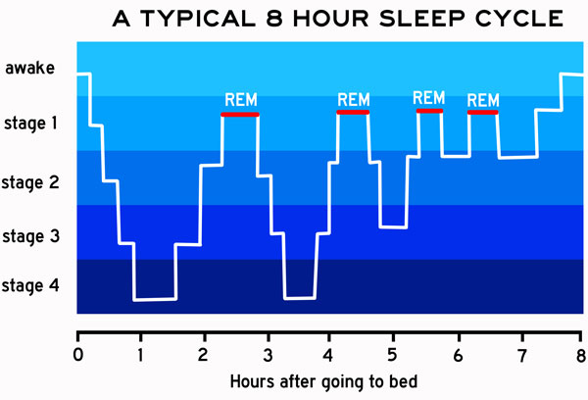

Rapid Eye Movement (REM) sleep segments are when we should be dreaming.

REM is also when the brain processes information, and consolidates memories.

Traditional “sleep” medication can stop you from experiencing REM sleep.

Melatonin can enhance REM sleep without any detrimental side effects (only benefits).
Critical Cleansing Actions Happen ONLY During Sleep
This is called the Glymphatic System = Glial (brain cell) Lymphatic System
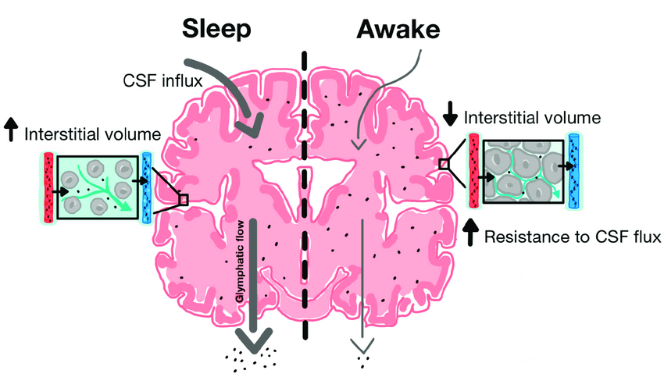
During sleep, your brain cells shrink just a bit to allow more cerebral spinal fluid to flow through the brain’s cells, effectively “washing away” any buildup of debris and metabolic waste.

You Must Make Sleep a Priority!!

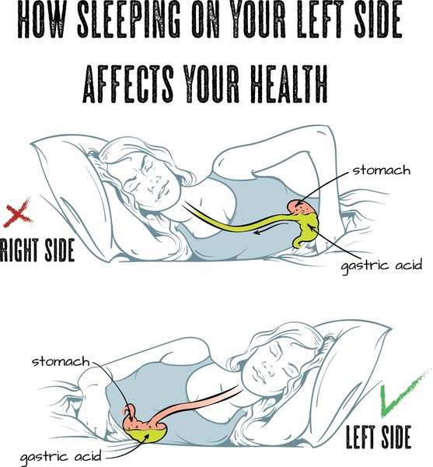
What Can Get in the Way of Good Sleep?

Sleeping position is important. Do not sleep on your right side or you may experience GERD symptoms.

Dr Helene Benveniste, MD, PhD, has been studying sleeping position and the effectiveness of the glymphatic system. She recommends sleeping on your side instead of back or stomach.

news.stonybrook.edu/newsroom/press-release/general/150804sleeping/
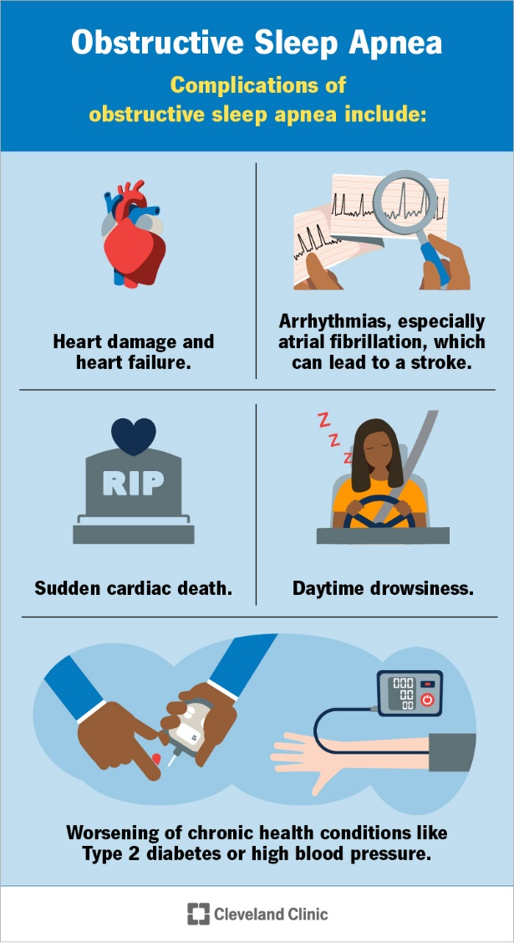
Sleeping position also affects snoring and obstructive sleep apnea issues.

Obstructive Sleep Apnea (OSA) is serious business and should be addressed by your physician. They often require a sleep study, which may or may not be helpful. Your dentist might also be able to help.

Interventions include lose weight, stay hydrated, exercise, no smoking, no alcohol in the evening, no mouth breathing.

www.theepochtimes.com/health/obstructive-sleep-apnea-symptoms-causes-treatments-and-natural-approaches
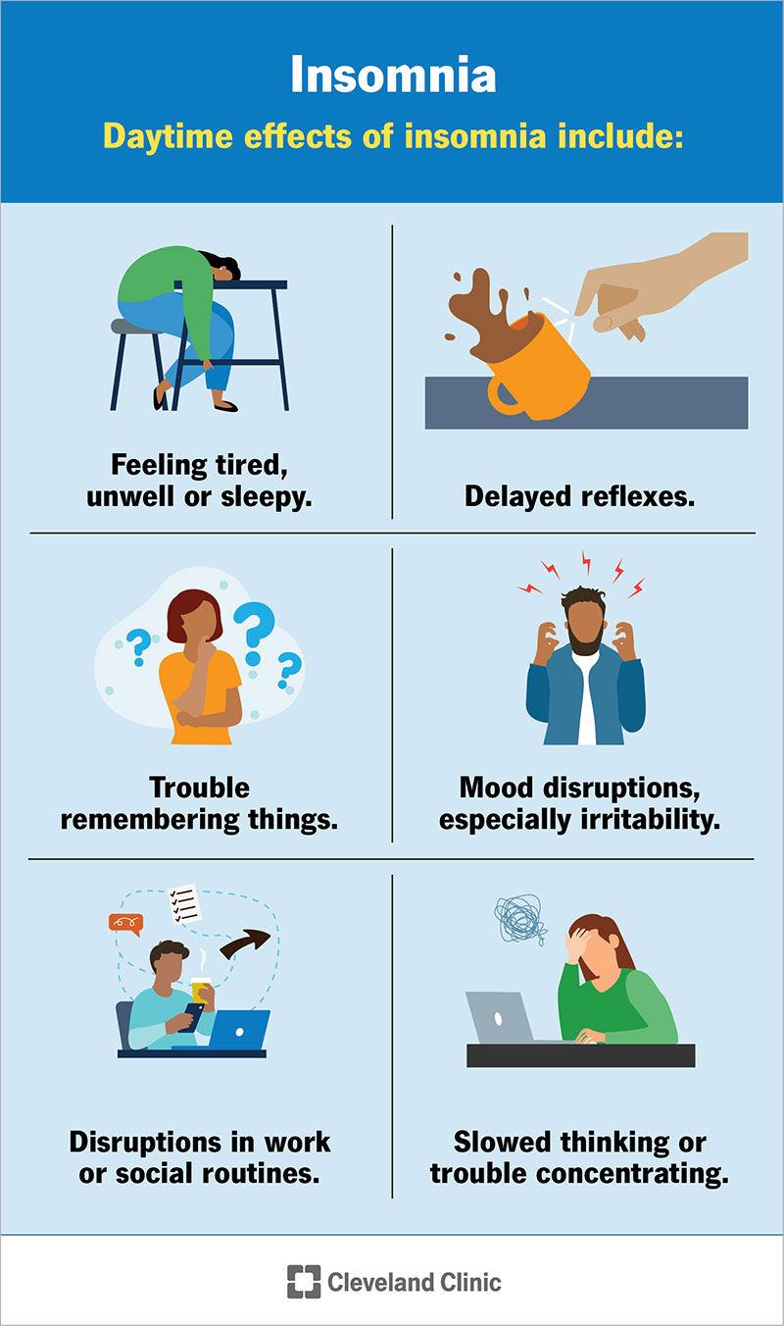
Insomnia is defined as a common sleep disorder characterized by difficulty falling asleep, staying asleep, or both, despite adequate opportunity for sleep, causing daytime impairment or distress, and occurring at least three nights per week for three months.

You may need to explore a lot of different areas before you come up with options that work for you.

my.clevelandclinic.org/health/diseases/12119-insomnia

In Order to Get Better Sleep, You Need to Understand EMF
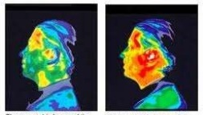
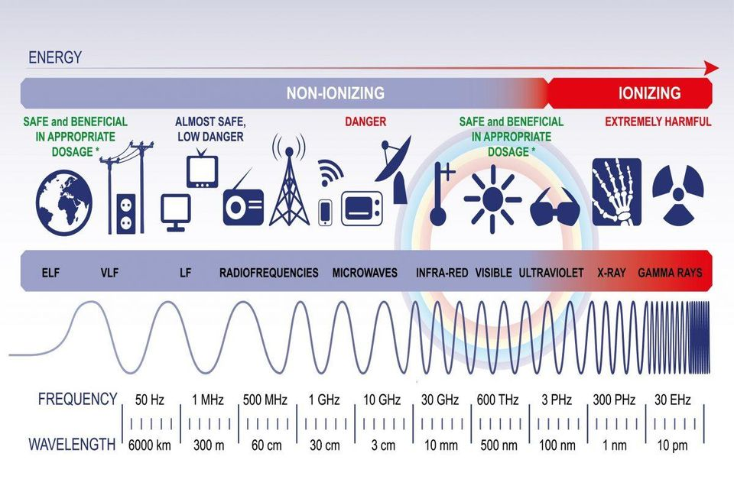
The scale is divided into NON-IONIZING and IONIZING. All research into the effects of EMF have been based on this erroneous premise. Does this mean that non-ionizing energy is safe? NO. Would you put a baby in a microwave? No, of course not, but we hand them cell phones.
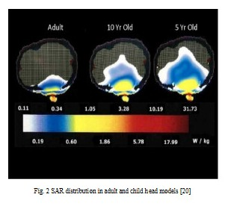
Cell phones are rated by specific absorption rate or SAR. That determines the extent of short-term thermal effects of the radiation on the body. The above thermographic readings of a normal adult head, and the same head after a 15-minute phone call. To the right, you can see the effects on an adult, child and infant.
All phone manufacturers recommend you hold your phone 5 to 15 millimeters (.59 inches) from your body, but it’s buried in fine print under Legal & Regulatory / RF Exposure.
researchgate.net/publication/304239546_A_study_of_SAR_pattern_in_biological_tissues_due_to_RF_exposure
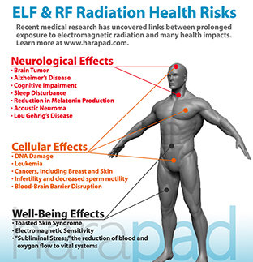
EMF Exposure inside and outside your home can cause all of these problems and more. And it’s not just humans!

The Environmental Health Trust is working to expose the EMF harms that also happen to the environment.

U.S experts of over 1,200 studies on the effects of non- ionizing radiation to wildlife entitled “Effects of non-ionizing electromagnetic fields on flora and fauna” published in Reviews on Environmental Health found adverse effects at even very low intensities including impacts to orientation and migration, reproduction, mating, nest, den building and survivorship.”
https://ehtrust.org/electromagnetic-radiation-wildlife-and-environment/

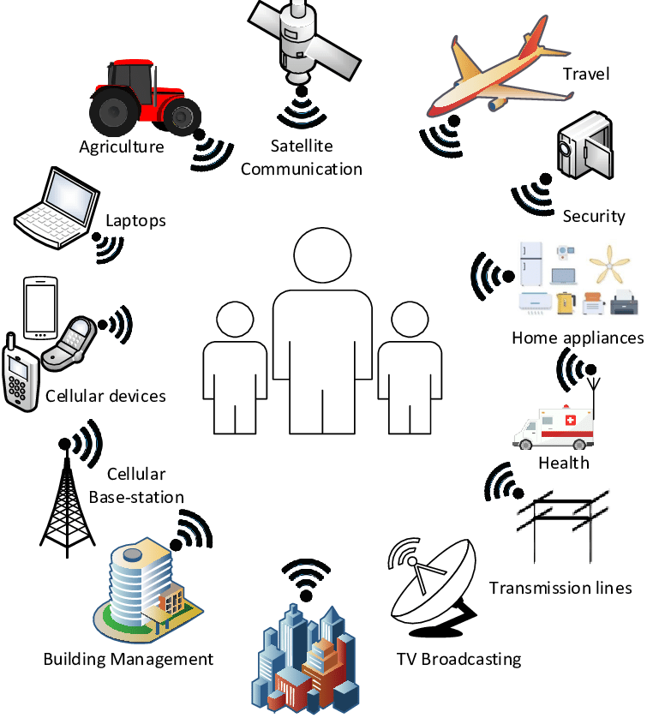

We are literally being bathed in radiation from all of these sources. But since you cannot see it, smell it, touch it or (for most people) feel it … it must not be a problem. Right? Note the “Subliminal Stress” comment under Well-Being Effects. How can that manifest? Anxiety.

Just a note. People get upset about having a new cell tower go up near them, but if you have a WiFi router in your home – it’s the same as having a cell tower in your home!
Take Action: Make Your Sleep Environment and Sleep Time Safe and Nurturing So That You Can Recover from the Daily Onslaught
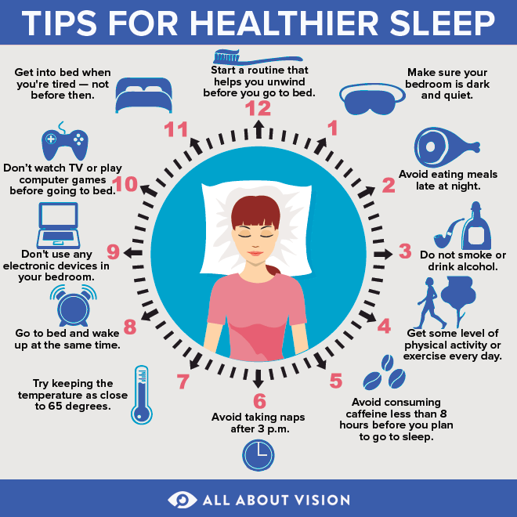

1. What You Eat and Drink Before Bed Matters:
Avoid sleeping pills – they make it difficult to get into deep sleep cycles.
Caffeine and alcohol are bad ideas
Start cutting back on fluids early, if getting up at night is an issue.
*Adequate melatonin can reduce bathroom trips*
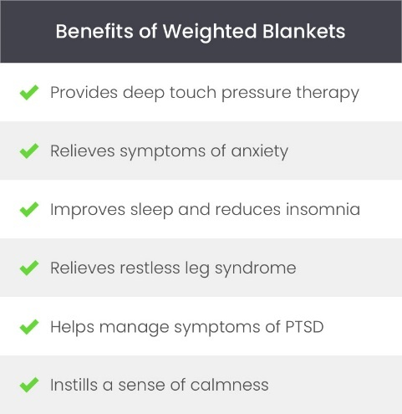
2. Have an Appropriate Sleep Environment
Cool temperature
DARK; use black out shades or a sleep mask
NO electronics (including TV), lighted clocks, nightlights
Use the bedroom for only appropriate activities
Try using a weighted blanket

3. Limit Your Exposure to Blue Light After Dark:
For 2 to 3 hours before sleeping (devices, TV, LED lights)

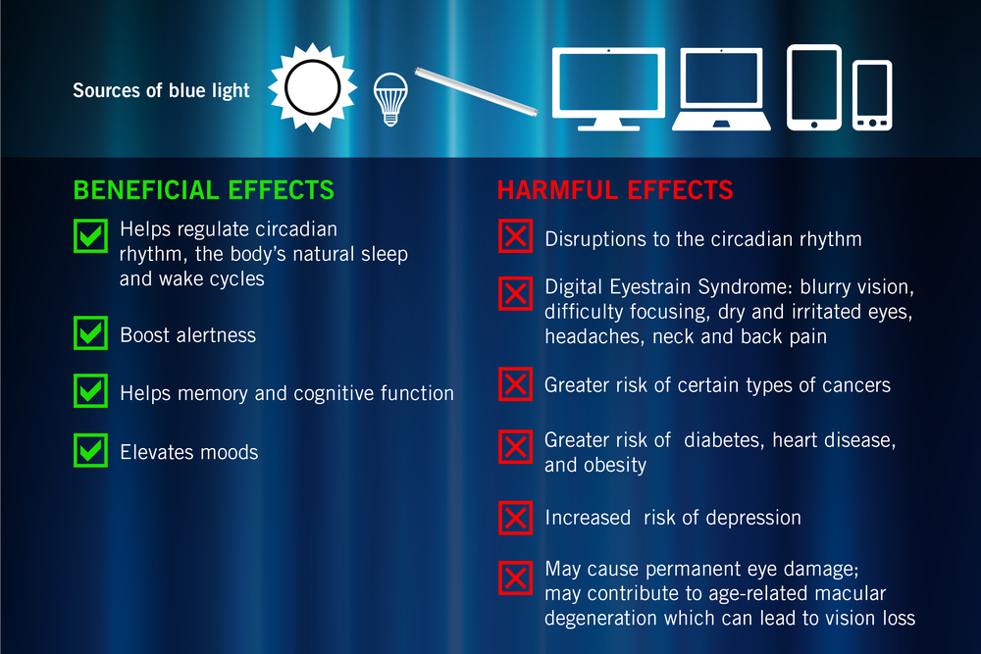

*You can use red light exposure to counteract blue light effects.*

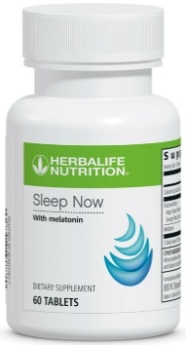

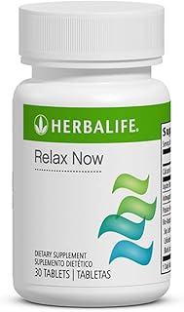

4. Support Your Body with Supplements for Optimal Recovery
Melatonin (Sleep Now)
Relaxing herbs like Ashwagandha and Passionflower
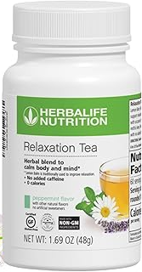
(Relax Now, Relaxation Tea, Tang Kuei Plus),
Nitric oxide support through high intensity workouts
and/or supplements (Niteworks)
Magnesium - a natural calcium channel blocker

5. Seek Medical Help, if needed, for Sleep Apnea
If you use a CPAP machine, turn off the WiFi and Bluetooth

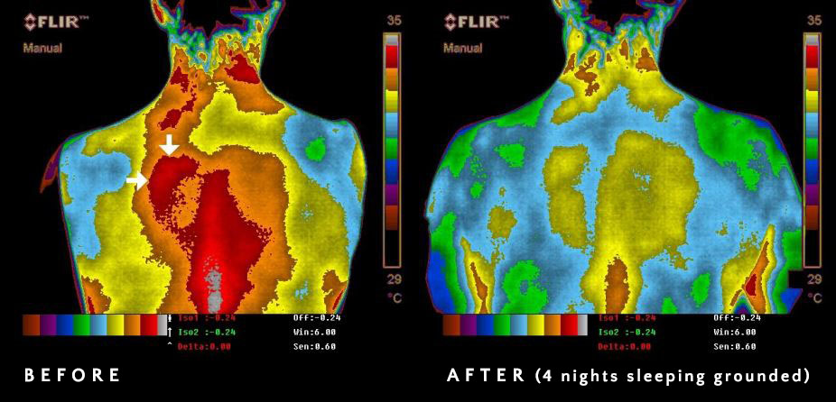
6. Get Grounded

What does that mean?

“The earth’s surface has a virtually limitless supply of mobile electrons that gives the ground we walk on (as well as lakes and oceans) a natural negative electric charge. When you touch your body to the ground, it dissapates static electricity and extraneous environmental electrical charges that are on you.”
FLIR images from ultimatelongevity.com/earthing-grounding/the-research.shtml
www.earthing.com/pages/what-is-earthing

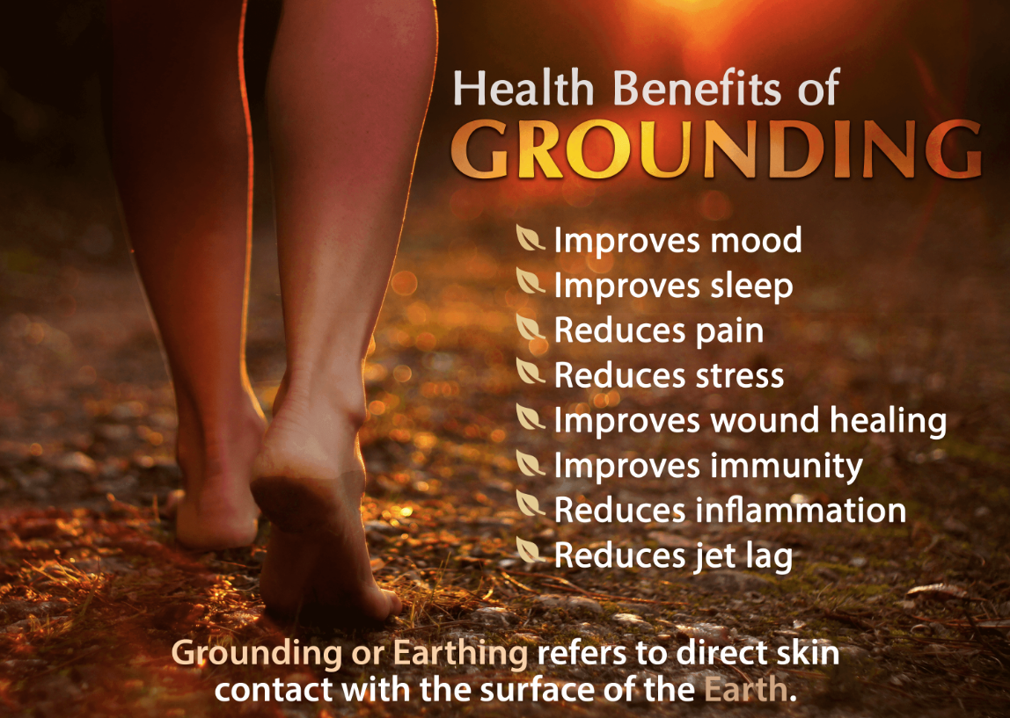

Sleep grounded!
For resources see
www.LessEMF.com
www.Earthing.com
www.UltimateLongevity.com
www.RedemptionShield.com

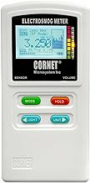
7. Limit Your Exposure to EMF: Time / Distance / Shielding
Spend the shortest amount of time being exposed.
Stay as far away as possible.
Shield yourself if nothing else.
Get rid of the baby monitor and cordless phones.
Have the smart meters removed from your home.

The easiest things to do are put cell phones into airplane mode
and turn off the WiFi at night.

Buy or borrow a meter to test your home environment for EMF
You can’t mitigate it if you don’t know that it’s there
Resources: www.LessEMF.com, www.Smart-Safe.com


8. Invest in Blushield Protection

Blushield is a revolutionary form of EMF protection that uses scalar waves and produces coherent frequencies within the human (animal and plant) responsive range, based on nature-mimicking mathematical algorithms. It emits frequencies using the same power sources as manmade devices, which created active, powerful fields. It is essentially “loud” enough to compete against the biologically incoherent non-native EMF fields. Instead of attempting to block EMFs, Blushield essentially overpowers non-native EMFs with harmonious frequencies. Then we no longer perceive the non-native EMFs as a threat. Our bodies can rest and heal.

blushield.com/blogs/education/getting-started-with-blushield antennasearch.com

Results Summary:
1190 towers and 191 antennas within a 3.0 mile radius of 6147 28th St SE, Grand Rapids, MI 49546, United States.
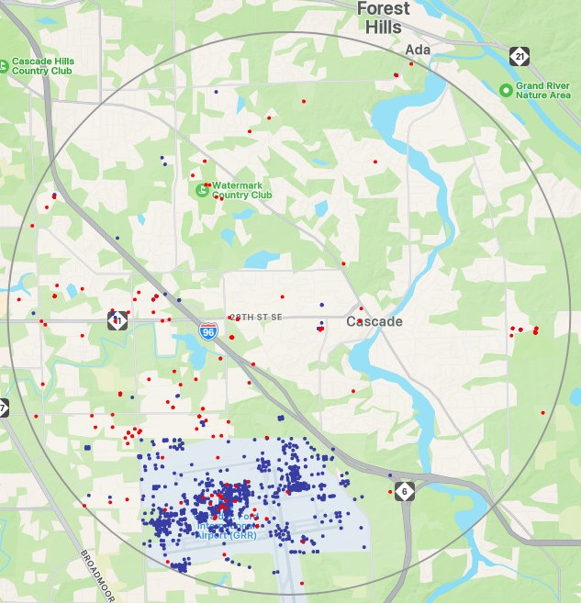

Results Summary: 29 towers and 25 antennas within a 3.0 mile radius of Cascade Rd SE, Lowell, MI 49331, US.
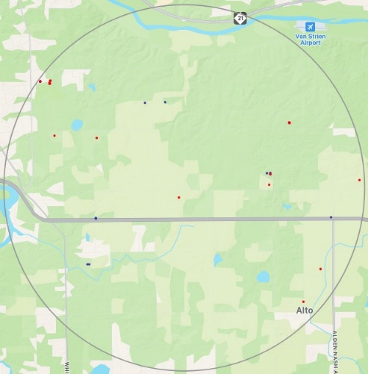

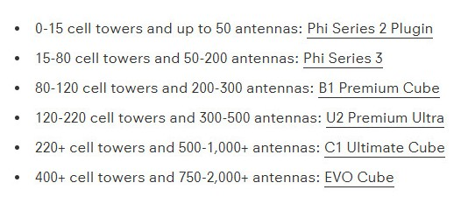
Blushield continued …

When people start using Blushield devices, what do they often report?
- More relaxed and “chill”
- Better able to focus
- Able to spend more time in front of a computer
- Less tired, zapped eyes
- Greater energy
- Better quality sleep


Cows can’t lie …

When cows are subjected to stress, the white blood cell (somatic cell) count in their milk rises. These cows, in New Zealand, used to graze happy and healthy until TV masts were erected in the 1970’s. Then the farmers had to put mineral blocks out for them, indicating they had higher biological stress. The white counts rose and the instances of mastitis increased.

This Blushield testing was around the year 2000. “The somatic cell count of their milk consistently went down within 10 days of plugging the Blushield devices. Their other previous stress markers went away, as well.”
https://blushield.com/pages/dairy-cow-tests?v=7516fd43adaa

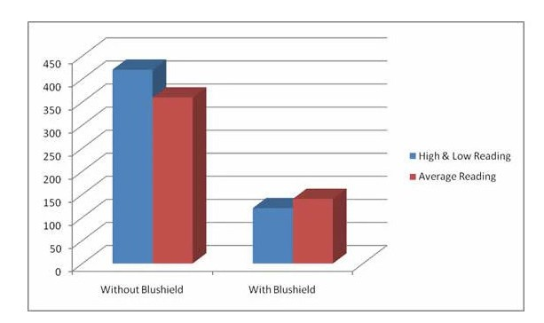
You should check out the chicken stories:

blushield.com/pages/poultry-farm

Use code SWell10
For a 10% discount

Resources for Further Study:
Gittleman, Ann Louise (2010, Harper One). Zapped: Why Your Cell Phone Shouldn’t Be Your Alarm Clock and 1,268 Way to Outsmart the Hazards of Electronic Pollution.
Gunnars, Kris (June 4, 2017, Healthline.com/nutrition). How Blocking Blue Light at Night Can Transform Your Sleep.
Heid, Markham (March 7, 2019, www.elemental.medium.com ) Are AirPods and Other Bluetooth Headphones Safe?
https://ehtrust.org/worlds-largest-animal-study-on-cell-tower-radiation-confirms-cancer-link/
https://prostate.net/articles/7-facts-prostate-cancer-young-men-know
Mercola, Joseph (2020, Hay House). EMF*D 5G, Wi-Fi & Cell Phones: Hidden Harms and How to Protect Yourself
Mercola, Joseph (February 19, 2015, www.mercola.com) How Much Sleep Is “Enough”?
Mercola, Joseph (September 9, 2017, www.Mercola.com). The Real Dangers of Electronic Devices and EMF
Mysterud, Iver and Flydal, Einar (What Doctors Don’t Tell You, January/February 2025). EMFs: Our New Silent Spring? Electromagnetic fields from cell phones and wireless echnology could be having just as devastating an effect on human health and life on Earth as pesticides.
Pall, Martin, interview about the Harmful Effects of EMF (September 3, 2017, www.mercola.com). https://articles.mercola.com/sites/articles/archive/2017/09/03/electromagnetic-fields-harmful-effects.aspx
Vaughn, Brandon (accessed November 12, 2017) Podcast #60 which includes a link to a fascinating TED Talk on the neuroscience of sleep. http://firstthingsproductivity.com/sleep/

