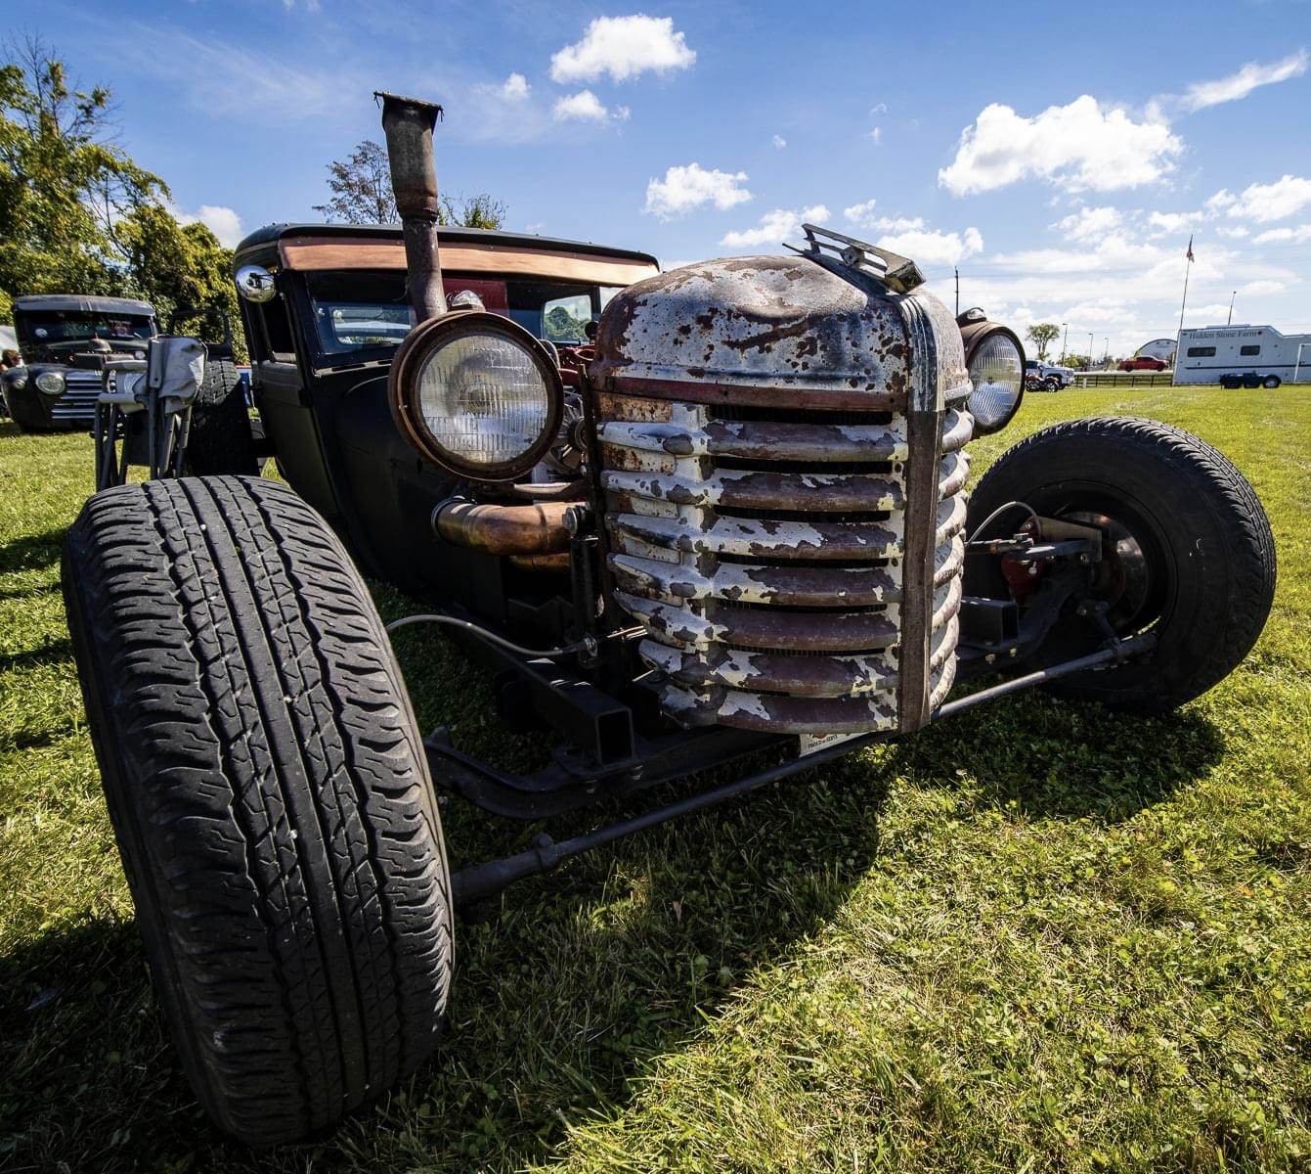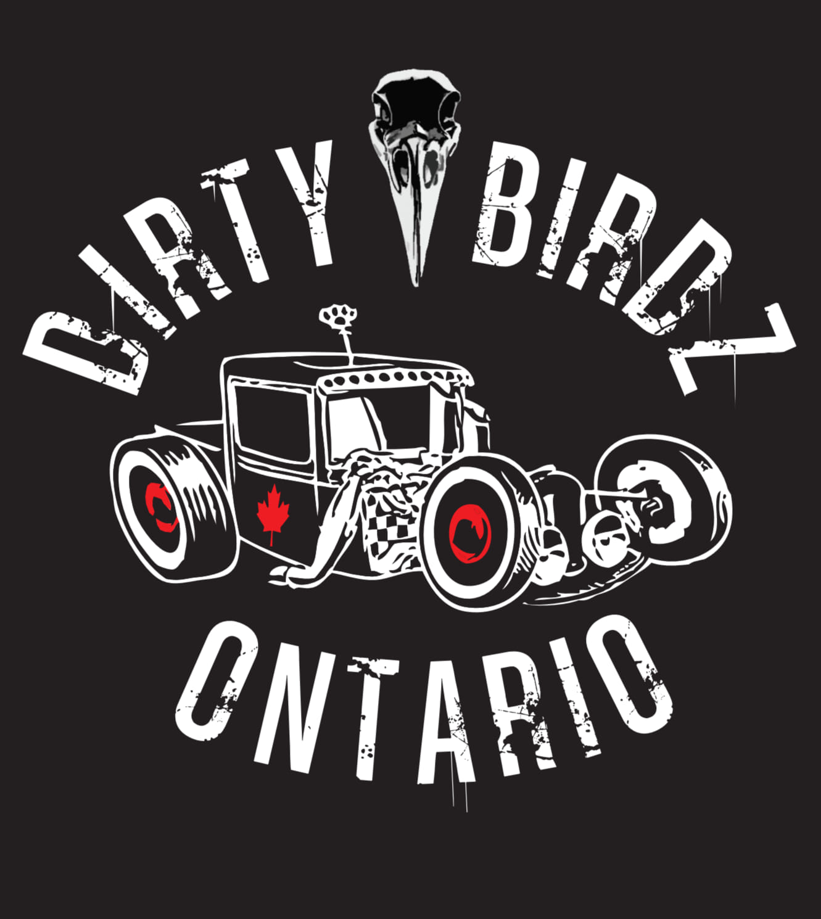

DJ with music all day long. This is a judged event with trophies going to class winners

Bring your cash for 50/50 draw, silent auction, bake sale and food vendor on site!

In lieu of admission for show cars and the public, food donations for the Georgina Food Pantry as well as for the Georgina Pet Food Bank (for cats/dogs), run by Unleashed Potential Canine Rescue, will be collecting at the gate. Please bring cash or cat/dog/food donations.

See list for food/donation ideas.

Check us out on facebook under Dirty Birdz Car Club

[www.hiddenstonefarm.ca](http://www.hiddenstonefarm.ca) or call/text Ray at 905-955-1070 for more information

Hosted by Hidden Stone Farm : 3504 Baseline Rd, Sutton West, L0E 1R0 (across from the Police Station) on Saturday September 16th 2023 starting at 9am

A show for classic cars, trucks and tractors. Open to the public as well so bring out the family for a fun day in the sun!

Dirty Birdz Car Show Sep 16th 2023