**Our Free Minds**

**Anti Bullying Policy Statement**

Our Free Minds is a consent-based, self-directed learning community for home-educated young people in Wiltshire.

We create a space for young people to explore what is interesting and important to them, facilitated by open and interested adults and supported by a flexible community structure in which their voices are heard.

Our Free Minds is committed to building a ‘culture of safety’ in which the children in our care are protected from harm - whether that harm is caused by adults or other young people.

As such at Our Free Minds we ensure safeguarding and child protection is at the heart of our community culture and activities.

**Legal framework**

Legislation provides the framework for safeguarding and child protection in England. It makes clear the expectations and requirements around duties of care to children and creates accountability for these. The main legislation in England is the Children Act 1989, the Children Act 2004 and the Children and Social Work Act 2017.

### **Who is responsible for safeguarding and child protection**

Local safeguarding partners are responsible for child protection policy, procedure and guidance at a local level. The local safeguarding arrangements are led by three statutory safeguarding partners:

* the local authority
* the integrated care board (ICB, previously clinical commissioning group or 'CCG')
* the police.

Working together with other relevant agencies, they must co-ordinate and ensure the effectiveness of work to protect and promote the welfare of children, including making arrangements to identify and support children at risk of harm.

This policy has been drawn up on the basis of legislation, policy and guidance that seeks to protect children in the UK, using NSPCC guidance on bullying and cyberbullying.

**The purpose and scope of this policy statement**

The purpose of this policy statement is:

• to prevent bullying from happening between children and young people who are a part of our organisation or take part in our activities

• to make sure bullying is stopped as soon as possible if it does happen and that those involved receive the support they need

• to provide information to all staff, volunteers, children and their families about what we should all do to prevent and deal with bullying.

This policy statement applies to anyone working on behalf of Our Free Minds, including managers and the board of trustees, paid staff, volunteers, sessional workers, agency staff and students.

Separate documents set out:

• our code of behaviour for children, young people and adult

• our policies and procedures for preventing and responding to bullying and harassment that takes place between adults involved with our organisation. See our information about behaviour management and codes of conduct

**What is bullying?**

Bullying includes a range of abusive behaviour that is:

1. Repeated, and
2. Intended to hurt someone either physically or emotionally.

Bullying is when individuals or groups seek to harm, intimidate or coerce someone who is perceived to be vulnerable (Oxford English Dictionary, 2021).

It can involve people of any age, and can happen anywhere – at home, school or using online platforms and technologies (cyberbullying). This means it can happen at any time.

Bullying encompasses a range of behaviours which may be combined and may include the behaviours and actions set out below:

**Verbal abuse:**

* name-calling
* saying nasty things to or about a child or their family.

**Physical abuse:**

* hitting a child
* pushing a child
* physical assault.

**Emotional abuse:**

* making threats
* undermining a child
* repeatedly excluding a child from a friendship group or activities with the intention of hurting that child.

**Cyberbullying/online bullying:**

* repeatedly excluding a child from online games, activities or friendship groups with the intention of hurting that child
* sending threatening, upsetting or abusive messages
* creating and sharing embarrassing or malicious images or videos
* 'trolling' - sending menacing or upsetting messages on social networks, chat rooms or online games
* voting for or against someone in an abusive poll
* setting up hate sites or groups about a particular child
* creating fake accounts, hijacking or stealing online identities to embarrass a young person or cause trouble using their name.

Bullying can be a form of discrimination, particularly if it is based on a child’s disability, race, religion or belief, gender identity or sexuality.

To read more about bullying and cyberbullying please visit this web page: <https://learning.nspcc.org.uk/child-abuse-and-neglect/bullying>

**Impact of Bullying**

The emotional effects of being bullied can include:

* sadness, depression and anxiety
* low self-esteem
* social isolation
* self-harm
* suicidal thoughts and feelings (Bainbridge, Ross and Woodhouse, 2017).

Children who have witnessed another child being bullied may also be distressed. They may not know the best way to help the person being bullied. They may fear for their own safety and experience feelings of guilt for not stepping in (Children’s Commissioner for Wales, 2017; NSPCC, 2016).

**Signs and Indicators of Bullying**

Indicators that a child could be experiencing bullying include:

* being reluctant to go to Group or to their usual activities
* being distressed or anxious
* losing confidence and becoming withdrawn
* having problems eating and/or sleeping
* having unexplained injuries
* changes in appearance
* changes in behaviour or performance at their usual activities

Adults may notice that a child isn't spending time with their usual group of friends, has become isolated or that other children's behaviour towards a child has changed.

### **Why children bully others**

There are many reasons why children bully others and it's not always a straightforward situation. Some of these include:

* peer pressure and/or wanting the approval of others
* wanting to feel powerful over someone with a perceived disadvantage
* being bullied themselves
* being worried, unhappy or upset about something
* lacking social skills or not understanding how others feel.

Children who bully others may not understand that they are making life difficult for another child, and may find this realisation very distressing. It can be difficult for them to get the support they need to change their behaviour (NSPCC, 2016).  
  
When posting online, children may not consider the impact their actions will have on others. Some children may be more likely to engage in bullying behaviour online as they can create anonymous accounts which may make them feel as if they can’t be 'found out'.

**Preventing Bullying**

At Our Free Minds we believe that:

• children and young people should never experience abuse of any kind

• we have a responsibility to promote the welfare of all children and young people, to keep them safe and operate in a way that protects them.

We recognise that:

• bullying causes real distress and affects a person’s health and development

• in some instances, bullying can cause significant harm

• all children, regardless of age, disability, gender reassignment, race, religion or belief, sex or sexual orientation, have the right to equal protection from all types of harm or abuse

• everyone has a role to play in preventing all forms of bullying (including online) and putting a stop to bullying.

We will seek to prevent bullying by:

• developing a code of behaviour that sets out how everyone involved in our organisation is expected to behave, in face-to-face contact and online, and within and outside of our activities (please refer to our other policy documents: Code Of Conduct, Safeguarding, Health and Safety, Internet and Social Media Policy)

• holding open discussions with staff, volunteers, children, young people and families who use our organisation about bullying and how to prevent it

• providing support and training for all staff and volunteers on dealing with all forms of bullying, including racist, sexist, homophobic, transphobic and sexual bullying

• putting clear and robust anti-bullying procedures in place

• remaining alert to the dynamics of children’s relationships

• considering what approaches might be appropriate to prevent any situations that might escalate into bullying

Our discussions with staff, volunteers, children, young people and families will focus on:

• what bullying is and how it affects the people involved

• why people bully others

• what bystanders should do when they witness bullying

• the importance of children telling someone if they or someone else is being bullied

• group members’ responsibilities to look after one another and uphold the behaviour code

• practising skills such as listening to each other

• respecting the fact that we are all different

• dealing with problems in a positive way

• checking that our anti-bullying measures are working well.

**Responding to bullying**

We will make sure our response to incidents of bullying takes into account:

• the needs of the person being bullied

• the needs of the person displaying bullying behaviour

• needs of any bystanders

• our organisation as a whole.

We will review the plan we have developed to address any incidents of bullying at regular intervals, in order to ensure that the problem has been resolved in the long term.

**When responding to incidents or allegations of bullying it's important for staff and volunteers to:**

* listen to all the children involved to establish what has happened
* record details of the incident and any actions you've taken
* inform the nominated child protection lead (Guy Asherson-Taylor)
* inform parents and carers (unless doing so would put a child at further risk of harm)
* provide support to the child/children being bullied, children who witnessed the bullying and the child/children who has been accused of bullying
* ask the child/children who have been bullied what they would like to happen next
* consider appropriate responses or sanctions for children that have carried out bullying
* continue to monitor the situation even if the situation has been resolved.

**Responding to cyberbullying**

When responding to online bullying:

* make sure children know not to retaliate online or reply to any bullying messages
* make sure children understand how they can take steps to prevent online bullying from happening again, for example by changing their contact details, blocking contacts or leaving a chat room
* ask the child if they have shared the bullying content with anyone else (if so, who).

If bullying content has been circulated online, take action to contain it:

* if appropriate, ask the person responsible to remove the content
* contact the host (such as the social networking site) and ask them to take the content down
* contact the [NSPCC helpline](https://www.nspcc.org.uk/preventing-abuse/our-services/nspcc-helpline/) for advice about what to do.

If the content is illegal, contact the police who can give advice and guidance.

### **Reporting**

If you have a concern about bullying, you should follow Our Free Minds anti-bullying procedures as soon as possible.

If you think a child is in immediate danger, contact the police on **999**. If you're worried a child is at risk of serious harm but they are not in immediate danger, you should share your concerns.

* **Follow Our Free Minds child protection and procedures**. - see the Anti Bullying Procedure below and Our Free Minds Safeguarding Policy.
* **Contact the NSPCC Helpline** on 0808 800 5000 or by emailing help@nspcc.org.uk.
* **Contact your local child protection services**. If you think a child or young person is at risk of significant harm, or is injured, contact the Integrated Front Door (IFD) on 0300 4560108, 8.45am-5pm, Monday-Thursday and 8.45am-4pm Friday; Out of Hours 0300 456 0100. For less urgent enquiries, email mash@wiltshire.gov.uk
* **Contact the police.**

Services will risk assess the situation and take action to protect the child as appropriate either through statutory involvement or other support. This may include making a referral to the local authority.

**Diversity and inclusion**

We recognise that bullying is closely related to how we respect and recognise the value of diversity. We will be proactive about:

• seeking opportunities to learn about and celebrate difference

• increasing diversity within our staff, volunteers, children and young people

• welcoming new members to our organisation.

**Find out more about:**

• safeguarding children who come from Black, Asian and minoritised ethnic communities

• safeguarding d/Deaf and disabled children and young people

• safeguarding LGBTQ+ children and young people

• safeguarding children with special educational needs and disabilities (SEND).

All of these topics and more are covered on the NSPCC website.

**Related policies and procedures**

This policy statement should be read alongside our organisational policies and procedures including:

• safeguarding and child protection policy and procedures

• managing allegations made against a child or young person

• managing allegations of abuse made against staff and volunteers • code of conduct for staff and volunteers

• equality, diversity and inclusion policies.

**Contact details**

**Nominated anti-bullying lead and child protection lead**

Name: Guy Asherson-Taylor

Phone: 07502337396

Email: guy@ourfreeminds.org

**Safeguarding and child protection trustee**

Name: Clea Sambrook

Email: cleasunshine@hotmail.com

**NSPCC Helpline** 0808 800 5000

We are committed to reviewing our policy and practice at least once a year.

| This policy statement was adopted by: Our Free Minds | Last reviewed date: 17.9.23 |
| --- | --- |
| To be reviewed: 17.09.2026 | Signed: Sze Wai Wong |

**Anti Bullying Policy Procedures**

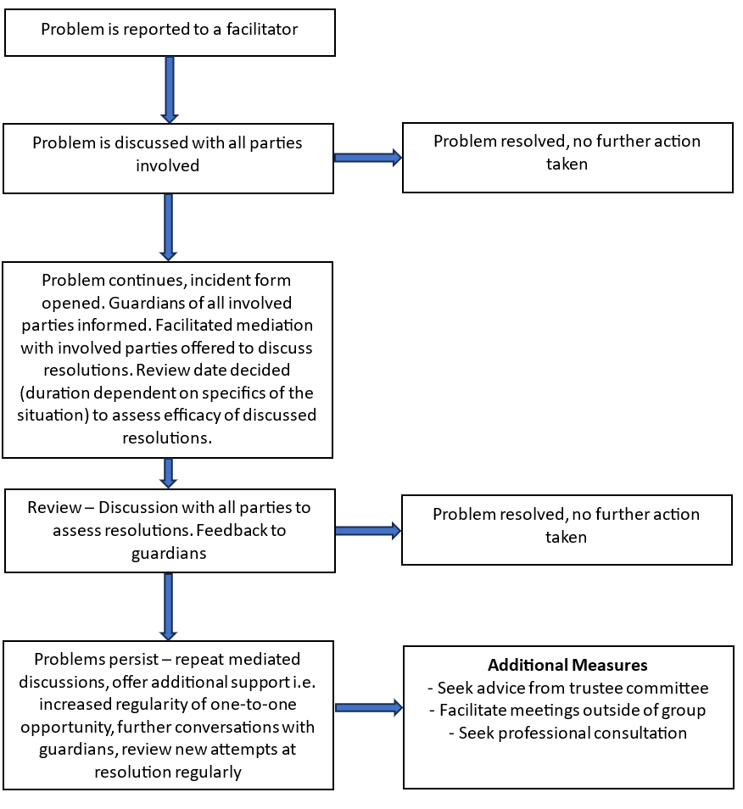

| This policy procedure was adopted by: Our Free Minds | Last reviewed date: 17.9.23 |
| --- | --- |
| To be reviewed: 17.09.2024 | Signed: Sze Wai Wong |