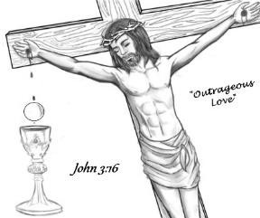
Heart of JMJ Foundation
2026 Catholic Women’s Conference
“Celebrating 10 Years of God’s Love”
September 11th 6pm-9pm…September 12th 8am-4pm
Registration Form

“Celebrating 10 Years of God’s Love” conference will be Friday, Sept 11, 2026, and Saturday Sept 12, 2026. The event will be at the McNease Convention Center, 501 Rio Concho Drive, San Angelo, TX. Bishop Michael Sis will be celebrating Mass on Saturday, Sept 12, 2026. Speakers for 2026 are Dr. Ray Gaurendi, Judy Hehr, & Kendra Von Esh

Light meal to be provided on Friday evening, along with a catered lunch provided on Saturday. Coffee and water will be available throughout the event. Vending machines are not available. If you prefer other drinks, please bring them with you.
Cost is $50 + $3.49 processing fee through September 12, 2026. If you register the day of the event, we cannot guarantee seating or lunch

Name:

Address: City/State/Zip:

Email: Phone

Parish: Parish (City/State/Zip):

We also have t-shirts available to order until Aug 15th. You can view them online at www.heartjmj.org Limited sales available at the conference. Cost is $20 + $1.99 processing fee. Please provide size.
2026 Celebrating 10 Years of God’s Love t-shirt(size)_________
Payment may be made with a credit card, check, or money order, payable to Heart of JMJ Foundation. Complete the registration above, select your payment type, and mail form along with your payment to:
Heart of JMJ Foundation
P.O. Box 61521
San Angelo, TX 76906
Select Payment Type: Check/Money Order Credit Card

Credit Card Number: Expiration Date: Security Code:
Billing Zip Code: __________

Waiver Agreement - I consent and agree that the Heart of JMJ Foundation, its employees, or representatives, have the right to take photographs or digitally record and print pictures of me. I understand that I will receive no compensation. Yes No

All conference information is on-line and to register on-line with Eventbrite go to www.heartjmj.org

Hotel rooms are blocked off for the event. Mention the “Catholic Women’s Conference for special rates. Participating hotel information is available at www.heartjmj.org

