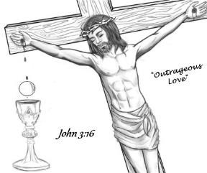**Heart of JMJ Foundation**

**2024 Catholic Women’s Conference**

**“Do Small Things with Great Love”**

**September 12th 6pm-9pm…September 13th 8am-4pm**

***Registration Form***

*“Do Small Things with Great Love” conference* will be Friday, Sept 12, 2025, and Saturday Sept 13, 2025. The event will be at the McNease Convention Center, 501 Rio Concho Drive, San Angelo, TX. Bishop Michael Sis will be celebrating Mass on Saturday, Sept 13, 2025. Speakers for 2025 are Fr. Ryan Rojo, Alexis Walkenstein, and Diana Wehbe

Lunch will be provided on Saturday. Coffee and water will be available throughout the event. Vending machines are not available. If you prefer other drinks, please bring them with you.

**Cost is $40 + $2.99 processing fee through September 12, 2025. *If you register the day of the event, we cannot guarantee seating or lunch***

Name:

Address: City/State/Zip:

Email: Phone

Parish: Parish (City/State/Zip):

We also have t-shirts available to order until Aug 15th. You can view them online at *www.heartjmj.org* Limited sales available at the conference. Cost is $20 + $1.99 processing fee. Please provide size.

2025 Do Small Things with Great Love t-shirt(size)_________

**Payment may be made with a credit card, check, or money order, payable to Heart of JMJ Foundation. Complete the registration above, select your payment type, and mail form along with your payment to:**

Heart of JMJ Foundation

P.O. Box 61521

San Angelo, TX 76906

Select Payment Type: Check/Money Order Credit Card

Credit Card Number: Expiration Date: Security Code:

Billing Zip Code: __________

Waiver Agreement - I consent and agree that the Heart of JMJ Foundation, its employees, or representatives, have the right to take photographs or digitally record and print pictures of me. I understand that I will receive no compensation. Yes No

All conference information is on-line and to register on-line with Eventbrite go to *www.heartjmj.org*

Hotel rooms are blocked off for the event. Mention the “Catholic Women’s Conference for special rates. Participating hotel information is available at *www.heartjmj.org*