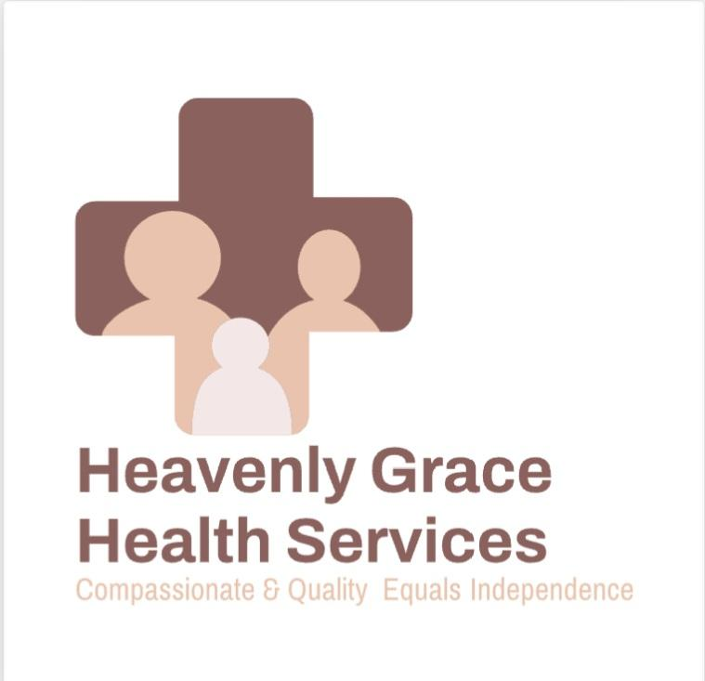patient letter

Our mission is to provide compassionate, high quality, and personalized care. Showcasing integrity and dignity with all services provided. To help those individuals maintain their independence and safety in their residence.

Welcome to Heavenly Grace health services. We are here to help. We offer highly trained and qualified staff to care for your loved ones. We know that it is difficult for families to care for their loved ones at times, but rest assured that you are in the hands of compassionate, caring, and trustworthy caregivers. We are dedicated to helping patients meet their needs may it be with medications, treatments, or companionship just to name a few. We have a RN who will assess the patient and determine what care is needed alongside the MD who gives the orders. Then once orders are in place staff will follow the patient's plan of care. This ensures the patient is receiving the care needed to improve or correct the health issue. Our compassionate and skilled team provides a wide range of services to support recovering, disabled, chronically, or terminally ill individuals. Whether you need medical, nursing, social, or therapeutic treatment, or assistance with essential daily activities, Heavenly Grace is here to help you maintain your independence and enhance your quality of life.

Payments

Patients will sign a service agreement which will describe the amount of the service and when payments are due. If payment is made by insurance or a third party and there is a balance due then the patient will be responsible for the remaining balance.

Emergency

If you are experiencing a medical emergency please call 911. Even if your caregiver or nurse will be there soon. It is better to seek medical assistance when needed in an emergency. Non emergency you can contact our office Monday-Friday 8:30 am to 4:30 pm. 262 394-6183

Services offered

We offer a variety of services from skilled nursing to personal care assistance. From our staff of RN's, LPN's, HHA's, and companions. Some services offered are as follows:

Advanced Wound Care: Specialized treatment and management of wounds to promote healing and prevent complications.

Medication Management & Education: Ensuring you take the right medications at the right time, along with clear education on their purpose and potential side effects.

Diabetes Management & Education: Empowering you with the knowledge and tools to effectively manage your diabetes.

Injections & Intravenous (IV) Therapy: Professional administration of necessary medications and fluids through IV.

Catheter Care: Routine care and maintenance for various types of catheters.

Disease Treatment & Prevention Education: Understanding your condition and how to prevent further health issues.

Family Instruction: Guidance and training for family members involved in your care.

Vitals : Regular checks of vital signs to track your cardiovascular health.

Nutritional Counseling: Personalized advice to support your health through proper nutrition.

We also provide contracts from therapy such as occasional, physical, and speech to meet patients needs.

Referrals

We love referrals! We provide exceptional care so that our patients and families will recommend us to others in the community.

Thank You for letting Heavenly Grace provide your healthcare needs!

