Name:  Phone#:  Ship to Address:  Order Date: / /  Measurments (inches):  Directions: Using the guide to the right, please take your measurements wearing a pair of jeans you prefer under your chaps. Measurements should be taken at the snugness you prefer your chaps to be (not too tight or too loose).  - Outseam (Belt to Floor):  - Inseam (crotch to floor):  - Waist (At Belt):  - Thigh (widest Part):  - Rise -Belt to Thigh (D):  - Mid Thigh:  - Belt to Top of knee:  - Around bent knee:  - Calf (Widest Part):  - CHINKS Only - Belt to where you  want bottom of fringe to fall on calf  Yoke Style - Regular 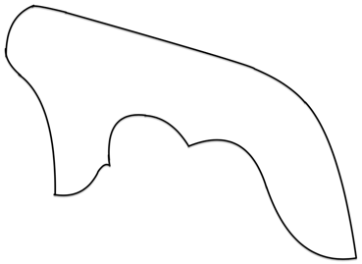 - Low Cut 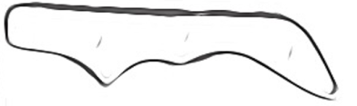  Customizations:  YOKE TOOLING:  PLAIN W/ BORDER  BASKETWEAVE  CUSTOM FLORAL OR TOOLED  ½ GEO or BASKET + ½ FLORAL  SPECIFY (TYPE OF FLOWERS, OAK LEAF, ETC): _______________________________  +ADD INITIALS OR BRAND? > ______  +ADD BUCKSTICH  LEG STYLE:  Basic sewn  LACED w/ Adjustable panel  BUCKSTITCH  SPOTS  SINGLE FRINGE  DOUBLE FRINGE  TWISTED FRINGE  Cuff on bottom  Longer than heel while riding  LEG CONCHOS: Selection TBD  1 PER LEG  3 PER LEG (MOST COMMON)  FULL – COUNT BASED ON LENGTH  POCKET:  Left Right Both  Smooth or Roughout  TOOLED  NO POCKET  Back belt:  PLAIN OR TOOLED  ADJUSTABLE BELT + BUCKLE  LACED OR RIVETED OR SEWN  DOUBLE CONCHO (ADJUSTABLE BELT)  SINGLE CONCHO  FRONT BELT:  BUCKLE (Standard)  STRING TIES | $300 Deposit due to place order and reserve spot. Order cancellation may be subject to a materials fee  ***I can only make your chaps as accurate as the measurements you give me. Measure with a tape or flexible material only. Please take your time and be accurate***  - Dropped Steep  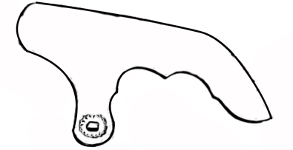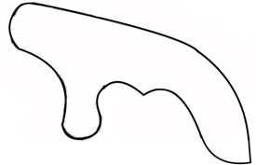  Color Selections: (Contact me if you are unsure)  Body Color:  Smooth or Roughout  Yoke: (examples: oil ONLY, dyed, 2-tone, dark background only) Please Specify Colors.  Fringe (if different):  Double fringe Colors (if any):  (Top color)  (Bottom color)  Buckstitch (if any):  Additional Notes:  Fit : Fitted or Loose?

