120 to Landfall: 2.0
Functional Exercise
EXERCISE PLAN 2022

This Exercise Plan provides the Exercise Planning Team with all the necessary tools for their conducting the exercise. This exercise document is intended for the exclusive use of exercise planners, facilitators, and evaluators, but players may view other materials that are necessary to their performance. Exercise participants should not have access to the Exercise Plan prior to conduct. Trusted agents should not share this document with exercise participants.

Contents
Exercise Overview 1
General Information 3
Exercise Objectives and Core Capabilities 3
Participant Roles and Responsibilities 3
Exercise Structure 4
Exercise Guidelines 5
Exercise Assumptions and Artificialities 5
Participant Feedback 6
Exercise Walk-through 8
120 Hours Pre-Landfall Conference Call: Wednesday, April 20, 2022, 11:00 am 8
96 Hours Pre-Landfall Conference Call: Thursday, April 21, 2022, 11:00 am 8
72 Hours Pre-Landfall Conference Call: Friday, April 22, 11:00 am 9
48 Hours Pre-Landfall Conference Call: Monday, April 25, 2022, 11:00 am 9
24 Hours Pre-Landfall Conference Call: Tuesday April 26, 2022 11:00 am 10
Functional Exercise Preparation: Tuesday, April 26, 2022 10
Functional Exercise Conduct: Wednesday, April 27, 2022 10
Appendix A: Exercise Schedule A-1
Appendix B: Weather Advisories B-1
Appendix C: Coastal Region Evacuation & Sheltering Guide Operational Phases C-1
Appendix D: Coalition Overview D-1

This page is intentionally blank.

Exercise Overview
Exercise Name | 120 to Landfall: 2.0 Functional Exercise 2022
Exercise Date | April 27, 2022 with pre-conduct notifications from April 20-26, 2022
Scope | This exercise is a six-hour functional exercise conducted in-person and virtually at the Crystal Coast Civic Center 203 College Cir., Morehead City, NC 28557. In person attendance is limited due to current COVID-19 restrictions and all participants must use proper face coverings and maintain required physical distancing measures during conduct. The functional exercise will also include conference calls leading up to conduct and serve as portion of the functional exercise. During these conference calls participants will be instructed to document patient tracking and transfer based on the current daily census.
Mission Area | Response
Health Care Preparedness and Response Capabilities | Health Care and Medical Response  Continuity of Health Care Service Delivery
Threat or Hazard | Category 4 hurricane
Scenario | A category 4 hurricane is predicted to make landfall at Topsail Beach, North Carolina. The hurricane brings sustained winds of 130 mph and storm surge of 15–20 feet. The impact from the storm is forecasted to be widespread on Eastern North Carolina’s healthcare and critical infrastructure. The hurricane triggers the activation of the Coastal Region Evacuation and Sheltering Plan.
Sponsors | Eastern Healthcare Preparedness Coalition  Southeastern Healthcare Preparedness Region
Points of Contact | Eastern Healthcare Preparedness Coalition  Chris Starbuck | 252-847-6634  CStarbuc@vidanthealth.com  Stephanie Seals | 252-814-8294  Stephanie.Seals@vidanthealth.com | Southeastern Healthcare Preparedness Region  Hans Edwards | 910‐508‐4865  Hans.Edwards@nhrmc.org  Heather Griffin | 910-398-5022  Heather.Griffin@nhrmc.org

This page is intentionally blank.

General Information

Exercise Objectives and Core Capabilities
The following exercise objectives in Table 1 describe the expected outcomes for the exercise. The objectives are linked to the Health and Human Services 2017–2022 Health Care Preparedness and Response Capabilities, which are distinct critical elements necessary to achieve the specific mission area. The objectives and aligned core capabilities are selected by the exercise planning team.
Exercise Objective | Capability
Demonstrate the ability to establish lines of communication and facility points of contact used by healthcare stakeholders for emergency notifications and information sharing. | Health Care and Medical Response Coordination
Demonstrate the capability for information sharing to ancillary healthcare providers (e.g., dialysis, home healthcare, assisted living, etc.), emergency management agencies, and regional emergency coordination points prior to, and during an evacuation.
Demonstrate the implementation of a policy, plan, or procedure implementing decision-making triggers used by healthcare stakeholders for executing the safe evacuation or shelter-in-place plans during an emergency.
Determine the resource needs for executing a full facility evacuation during an emergency incident and demonstrate the process for obtaining those resources.
Demonstrate the ability to prioritize the emergency evacuation process of patients when transportation resources are limited. | Continuity of Health Care Service Delivery
Table 1. Exercise Objectives and Associated Core Capabilities

Participant Roles and Responsibilities
The term participant encompasses many groups of people, not just those playing in the exercise. Groups of participants involved in the exercise, and their respective roles and responsibilities, are as follows:
Players. Players are personnel who have an active role in discussing or performing their regular roles and responsibilities during the exercise. Players discuss or initiate actions in response to the simulated emergency.
Observers. Observers do not directly participate in the exercise. However, they may support the development of player responses to the situation during the discussion by asking relevant questions or providing subject matter expertise.
Facilitators. Facilitators provide situation updates and moderate discussions. They also provide additional information or resolve questions as required. Key exercise planning team members also may assist with facilitation as subject matter experts during the exercise.
Evaluators. Evaluators are assigned to observe and document certain objectives during the exercise. Their primary role is to document player discussions, including how and if those discussions conform to plans, polices, and procedures.

Exercise Structure
The design of the exercise is designed in a manner to ensure that all exercise objectives can be accomplished. It is designed in collaboration with the Exercise Planning Team and Exercise Support Team. The exercise will be conducted over several day. Coalition members will participate in a series of conference call to simulation the emergency planning, coordination, and communications outlined in the coalition communications plan. The purpose of these conference calls is to begin the assessment process for removing and receiving patients/residents from healthcare facilities which would be impacted by a Category 4 Hurricane. Coalition members will be provided with scenario information during the facilitated call and requested to complete an assessment of transportation and sheltering needs. Threatened facilities will be asked to complete a patient/resident tracking document and transportation assessment of resources required for evacuating patients/resident. Receiving facilities will be asked to complete a surge capability and/or bed availability assessment for receiving patients/residents. Throughout the conference call process, the coalition leadership will begin to consolidate needs, requests, and identify gaps in the planning process. Participants will be asked to provide those completed documents on the day of conduct in order to identify resources needs in an attempt to identify how these resources may be obtained. This will also allow participants to share best practices.
On the day of the Functional Exercise, players will participate in the following two modules:
Module 1: 96 Hours to 72 Hours Pre-Landfall
Module 2: 48 Hours to 0 Hour Landfall
Each module begins with a multimedia update that summarizes key events occurring within that time period. After the updates, participants will separate into two multi-discipline, multi-organization breakout groups with a facilitator, to review the situation and engage in group discussions of appropriate pre-landfall response issues; discussion questions will correspond to the exercise objectives. For this exercise, the functional groups are as follows:
Group 1: Eastern Health Preparedness Coalition
Group 2: Southeastern Healthcare Preparedness Region
After these functional group discussions, participants will engage in a moderated plenary discussion in which spokespersons from each group will present a synopsis of the group’s actions, based on the scenario.

Exercise Scenario
- Category 4 Hurricane -Tidal Surge 15-20 feet - Landfall near Topsail Beach, NC
- Begins with weather advisory from April 20 that indicates the development of a tropical depression in the Caribbean.
- Strengthens to a major hurricane on April 20, 2022 (120 hours).
- During the track of the storm, initial landfall occurs in Haiti as a Category 4 Hurricane on April 21, 2022, then hits lower Florida on the early morning of April 22, 2022, as a Category 3 Hurricane.
- The last advisory indicates the landfall of Hurricane Hans as a Category 4 storm near Topsail Beach, North Carolina on April 25, 2022, with wind speeds of 130 mph.
- Advisory also reports that the hurricane will decrease in forward movement and remain strong as it moves inland; coastal storm surge is expected to be 15–20 feet above ground level.
- This projection will prompt the activation of the Coastal Region Evacuation and Sheltering Plan as well as trigger agencies to perform their pre-landfall operations for a severe hurricane threat.
- The impact from the storm is predicted to be widespread on eastern North Carolina’s healthcare and critical infrastructure.

Exercise Guidelines
This exercise will be held in an open, low-stress, no-fault environment. Varying viewpoints are expected.
Respond to the scenario using your knowledge of current plans and capabilities (i.e., you may use only existing assets) and insights derived from your training.
Decisions are not precedent setting and may not reflect your organization’s final position on a given issue. This exercise is an opportunity to discuss and present multiple options and possible solutions.
Issue identification is not as valuable as suggestions and recommended actions that could improve pre-landfall response efforts; problem-solving efforts should be the focus.

Exercise Assumptions and Artificialities
In any exercise, assumptions and artificialities may be necessary to complete play in the time allotted and/or account for logistical limitations. Exercise participants should accept that assumptions and artificialities are inherent in any exercise and should not allow these considerations to negatively impact their participation. During this exercise, the following apply:
Participants will be asked to take action based on their daily census and patient/resident condition; however, as an artificiality Covid-19 does not exist for this exercise.
The conference call schedule will be adjusted to accommodate for the weekend and symposium schedule. Some of the conference calls may be joint coalition calls. Otherwise, the conference calls will be conducted as normal.
The exercise is conducted in a no-fault learning environment wherein capabilities, plans, systems, and processes will be evaluated.
The exercise scenario is plausible, and events occur as they are presented.
All players receive information at the same time.

Participant Feedback
Participant feedback provides players with the opportunity to comment candidly on exercise activities and exercise design. An online Participant Feedback Form will be provided for those attending the exercise virtually and a printed Participant Feedback Form will be provided to those attending in-person. The online version will be established by the Exercise Planning Team and participants will be provide a link during the exercise. The Exercise Support Team will provide the in-person version of the form.

Exercise Walkthrough

120 Hours Pre-Landfall Conference Call: Wednesday, April 20, 2022, 11:00 am
- The Southeastern Healthcare Preparedness Region and Eastern Healthcare Preparedness Coalition will send invitations/notifications for coalition members to participate in a scripted “conference call” through the normal coalition communications procedures.
- The Southeastern Healthcare Preparedness Region and Eastern Healthcare Preparedness Coalition will provide coalition members the current weather advisories and statements.
- Coalition members should begin the planning process in preparation for landfall of a Category 4 Hurricane.

96 Hours Pre-Landfall Conference Call: Thursday, April 21, 2022, 11:00 am
- The Southeastern Healthcare Preparedness Region and Eastern Healthcare Preparedness Coalition will send invitations/notifications for coalition member to participate in a scripted “conference call” through the normal coalition communications procedures, if required.
- The Southeastern Healthcare Preparedness Region and Eastern Healthcare Preparedness Coalition will provide coalition members the current weather advisories and statements.
- The Southeastern Healthcare Preparedness Region and Eastern Healthcare Preparedness Coalition will advise coalition members to begin to assess their needs in the event that an evacuation of the facility is required.
- The assessment should address:
  - Assessment of transportation resources based on patient/resident daily census.
  - Assessment of staffed/staffable bed availability based on daily census.
  - Assessment of patients/residents that require transportation to another facility vs. discharge to family or caregivers.
- Covid-19 in not a consideration during this exercise, patient/resident care needs should be based on other respiratory diagnosis or non-Covid related illness requiring similar care (i.e., non-viral pneumonia, chronic lung disease, etc.).
- Exercise Participants will be instructed to utilize the North Carolina Patient/Resident Tracking Form be initiate the process for transporting and tracking patients/residents being evacuated, which will assist in assessing transportation resource requirements.
- Exercise Participants which do not anticipate facility evacuation will be asked to conduct a facility assessment regarding the ability receive patients/residents from evacuating facilities based on the current bed census.
- Exercise Participants will be instructed to be prepared to discuss their assessment during the next conference call.

72 Hours Pre-Landfall Conference Call: Friday, April 22, 2022, 11:00 am
- The Southeastern Healthcare Preparedness Region and Eastern Healthcare Preparedness Coalition will send invitations/notifications for coalition members to participate in a scripted “conference call” through the normal coalition communications procedures, if required.
- The Southeastern Healthcare Preparedness Region and Eastern Healthcare Preparedness Coalition will provide coalition members the current weather advisories and statements.
- Through a facilitated discussion the Southeastern Healthcare Preparedness Region and Eastern Healthcare Preparedness Coalition with coalition members will collect facility assessments to provide a situational awareness, attempt to resolve conflicts and address gaps in evacuation plans.
  - Numbers/percentage discharged to family/caregivers
  - Numbers/percentage requiring transportation to receiving facilities
  - Numbers/percentage requiring specialized transportation (i.e., advanced life-support ambulance, non-life support ambulance, van/bus transportation).
  - Bariatric or other special medical conditions.
- Coalition members should be instructed that the next conference call will be a joint call with coalition members from both regions participating jointly. Coalition members should be prepared to provide an update on evacuation and receiving plans.

48 Hours Pre-Landfall Conference Call: Monday, April 25, 2022, 11:00 am
- The Southeastern Healthcare Preparedness Region and Eastern Healthcare Preparedness Coalition will send invitations/notifications for coalition members to participate in a scripted “conference call” through the normal coalition communications procedures, if required.
- This will be a joint call between the Southeastern Healthcare Preparedness Region and the Eastern Healthcare Preparedness Coalition members.
- The Southeastern Healthcare Preparedness Region and Eastern Healthcare Preparedness Coalition will provide coalition members the current weather advisories and statements.
- The purpose of this joint call is to collaborate and deconflict evacuation and receiving plans, and address gaps as required. Coalition members should provide an up-date on implementation of evacuation and receiving plans.

24 Hours Pre-Landfall Conference Call: Tuesday, April 26, 2022 11:00 am
- The Southeastern Healthcare Preparedness Region and Eastern Healthcare Preparedness Coalition will send invitations/notifications for coalition members to participate in a conference call through the normal coalition communications procedures, if required.
- This will be a joint call between the Southeastern Healthcare Preparedness Region and the Eastern Healthcare Preparedness Coalition members.
- The Southeastern Healthcare Preparedness Region and Eastern Healthcare Preparedness Coalition will provide coalition members the current weather advisories and statements.
- The purpose of this joint call is to collaborate and deconflict evacuation and receiving plans, and address gaps as required. Coalition members should provide an up-date on implementation of evacuation and receiving plans.

Functional Exercise Preparation: Tuesday, April 26, 2022
- The Exercise Support Team will begin to collect and display exercise data collected during the pre-landfall conference calls along with updating current weather advisories and statements.
- The Exercise Support Team will prepare the exercise venue and technology testing.
- The Exercise Support Team will provide Controller/Evaluator Training from 3:00 pm until 5:00 pm.

Functional Exercise Conduct: Wednesday April 27, 2022
- 8:00 am: The Exercise Support Team finalizes preparation of the exercise venue and arrival of Exercise Participants.
- 9:00 m: Registration opens, with support from the Exercise Support Team and Exercise Planning Team.
- 9:30 am: Exercise Start
  - Introductions
  - Exercise Overview
- 9:45 am Module1 (96 hours to 72 hours pre-landfall)
- 10:45 am Break
- 11:00 am Group Reports
- 11:30 am Module 2 (48 hours to landfall)
- 12:30 pm Working Lunch
- 2:00 pm Group Reports
- 2:30 pm Hotwash
- 3:00 pm Conclusion and Dismissal
- 3:30 pm Controller/Evaluator Debrief
This page is intentionally blank.

Appendix A: Exercise Schedule
Time | Activity
April 20, 2022
11:00 am | 120 Hours to Landfall “Call” conducted via e-mail
April 21, 2022
11:00 am | 96 Hours to Landfall “Call” conducted via e-mail
April 22, 2022
11:00 am | 72 Hours to Landfall “Call” conducted via e-mail
April 25, 2022
11:00 am | 48 Hours to Landfall “Call” conducted via e-mail
April 26, 2022
10:30 am | 24 Hours to Landfall Conference Call
12:00 pm – 5: 00 pm | Venue Preparation, Controller and Evaluator training
April 27, 2022
9:00 am | Registration/Virtual Log-in
9:30 am | Welcome, Opening Remarks, Exercise Overview
9:45 am | Module 1: 96 Hours – 72 Hours Pre-Landfall
10:45 am | Break
11:00 am | Group Reports
11:30 am | Module 2: 48 hours Pre-Landfall
12:30 pm | Working Lunch
2:00 pm | Group Reports
2:30 pm | Hotwash
3:00 pm | Conclusion and Dismissal

This page is intentionally blank.

Appendix B: Weather Advisories

Weather Advisory 16
EXERCISE | EXERCISE | EXERCISE | EXERCISE | EXERCISE | EXERCISE | EXERCISE
ZCZC MIATCPAT5 ALL
TTAA00 KNHC DDHHMM
BULLETIN
HURRICANE HANS ADVISORY NUMBER 16
NWS TPC/NATIONAL HURRICANE CENTER MIAMI FL AL082015
5 PM EDT Wed April 20, 2022

...DANGEROUS CATEGORY FOUR HANS MOVING OVER SOUTHWEST HAITI...THREAT OF HEAVY RAINS AND FLOODING CONTINUES...

AT 5 PM EDT THE HURRICANE WATCH HAS BEEN EXTENDED ALONG THE FLORIDA EAST COAST TO NEW SMYRNA BEACH AND A HURRICANE WATCH HAS BEEN ISSUED FOR LAKE OKEECHOBEE. ALSO...THE GOVERNMENT OF THE BAHAMAS HAS ISSUED A HURRICANE WATCH FOR THE BIMINI ISLANDS AND GRAND BAHAMA ISLAND.

A HURRICANE WATCH IS NOW IN EFFECT FROM NEW SMYRNA BEACH SOUTHWARD ON THE FLORIDA EAST COAST...AND FROM SOUTH OF CHOKOLOSKEE SOUTHWARD ALONG THE WEST COAST...FOR LAKE OKEECHOBEE...AND FOR ALL OF THE FLORIDA KEYS...FROM OCEAN REEF TO THE DRY TORTUGAS. A HURRICANE WATCH IS ALSO IN EFFECT FOR ANDROS ISLAND...THE BIMINIS...AND GRAND BAHAMA ISLAND IN THE NORTHWESTERN BAHAMAS. A HURRICANE WATCH MEANS THAT HURRICANE CONDITIONS ARE POSSIBLE WITHIN THE WATCH
AREA...GENERALLY WITHIN 48 HOURS.

HURRICANE WARNINGS MAY BE REQUIRED FOR PORTIONS OF THE HURRICANE WATCH AREAS LATER TODAY.

AT 5 PM EDT THE GOVERNMENT OF CUBA HAS CHANGED THE HURRICANE WARNING TO A TROPICAL STORM WARNING FOR THE CUBAN PROVINCES OF GUANTANAMO...SANTIAGO DE CUBA...GRANMA... HOLGUIN...LAS TUNAS...AND CAMAGUEY.

A TROPICAL STORM WARNING IS IN EFFECT FOR RAGGED ISLAND AND GREAT EXUMA IN THE CENTRAL BAHAMAS. A TROPICAL STORM WARNING MEANS THAT TROPICAL STORM CONDITIONS ARE EXPECTED WITHIN THE WARNING AREA WITHIN THE NEXT 36 HOURS.

INTERESTS ELSEWHERE IN THE CENTRAL AND NORTHWESTERN BAHAMAS SHOULD MONITOR THE PROGRESS OF HANS.

FOR STORM INFORMATION SPECIFIC TO YOUR AREA...INCLUDING POSSIBLE INLAND WATCHES AND WARNINGS...PLEASE MONITOR PRODUCTS ISSUED BY YOUR LOCAL WEATHER OFFICE.

AT 5PM EDT THE CENTER OF HURRICANE HANS WAS LOCATED NEAR LATITUDE 20.3 NORTH... LONGITUDE 75.7 WEST OR ABOUT 35 MILES WEST-NORTHWEST OF GUANTANAMO CUBA.

HANS IS MOVING TOWARD THE NORTHWEST NEAR 10 MPH AND THIS GENERAL MOTION IS EXPECTED TO CONTINUE FOR THE NEXT 24 HOURS. ON THIS TRACK THE CENTER WILL CONTINUE TO MOVE OVER EASTERNN CUBA TODAY AND POSSIBLY EMERGE OFF THE NORTH COAST OF CUBA TONIGHT.

MAXIMUM SUSTAINED WINDS ARE 145 MPH WITH HIGHER GUSTS. ADDITIONAL SLOW WEAKENING IS LIKELY AS HANS MOVES OVER LAND TODAY...BUT RE-STRENGTHENING IS EXPECTED WHEN THE CENTER MOVES OVER THE WATERS TO THE NORTH OF CUBA.

HURRICANE FORCE WINDS EXTEND OUT 30 MILES FROM THE CENTER AND TROPICAL STORM FORCE WINDS EXTEND OUTWARD UP TO 70 MILES FROM THE CENTER.

ESTIMATED MINIMUM CENTRAL PRESSURE IS 932 MB...27.52 INCHES.

TIDES UP TO 10 FEET ABOVER NORNAL TIDE LEVELS ARE EXPECTED OF EASTERNN CUBA. RAINFALL AMOUNTS OF 6 TO 12 INCHES...WITH POSSIBLE ISOLATED AMOUNTS OF UP TO 20 INCHES...ARE EXPECTED OVER PORTIONS OF HISPANIOLA AND CENTRAL AND EASTERNN CUBA. THESE RAINS COULD CAUSE LIFE-THREATENING FLASH FLOODS AND MUD SLIDES. RAINFALL AMOUNTS OF 2 TO 4 INCHES ARE POSSIBLE OVER THE SOUTHERN BAHAMAS.

REPEATING THE 5 PM EDT POSITION...20.3 N...75.7 W. MOVEMENT TOWARD... NORTHWEST NEAR 10 MPH. MAXIMUM SUSTAINED WINDS...145 MPH. MINIMUM CENTRAL PRESSURE...932 MB OR 27.52 INCHES.

$$
FORECASTE R PASCH 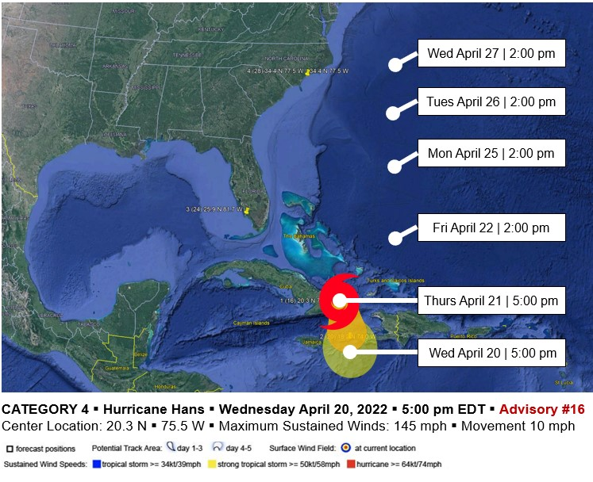
EXERCISE | EXERCISE | EXERCISE | EXERCISE | EXERCISE | EXERCISE | EXERCISE

EXERCISE | EXERCISE | EXERCISE | EXERCISE | EXERCISE | EXERCISE | EXERCISE

Weather Advisory 20

ZCZC MIATCPAT5 ALL
TTAA00 KNHC DDHHMM
BULLETIN
HURRICANE HANS ADVISORY NUMBER 20
NWS TPC/NATIONAL HURRICANE CENTER MIAMI FL AL082015
7 PM EDT Thurs April 21, 2022

AT 5 PM EDT...HURRICANE HANS MADE LANDFALL ON THE SOUTHWEST SIDE OF HISPANOLA. THE CENTER OF THE HURRICANE WAS LOCATED NEAR LATITUDE 18.2 NORTH… LOGITUDE 74.0 WEST OR NEAR THE COTEAUX SUBDIVISION IN HAITI.

...OUTER RAINBANDS OF EXTREMELY DANGEROUS HANS NEAR THE SOUTHEAST COAST OF CUBA AND IS EXPECTED TO CONTINUE NORTH TO SOUTH FLORIDA COAST. U.S. LANDFALL IS EXPECTED April 22.

AT 3PM A HURRICANE WATCH HAS UPGRADED TO A HURRICANE WARNING FOR SOUTHEAST CUBA.

RAINFALL TOTALS OF 10 TO 12 INCHES ARE POSSIBLE NEAR THE TRACK OF HANS OVER WESTERN HISPANOLA THROUGH SUNDAY...WITH ISOLATED AMOUNTS UP TO 15 INCHES POSSIBLE. RAINFALL AMOUNTS OF 2 TO 4 INCHES WITH ISOLATED AMOUNTS UP TO 6 INCHES ARE EXPECTED OVER EASTERN AND CENTRAL CUBA. RAINFALL AMOUNTS OF 1 TO 2 INCHES WITH ISOLATED AMOUNTS OF 4 INCHES ARE POSSIBLE OVER THE BAHAMAS.

A HURRICANE WATCH IS EXTENDED NORTHWARD ALONG THE U.S. EAST COAST NORTH OF NEW SMYRNA BEACH FLORIDA TO CAPE LOOKOUT, NC.

AT 5 PM EDT THE HURRICANE WATCH IS CHANGED TO A HURRICANE WARNING FOR THE FLORIDA WEST COAST FROM NORTH OF BONITA BEACH NORTHWARD TO TARPON SPRINGS.

A HURRICANE WARNING REMAINS IN EFFECT FROM NEW SMYRNA BEACH SOUTHWARD ON THE EAST COAST...INCLUDING LAKE OKEECHOBEE...FROM BONITA BEACH SOUTHWARD ON THE WEST COAST...AND FOR ALL OF THE FLORIDA KEYS FROM OCEAN REEF TO THE DRY TORTUGAS.

AT 5 PM EDT THE GOVERNMENT OF THE BAHAMAS HAS CONTINUED THE TROPICAL STORM WARNING FOR RAGGED ISLAND AND GREAT EXUMA IN THE CENTRAL BAHAMAS.

A TROPICAL STORM WARNING AND A HURRICANE WATCH REMAIN IN EFFECT FOR ANDROS ISLAND...THE BERRY ISLANDS... THE BIMINIS AND GRAND BAHAMA ISLAND IN THE NORTHWESTERN BAHAMAS.

INTERESTS ELSEWHERE IN THE NORTHWESTERN BAHAMAS SHOULD MONITOR THE PROGRESS OF HANS.

FOR STORM INFORMATION SPECIFIC TO YOUR AREA...INCLUDING POSSIBLE INLAND WATCHES AND WARNINGS...PLEASE MONITOR PRODUCTS ISSUED BY YOUR LOCAL WEATHER OFFICE.

HANS IS MOVING TOWARD THE NORTHWEST NEAR 13 MPH AND THIS GENERAL MOTION IS EXPECTED TO CONTINUE TODAY AND TONIGHT. ON THIS TRACK...THE CENTER WILL BE NEARING THE FLORIDA KEYS AND EXTREME SOUTHERN FLORIDA TONIGHT WITH TIDES
10 TO 15 FT ABOVE NORMAL AND DAMAGING WINDS WELL IN ADVANCE OF THE CENTER.

MAXIMUM SUSTAINED WINDS ARE NEAR 140 MPH WITH HIGHER GUSTS. HAS IS EXPECTED TO DECREASE IN STRENGTH BEFORE THE CENTER REACHES FLORIDA.

HURRICANE FORCE WINDS EXTEND OUT 30 MILES FROM THE CENTER WITH TROPICAL STORM FORCE WINDS EXTENDING OUTWARD UP TO 75 MILES FROM THE CENTER.

ESTIMATED MINIMUM CENTRAL PRESSURE IS 935 MB...27.61 INCHES.
COASTAL STORM SURGE FLOODING OF 10 TO 15 FEET ABOVE NORMAL TIDE LEVELS
CAN BE EXPECTED IN AREAS OF ONSHORE FLOW WITHIN THE WARNING AREA.

REPEATING THE 5 PM EDT POSITION… 18.2N 74.0W. MOVEMENT TOWARD... NORTHWEST NEAR 13 MPH. MAXIMUM SUSTAINED WINDS...140 MPH. MINIMUM CENTRAL PRESSURE... 935 MB.

$$
FORECASTER PASCH
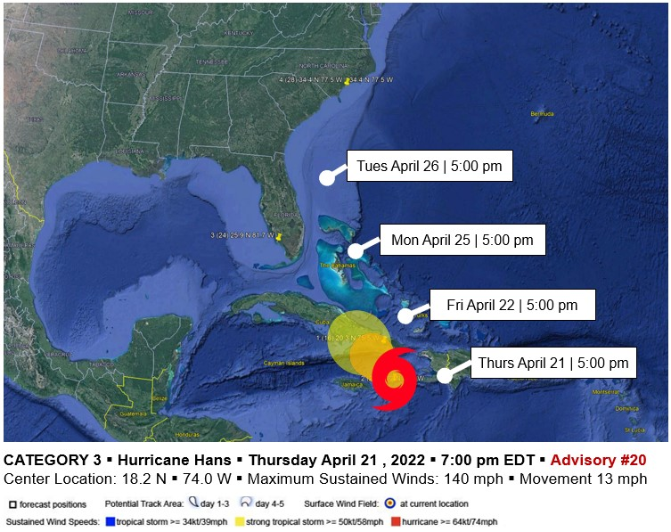
EXERCISE | EXERCISE | EXERCISE | EXERCISE | EXERCISE | EXERCISE | EXERCISE

Weather Advisory 24
EXERCISE | EXERCISE | EXERCISE | EXERCISE | EXERCISE | EXERCISE | EXERCISE
ZCZC MIATCPAT5 ALL
TTAA00 KNHC DDHHMM
BULLETIN
HURRICANE HANS ADVISORY NUMBER 24
NWS TPC/NATIONAL HURRICANE CENTER MIAMI FL AL082015
5 PM EDT Tues April 26, 2022

...HURRICANE HANS WEAKENS TO A CATEGORY 3 AS IT MAKES LANDFALL IN SOUTH FLORIDA...

AT 9 AM EDT THE HURRICANE WATCH FROM SOUTH OF SEBASTIAN INLET SOUTHWARD AROUND THE FLORIDA PENINSULA TO BONITA BEACH ON THE WEST COAST INCLUDING LAKE OKEECHOBEE AND THE FLORIDA KEYS HAS BEEN UPGRADE TO A HURRICANE WARNING.

AT 5 PM EDT...A HURRICANE WARNING IS NOW IN EFFECT FROM JACKSONVILLE FLORIDA TO SAVANNAH GEORGIA.

AT 5 PM EDT...A HURRICANE WATCH HAS BEEN EXTENDED NORTHWARD AND IS NOW IN EFFECT FROM SEBASTIAN INLET FLORIDA NORTHWARD AND NORTHEASTWARD ALONG THE COAST TO PINE KNOLL SHORES NORTH CAROLINA.

FOR STORM INFORMATION SPECIFIC TO YOUR AREA...INCLUDING POSSIBLE INLAND WATCHES AND WARNINGS...PLEASE MONITOR PRODUCTS ISSUED BY YOUR LOCAL WEATHER OFFICE.

AT 5 PM EDT THE CENTER OF HURRICANE HANS WAS LOCATED NEAR LATITUDE 25.9 NORTH...LONGITUDE -81.7 WEST OR NEAR MARCO ISLAND, OR 25 MILES FROM NAPLES FLORIDA.

HANS IS MOVING TOWARD THE NORTHEAST NEAR 10 MPH AND THIS GENERAL MOTION IS EXPECTED TO CONTINUE TODAY ACROSS THE FLORIDA PENINSULA. ON THIS TRACK THE CENTER SHOULD MOVE OVER TO THE ATLANTIC WATERS ON MONDAY NIGHT.

MAXIMUM SUSTAINED WINDS ARE NEAR 115 MPH WITH HIGHER GUSTS. HANS IS FORECAST TO SLOWLY WEAKEN OVER LAND BUT REMAIN A MAJOR HURRICANE AS THE SYSTEM MOVES OVER THE ATLANTIC ON TUESDAY AND WEDNESDAY.

ESTIMATED MINIMUM CENTRAL PRESSURE IS 950 MB...28.05 INCHES.

COASTAL STORM SURGE FLOODING OF 7 TO 10 FEET ABOVE NORMAL TIDE LEVELS CAN BE EXPECTED IN AREAS OF ONSHORE FLOW WITHIN THE WARNING AREA.

ISOLATED TORNADOES ARE POSSIBLE ALONG THE SOUTHERN EAST COAST.

RAINFALL TOTALS OF 3 TO 5 INCHES ARE POSSIBLE NEAR THE TRACK OF HANS OVER THE FLORIDA PENINSULA...WITH ISOLATED AMOUNTS UP TO 10 INCHES POSSIBLE. RAINFALL TOTALS OF 4 TO 8 INCHES ARE POSSIBLE FROM COASTAL SOUTH CAROLINA NORTHWARD INTO THE MID ATLANTIC REGION WITH MAXIMUM AMOUNTS OF 12 INCHES OVER THE NEXT FEW DAYS. ADDITIONAL RAINFALL AMOUNTS OF 1 TO 2 INCHES...WITH ISOLATED AMOUNTS OF 4 INCHES ARE POSSIBLE OVER THE NORTHWESTERN BAHAMAS.

REPEATING THE 5 PM EDT POSITION...25.9 N... -81.7 W. MOVEMENT TOWARD...NORTH NEAR 10 MPH. MAXIMUM SUSTAINED WINDS...115 MPH.MINIMUM CENTRAL PRESSURE ...950 MB.

$$
FORECASTER AVILA

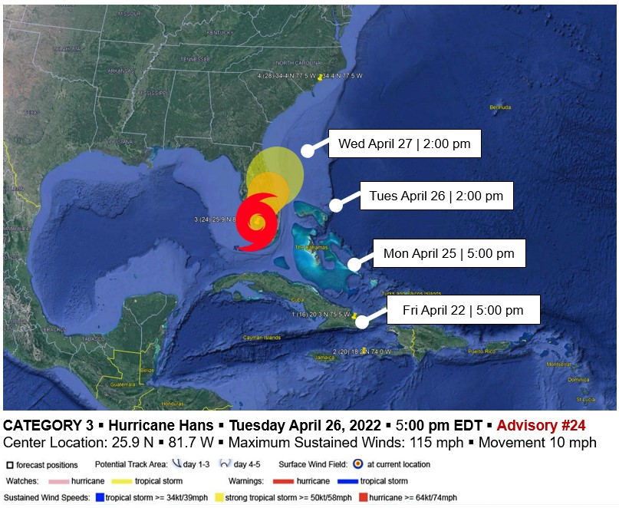
EXERCISE | EXERCISE | EXERCISE | EXERCISE | EXERCISE | EXERCISE | EXERCISE

Weather Advisory 28
EXERCISE | EXERCISE | EXERCISE | EXERCISE | EXERCISE | EXERCISE | EXERCISE
ZCZC MIATCPAT5 ALL
TTAA00 KNHC DDHHMM
BULLETIN
HURRICANE HANS ADVISORY NUMBER 28
NWS TPC/NATIONAL HURRICANE CENTER MIAMI FL AL082015
5 AM EDT Wed April 27, 2022

...HURRICANE HANS HAS UPGRADE TO A CATEGORY 4 AND IS HEADING TOWARD THE CAROLINAS...

AT 5 AM EDT UTC...A HURRICANE WARNING REMAINS IN EFFECT FROM THE SOUTH SANTEE RIVER EXTENDING NORTHWARD TO CURRITUCK BEACH LIGHT NORTH CAROLINA INCLUDING THE PAMLICO AND ALBEMARLE SOUNDS.

AT 5 AM EDT THE TROPICAL STORM WARNING IS DISCONTINUED SOUTH OF THE SAVANNAH RIVER.

A TROPICAL STORM WARNING IS NOW IN EFFECT FROM THE SAVANNAH RIVER NORTHWARD TO THE SOUTH SANTEE RIVER...AND NORTH OF CURRITUCK BEACH LIGHT NC INCLUDING ALL OF THE DELMARVA REGION.

FOR STORM INFORMATION SPECIFIC TO YOUR AREA...INCLUDING POSSIBLE
INLAND WATCHES AND WARNINGS...PLEASE MONITOR PRODUCTS ISSUED
BY YOUR LOCAL WEATHER OFFICE.

AT 5 AM EDT THE CENTER OF HURRICANE HANS WAS LOCATED NEAR LATITUDE 34.4 NORTH...LONGITUDE -77.5 WEST OR ABOUT 20 MILES NORTH-NORTHEAST OF WILMINGTON NORTH CAROLINA AND ABOUT 145 MILES SOUTH-SOUTHEAST OF RALEIGH NORTH CAROLINA.

HANS IS MOVING TOWARD THE NORTH-NORTHWEST NEAR 17 MPH...28 KM/HR.
ON THIS TRACK THE CENTER OF HANS WILL BE NEARING THE COAST OF THE CAROLINAS LATER TODAY.

THE CENTER OF EXTREMELY DANGEROUS HURRICANE HANS IS PREDICTED TO MAKE LANDFALL ON THE NORTH CAROLINA COAST JUST SOUTH OF NORTH TOPSAIL BEACH

MAXIMUM SUSTAINED WINDS ARE NEAR 130 MPH WITH HIGHER GUSTS. NO SIGNIFICANT STRENGTHENING IS EXPECTED BEFORE LANDFALL.

HURRICANE FORCE WINDS EXTEND OUT 75 MILES FROM THE CENTER AND TROPICAL STORM FORCE WINDS EXTEND OUTWARD UP TO 150 MILES MAINLY TO THE NORTH AND EAST OF THE CENTER.

LATEST MINIMUM PRESSURE REPORTED BY A NOAA P-3 RECONNAISSANCE PLANE
940 MB...27.76 INCHES.

COASTAL STORM SURGE FLOODING OF 15 TO 20 FEET ABOVE NORMAL TIDE LEVELS
IS POSSIBLE ALONG THE COAST OF NORTH CAROLINA IN AREAS OF ONSHORE
FLOW WITHIN THE WARNING AREA...WITH 10 TO 15 FEET ABOVE GROUND LEVEL INUNDATION ACROSS SOME AREAS ADJACENT TO THE SOUNDS AND RIVERS ACROSS EASTERNN NORTH CAROLINA. TIDES ARE CURRENTLY RUNNING ABOUT 10 FEET ABOVE NORMAL AT ONSLOW BEACH.

RAINFALL TOTALS OF 5 TO 10 INCHES ARE POSSIBLE FROM SOUTH CAROLINA
INTO THE MID-ATLANTIC STATES...AND THE SOUTHERN AND CENTRAL
APPALACHIANS...WITH ISOLATED MAXIMUM AMOUNTS OF 15 INCHES...THROUGH
FRIDAY. THESE AMOUNTS COULD CAUSE LIFE-THREATENING FLASH FLOODS.

ISOLATED TORNADOES ARE POSSIBLE OVER EASTERNN NORTH CAROLINA TODAY AND TONIGHT.

REPEATING THE 5 AM EDT POSITION...34.4 N... -77.5 W. MOVEMENT
TOWARD...NORTH-NORTHEAST NEAR 17 MPH. MAXIMUM SUSTAINED WINDS...130
MPH. MINIMUM CENTRAL PRESSURE...940 MB.

$$
FORECASTER AVILA
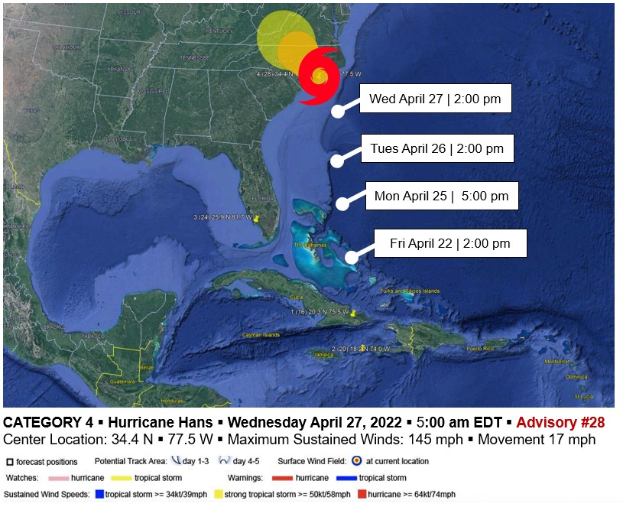
EXERCISE | EXERCISE | EXERCISE | EXERCISE | EXERCISE | EXERCISE | EXERCISE

Appendix C: Coastal Region Evacuation & Sheltering Guide Operational Phases
Phase 1: Preparedness  120+hours | Phase 2: Standby  120–96 hours | Phase 3: Decision  96–72 hours | Phase 4: Implementation  72–12 hours | Phase 5: Storm Effects  12–0 hours | Phase 6: Re-entry  0+ hours
Activity Overview | Activity Overview | Activity Overview | Activity Overview | Activity Overview | Activity Overview
Update State and Local Regional procedures  Annual update of relevant plans  Review public information program  Train and Exercise  Monitor National Weather Service/National Hurricane Center for Tropical Storm formation | Storm forms or is located W of 45 Longitude and No of 15 latitude  Activate State EOC & Regional Coordination Centers  Alert OEMS/SMAT  Monitor progress of storm via HURREVAC/HVX, etc.  Alert/Status of the SCRS  Conduct Regional conference calls  Evaluate EMAC requirements  Assess vulnerability and decisions times | May pre-position resources  Regional evacuative decision making  Prepare evacuative timeline  Disseminate pre-event public information  Coordinate shelter openings | Enhanced coordination  Evacuation monitoring  Respond as required to observed delays  Assess need to terminate  Monitor shelter populations and transportation  Assist shelter logs | Monitor storm effects on State  Develop situational damage assessments  Prepare for post-storm activities  Perform response activities when safe for deployment  Monitor status of shelters and population | Develop Regional re-entry Incident Action Plan  State resources  Distribute post-event public information  Account for all evacuees  Evaluate/recon evacuation re-entry routes  Demobilize resources  Coordinate shelter closings

This page is intentionally blank.

Appendix D: Long-Term Care, Adult Care, and Hospital Facilities within the Regions
Highlighted facilities are a at risk for storm surge flooding for a Category 4 Hurricane. These tables do not factor in hurricane wind speed which may also be a consideration for evacuation or sheltering-in-place.
Joint Skilled Nursing Facility/Adult Care Home Facilities by County | SNF Beds | ACH Beds
Beaufort | 268 | 10
Ridgewood Living & Rehabilitation Center, 1624 Highland Drive, Washington, NC 27889 | 128 | 0
River Trace Nursing and Rehabilitation Center, 250 Lovers Lane, Washington, NC 27889 | 140 | 10
Bertie | 142 | 20
Brian Center Health & Rehabilitation/Windsor, 1306 South King Street, Windsor, NC 27983 | 82 | 0
Three Rivers Health and Rehab, 1403 Conner Drive, Windsor, NC 27983 | 60 | 20
Brunswick | 564 | 67
Autumn Care of Shallotte, 237 Mulberry Street, Shallotte, NC 28470 | 100 | 10
Brunswick Cove Nursing Center, 1478 River Road, Winnabow, NC 28479 | 175 | 40
Brunswick Health & Rehab Center, 9600 No. 5 School Road, Ash, NC 28420 | 100 | 0
Liberty Commons Nursing & Rehab Center of Southport LLC, 630 Fodale Avenue, Southport, NC 28461 | 99 | 17
Universal Health Care/Brunswick, 1070 Old Ocean Highway, Bolivia, NC 28422 | 90 | 0
Carteret | 382 | 0
Croatan Ridge Nursing and Rehabilitation Center, 210 Foxhall Rd., Newport, NC 28570 | 64 | 0
Crystal Bluffs Rehabilitation and Health Care Center, 4010 Bridges Street Extension, Morehead City, NC 28557 | 92 | 0
Harborview Health Care Center, 812 Shepard Street, Morehead City, NC 28557 | 122 | 0
PruittHealth-SeaLevel, 468 Highway 70 East, Sea Level, NC 28577 | 104 | 0
Chowan | 130 | 0
Chowan River Nursing and Rehabilitation Center, 1341 Paradise Road, Edenton, NC 27932 | 130 | 0
Craven | 470 | 12
Bayview Nursing & Rehabilitation Center, 3003 Kensington Park Drive, New Bern, NC 28560 | 60 | 12
Cherry Point Bay Nursing and Rehabilitation Center, 110 McCotter Blvd., Havelock, NC 28532 | 70 | 0
PruittHealth-Neuse, 1303 Health Drive, New Bern, NC 28560 | 110 | 0
PruittHealth-Trent, 836 Hospital Drive, New Bern, NC 28560 | 116 | 0
Riverpoint Crest Nursing and Rehabilitation Center, 2600 Old Cherry Point Road, New Bern, NC 28563 | 114 | 9
Currituck | 100 | 0
Currituck Health & Rehab Center, 3907 Caratoke Hwy, Barco, NC 27917 | 100 | 0
Dare | 126 | 0
Peak Resources-Outer Banks, 430 West Health Center Drive, Nags Head, NC 27959 | 126 | 0
Hyde | 50 | 30
Cross Creek Health Care, 1719 Quarter Road, Swan Quarter, NC 27885 | 50 | 30
Martin | 154 | 0
The Carrolton of Williamston, 119 Gatling Street, Williamston, NC 27892 | 154 | 0
New Hanover | 1041 | 138
Accordius Health at Wilmington, 820 Wellington Avenue, Wilmington, NC 28401 | 120 | 0
Autumn Care of Myrtle Grove, 5725 Carolina Beach Rd., Wilmington, NC 28412 | 90 | 20
Azalea Health & Rehab Center, 3800 Independence Blvd, Wilmington, NC 28412 | 80 | 0
Bradley Creek Health Center, 740 Diamond Shoals Road, Wilmington, NC 28403 | 30 | 78
Cypress Pointe Rehabilitation Center, 2006 South 16th Street, Wilmington, NC 28401 | 90 | 0
Davis Health Care Center, 1011 Porters Neck Road, Wilmington, NC 28411 | 179 | 0
Davis Health and Wellness Center at Cambridge Village, 83 Cavalier Drive, Ste. 200, Wilmington, NC 28405 | 20 | 0
Liberty Commons Rehabilitation Center, 121 Racine Drive, Wilmington, NC 28403 | 82 | 40
NorthChase Nursing and Rehabilitation Center, 3015 Enterprise Drive, Wilmington, NC 28405 | 140 | 0
Peak Resources-Wilmington, Inc., 2305 Silver Stream Lane, Wilmington, NC 28401 | 110 | 0
Trinity Grove, 631 Junction Creek Drive, Wilmington, NC 28412 | 100 | 0
Onslow | 359 | 7
Carolina Rivers Nursing and Rehabilitation Center, 1839 Onslow Dr, Jacksonville, NC 28540 | 120 | 0
Premier Nursing and Rehabilitation Center, 225 White Street, Jacksonville, NC 28546 | 239 | 7
Pamlico | 96 | 8
Grantsbrook Nursing and Rehabilitation Center, 290 Keel Road, Grantsboro, NC 28529 | 96 | 8
Pasquotank | 278 | 0
Citadel Elizabeth City LLC, 901 S. Halstead Boulevard, Elizabeth City, NC 27909-6920 | 108 | 0
Elizabeth City Health and Rehabilitation, 1075 US Highway 17 South, Elizabeth City, NC 27909 | 170 | 0
Pender | 210 | 0
The Laurels of Pender, 311 South Campbell Street, Burgaw, NC 28425 | 98 | 0
Woodbury Wellness Center Inc, 2778 Country Club Drive. Hampstead, NC 28443 | 112 | 0
Perquimans | 78 | 0
Brian Center Health and Rehabilitation/Hertford, 1300 Don Juan Road, Hertford, NC 27944 | 78 | 0
Washington | 114 | 9
The Carrolton of Plymouth, 1084 US 64 East, Plymouth, NC 27962 | 114 | 9
Total Joint SNF/ACH Licensed Beds | 4562 | 301

Adult Care Home Facilities by County | ACH Beds
Beaufort | 157
Autumnfield of Belhaven, 1345 Seed Tick Neck Road; Pinetown, NC 27865 | 64
Clara Manor, 1218 Pamlico Street; Washington, NC 27889 | 20
Pantego Rest Home, 143 Swamp Road; Pantego, NC 27860 | 30
Washington Manor, 609 West 2nd Street; Washington, NC 27889 | 9
Willow Manor, 4288 Highway 17 South; Chocowinity, NC 27817 | 34
Bertie | 85
Windsor House, 336 South Rhodes Avenue; Windsor, NC 27983 | 60
Winston Gardens, 205 Watson Street; Windsor, NC 27983 | 25
Brunswick | 406
Coastal Pointe, 5220 Ocean Hwy W; Shallotte, NC 28470 | 110
Elmcroft of Southport, 1125 E Leonard Street; Southport, NC 28461 | 96
Ocean Isle Operations, 5490 Arbor Branch Drive; Shallotte, NC 28470 | 40
Shallotte Assisted Living, 520 Mulberry Street; Shallotte, NC 28470 | 80
The Landings of Oak Island, 2910 Pine Plantation Parkway; Oak Island, NC 28461 | 80
Carteret | 246
Brookdale Morehead City, 107 Bryan Street; Morehead City, NC 28557 | 72
Carteret House, 3020 Market Street; Newport, NC 28570 | 64
Carteret Landing, 221 Friendly Road; Morehead City, NC 28557 | 110
Chowan | 120
Edenton House, 323 Medical Arts Drive; Edenton, NC 27932 | 60
Edenton Prime Time Retirement Village, 106 Mark Drive; Edenton, NC 27932 | 60
Craven | 450
Brookdale New Bern, 1336 South Glenburnie Road; New Bern, NC 28562 | 60
Croatan Village, 4522 Old Cherry Point Road; New Bern, NC 28560 | 72
Good Shepherd Home for the Aged, 603 West Street; New Bern, NC 28560 | 54
Homeplace of New Bern, 1309 McCarthy Blvd.; New Bern, NC 28562 | 60
Riverstone, 104 Efird Boulevard; New Bern, NC 28562 | 64
The Gardens of Trent, 2915 Brunswick Avenue; New Bern, NC 28562 | 60
Truewood by Merrill, New Bern, 2701 Amhurst Boulevard; New Bern, NC 28562 | 55
Truewood by Merrill, New Bern Memory Care, 2701 Amhurst Boulevard; New Bern, NC 28562 | 25
Currituck | 90
Currituck House, 141 Moyock Landing Drive; Moyock, NC 27958 | 90
Dare
Spring Arbor of the Outer Banks, 803 Bermuda Bay Blvd; Kill Devil Hills, NC 27948 | 102
Martin | 182
Vintage Inn Retirement Community, 826 East Blvd. 17 N By-Pass; Williamston, NC 27892 | 122
Williamston House, 160 Santree Drive; Williamston, NC 27892-1466 | 60
New Hanover | 837
Brookdale Wilmington, 3501 Converse Drive; Wilmington, NC 28403 | 28
Castle Creek Memory Care, 4724 Castle Hayne Road; Castle Hayne, NC 28429 | 84
Cedar Cove Assisted Living, 4200 Jasmine Cove Way, Wilmington, NC 28412 | 64
Champions Assisted Living, 1007 Porters Neck Road; Wilmington, NC 28411 | 148
Morningside of Wilmington, 2744 S 17th Street; Wilmington, NC 28412 | 101
New Hanover House, 3915 Stedwick Court; Wilmington, NC 28412 | 61
Spring Arbor of Wilmington, 809 John D. Barry Drive; Wilmington, NC 28412 | 66
The Commons at Brightmore, 2320 41st Street; Wilmington, NC 28403 | 201
The Kempton at Brightmore, 2298 S. Forty-first Street; Wilmington, NC 28403 | 84
Onslow | 431
Kempton of Jacksonville, 3045 Henderson Drive Extension; Jacksonville, NC 28546 | 79
Lighthouse Village, 182 Village Drive; Jacksonville, NC 28546 | 80
Onslow House, 34 McDaniel Drive; Jacksonville, NC 28546 | 120
The Arc Community, 1241 Onslow Pines Road; Jacksonville, NC 28540 | 32
The Heritage of Richlands, 148 Cox Avenue; Richlands, NC 28574 | 40
The Landings of Swansboro, 280 Swansboro Loop Road; Swansboro, NC 28584 | 80
Pamlico | 70
The Gardens of Pamlico, 22 Magnolia Way; Grantsboro, NC 28529 | 70
Pasquotank | 266
Brookdale Elizabeth City, 401 Hastings Lane; Elizabeth City, NC 27909 | 76
Heritage Care of Elizabeth City, 100 Timmerman Drive; Elizabeth City, NC 27909 | 60
Waterbrooke of Elizabeth City, 143 Rosedale Drive; Elizabeth City, NC 27909 | 130
Pender | 79
Arbor Landing at Hampstead, 13937 US Highway 17; Hampstead, NC 28443 | 19
Ashe Gardens, 300 West Ashe Street; Burgaw, NC 28425 | 60
Perquimans | 74
Hertford Manor, 464 Two Mile Desert Road; Hertford, NC 27944 | 24
The Landings of Albemarle, 603 South Church Street; Hertford, NC 27944 | 50
Washington | 40
Cypress Manor, 503 West Buncombe Street; Roper, NC 27970 | 40
Total Licensed ACH Beds | 3743

Hospital Facilities by County
Facility | Beds | General Surgery | L&D Beds | Amb. Surgery | Endo | Psych | Rehab | Open Heart
Beaufort
Vidant Beaufort Hospital, A Campus of Vidant Med. Ctr., 628 East Twelfth St, Washington, NC 27889 | 120 | 5 | 1 | Shared | 1 | 22 | 0 | 0
Bertie
Vidant Bertie Hospital, 1403 S King St, Windsor, Windsor, NC 27983 | 6 | 2 | 0 | 0 | 0 | 0 | 0 | 0
Brunswick
J. Arthur Dosher Memorial Hospital, 924 Howe St., Southport, NC 28461 | 25 | 2 | 0 | Shared | 2 | 0 | 0 | 0
Novant Health Brunswick Medical Center, 240 Hospital Dr, Bolivia, NC 28422 | 74 | 4 | 1 | Shared | 1 | 0 | 0 | 0
Carteret
Carteret General Hospital, 3500 Arendell St, Morehead City, NC 28557 | 135 | 5 | 1 | Shared | 1 | 0 | 0 | 0
Chowan
Vidant Chowan Hospital, 211 Virginia Rd, Edenton, NC 27932 | 49 | 3 | 0 | Shared | 1 | 0 | 0 | 0
Craven
CarolinaEast Medical Center, 2000 Neuse Blvd, New Bern, NC 28560 | 307 | 9 | 1 | 6 plus shared general OR | 2 | 23 | 20 | 2
Currituck
N/A | 0 | 0 | 0 | 0 | 0 | 0 | 0 | 0
Dare
The Outer Banks Hospital, Inc., 4800 South Croatan Highway, Nags Head, NC 27959 | 21 | 3 | 1 | Shared | 2 | 0 | 0 | 0
Hyde
N/A | 0 | 0 | 0 | 0 | 0 | 0 | 0 | 0
Martin
Martin General Hospital, 310 S McCaskey Rd, Williamston, NC 27892 | 49 | 2 | 0 | Shared | 1 | 0 | 0 | 0
New Hanover
New Hanover Regional Medical Center, 2131 S. 17th Street; Wilmington, NC 28401 | 678 | 29 | 3 | 4 | 4 | 62 | 60 | 2
Onslow
Onslow Memorial Hospital, Inc.  317 Western Blvd, Jacksonville, NC 28546 | 162 | 5 | 1 | 4 | 3 | 0 | 0 | 0
Pamlico
N/A | 0 | 0 | 0 | 0 | 0 | 0 | 0 | 0
Pasquotank
Sentara Albermarle Medical Center, 1144 N Road St, Elizabeth City, NC 27909 | 182 | 8 | 2 | Shared | 3 | 0 | 0 | 0
Pender
Pender Memorial Hospital, Inc.  507 E Fremont Street,  Burgaw, NC 28425 | 43 | 2 | 0 | Shared | 1 | 0 | 0 | 0
Perquimans
N/A | 0 | 0 | 0 | 0 | 0 | 0 | 0 | 0
Washington
Wayne UNC Healthcare  2700 Wayne Memorial Dr  Goldsboro, NC 27533 | 255 | 11 | 1 | 2 | 3 | 61 | 0 | 0
 | 2106 | 90 | 12 | 16 | 25 | 168 | 80 | 4

