MUST LOVE DOODLES
265 Sherman Nixon Rd
State Road, NC 28676
336.428.0610

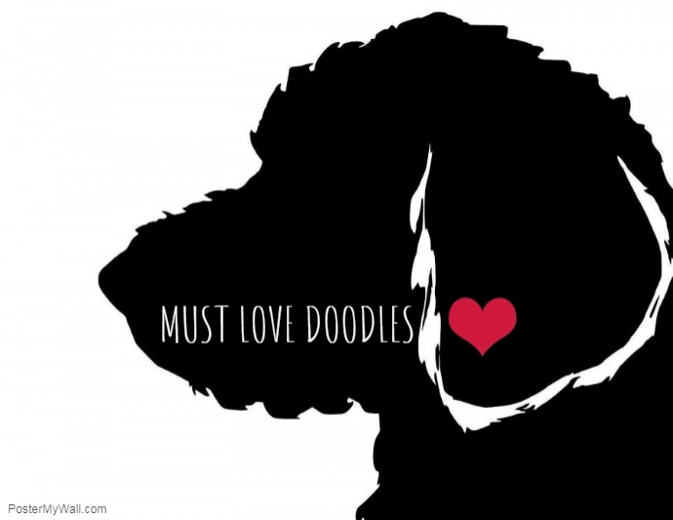

Email: mustlovedoodlesnc@gmail.com www.mustlovedoodles.com

PURCHASE AGREEMENT/HEALTH WARRANTY

Thank you for deciding to purchase one of our puppies. We want to make this a stress free enjoyable experience for you. Please feel free to email or call me with any questions or concerns that you might have along the way. We will keep you up to date with information about your puppy as it grows until it is time for your puppy to go to its new home. This contract is written for the protection of both the breeder and the buyer. However, it is primarily written to protect the health and general well-being of the puppy.

On this day the ____ of ______ 2020, the following agreement has been entered into between the following persons: Robin Norman, Must Love Doodles, hereafter referred to as seller and the following person, hereafter referred to as buyer.

Buyer Contact Info: ______________________________(Name)
______________________________(Address)
______________________________
______________________________(Phone number)
______________________________ (Email)

The Seller hereby sells to the Buyer a male/female, F1b ____________, whelped on____________, and referred to by the name(or collar color) of_____________________________________.

The consideration of this sale shall be the total sum of $_____.00, plus terms and consideration hereinafter set forth. All applicable terms and conditions will apply.

The Seller accepts a non-refundable deposit via the form of cash, money order or check, of $400.00 (along with signed deposit contract) toward the purchase of the identified puppy. The CASH balance of $_______ will be due upon receipt of the puppy by the buyer. Puppy will need to be picked up by buyer at 10 weeks of age (within 5 business days from notification of pup’s availability),or deposit will be forfeited unless prior arrangements have been made.

TERMS AND CONDITIONS: Warranty and 24 Month Health Guarantee

1. At the time of delivery, the Breeder guarantees your puppy is in good health, and has received age appropriate vaccinations as well as deworming. Purchaser will be provided with all health records of puppy while puppy was in the care of Breeder.
2. At the time of delivery, Purchaser must take the puppy to a licensed veterinarian for an initial health exam within 5 days (excluding Sunday). If puppy is purchased on a Sunday, the 5 day period will begin on the 1st Monday after purchase. At this initial visit, if puppy is found to have a serious health condition, the Seller must be notified and the puppy must be returned immediately at the Buyer’s expense, if a full refund is requested provided the puppy has not been injured or neglected. This health guarantee becomes null and void if Purchaser has not taken the puppy into a licensed veterinarian within 5 days of purchasing puppy. This health guarantee becomes null and void if Buyer decides to keep puppy after it is found to have a serious health condition.
3. If the Purchaser’s veterinarian identifies a chronic or serious health problem with the puppy within 24 months of the date of purchase, proof of medical exam and diagnosis by the veterinarian must be presented to Breeder in order for a 50% refund of the purchase price to be given. Breeder reserves the right to have a second opinion by a veterinarian of Breeder’s choice, at Breeder’s expense. If puppy should die or be euthanized due to a suspected congenital defect, an autopsy/necropsy must be performed at the purchaser’s expense. This health guarantee becomes null and void when the Purchaser accepts a 50% refund. Seller has 90 days from the date of confirmed diagnosis to distribute refund.

(________Buyer has read and understands this statement)

4. It is the Purchaser’s responsibility to provide due care, and not expose unprotected puppy whose vaccines have not yet fully taken effect to contagious situations. The Seller is not responsible for any contagious diseases the puppy may contract once it has left our care. This guarantee will not cover, including but not limited to: Parasites (internal or external), Coccidia, Giardia, Leptospirosis, Parvovirus, Kennel Cough, Distemper, Rabies and Corona. Seller makes no guarantee regarding loss of the dog due to accidental death, theft, sickness, etc., or any other loss beyond the Seller’s control.

5. All of our puppies are sold as PETS ONLY with a spay/neuter contract. All puppies must be spayed/neutered by one year of age and documentation must be sent to us verifying the procedure. In purchasing a puppy from us, you agree to enter a spay/neuter contract agreement. This means that you agree to spay/neuter the pup before one year (12 months) of age.
It is very important for breeding dogs to have a documented history of many generations of their ancestor's health, temperament, and confirmation. We as breeders hand select which offspring we will use to breed based on the breed standards and temperaments. Breeding stock must be of appropriate age/weight, health, temperament and promote the same in their future offspring. In order to guarantee the success of the breed, it is crucial that only the best adult dogs be bred, resulting in exceptional puppies that will carry on the breed standards.

6. The seller guarantees the puppy for 2 years (from purchase) against hip dysplasia providing the dog is at an ideal weight; has been fed only TLC dog food (proper nutrition is key to preventing excessive growth), has not been exposed to negative environmental factors regularly (steps, slick flooring, etc.) and has only been exposed to age appropriate exercise. Reasonable precautions have been taken to prevent this puppy from acquiring hereditary defects of the hips, eyes and heart. Should said puppy be diagnosed by a board certified licensed specialist as being affected by a hereditary defect, and verified by another board certified licensed specialist upon the sellers discretion, the Seller will reimburse 50% of the purchase price within 90 days of seller’s verification of condition.

7. Puppies can on occasion have allergic reactions to vaccinations. Health issues that are the result of vaccinations including: sarcomas, tumors, auto-immune disorders, thyroid disease, allergies & seizures that occur following an administered vaccine will not be covered under the genetic portion of this warranty. Leptosporosis vaccine has a known history of causing allergic reactions that can sometimes trigger auto-immune reactions in puppies. This contract becomes void if Leptosporosis vaccine is given before 1 year of age. Buyer also agrees to not have the rabies vaccine administered at the same time as any other vaccine, but to allow at minimum three weeks from the last vaccine date before having rabies vaccine administered to dog. With this said, the seller will not be liable in any manner for illness or injury that occurs or may be triggered by a vaccine of any nature. We highly recommend that this be discussed with your veterinarian before giving any vaccines.

(________Buyer has read and understands this statement)

Buyer also agrees:
1. The puppy will be given proper medical care including, but not limited to vaccinations and annual boosters, regular deworming, heart worm preventative, adequate and proper shade/housing in a fenced yard or kennel for limited amounts of time, but will mainly reside inside the home, and puppy will not be “tied out”.

2. This puppy will never be surrendered to any humane society, animal rescue group or animal shelter. Buyer will contact seller to offer puppy back to seller, at no charge, should buyer become unable to properly care for said puppy.

3. This contract is non-transferable and becomes null and void if the dog is sold.

Other Considerations:

It is impossible to accurately determine the exact adult size, coat color and /or type of coat or shedding of any puppy sold. Therefore we do not give any size, color or type of coat guarantee. Size, coat color, and type of your puppy/dogs coats is estimated based on bloodline, age, bone structure, size of the puppy, and our experience with how the puppies have matured in the past.

We do our very best to have healthy, happy, well socialized puppies. We hope you will continue this as you feed quality dog food, keep current with shots and deworming, place him/her on heartworm/flea preventative and most of all enjoy your puppy/dog and let him/her enjoy their time being with you. Should you the buyer have any questions about your puppy as he/she grows (ages), we will always be available to answer your questions.

Buyer:________________________________________________Date___________

Seller:________________________________________________Date___________

