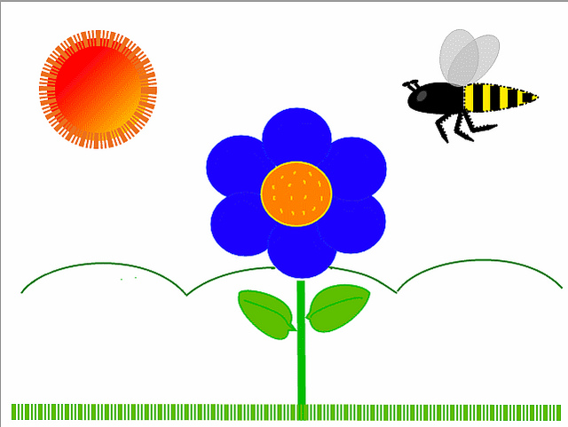
MAY 2018
Classroom News

Ms. Evelyn – Music

I can’t believe the end of school is almost here. The children and I have had such a wonderful time in music class. We have learned many new songs. We have danced, marched, skipped and hopped. We have learned to listen to songs and follow the directions. The older children got to see a video that helped them learn about the instruments of the orchestra. Kindergarten learned about children in Africa and what type of instruments they play. But everyone always has the most fun playing instruments.
Please plan to attend our End of Year & Graduation Programs on Thursday May 24, in the Parish Hall. The younger classes, 2’s & 3’s, will be presenting their program at 12:30. Then later that evening at 6:30 we will have Pre-k and Kindergarten graduation. Thank you for sharing your precious child with me. I hope you all have a glorious summer.
I will sing to the Lord, for he has been good to me. Psalm 13:6

Ms. Heather – Primary

I cannot believe the school year is almost done. It feels like just a couple weeks ago I was coming in as the new teacher for your kiddos. What a blessing it has been to be their teacher. It has been wonderful to see them grow!

In the last few weeks of school we will review our colors and shapes. Learn about Peace, the fruit of the spirit for May, and also celebrate mothers and fathers. To finish it out, we will have a water day and graduation! The month is going to be filled with so much fun!!!

I hope that your child has enjoyed their time with me and their year at Grace. My time with them has been amazing!! Prayers your summer is filled with fun and excitement!!! Happy 3rd Birthday to Charlie in August!!!

Ms. Andrea – Primary

How is it that we only have one month left before the school year is over? I guess it really is true that- “Time flies when you are having fun!” This year is filled with so many good memories for me. It has been my absolute pleasure to care for your children over the last 9 months. Watching them grow and learn has been a true joy.
I know for many of you- the first few days/ weeks were challenging - but isn’t it amazing to see how much things have changed!? Goodbye hugs, smiles, kisses and waves at drop off instead of sad faces and tears.

This month we will learn about PEACE, our Fruit of the Spirit. We will review all of our colors and shapes. We will celebrate our mothers and fathers and shower them with a few special treats. I am especially looking forward to water day and our special Friendship Fruit Salad.

I hope that your child had fun this year. I hope they were challenged. I hope they experienced new things, but most importantly, I hope they felt smart, loved and important! Let’s make the most of our last month together.

Happy summer birthday to Joshua on July 28th!

Proverbs 22:6
Start children off on the way they should go, and even when they are old they will not turn from it.

Ms. Lisa– 3/4’s

Happy birthday blessings to Willa on June 21, Titus on June 27, Casey Lynn on July 5, and Lucy on August 17!

May is here, and our beach theme is very fitting! Our fruit of the spirit is peace, and we will be building our peacemaking skills, including cooperation and resolving conflict. The children will explore math objectives (shapes, colors, and patterns) through crafts and projects. We will experience weekly story baskets, and the children will continue tracing and writing their names and letters. Our weekly yoga helps develop our flexibility, balance, and mental focus. We will put the finishing touches on their "Eat a Rainbow" booklets, which help them explore the colors we have learned this year as well as healthy eating and nutrition. Thank you for sharing your precious children with me this year--they are each a special blessing!

Ms. Debra – 3/4’s

Well we made it -- the last month of school!!!!! We finished up our alphabet and will be doing review of all letters & numbers. I will be sending home a binder that has all work that was being completed throughout the school year. We will be having an end of the year party; more information will be coming soon. The kids have been working hard on their song for graduation; hope to see you there.
Thank you for trusting me with your child. I have enjoyed spending this year with them. Have a wonderful and safe summer.
Happy Birthday to Julia this week, and happy summer birthdays to Joey & Wyatt!

Ms. Margaret W. – Pre K

My goodness this year has flown by! I have so enjoyed your children and the bond our class has created. They have all grown up in so many ways!
This month we will finish learning all of our capital letters---we're almost done! We will also continue to share wonderful stories--both fiction and non-fiction. We will try our hand at using context clues to understand what is happening in a story without being directly told. Summarizing is another skill we continue to practice. Concepts of time will be a skill we talk about this month too---morning, afternoon, night, yesterday, today, and tomorrow. We will learn about gardening as well--how plants grow and their needs. We may even have a surprise theme later in May.
There's lots of fun left to be had this month! I love each one of these babies so much!
Happy birthday to Ian Willhite on August 1! Big 5 yay!!

Ms. Margaret C. – Pre K

This just does not seem possible that we are in the month of May. I cannot believe how fast this year has gone, and we are planning our graduation program. Each day is an adventure in learning for the kids and for me. The progress has been tremendous in many different aspects. The social skills, the learning skills, the fine motor and gross motor development has been phenomenal. We had a whirlwind April that was full of fun and adventure. Our biggest event was our mystery beans and our Easter egg hunt and family day together. I must admit that is the best day ever to see all the families and children together laughing, eating, and having fun. An event we are looking forward to in May is hunting for dinosaur eggs! Once they are found, the children will use their fine motor (and some gross motor) skills to crack them open to see what is inside. It will be a fun activity! Also in May we will be finishing up things in our letter writing, talking about summer, and just enjoying our closing weeks together with fun. I have learned so much from this class and want to thank you for your help and support. I have fallen in love with each little boy and girl in my class.
Happy birthday blessings this month to Emmett (May 31)!

Ms. Diane– Pre K

I cannot believe the end of the year is almost here! This year has been such an exciting, educational experience for all of us! I love to ask our students what their favorite activity has been over the year. Here are some of their answers… playing on the playground with friends, center time, Art, spending time with each other, dinosaurs, Play-Doh, Easter at the park, and of course, watching the caterpillars turn into butterflies! I have loved getting to know your children this year. They have each brought something different to the dynamics of our class, and it has been so amazing to see them grow!

These last few weeks in May, we will be learning all about plants and what they need to grow, reviewing letters and numbers, and anticipating summer fun! Watch for more information to come about our Water Day May 23rd and End of Year Program May 24th. Thank you for sharing your children with me this year! I wish everyone a safe and happy summer!

Happy Birthday to…

Dylan on May 4
Victoria on June 24
Sarah on July 25
Kaden on August 12

Ms. Ellen – Kindergarten
Ms. Ellen’s Kindergarten room is going to be filled again with activity during the month of May. Like all the bees in the area, there is a new buzz in the classroom as we finish up a number of items for this class year. During our reading block we will finish our exploration reading in our emergent readers that focused on short i/o/u vowels. Math skills focus will be a continuation of our learning to use a sliding number line to add and subtract simple math problems. Other math topics will include telling time to the half hour, counting money with pennies, nickels, dimes, reviewing number words and using a hundreds chart to find “mystery numbers”. The class is excited because they can all now count up to 100, either by 5’s, 10’s or 1’s. We will spend our social studies block learning about having a safe summer and animals that are found at the beach. There is also a unit dedicated to summer plants and insects. Overall, April saw a lot of new skills learned, and we plan more for May. There is rising excitement and anticipation of Kindergarten graduation in May. I want to say a special thank you to all of the parents this year that helped make their child’s learning experience a success. I am also appreciative of all the parent support for our class this year. Happy birthday to Elina on May 4th, and a special shout out for my students that will celebrate their birthday during the summer months: Cole Adams, June 23; Hudson Bovard, August 7; Shepherd Sauter August 7. Hope you have a super celebration. Thank you all so much. Have a safe and happy summer.

May Birthday Wishes Go To:

Julia Everton – 3
Dylan Arning – 4
Elina Perry – 4
Trent Snyder – 4
Ms. Debra – 8
Addie Oldham – 22
Emmett Grady – 31
Ms. Margaret C. – 31

June Birthday Wishes Go To:

Ms. Lisa – 9
Willa Sauter – 21
Victoria Shumate –24
Joseph Tancrator – 26
Titus Dunson – 27
Cole Adams – 28

July Birthday Wishes Go To:

Casey Hayner-Rhymes – 5
Brayden Gao – 18
Sarah Smith – 25
Joshua Wueste – 28

August Birthday Wishes Go To:

Ian Willhite – 1
Hudson Bovard – 7
Shepherd Sauter – 7
Charlie Bovard – 11
Kaden Oldham – 12
Lucy Castro – 17
Ms. Heather – 18

