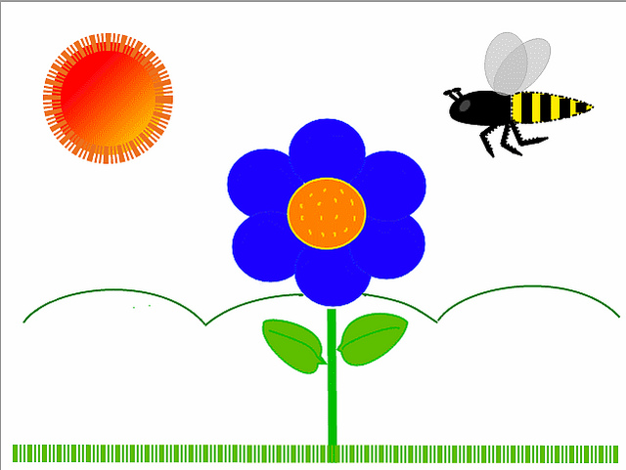
MAY 2022
Classroom News

Ms. Evelyn – Music

I can’t believe the end of school is almost here. The children and I have had such a wonderful time in music class. We have learned many new songs. We have danced, marched, skipped, and hopped. We have learned to listen to songs and follow the directions. Kindergarten watched a video that helped them learn about the instruments of a symphony orchestra. They also learned about children in Africa and what type of instruments they play. But everyone always has the most fun playing our school instruments.
Please plan to attend our End of Year & Graduation Programs on Thursday May 19. The younger classes [2’s & 3’s] will be presenting their program at 11:00 a.m. in the church parish hall. Then later that evening at 6:30 p.m. we will have Pre-K 4’s and Kindergarten graduation. Thank you all for sharing your precious child with me. I hope you all have a fun-tastic summer.
I will sing to the Lord, for he has been good to me. Psalm 13:6

Ms. Andrea – Primary

How is it that we only have one month left before the school year is over? I guess it really is true that “Time flies when you’re having fun.” This year has been filled with so many good memories for me. It has been my absolute pleasure to care for your children over the last nine months. Watching them grow and learn has been a true joy.
I know for many of you the first few days and weeks were challenging, but isn’t it amazing to see how much things have changed? Goodbye hugs, smiles, kisses and waves at drop off instead of sad faces and tears.
This month we will learn about peace, our fruit of the spirit. We will review all of our colors and shapes. We will celebrate our mothers and fathers and shower them with a few special treats. I am especially looking forward to our special friendship fruit salad, and our end of year program.
I hope that your child had fun this year. I hope they were challenged. I hope they experienced new things, but most importantly, I hope they felt smart, loved and important! Let’s make the most of our last month together- and as Dr. Seuss says, “Don’t cry because it’s over; smile because it happened.”
Happy summer birthday to Zane on June 7th!

Ms. Debra - Pre-K 3’s

I can't believe it's May! The kids have done a great job this year and have grown up so much.
Parent teacher conferences will be on May 11th; if you haven't signed up and would like to, I still have times available. Our end of year celebration will be on May 19th @ 11am. And we'll have our end of year class party on the 18th. I hope everyone has a wonderful and safe summer.

Happy birthday Isla- July 17th

Ms. Jacqueline – Pre-K 3’s

Wow! I cannot believe we are already to the month of MAY! Summer is just around the corner!!! We have so many fun things planned this month! Mr. Dabbs will be here May 4th for individual and group pictures. My end of year conferences will be held on May 11th. Please see the email for sign up times. Our Bowl-A-Thon is Friday, May 13th! I hope to see many smiling faces there! Splash day will be held on the 18th. More details to come about that! Finally, May 19th is our last day and our end of the year program! Whew!! What a busy and FUN month! We are planning to have fun with plants, alphabet review, science, cooking and art! Our fruit of the spirit this month is Peace. We will be celebrating our summer birthdays during chapel this month. June birthdays will be celebrated on May 3rd, July birthday will be celebrated on May 10th, and August birthdays will be celebrated on May 17th. Wishing a very Happy Birthday to Kalvin (July 24th), Liam (August 27th) and Caleb (August 29th)!!!! I am looking forward to a super fun last month with your wonderful children!

Ms. Kim – Pre-K 4’s

It is so hard to believe that we are in our last few weeks of school. Your children have grown so much this year and it has been a joy to be a part of their lives. They have all worked so hard as we have worked our way through all 26 letters of the alphabet, and I am so proud of them. We will be working on our end of year evaluations during the first week of May, with conferences available on May 10th. We will spend the rest of May discovering Animal Habitats, learning about the water cycle and simply having some pre-summer fun!
We have three special Birthdays to celebrate this month, Ryan and Evelyn will both be 5 in May and Emma will be 5 in June; so a BIG Happy Birthday to our friends!

Ms. Kara – Pre-K 4’s

This month is sure to go by fast! We will continue to review the alphabet and the numbers 1- 20. May will also be about plants and seeds. I have some cool science projects lined up for this! I also have some ladybug larvae for the students to watch metamorphose into ladybugs.
I am excited to see everyone at the bowling event! Splash day will be a blast for sure!

We will celebrate Azby turning 5 on May 10th! On May 3rd we will celebrate our June birthdays, Kurt and Nettie. May 10th we will celebrate Charlotte turning 5 on July 20th. Riley will be celebrated on May 17th for his August birthday.
Ms. Ellen – Kindergarten
Miss Ellen’s Kindergarten classroom is going to be filled again with activity during the month of May. Like all the bees in the area, there is a new buzz in our classroom as we finish up a number of items for this class year. During our reading block we will finish our exploration reading in our emergent readers that focused on short i/o/u vowels. Our math skills focus will be a continuation of our learning to use a sliding number line to add and subtract simple math problems. Other math topics will include telling time to the half hour, counting money with pennies, nickels, dimes, reviewing number words and using a hundreds chart to find “mystery numbers”. The class is excited because they can all now count up to 100, either by 5’s, 10’s or 1’s. We will spend our social studies block learning about having a safe summer and animals that are found at the beach. There is also a unit dedicated to summer plants and insects. Overall April saw a lot of new skills learned in our classroom experience, and we plan more for May. There is rising excitement and anticipation of Kindergarten graduation. I would just like to take this time to say THANK YOU for such an amazing and fun year. I could not have asked for a better group of students and parents than this group. We laughed, we sang, we explored, we created and we grew! I am so glad that I was given the opportunity to get to know not only your child but also you, the parents. The support of parents is truly what makes education such an amazing and wonderful place to spend my days. I will remember this group of students forever. Their awesome personalities and their sharp minds will take them to places they can only dream of. Go now and enjoy your summer. Spend time with your future kindergartener/first grader and keep up the great work. A final message to always remember: “Never, ever wrinkle anyone’s heart!” May birthday shout-outs go to Franco – May 1’st, Abel – May 22’nd. Summer birthday shout-outs go to Grayson – June 28’th, Charlotte – June 29’th, Hayes – July 2’nd, Charlie – July 21’st, and Owen – August 10’th.

May Birthday Wishes Go To:
Franco Azzaretto – 1
Ms. Debra – 8
Azby Jorgensen – 10
Evelyn Costello – 11
Lincoln Gillespie – 11
Ryan Kovalcik – 19
Abel Granados – 22
Ms. Margaret – 31

June Birthday Wishes Go To:
Kurt Snyder – 2
Zane Huss – 7
Emma Hubert – 8
Nettie Watts –24
Grayson Rickey – 28
Charlotte Byars – 29

July Birthday Wishes Go To:
Hayes Hauber -2
Isla Pelton – 17
Charlotte Hartman – 20
Charlotte Luna – 21
Kalvin Ketterman – 24

August Birthday Wishes Go To:
Riley Spruiell – 1
Owen Painter – 10
Ms. Jacqueline – 18
Liam Serrano – 27
Caleb Medina – 29

