Sagecreek Bible Church
Worksheet
“Daniel Chapter 11 History Overlay”

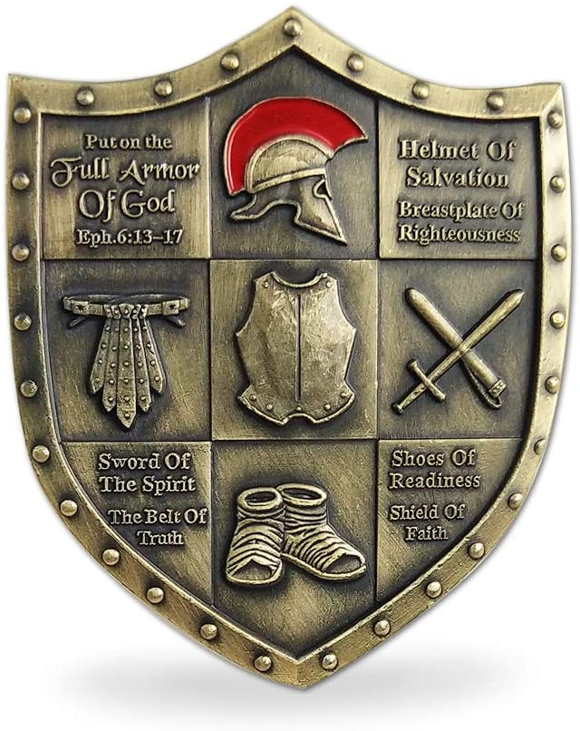

22 July 2022

Daniel Chapter 11:1-4 - Under Persian rule
Daniel 11:1 “Also in the first year of Darius the Mede, I, even I, stood up to confirm and strengthen him.) ² And now I will tell you the truth: Behold, three more kings will arise in Persia, and the fourth shall be far richer than them all; by his strength, through his riches, he shall stir up all against the realm of Greece. ³ Then a mighty king shall arise, who shall rule with great dominion, and do according to his will. ⁴ And when he has arisen, his kingdom shall be broken up and divided toward the four winds of heaven, but not among his posterity nor according to his dominion with which he ruled; for his kingdom shall be uprooted, even for others besides these.
The first of these timelines summarizes the rulers of the Persian empire. To the left side in the graphic is the verse in Daniel 11:1-45 that is referenced. The horizontal triangle points to the name of the Persian ruler who fulfilled that verse. Each Persian ruler is in a light green box. Other information is included further to the right, including the dates that king ruled, and any relevant notes as regards to what has been revealed in the book of Daniel. At the bottom of this graphic is the reference to the transition from the Persian empire to the Grecian empire. Those rulers are in light blue boxes.
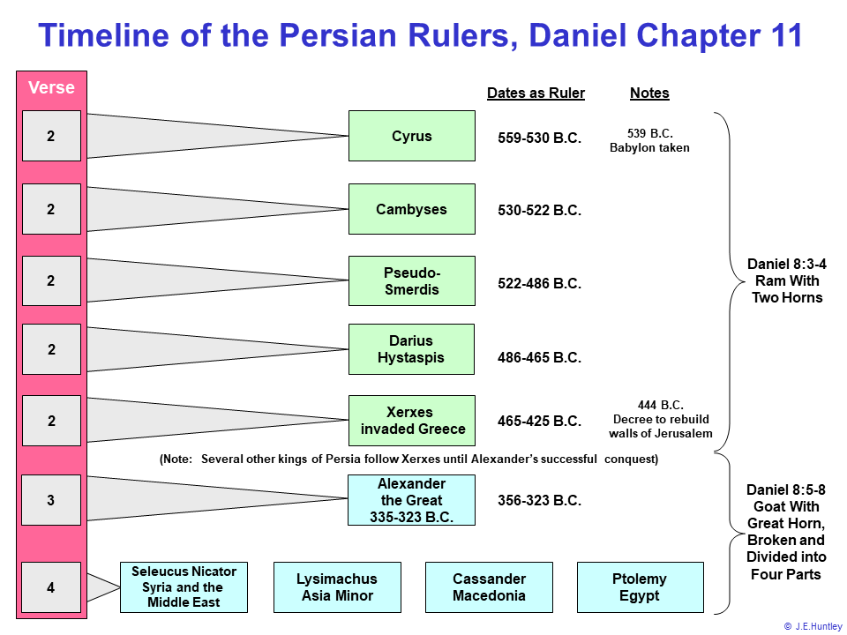

Daniel Chapter 11:4-35 - Under Grecian rule
During the next two centuries following the death of Alexander the Great, his kingdom was split into four warring factions. The following table is the similar format as the one above, with the verse referenced to the left, and the remaining part of the table divided into four columns for each kingdom. Daniel 11:4-35 gives a prophetic list of events focusing mostly on two kingdoms; the northern kingdom under the rule of the Seleucid rulers, and the southern kingdom under the rule of the Ptolemaic rulers. This is also reflected in the following table, where the kings are named for each kingdom, and their interaction in the verse is cited to the left in each row. The arrows reflect the influence of one person upon another. For example, in the row describing Daniel 11:6, Ptolemy II Philadelphus gave his daughter Bernice for marriage to Antiochus II Theos to form an alliance with him. Though names are not given in these series of prophecies but rather events are specified, it is clear from the historical record that these names and places exactly fulfill the prophecies written by Daniel.
These passages of Daniel are exciting to compare against the historical record. To actually map the historical record over these verses or read or hear the account that others have studied, is truly remarkable. In preparation for our Daniel Chapter 11 study, I have consulted resources by Dr. J Vernon McGee, John F. Walvoord, and others.
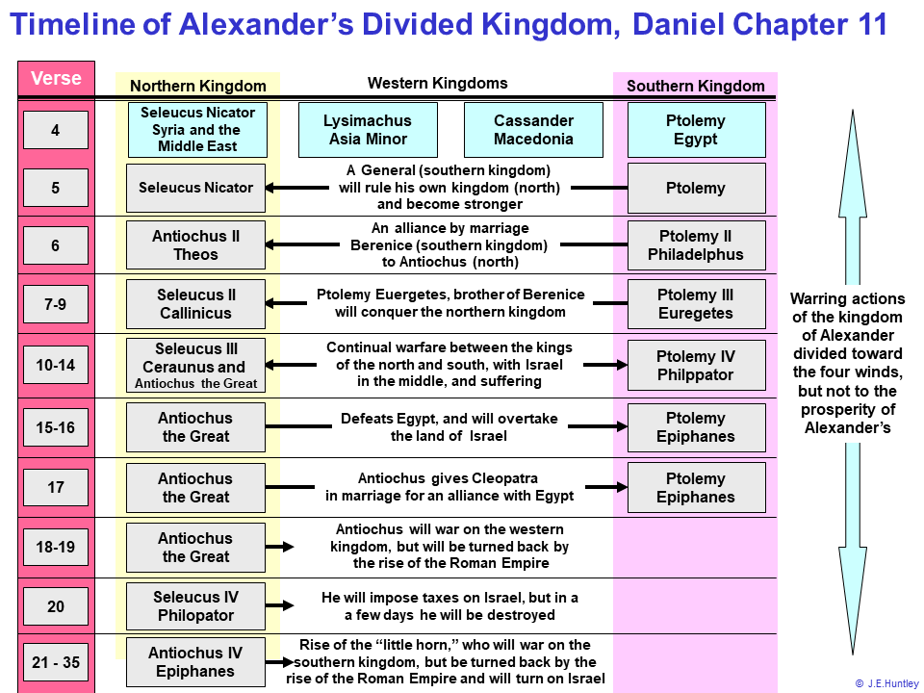

The timeline for Daniel 11
The focus of this timeline is in the center of the graphic on the yellow oval with one arrow to the left, the other to the right. These arrows illustrate two groups of verses in Daniel 11:1-45, and the timeframe in which they were or will be fulfilled at the time of this writing. For Daniel 11:2-35 the yellow arrow points left toward the section on Daniel 8:1-27 where the discussion on the little horn was presented. The arrow on the right represents Daniel 11:36-43 and the discussion on the little horn in Daniel 7:1-28, which is the Antichrist.

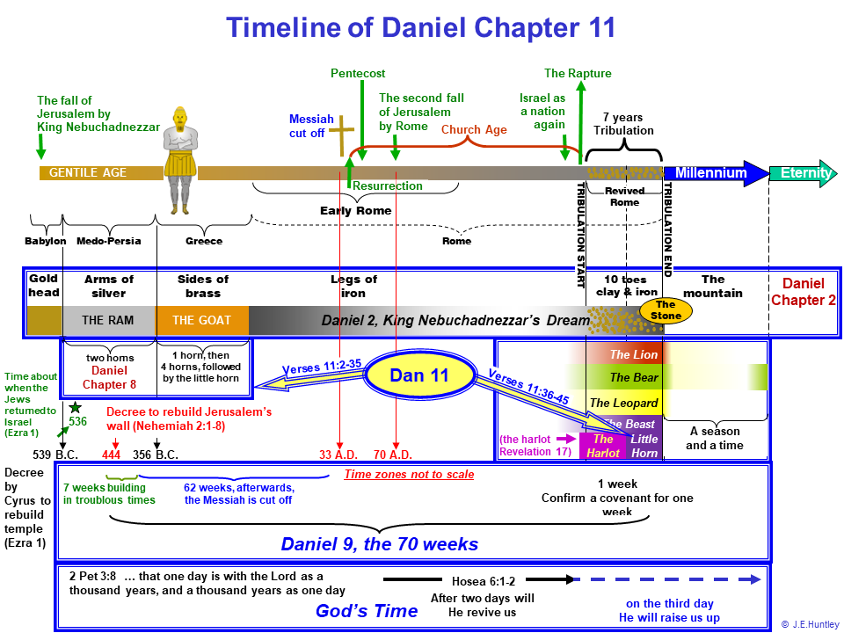

The Antichrist during the seven years of tribulation (the little horn in Daniel 7:8)
The following charts amplify Daniel 11:1-45 and the passages concerning the Antichrist and his invasion into Israel during the latter half of the tribulation during the middle part of the seven years of tribulation.
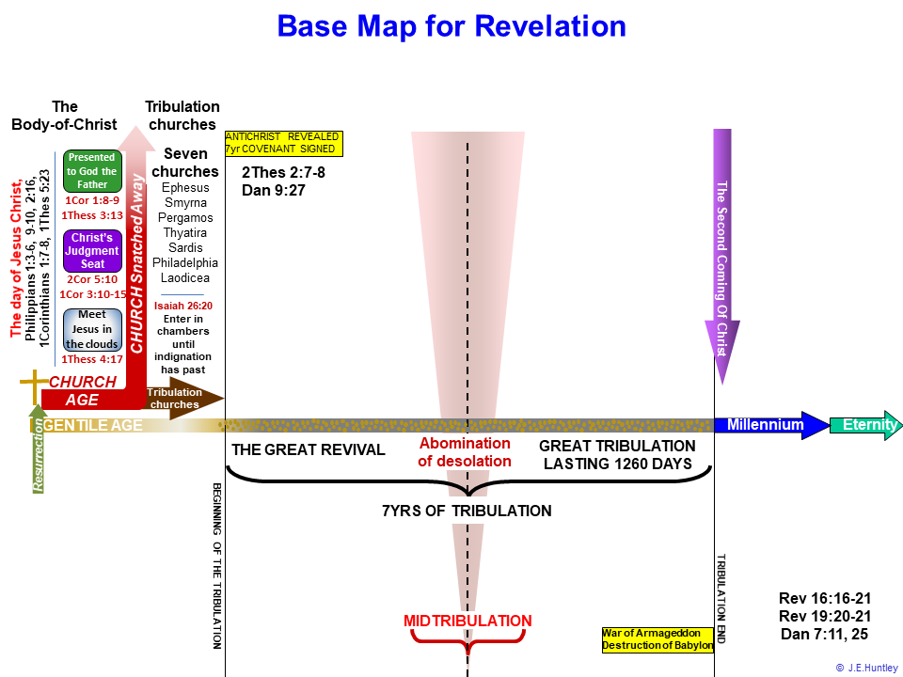
With the above chart as a backdrop that amplifies the seven years of the tribulation, it is instructive to overlay the events concerning the Antichrist described in the latter verses for Daniel 11:36-45. At this juncture, it is important to get a sense of what has been revealed to Daniel so far:
- Daniel 2:1-49 provided the synoptic view of the Gentile nations rule over Jerusalem
- Daniel 7:1-28 provides the view of the end times that move into the tribulation period where the world suffers under the judgment of God and the destruction of the Antichrist
- Daniel 8:1-27 gives the prophetic view (from Daniel’s perspective) of Persian empire, then conquered by the Alexander the Great, whose empire was divided into the four pieces, with Antiochus Epiphanes being called out as a type of the future Antichrist during the seven years of tribulation
- Daniel 9:1-27 provides in just a few verses, the future of the nation of Israel according to the prophesy of 70 weeks
- Daniel 10:1-21 through Daniel 11:1-45 gives a series of concise and precise statements that were future relative to Daniel, which confirms the word of God as true
As evidenced in these forgoing chapters, as the reader progresses through the book of Daniel, greater detail and information build upon the previous chapters. Reading Daniel 11:36-45, the true form of the vile nature of the Antichrist become clear. Antiochus Epiphanes is a forerunner or serves as a type of the Antichrist who is yet to arrive on the world scene at the time of this writing. A transition is evident in Daniel from the times of Antiochus Epiphanes in Daniel 11:21-35 to the Antichrist of the future seven years of tribulation as described in Daniel 9:27. The following are the characteristics of the Antichrist shown in Daniel 11:1-45.
- Daniel 11:36
  - Do his own will
  - Magnify himself above every ruler
  - Blaspheme God
  - He will prosper until the end of the tribulation
- Daniel 11:37
  - He will not regard the God of his fathers
  - The desire of women (birthing Christ, (Genesis 3:15)
  - Not regard any god, but declare himself as god
- Daniel 11:38
  - He will promote military strength within his own estate
  - He will honor Satan with his riches, Deuteronomy 32:15-18, Revelation 13:4-5
- Daniel 11:39
  - He will reward those of other realms who follow him by:
    - Acknowledgement
    - Increased wealth and power
    - Ruling over many and divide lands
Antiochus Epiphanes helps to depict the character of the future Antichrist, who will be revealed during the seven years of tribulation. The events leading up to the invasion of Israel by the Antichrist and his forces can be better understood, as seen in the remaining verses in Daniel 11:1-45. Daniel 11:40 indicates that a significant battle will take place in which the forces of the north and south of Jerusalem will array themselves in battle against the Antichrist. The reason for the Antichrist and his forces even being involved with Israel at that time is seen in Daniel 9:27, where there will be a covenant between the government(s) that the Antichrist represent with Israel for seven years, and which defines the beginning of the seven years of the tribulation. However, at the midpoint of this period, the Antichrist will cause the cessation of the sacrificial system and offerings to the Lord on the temple mount, and in its place, he will erect his own image to be worshiped, Matthew 24:15. This worship of the Antichrist will continue for the remaining 3½ years of the tribulation period.
Daniel 11:40 indicates that many countries that are part of this confederation who will fight against the Antichrist, but none are explicitly listed. Based on the seven-year covenant entered into between the Israel and the government represented by the Antichrist, this push is actually an invasion into Israel. Because of the existence of this covenant, any attack on Israel would be an attack on the Antichrist's sovereignty. It will be a ferocious battle.
These confederated countries will have ships in the Mediterranean Sea to oppose the Antichrist, and all their forces will come upon him suddenly, which may be Syria and Egypt. As shown in the following timeline, the solid yellow object begins just prior to the mid-point for the seven years of tribulation and ends with the battle of Armageddon and the return of the Lord Jesus Christ with all His saints, Revelation 19:1-21. Showing the invasion just prior to the mid-tribulation point will not violate the other passages concerning the erection of the image of the Antichrist in the temple used by the Jews during the tribulation. The Antichrist will first have to fight the war, and occupy Israel, then kill the two witnesses, Revelation 11:1-19, and after that time has elapsed, then the events revealed in Revelation 13:1-19 will occur concerning the image of the Antichrist. Daniel 11:1-45 reveals that about the mid-tribulation point, the Antichrist’s forces will enter and occupy Israel. However, for some reason Antichrist will not invade the ancient countries of Moab, Edom, and Ammon, or modern-day Jordan, but he will invade and conquer Egypt, and spoil all her riches from since antiquity. Libya and Ethiopia are on the slate to be taken next also, but news from the east stop the Antichrist from pursuing after them.
The reports from the east that trouble the Antichrist will describe the westward march of the 200,000,000-man army toward the Antichrist's position and his possessions. This massive army is a result of the sixth trumpet that is blown in judgment during the first half of the tribulation, and the four demonic angels released. They had been prepared for the hour, day, month, and year. In other words, they have a divine appointment to do battle with the Antichrist, and thereby set the stage for the Lord's return and the total destruction of the Antichrist and his forces. This 200,000,000-man army will be solely responsible for the deaths of 1/3 of mankind. The speculation is that this army will originate in China, as they are the only country in the world today to muster an army of this magnitude, Revelation 9:13-21. The sixth bowl judgment dries up the Euphrates River, which prepares the way for the kings from the east and facilitate their crossing, Revelation 16:12. This is the time when Satan, the Antichrist, and false prophet gather the kingdoms of the world to meet this threat and do battle at Armageddon Revelation 16:13-16.
This is described in Daniel 11:45, where all these events lead up to the Antichrist invading Israel and establishing a permanent presence in Jerusalem. Again, this may occur prior to, or during the mid-tribulation, when the covenant with Israel is broken, and the image of the beast is erected within the holy place in the temple, Daniel 9:27, Revelation 13:11-18. The Antichrist will come to his end, and none shall help him, Revelation 19:19-21, Daniel 7:11-12, and Daniel 7:21-28.

