Sagecreek Bible Church
Worksheet – Heavenly Rewards

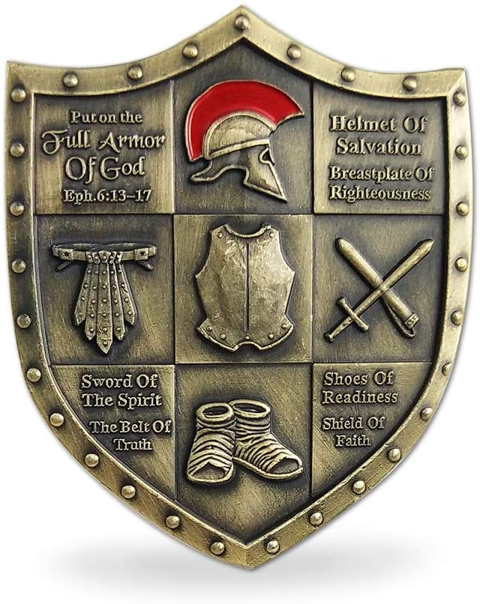

24 April 2020
Judgment Seat of Christ and Eternal Rewards – Study Guide

- Judgment Seat of Christ
What do you conclude about the inevitability of our appearance before the judgment seat of Christ from 2 Corinthians 5:9-10?
How about Romans 14:10-12?
For further study, see (1 Corinthians 4:1-5; 9:24-27; Philippians 3:8-14, 1 Thessalonians 2:19; 2 Timothy 4:8; James 1:12; 1 Peter 5:4; Revelation 2:10; 3:11; 4:4, 10).

What does 1 Corinthians 4:5 tell us about the time of the judgement of believers?
Reminder: the judgment seat of Christ is not a judgment of the believer for sin. See Romans 4:25. What does Psalm 103:12 tell us about our actual sins?
How about Hebrews 10:17?
How about Jeremiah 31:33-34?
The judgment seat of Christ relates to the believer’s works. The Greek word translated, “judgment seat” is the word, bema. What was the intent of this bema seat?
What do Philippians 3:14 and 1 Corinthians 9:24, 26, 27 tell us we need to meet the demands of this judgment for our works?
One can observe from 1 Corinthians 9:24-27, that there are three elements characteristic of a winning attitude for a believer who would win the prize: 1) clarity of purpose (24); 2) self-control (25); and 3) persevering bodily discipline.
What is the purpose spoken of in Philippians 3:8?
What does 1 Corinthians 9:25-27 tell us about exercising self-control and personal discipline?
What does 1 Timothy 4:7-8 tell us about disciplining our bodies and why is that important?
Study 1 Corinthians 3:5-17. Seek out answers to these questions: 1) What is the work? 2) Where does the work occur? and 3) Who are the workmen?
What does 1 Corinthians 3:10, 16-17, tell us about where our work is to take place?

- Rewards
How do you view the subject of eternal rewards? (Are you comfortable that you have enough knowledge about this subject to be confident you understand God’s criteria?)
Here are some of the verses early Christians would have read about this subject that made them so adamant in their stand on it.

Ruth 2:12 (What does this verse say about God’s view of rewards?)
2 Chronicles 15:7 (What is Asa told will occur if he worships as he should?)
Psalm 58:11 (What does this verse say about God’s view of rewards?)
Revelation 22:12 (What does this verse say about God’s view of rewards?)
(For further reference: Jeremiah 31:16; Matthew 5:11-12; Matthew 16:27; Mark 9:41; Colossians 2:18; Hebrews 6:10; Mark 10:29-30))

What does 1 Corinthians 3:3 and Ephesians 4:1-3 tell us about sources of losing our rewards?
We want to hear Him say: Matt 25:23 His lord said unto him, Well done, good and faithful servant; thou hast been faithful over a few things, I will make thee ruler over many things: enter thou into the joy of thy lord.

Study these rewards (crowns) spoken to in the Bible.
First, there is the Victor’s Crown - 1 Corinthians 9:25-27. (What is the criteria for this crown?)
See Titus 2:11-13. What does this passage express about this crown?
Second, there is the crown of rejoicing - 1 Thessalonians 2:19. (What is the criteria for this crown?)
See 1 Corinthians 3:6. What does this passage express about this crown?
Third, there is the crown of righteousness - 2 Timothy 4:8. (What is the criteria for this crown?)
Fourth, there is the crown of life - James 1:12; Revelation 2:10. (What is the criteria for this crown?)
See 2 Timothy 3:12. What does this passage express about this crown?
Fifth, there is the Crown of Glory - 1 Peter 5:1-4. (What is the criteria for this crown?)

Charles Spurgeon said this – “Rewards, not of debt, but of grace, shall be given to the most obscure and unknown of you, who for his sake have sought to teach little children or to reclaim the adult who had fallen into sin. Take courage – your work of faith and labor of love are not in vain in the Lord, and will do wonders yet to the praise of his grace.” What conclusions do you draw from his words?
See Revelation 4:10-11. What are we going to do with these crowns?

Questions for extra study.

What does Matthew 6:1 advise against?
Have you ever been at fault for doing this while performing a good deed?
Read 1 Corinthians 3:11-15 (verses 11-13 specifically). Christians will be judged in spite of having received the gift of salvation freely. What will be the basis of their judgment?

