Sagecreek Bible Church
Worksheet – “I AM”

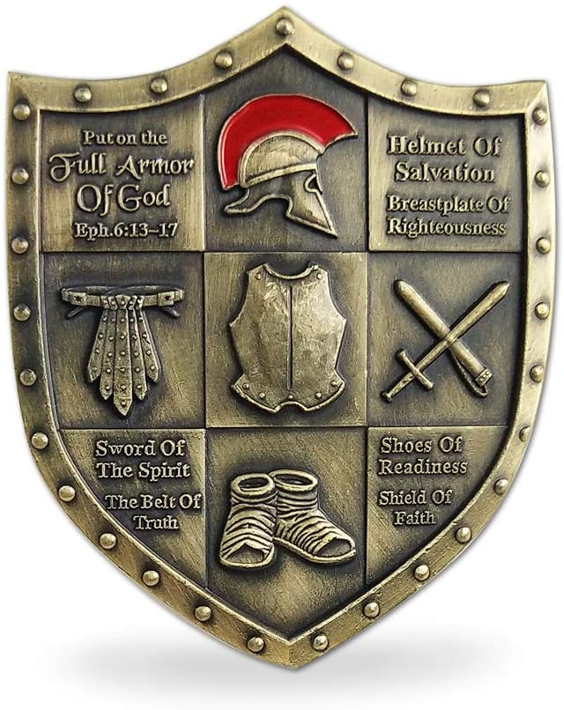

13 June 2020

“I AM” Worksheet

John’s Gospel records Jesus’ seven “I AM” statements—seven ways He meets the world’s needs. Read each verse in its context and answer the questions.

John 6:35 “I am the bread of life.”
What does Jesus mean by this statement?
What impact has this particular statement had on your life?
John 8:12 “I am the light of the world.”
What does Jesus mean by this statement?
What impact has this particular statement had on your life?
John 10:7,9 “I am the door of the sheep.”
What does Jesus mean by this statement?
What impact has this particular statement had on your life?
John 10:11,14 “I am the good shepherd.”
What does Jesus mean by this statement?
What impact has this particular statement had on your life?
John 11:25 “I am the resurrection, and the life.”
What does Jesus mean by this statement?
What impact has this particular statement had on your life?
John 14:6 “I am the way, the truth, and the life.”
What does Jesus mean by this statement?
What impact has this particular statement had on your life?
John 15:1 “I am the true vine.”
What does Jesus mean by this statement?
What impact has this particular statement had on your life?

Test Your Knowledge

- After His resurrection, what did Jesus say His followers would be able to drink?

- Juice
- Milk
- Water
- Poison

The correct answer is D (Mark 16:18)

- In the Gospel of John, who anointed Jesus’ feet with spikenard, and expensive ointment?

- Mary Magdalene
- Mary, Mother of Jesus
- Mary, sister of Lazarus
- Mary, a nurse

The correct answer is C (John 12:3)

- In the Gospel of Luke, where was Jesus when a sinful woman poured an alabaster jar of perfume on His head?

- At the home of Simon the Pharisee
- At Peter’s house
- At the home of John and James
- In Bethlehem

The correct answer is A (Luke 7:36)

- What wicked ruler ordered the infant boys of Bethlehem to be slaughtered?

- Pharaoh
- Saul
- Archelaus
- Herod

The correct answer is D (Matthew 2:16-18)

- Who was with Jesus at the Transfiguration?

- Matthew
- John
- Mark
- Luke

The correct answer is B (Matthew 17:1-3)

- Who healed Aeneas, a paralytic?

- Paul
- Stephen
- Peter
- Jesus

It’s a bit of a trick question. The correct answer is C (Acts 9:32-34), but Peter healed Aeneas in the name of Jesus.

- Who brought Greeks to Jesus?

- Andrew
- James
- Thaddeus
- Matthew

The correct answer is A (John 12:20-22)

- Where was Jesus when a Roman officer asked Him to heal his faithful servant?

- Bethsaida
- Capernaum
- Cana
- Tiberias

The correct answer is B (Luke 7:1-5)

- Who was anointed by the Holy Ghost?

- Moses
- Peter
- Joseph
- Jesus

The correct answer is D (Acts 10:38)

- What parable of Jesus featured greedy birds?

- The Tares
- The Prodigal Son
- The Sower
- The Great Supper

The correct answer is C (Mark 4:1-4)

