Sagecreek Bible Church
Worksheet
“The Case For Defining Grace”

I am not what I ought to be. I am not what I want to be. I am not what I hope to be. But still, I am not what I used to be. And by the grace of God, I am what I am.
- John Newton

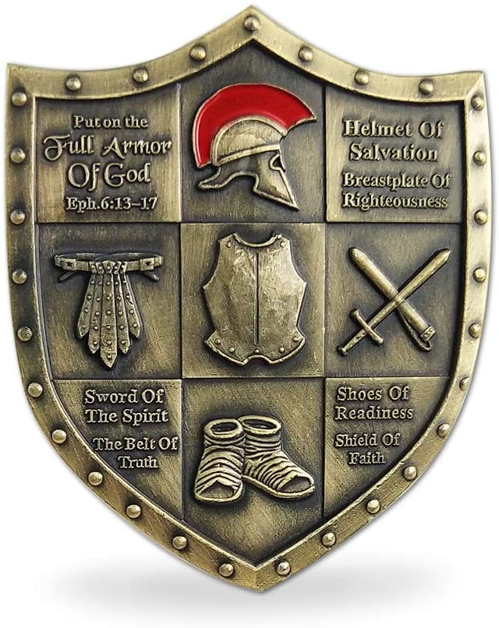
15 November 2020

The Case for Defining Grace

These notes accompany the message on this subject delivered on 15 November 2020.

Grace is the bedrock truth upon which all of Christian belief and practices stand.

Our objective for this study: To understand that God chose to have grace upon us by mandating faith as the means to have a relationship with Him.

In your own words, define the Grace of God.
The first time we see the word “grace” used in the Bible is found in Genesis 6:8. Who found grace in God’s eyes and why? Is there a message to us in Genesis 6:8?
The last time we see the word “grace” used in the Bible is Revelation 22:21. What is the significance of its’ use there?

The Ephesian Church got quite a lesson on grace from Paul. Fill in the blank spaces.
1. We are ______ in the Beloved to the "praise of the glory of His grace" (1:6).
2. We are ______ "according to the riches of His grace" (1:7).
3. We are ______ by grace," (2:5, 8).
4. We are ______ of His love through "the exceeding riches of His grace" (2:7).
5. We are privileged to be ______ of the Lord through the "grace given" (3:7, 8).
6. We are exhorted to ______ ______, that we may "minister grace" to them (4:29).
7. The benediction of love is, "______ be with all who love our Lord Jesus Christ" (6:24).

Read Ephesians 2:4-9. What conclusions do you come to regarding the grace of God?
Read Romans 3:23-28. What conclusions do you come to regarding the grace of God?
Read Romans 5:1-2. What conclusions do you come to regarding the grace of God?

What do you think Paul means when he says “but by the grace of God I am what I am” in 1 Corinthians 15:10? You can use 1 Corinthians 15:9 and Ephesians 3:8 to formulate your answer.
In 2 Corinthians 5:21 Grace is defined as__________________________________.

In Rom 3:22 grace is defined as: __________________________________.

In Ephesians 1:7 grace is defined as: __________________________________.

In Ephesians 2:8-9 grace is defined as: __________________________________.

In John 1:17 we see that Jesus Christ is: __________________________________.

In Romans 5:17 grace: __________________________________.

Has your understanding of the definition of grace changed during the course of this study, and if so, how?

