Sagecreek Bible Church
Worksheet
“The Case For The Children of Heaven”

AMPLIFIED VERSION – 2 Samuel 2:23 But now he is dead; why should I [continue to] fast? Can I bring him back again? I will go to him [when I die], but he will not return to me.”
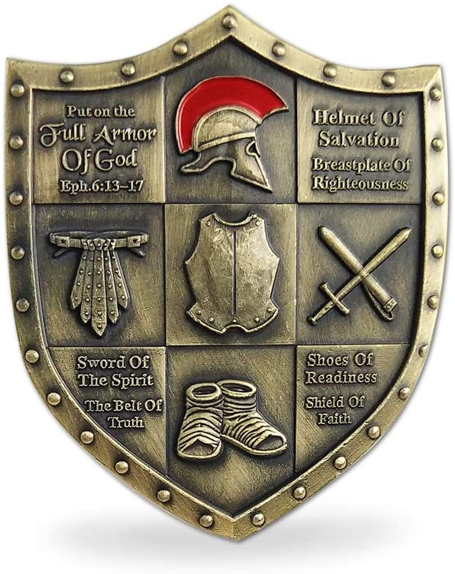
9 September 2020
“The Case for The Children of Heaven” Worksheet

The world is full of broken hearts over the loss of unborn, newborn, or young children. God has much to say about this subject that is intended to help us find comfort. This worksheet accompanies the message that will cover this subject.

When mankind fell to sin in the garden of Eden, death was introduced to us as a very powerful force. Study Genesis 2:17; Genesis 3:4. You will see that God spoke the truth about death and Satan lied about it.

But just as things seemed totally hopeless, Jesus Christ, using the very thing we all fear, took that fear away.

Jesus destroyed the power of death by experiencing it firsthand, and then resurrecting from death. Study 2 Timothy 1:8-10.

Several Old Testament Prophets saw this coming. Study Isaiah 25:8-9; Hosea 13:14.

Paul fills in some more of the gaps for us. Study 1 Corinthians 15:24-26; 54-57.

See also Hebrews 2:14, Revelation 20:14,Revelation 21:4, Luke 20:35-36, 2 Corinthians 5:1-2, John 11:43-44, Romans 1:4, Revelation 1:18, John 5:28-29, and Acts 2:27.

So, we can conclude that death was overcome by Jesus Christ and no longer needs to be feared. But the loss of children is particularly hard to accept and deal with. Without any trace of doubt children who die go straight to heaven. Why do I think that so strongly? The primary reason I believe this is because of the Character of God. From these verses, note all the attributes of God that are mentioned:
Psalm 86:15
Exodus 33:19
Exodus 34:6-7
Psalm 103:8

Joel 2:13
Jonah 4:2, 11
How do these attributes of God influence your consideration of how God treats the innocent among us?
What does He refer to children as while displaying His tender compassion toward them? (Study Mathew 19:13-14; Mark 10:13-14)
According to Matthew 18:14, what does Jesus say is not the will of the Father?
What was David confident of after the passing of his own child? Study 2 Samuel 12:23.
What conclusion do you draw from God’s attributes regarding how He deals with our young ones who meet death?
God the Father saw His only begotten Son die on the cross. How do you believe having that experience affects how He treats us in the midst of our own losses?
Often times, in the death of a child, the question is asked, “how could God allow this to happen?” How does an understanding of God’s own loss change that question?
The character traits of God, the Word of God, and the compassion of Christ lead me to these conclusions (add your comments after mine):
Our unborn, newborn, and young children who die, though they possess a sinful nature, are described in the Bible as “innocent”.
They cannot yet understand all the implications of good, evil, sin, death, heaven, hell, or the Cross of Christ, but they are covered by His blood.
I believe when God judges the world He will do right.
Those who don’t understand accountability won’t be held accountable.
I believe these little ones are shielded by the blood of Jesus, who loves all the little children.
I believe for those who have lost little ones, they can rest assured that the little ones bypass the sorrows of life and go immediately into God’s presence in heaven.
Jesus had an incredible love for children. Study Matthew 18:14; Matthew 19:13; Mark 10:13-14; Luke 18:15; Matthew 18:1-5.

I believe we can conclude that the character of God, the condition for salvation, and the compassion of the Savior, all point to the fact that babies who die before they’re old enough to understand the Gospel go to heaven – every one of them.

Now let’s do a case study. We’ll call this, “The Case of King David’s Sin”.

A quick overview tells us some facts. King David fell into adultery with Bathsheba, wife of Uriah. To cover his sin, David successfully arranged to have Uriah murdered. David hid all this in his heart for about a year, which was God giving him plenty of time to repent of his sin. But finally, God sent the prophet Nathan to confront him. Nathan predicted that the child conceived by David and Bathsheba would die.

Study 2 Samuel 12:15-23. What conclusions do you draw, particularly from V23?

Quotes

An amazing document was discovered by archeologists, a letter written around AD 125 by Marcianus Aristides to the Roman Emperor Hadrian.

Marcainus said:

“If any righteous person of their number passes away from the world, they rejoice and thank God, and escort his body as if he were setting out from one place to another nearby. When a child is born to one of them, they praise God. If it dies in infancy, they thank God the more, as for one who has passed through the world without sins.”

A very moving letter was written in 1925 by a missionary to China. Dr. and Mrs. L. Nelson Bell faced a lot as China missionaries. But the most difficult was the loss of their infant son. In a letter, Dr. Bell wrote this:

“Virginia and I realized that he was going and we were with him alone when the end came. It was so sweet and so peaceful, no struggle and no evidence of pain just quietly leaving us and going back to Him.

His going has left an ache in our hearts and or arms feel very empty, but oh the joy of knowing he is safe. It has but drawn us closer to Him and given us a new tie and joy to look forward to in heaven. We would not have him back for we know it was His will that he should go. There is no repining, wishing we had used other medicines, etc. we feel that everything that could have possibly been done was done. We had the joy of caring for him ourselves while he was sick and the memory is very sweet. He had been such a perfectly healthy baby, in some ways one of the best-developed children I have ever seen and so full of life that he was a favorite with the foreigners and Chinese alike.

Virginia and I had the privilege of fixing him ourselves when he died and then Virginia immediately went to the Talbots where Rosa and Ruth were at school. She wanted to tell them herself, rather than have them hear the news thru the Chinese. They were nearly heartbroken, but it was a wonderful opportunity to bring the great hope that is ours very close and plain to them.

We laid him to rest just at sunset and the service was such a sweet one and we pray was a blessing to the large number of Chinese friends who came. Virginia expressed by feelings exactly as we were leaving the little cemetery (owned by our hospital) when she said, “I have a song in my heart, but it is hard to keep the tears from my eyes.” At the grave we sang “Praise God from Whom All Blessings Flow” for this had made the wonderful hope of eternity doubly precious to us. Were it not for that hope we would not be here in China.”

J.I. Packer speaks regarding our thoughts about heaven:

“The lack of long, strong thinking about our promised hope of glory is a major cause of our plodding, lack-luster lifestyle…it is the heavenly Christian that is the lively Christian.”

Robert P. Lightner wrote a book called “Safe in the Arms of Jesus.” He said:

“In all the Bible references to infants…little children and others who cannot believe are neither told to believe nor expected to do so. They are not classified as wicked…rejectors of God’s grace. It is always adults who are addressed either directly or indirectly, regarding these matters.”

Charles Spurgeon says regarding the loss of infants:

“Are infants saved? And if so, how? I answer, saved they are beyond a doubt; all children dying in infancy are caught away to dwell in heaven. But mark this – no infant was ever saved apart from the death of Christ. Christ Jesus has with his blood bought all those who die in infancy. They are washed from all original corruption which they had inherited from their parents, and thus washed and cleansed they enter into the kingdom of heaven. Otherwise, beloved, infants would be unable to join in the everlasting song, “Unto him that loved us and washed us from our sins in his blood.” If infants were not washed in the blood of Christ, they could not join in that universal song which perpetually surrounds the throne of God. We believe that they are saved – every one of them without exception – but not apart from the one great sacrifice of the Lord Jesus Christ.”

Index of Bible Verses Used In Order of Usage
Genesis 2:17
Genesis 3:4
2 Tim 1:8-10
Isaiah 25:8-9
Hosea 13:14
1 Corinthians 15:24-26
1 Corinthians 15:54-57
Hebrews 2:14
Revelation 20:14
Revelation 21:4
Luke 20:35-36
2 Corinthians 5:1-2
John 11:43-44
Romans 1:4
Revelation 1:18
John 5:28-29
Acts 2:27
Deuteronomy 1:29-31
Psalm 86:15
Psalm 145:9
Genesis 18:25
Psalm 139:13-17
Jeremiah 1:5
John 19:25
Psalm 22:9-10
Matthew 10:29-31
Deuteronomy 1:39
Jonah 4:11
Jeremiah 2:34
Jeremiah 19:4
Revelation 21:8
Ezekiel 18:20
Isaiah 7:16
Psalm 51:5
Matthew 18:14
Matthew 19:13
Mark 10:13
Luke 18:15-16
Matthew 18:1-5
Matthew 18:14
2 Samuel 12:15-23
Luke 2:41-50

