Sagecreek Bible Church
Worksheet
“The Case For The Identity of Jesus Christ”

AMPLIFIED VERSION – Isaiah 9:6 For to us a Child shall be born, to us a Son shall be given; And the government shall be upon His shoulder, And His name shall be called Wonderful Counselor, Mighty God, Everlasting Father, Prince of Peace.
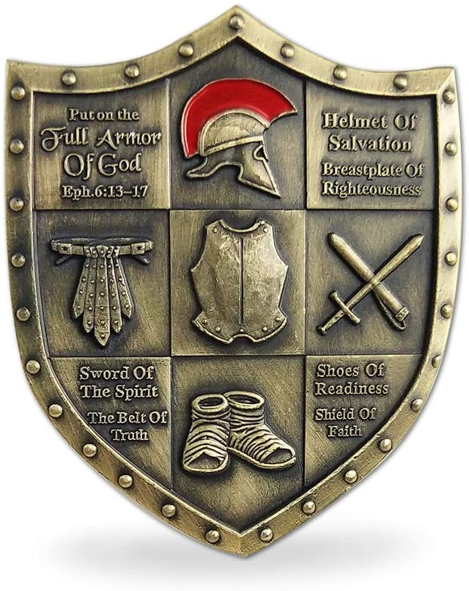
9 September 2020
“The Case for The Identity of Jesus Christ” Worksheet

What are some of the names given to Jesus Christ in the Bible?
See Isaiah 9:6; Malachi 4:2; Mathew 20:28; John 1:29; 3:18; 10:11; 13:13; Acts 3:15; Hebrews 4:14; Revelation 19:13, 16; 22:16.
What did Jesus teach about His existence before He was born in Bethlehem?
See John 17:5; Micah 5:2; John 1:15; 6:62; 8:57-58; 16:28-30; 1 Corinthians 10:4; Philippians 2:6-7; Colossians 1:17.
What does the Bible teach about the Birth of Christ?
See Genesis 3:15; Isaiah 7:14; Matthew 1:18-25; Luke 1:26-35; 2:1-14; Romans 1:3; Galatians 4:4.
How does the Bible teach that Jesus Christ is God?
See John 1:1; John 5:17-18, 23; 20:28-29; Romans 9:5; Colossians 2:9; Titus 2:13; Hebrews 1:6, 8; 13:8; 1 John 5:20.
What are some of the works of Christ which show that He is God?
See John 1:3; Mark 2:5-7; John 10:28, 14:14; 5:21-22; Hebrews 1:3.
What are some of our Lord’s claims for Himself, which prove that He is God?
See John 14:6; Matthew 11:28; John 6:35; 7:37; 8:12; 10:9; 10:14 with Psalm 23:1; John 11:25; 15:5; 16:15.
Explain how and why Jesus Christ became a real human being by His birth into the world.
See Hebrews 2:17; Matthew 4:2; Luke 2:40, 52; John 4:6; 11:35; 19:28; 1 Corinthians 15:47; Hebrews 5:8.
What does the Bible teach about the wonderful works of Christ while He was on earth?
See Acts 10:38; Matthew 4:23; 11:20; 13:58; Luke 2:49; John 5:36; 9:4; 10:32; 17:4.
Did Jesus ever do anything wrong or sinful?
See 1 John 3:5; John 8:46; Acts 3:14; 2 Corinthians 5:21; Hebrews 4:15; 7:26-27; 1 Peter 1:19; 2:22.
Why was Jesus born into the world as a man?
See 1 Timothy 1:15; John 1:14; 10:10; 2 Corinthians 8:9; Galatians 4:4-5; 1 Peter 2:21.
What did Christ do to save sinners?
See 1 Corinthians 15:3; Isaiah 53:5-8; Matthew 20:28; Mark 8:31; John 10:10, 17-18; 12:23-24; Romans 5:6-8.
How did Jesus suffer and die for our sins?
See Luke 23:33; Psalm 22:14-18; Matthew 27:26-31; Mark 15:29-34; John 19:28-35; Acts 2:23.
What did the death of Jesus do for all who believe on Him?
See Galatians 3:13; John 6:51; Romans 5:9-10; 2 Corinthians 5:15, 21; Ephesians 2:12-13; Galatians 1:4; 1 Thessalonians 5:10; Hebrews 10:10; 1 Peter 1:18-19; 2:24; Revelation 1:5.
What great thing took place three days after Christ died?
See Acts 13:30-31; Psalm 16:8-10; Isaiah 53:10; Matthew 28:1-10; Mark 9:31; Acts 4:33; Revelation 1:18.
How did Jesus prove that His body was raised from the dead?
See Acts 1:3; Luke 24:36-43; John 20:24-29; 1 Corinthians 15:3-8.
Why is the Resurrection of Christ important to us?
See 1 Peter 1:3; John 2:18-21; 14:19; Acts 17:30-31; Romans 1:4; 4:25; 6:8-9; 14:9; 1 Corinthians 15:14-20.
Where did Christ go after His Resurrection?
See Luke 24:51; Mark 16:19; John 6:62; Acts 1:9; Ephesians 1:20-21; 4:8-10.
What is Christ doing now in heaven?
See Hebrews 9:24; John 14:2; Acts 2:33; Hebrews 4:14-16; 6:20; 8:1; 10:12-13; 1 John 2:1.
Will Jesus ever come back from heaven to earth?
See Acts 1:11; John 14:1-3; 1 Thessalonians 4:15-18; Hebrews 9:28; Revelation 1:7.
Since Christ had done so much for us, how should we show or gratitude?
See 1 Corinthians 6:20; John 13:34; 14:15; Ephesians 5:2; Colossians 3:1-2, 13; 1 Peter 2:21-22; 1 John 2:6.

