Sagecreek Bible Church
Worksheet
“The Millennium”

AMPLIFIED VERSION – Ecclesiastes 3: ¹¹ He has made everything beautiful and appropriate in its time. He has also planted eternity [a sense of divine purpose] in the human heart [a mysterious longing which nothing under the sun can satisfy, except God]—yet man cannot find out (comprehend, grasp) what God has done (His overall plan) from the beginning to the end.
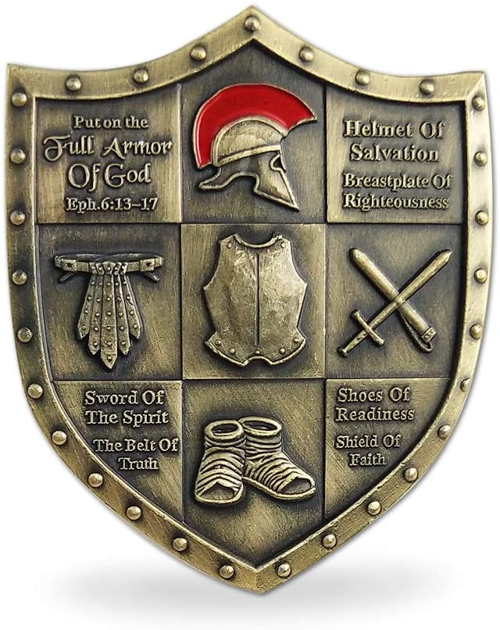
25 June 2020

- What is the Millennium? (Revelation 20)
- List at least four purposes of the Millennium. See Page 6 for help if needed.
Purpose #1: (Matthew 16:27; Matthew 25:34; Revelation 22:12)
Purpose #2: (Psalm 72:11; Isaiah 9:7; Luke 1:32-33)
Purpose #3: (Matthew 6:8-13)
Purpose #4: (Revelation 20:1-3, 7-8)
- Will you as a Believer today be on Earth for the Millennium? (Revelation 20:4; Matthew 25:14-30)
- Does the coming of the Millennium mean there will be no more conflict? (Micah 4:4; Isaiah 19:23-25; Isaiah 2:4)
- Does any human being die during the Millennium period? (Isaiah 35:5-6; Isaiah 65:20)
- Will sin still plague mankind during the Millennium? (Revelation 20:7-9)
- Where is Satan during the Millennium? (Revelation 20:1-3)
- Essay question: In the coming Kingdom, we know that all things will submit to Jesus Christ, and Christ will be subject unto the Father. Describe what this will look like.
(Psalm 8:6; Matthew 11:27; Matthew 28:18; John 3:35; John 13:3; Ephesians 1:20; Philippians 2:9; Philippians 2:10-11; Hebrews 1:13; Hebrews 2:8; Hebrews 10:12; 1 Peter 3:22; Revelation 1:18)
- Will God reward His followers for their faithful service? If so, how? (Isaiah 40:10; Matthew 16:27; Matthew 25:34; Colossians 3:24; Revelation 22:12; 1 Corinthians 6:2; Revelation 20:4)
- Many of the promises God made to Israel have yet to be literally fulfilled, but they will be – during the Millennium. Here are some examples. As you read them, ask yourself if they have already been fulfilled or if their fulfillment is in the future.
Psalm 72:11
Isaiah 9:7
Isaiah 60:21
Zechariah 9:10
Luke 1:32-33
- Is the commitment God made that a descendant of David will sit on Israel’s throne fulfilled during the Millennium? (2 Samuel 7:16; Luke 1:32-33)
- Does the Millennium fulfill the prayer of the Disciples? (Matthew 6:10)
- How does the Millennium reemphasize man’s depravity and the necessity of Christ’s death? (Revelation 20:7-9)
- What are some of the blessings man will enjoy during the Millennium? (Joel 2:28-29)
- In what ways will the Millennium will be a time of peace? (Isaiah 2:1-4; Psalm 72:7; Micah 4:1-3; Isaiah 11:6-9)
- The Land of Israel will flourish beyond anything imaginable during the Millennium. What will this look like? (Ezekiel 34:26-27; Ezekiel 36:29-30; Ezekiel 36:35; Amos 9:13; Isaiah 35:1)
- How will the Millennium will be a time of purity? (Isaiah 11:9; Isaiah 25:9; Isaiah 66:23; Zechariah 13:2)
- What will longevity of life look like in theMillennium? (Isaiah 65:20)
- What personal joys will be enjoyed during the Millennium? (Isaiah 9:3; Isaiah 12:3; Isaiah 14:7; Isaiah 25:8-9; Isaiah 30:29; Isaiah 42:10-12)
- How does Isaiah 11:1-5 describe the Messiah’s reign?
- Essay Question: With a perfect, just, and incorruptible King ruling over the world, what current world problems would be eliminated or at least greatly reduced?
- Read Revelation 20:7-10. How will God test the future generations of humanity at the end of the millennial kingdom?
- Even in a perfect world with Christ on the throne, sinful, fallen humans will be deceived by Satan and will rebel against God. What does this tell us about the human heart?
- Read 1 John 5:19. Though Satan holds sway over the current world system, his power is not absolute. According to the following passages, what things limit Satan’s power and activity right now?
Job 2:4-6
Ephesians 6:11-17
James 4:6-7
- How does the knowledge that Satan and his cohorts will be completely defeated by God affect your attitude toward sharing your faith with the lost?
- Colossians 1:13 says that God “rescued us form the domain of darkness, and transferred us to the kingdom of His beloved Son.” As Christians, we have the assurance of eternal life with Christ in the coming kingdom. Today, we have the opportunity to live lives that honor this precious gift. Over the next week, study the following passages, considering the behaviors that would define a kingdom-honoring life, and answer the questions below.
1 Corinthians 6:9-11
Galatians 5:19-25
1 Thessalonians 2:10-12
26a. In the present evil age, as I await Christ’s perfect reign, how can I live as a servant of God’s kingdom?
26b. According to these passages, is my life right-side up or upside-down?
- Study the drawings at the end of this worksheet to determine where the Millennium fits into God’s master plan. What do you conclude?

Suggested answer key to question #2.

Purpose #1 – to reward the people of God.
Purpose #2 – to respond to the prophet’s predictions.
Purpose #3 – to receive an answer to the disciple’s prayer.
Purpose #4 – to reemphasize man’s depravity and the necessity of Christ’s death.

Quotes

Thomas Ice and Timothy J. Demy wrote a book on heaven and eternity, and they say this:

“The Millennium is the precursor of the eternal state. It will be different than life as we know it today, but it will still fall short of the absolute perfection of the eternal state.”

Dr. George N. H. Peters calls The Millennium the “theocratic Kingdom”.

J. Vernon McGee:

“When He rules on this earth a bird won’t even cheep, a rooster won’t crow and a man won’t open his mouth without His permission. That’ll be a time when His will at last will be done on this earth. And, my friend, even the Millennium would be a hell for any man who is in rebellion against God.”

Randy Alcorn said this in his book on heaven:

“Service is a reward, not a punishment. This idea is foreign to people who dislike their work and only put up with it until retirement. We think that faithful work should be rewarded by a vacation for the rest of our lives. But God offers us something very different: more work, more responsibilities, increased opportunities, along with greater abilities, resources, wisdom, and empowerment. We will have sharp minds, strong bodies, clear purpose, and unabated joy.”

J. Dwight Pentecost, in his book Things To Come, wrote this:

“A larger body of prophetic Scripture is devoted to the subject of the millennium, developing its character and conditions, then any other one subject.”

