Sagecreek Bible Church
Worksheet – Worship

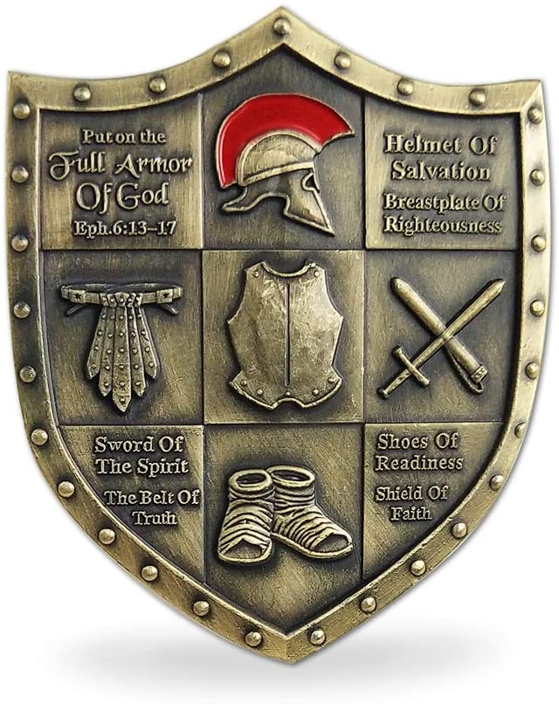

11 May 2020

WORSHIP

Text Verses, AMPLIFIED VERSION. Matthew 5: ²¹ “You have heard that it was said to the men of old, ‘You shall not murder,’ and ‘Whoever murders shall be guilty before the court.’
²² But I say to you that everyone who continues to be angry with his brother or harbors malice against him shall be guilty before the court; and whoever speaks [contemptuously and insultingly] to his brother, ‘Raca (You empty-headed idiot)!’ shall be guilty before the supreme court (Sanhedrin); and whoever says, ‘You fool!’ shall be in danger of the fiery hell.
²³ So if you are presenting your offering at the altar, and while there you remember that your brother has something [such as a grievance or legitimate complaint] against you,
²⁴ leave your offering there at the altar and go. First make peace with your brother, and then come and present your offering.
²⁵ Come to terms quickly [at the earliest opportunity] with your opponent at law while you are with him on the way [to court], so that your opponent does not hand you over to the judge, and the judge to the guard, and you are thrown into prison.
²⁶ I assure you and most solemnly say to you, you will not come out of there until you have paid the last cent.
What is Jesus telling us about our actions and their effect on our worship experience?
Define the words “Worship” and “Worshiping”
What does Exodus 34:14 tell us about worship?
After what Jesus said about the 6th commandment in out text verses, what can we assume that He’s interested in regarding our worship?
What does Hosea 6:6 tell us about what the Lord looks for in worship?
Worship case study: “The Case of the Woman at the Well”.
Read John 4. Study John 4:23-24. Define the following terms:

True worshippers

The Father

Spirit and Truth

Seeketh

Read Micah 6:6-8.
Knowing that The Lord wants genuine, Spirit-empowered worship, do our good works or the works of our own hands have a place in our worship?
Our Worship Experience
Based upon the words of Jesus on that mountainside, Jesus isn’t just concerned about relationships – He’s also very concerned with our worship experience.
Read Psalm 150:1-6 to see what our worship experience should look like.
In Psalm 150:1, what is the message of each word? (For further study, see Psalm 111:9, Luke 8:8, Jeremiah 25:6, Jeremiah 44:5-8.)

Praise

Ye

The LORD

Individual Worship
Why do you believe that the Lord started the Sabbath at sundown of the evening before the day and what does that, if anything, have to do with worship?
Individual preparation for worship includes the restoral of relationships, facing and fixing sin within our lives, making sure there are no hinderances individually that will affect us corporately.
What was Paul stressing regarding personal relationships in 1 Corinthians 11:17-18 and what affect will that have on corporate worship?
If I assess myself against the criteria Jesus is presenting on that mountainside and find I am at fault, what actions should I take? See Matthew 5:23-26.
How do personal prayer and devotional time help us to live in an attitude of individual worship as we go about our daily tasks?
See Colossians 3:23, 1 Thessalonians 5:17, and Hebrews 13:15.
The Lord is to be the only object of our worship. Study Jeremiah 44:6-8.
Among other things, God asked some questions. Examine yourself as you study each one.
- Why do you commit self-destructive acts of worship that don’t just affect you, but your family too?
- Why do you deliberately provoke Me to anger by worshipping the make-believe idols you have created in your life?
- Don’t you realize that your false worship makes you nothing more than a joke to the lost?
How does marriage represent our relationship with Jesus Christ and how does that apply to personal worship? Read Ephesians 5:21-33 and Revelation 19:7.
What conclusions do you come to regarding personal worship and how it is intended to prepare us for corporate worship?
Corporate Worship – the Church.
In the Bible, a gathering of believers is called a sanctuary (Psalm 150:1), the assembly of the upright and a congregation (Psalm 111:1), and a church (Acts 2:47).
What does Matthew 18:20 tell us about what a church is?
What do Acts 2:42 and Hebrews 10:24-25 tell us about Jesus’ expectation of us regarding church attendance?
What particular components of worship do Psalm 150:3-6, Isaiah 12:5-6, Psalm 95:1-2, Psalm 98:4, Hebrews 2:12 speak of as being part of the components of corporate worship that please the Lord?
What particular component of worship does Acts 12:5 & 12, James 5:14 speak of as being part of the components of corporate worship that please the Lord?
What particular component of worship does Acts 11:26, Acts 20:28 speak of as being part of the components of corporate worship that please the Lord?
What particular component of worship does Psalm 150:2, Acts 14:27, Acts 15:4 speak of as being part of the components of corporate worship that please the Lord?
What particular component of worship does Philippians 4:15 speak of as being part of the components of corporate worship that please the Lord?
Read Psalm 111:2-9 and pick out at least 10 subjects that can be preached in a church service to bring honor and worship to the Lord.
Essay question #1: How does personal worship prepare us for corporate worship and “what could possibly go wrong” if our personal worship is faulty?
Essay question #2: How can you as an individual better prepare yourself through personal worship for corporate worship?
Essay question #3: What can we do to help each other participate in personal worship as preparation for our corporate worship?
Essay question #4: Since I still had room on the page, make up your own question regarding worship and enter it here.

