
Town of East Hampton Airport
P.O. Box 836
East Hampton, NY 11937
631.537.1130

June 2, 2014

Helicopter
Noise Abatement
Revision 1

The following Helicopter Noise Abatement Procedures have been developed in collaboration with the East Hampton Control Tower, the Eastern Region Helicopter Council (ERHC), and East Hampton Airport Operations. They have been reviewed by both sub-committees of the Airport Planning Committee – the Noise Abatement Advocates Sub-Committee and the Aviation Community Sub-Committee. These routes are strongly recommended in order to mitigate the noise associated with helicopter operations at HTO.

This plan has been selected to best relieve communities surrounding East Hampton Airport from the noise produced from Arriving and Departing helicopter traffic. While noise mitigation is extremely important, these procedures should in no way supersede the safe operation of aircraft. These procedures will be monitored for compliance at all checkpoints for accuracy of the route and recommended altitudes and ERHC will receive weekly compliance reports.

ARRIVALS

November: (figure 1)

Arrivals from the west proceed to “November 1” (N40.59.5.48 W072.25.58.48) at or above 3500 feet, continue to “November 2” (N40.58.15.10 W072.20.26.56) at or above 3000 feet, to “November 3” (N40.58.2.70 W072.17.31.67) at or above 2500 feet, then to the airfield.

Sierra Inbound: (figure 2)

Arrivals from the south fly along the south shore approximately half a mile offshore, via S1 (N40.52.56.30 W072.20.8.26) at or above 3000 feet until passing S2 (N40.53.55.90 W072.17.11.03) which is a point of converging traffic departing East Hampton Airport (HTO) on the Sierra Route.
Proceed past the mouth Georgica Pond to S3 (N40.55.52.92 W072.12.35.84) which is a flyover fix and enter a left base for runway 28 or the parallel taxiway depending on the traffic at the airport and the direction of the air traffic controller.

Please hold your altitude as high as possible. Please look for fixed wing traffic in the traffic pattern or on approach to the airport. Overhead Georgica arrivals with spiraling descents on the north side of the airport are no longer expected and impede the safe flow of traffic on the north side of the airport.

DEPARTURES

Echo: (figure 3)

Depart heading northwest over the power lines to “Echo 1” (N40.58.02.0 W072.16.16.5). Turn right, remaining well east of Town Line Road and proceed to the west side of Barcelona Neck “Echo 2” (N41.00.47.5 W072.15.44.3). Use max performance climb so as to cross Barcelona Neck at or above 3000 ft. MSL. When possible, climb above 2000 ft. within the airport boundary before initiating the outbound leg so as to fly the route at the highest possible altitude.

Sierra Outbound: (figure 2)

Depart the airport via runway heading until passing 1,500 feet in the vicinity of O1 (N40.57.25.83 W072.17.6.39) then turn left to S2 (N40.52.56.30 W072.17.11.03) climbing to 3,000 feet BROC. After reaching S2, proceed westbound approximately a half mile off shore.

PLEASE NOTE:

The success of noise abatement depends on the requested routes and altitudes being observed with precision to the greatest extent possible.

East Hampton Airport Curfew: 11pm to 7am Daily

Pathways depicted on the map are for illustration only and may not conform precisely to coordinates.

Fixed wing traffic patterns will be directed by the Control Tower to remain south of the airport—left hand pattern for RWY 28, right hand pattern for RWY 10. The Control Tower will advise pilots of traffic conflicts on each of the voluntary helicopter routes and will retain the option of issuing arrival and departure instructions as traffic permits.

Ramp Operations

All arrivals and departures to HTO should be to and from active runways or parallel taxiways so as not to interfere with fixed wing traffic. Approaches and departures directly to and from the Terminal Ramp area are prohibited.

No part of a helicopter, including rotor tips, is to come closer than 100 feet to the Terminal building. Parking spot 1 in front of the Terminal Building is reserved for fixed wing aircraft only.

Boarding and deplaning a helicopter with the rotors turning should be avoided. Use of a rotor brake, if installed is encouraged.

Operating rotors for an extended period of time on the ramp is discouraged. More than five (5) minutes is considered excessive. Your cooperation with this limit is for noise and environmental considerations. Passengers who demand rotors turning when they arrive should be informed of this limit. If it is necessary to operate engines and/or rotors for extended periods of time, please move to one of the transient helicopter pads or as far from the Terminal Building as possible.

Other Considerations

Helicopter operations are the most serious environmental challenges we have at HTO. Anything you can do to mitigate the environmental impact of your operations will be greatly appreciated by this office and the surrounding communities.

Noise complaints increase dramatically during periods of inclement weather because of aircraft flying below a broken or overcast layer. While such operations are strongly discouraged (and may violate FAR 91.13), adherence to suggested routes is even more important.

The area surrounding HTO has substantial air traffic during the summer months some of which may have neither a radio nor transponder. Adherence to the suggested routes reduces the potential for conflicts but does not eliminate it. Frequent announcements of position, altitude and intended route are strongly encouraged. See and avoid is paramount, all available aircraft lights should be illuminated day or night. Coordination with or monitoring of New York approach frequency is recommended to help avoid IFR traffic that may otherwise appear suddenly from IMC conditions. Operators are reminded that merely because an operation may be legal does not necessarily make it safe.

Sincerely,

James L. Brundige Airport Manager
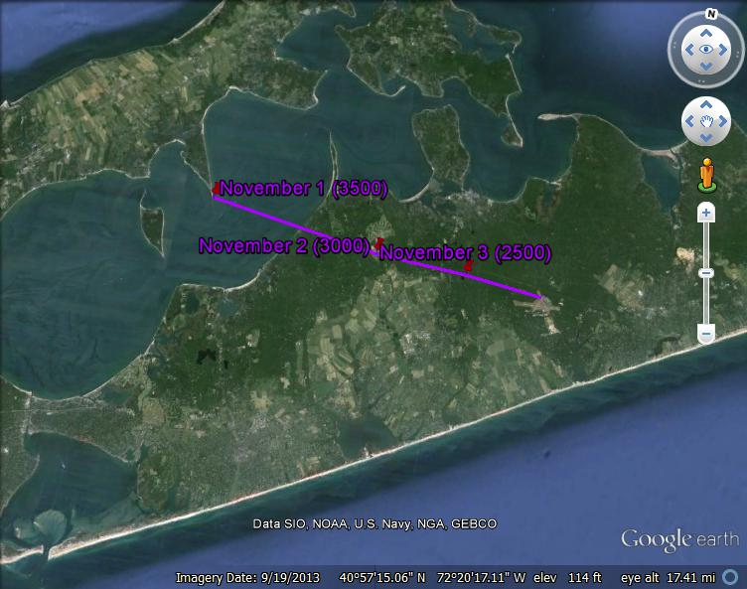

November Route (figure 1)

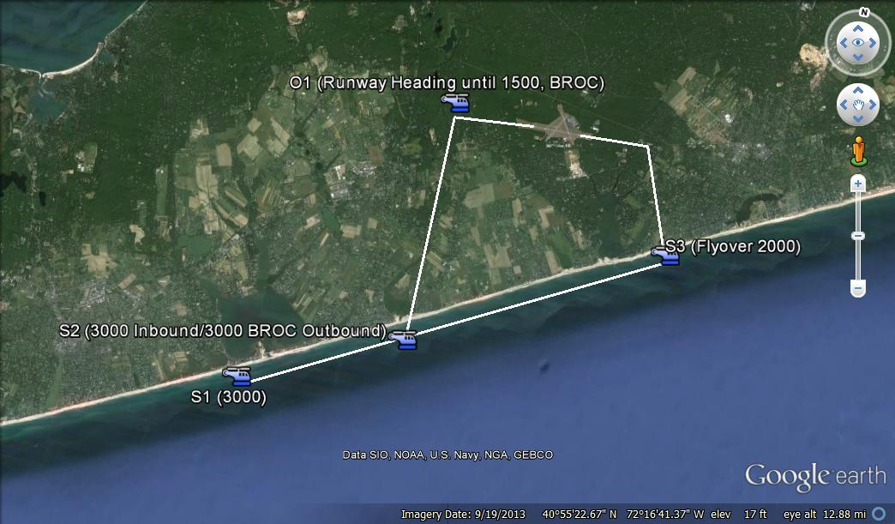

Sierra Route (figure 2)

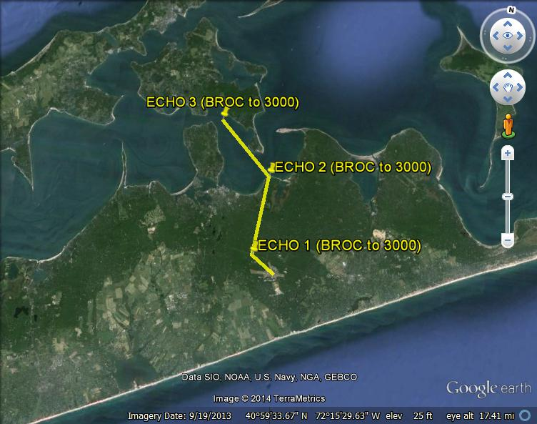

Echo Route (figure 3)

