Messy Church – 17th May 2025
The early church

The activities are:

- Pentecost – Acts chapter 2, verses 1 – 4 – resist painting
- Peter and the lame man – Acts chapter 3, verses 1 to 10 – jumping puppet
- Philip and the Ethiopian – Acts chapter 8, verses 26 to 40 – chariot
- Ananias and Saul – Acts chapter 9, verses 1 to 19 – glasses
- Saul escaping in a basket: Acts chapter 9, verses 19 to 25 – basket (in the Celebration)
- Peter and Cornelius - Acts chapter 10, verses 1 to 48
  - Picture of a Roman soldier (in the Celebration)
  - Marzipan animals
- Eutychus falls out of a window – Acts chapter 20, verses 7 to 12
  - Clay and pipecleaner construction
  - Ice cream wafers and jelly babies

Stories and Activities
All our stories today are told in the book of Acts (in full, The Acts of the Apostles), which tells the stories of the beginning of the Christian Church.
- Pentecost Acts chapter 2, verses 1 – 4
At Pentecost the friends of Jesus were all together. Suddenly, they heard a noise like a gust of wind. It seemed to blow right through the house where they were. Then they seemed to see flames, touching each one of them. Then they were amazed to discover that they appeared to be able to talk in languages they didn’t know they knew.
You will need: a piece of paper, paint in red and yellow colours (flame colours), and some form of paint resistant medium. We have some masking fluid, which will peel off when the paint is dry, but white candles work quite well, and you don’t have to peel the wax off!
Write “The Holy Spirit is here” on the paper with your resist medium – make the letters quite big (you could practice on a piece of scrap paper, or perhaps write them with a light coloured pencil, and then use the resist medium over the top). Paint all over the paper with red and yellow paint – don’t worry if the colours blend, and don’t make the paper too wet! When the paper is dry, if you have used a removable resist medium (you don’t need to do this with wax, you will already be able to see the words), carefully remove it, to show the words.
Talk about: hearing the wind, but only seeing its effects, or seeing the flames. Think about the changes fire and/or wind might make.

2. Peter and the lame man – Acts chapter 3, verses 1 to 10 – jumping puppet
Peter and John went to pray at the Temple in Jerusalem. As they were going in through the Beautiful Gate, a beggar asked them for money. They didn’t have any to give him, but Peter said “in the name of Jesus Christ of Nazareth, get up and walk!”. Then he helped the man get up, and he walked and jumped into the Temple with them, praising God.

You will need: print out of the puppet parts (supplied with this booklet) (if you can print on card, the puppet will be sturdier), colouring pencils, thread (heavy duty button thread, or crochet cotton would be best, but ordinary sewing thread will do, especially on ordinary paper), needle to suit thread, paper fasteners, scissors
Cut out the parts and colour them. Join the parts as shown in the diagram. When you pull the long thread, the puppet’s arms and legs will jump.

Talk about: being able to help people – however you can. Remember that Peter and John couldn’t give the lame man what he asked for, but they could help him.

3. Philip and the Ethiopian – Acts chapter 8, verses 26 to 40 - chariot
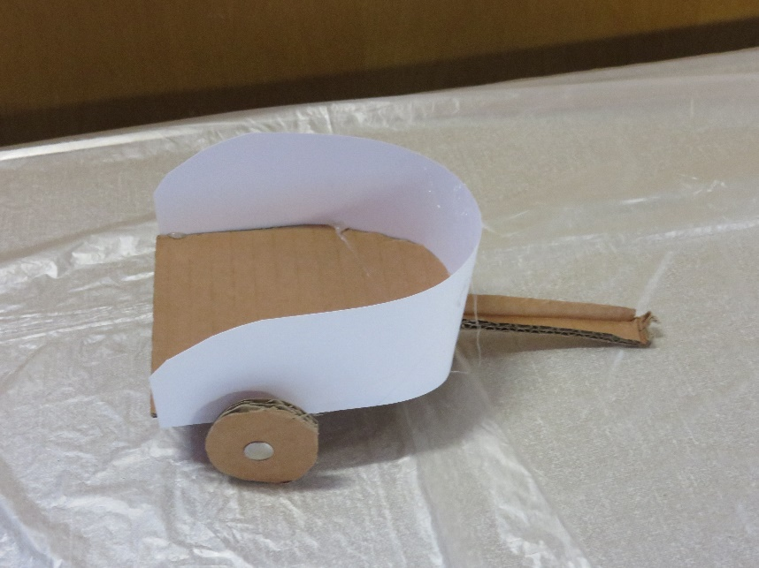
This story comes when Luke (who wrote the book of Acts, as well as the Gospel that is named after him) has just introduced us to Saul, who will become Paul. The Jews of Jerusalem have decided to get rid of this new religious movement, and Saul is involved in arresting believers in Jerusalem, so many of the leaders of the Church left Jerusalem, and started teaching the way of Jesus in other places. Among these leaders was Philip. An angel of the Lord, says Luke, told Philip to leave Jerusalem on the road that leads to Gaza. On the way, a chariot caught him up, on the same road. The passenger in the chariot was an Ethiopian who was interested in the Jewish faith, and had come to worship in Jerusalem, and was now going home. The Holy Spirit told Philip to walk with the chariot. The Ethiopian was reading the scroll of the prophet Isaiah, and Philip asked him if he understood what he was reading. The man said “how can I understand, unless someone explains it to me?” and he invited Philip to sit in the chariot with him, and explain it to him. If you want to look up what the Ethiopian was reading, it is in Isaiah chapter 53, verses 7 and 8. Philip used this passage

You will need: card of various types (we used thin card for the body of the chariot, and corrugated card for the floor, the shaft and the wheels), glue, scissors, fine wood for the axle, drawing pins, picture of a chariot.
Cut out the parts, as you can see them. The shaft at the front is fixed under the floor of the chariot, and the axle needs to be a little longer than the chariot is wide, so that the wheels are outside the chariot body.
Talk about:

4. Ananias and Saul – Acts chapter 9, verses 1 to 19 – glasses
Saul became very determined to make sure that Christianity could not spread, and he was given permission to go to Damascus and bring back all the Christians he could find, to be tried (and probably executed) in Jerusalem.
On the way to Damascus, he was suddenly surrounded by a blinding light, and heard a voice, asking him why he was persecuting the voice. Saul couldn’t see anyone, so he asked who the voice was. The answer from the voice was that he was Jesus. The people with Saul heard the voice, but they didn’t see anything. The voice told Saul to go to Damascus, and there he would be told what to do next. When he opened his eyes, Saul couldn’t see, so the people with him led him into Damascus, holding his hand, and found him somewhere to stay. There he waited for three days.
In Damascus, there was a Christian called Ananias. God told him that there was a man named Saul, who had had a vision of a man called Ananias coming and healing him. Ananias told God that he knew about Saul, and that he had come to Damascus to arrest Christians. God said that he had chosen Saul to spread the stories of Jesus to people who were not Jewish, as well as those who were. Ananias went to Saul, and healed him so that he could see again. Then Saul was baptised, in the name of Jesus. He changed his name later, to Paul.
You will need: a paper plate, scissors, a pencil to draw with, a hole punch and some elastic or string. Optional – colouring pencils or felt tip pens to colour the frames.
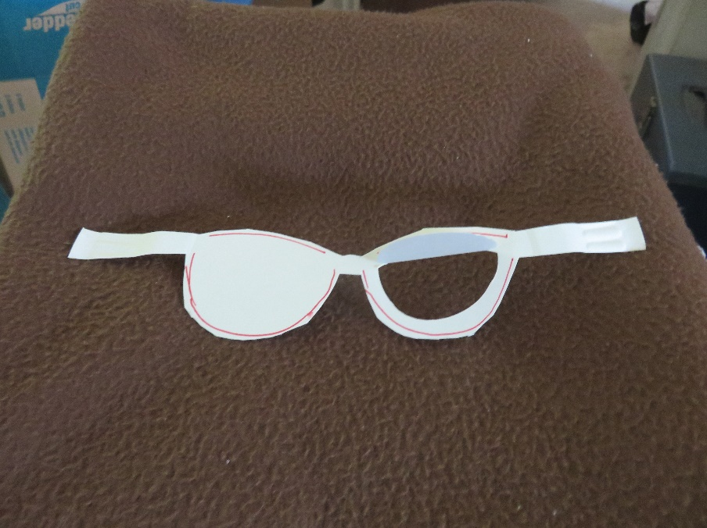
On the back of the plate, draw a pair of glasses – if you need an adult to help, ask. The glasses should fit across your own face, and you can use elastic or string to hold them on. If you don’t usually wear glasses, look at someone who does – there should be a bar between the lenses, to balance on your nose. Cut out the outline of the glasses, but not the lenses. If you want to colour the frames, do that now. Then carefully cut round the lower part of the lens, so you can fold the card up (so you can see!)
Talk about: not being able to see

5. Saul escaping in a basket: Acts chapter 9, verses 19 to 25 – basket (in the Celebration)
Saul started telling the the Jews of Damascus about Jesus. They were a bit upset – they had heard that he would come and arrest the Christians, and here he was, supporting them. They got very cross and planned to kill him. They put watchers at the city gates so he could not escape, so the Christians took him to a house which had a window in the outside wall of the city and let him out of the window in a basket, lowered by a rope.
You will need: a print out of the net provided, pencils or felt tip pens to colour, scissors, string and a little glue.
Cut out the net round the outside lines, and fold it on the bold lines within the shape. Carefully cut along the slits marked with bold lines on the sides. Glue the basket together using the tabs. Thread a length of string through the slits, and tie it in a loop above the basket. (The basket will not be very strong, so don’t put too much weight in it – you could use your pipe cleaner man from activity 7.)
Talk about: doing what you think is right, but finding that it upsets other people.

6. Peter and Cornelius - Acts chapter 10, verses 1 to 48
This is how Peter found out that God intended his new teaching to apply to people who were not Jewish – up to this point, the friends of Jesus had been limiting their teaching about Jesus to Jews.
Peter was staying in Joppa with friends. One day, he was in the house, and went up on the roof to pray while a meal was being prepared. As he was praying, he saw what looked like a sheet – like on a bed – in front of him, full of animals. The puzzling thing for Peter was that they were all the sorts of animals that Jews were not allowed to eat, and a voice said to him “Get up, Peter. Kill, and eat.” Peter was very clear “Certainly not, Lord. I have never eaten anything forbidden!” The sheet was picked up by its four corners, and lifted up out of sight. Then it appeared again – three times altogether, with the same conversation happening each time.
Then Peter heard someone knocking on the door, and the voice that had told him to kill and eat something told him to go downstairs to meet the newcomers. When he got there, he found that these people were not Jewish, they came from a Roman called Cornelius, who wanted to know about Jesus. God had told him to send messengers to Joppa, to find a man called Peter. Now Peter knew that Jesus, and God, were for everyone, not just for Jews.
Again, we have two activities here.
- Picture of a Roman soldier (in the Celebration)
You will need: a print out of the picture supplied, colouring pencils or felt tip pens.
Colour the soldier
- Marzipan animals
You will need: marzipan (or ready to roll icing), a paper plate
Shape the marzipan (or icing) into animals and/birds: concentrate on snakes, lizards, shellfish, which were animals Jews were not allowed to eat.
Talk about: a special meal when you have been working hard, or to celebrate something, or even just a meal you haven’t had to do all the preparation for!

7 Eutychus falls out of a window – Acts chapter 20, verses 7 to 12
This story comes from part of Paul’s last (third) missionary journey. Paul is on his way back from Greece to Jerusalem. Instead of going by boat, he is working his way through Macedonia and what we call Turkey, back to Judea. One of the places he stops is Troas. Luke says that on Paul’s last Saturday evening (he was going to leave the next day), the Christians got together for a meal in a private house. Although for Jews this would have been just after the end of the Sabbath, and so they would not have been working all day, this was not the case for non-Jews, so it is quite possible that some of those listening to Paul had been working all day. A young man called Eutychus perched on the window sill to listen to Paul, and as it got later and later, Eutychus got sleepier and sleepier, until at last he fell asleep, and fell out of the window to the ground below – Luke says from the third floor. When the people rushed downstairs to see if he was alright, they found he was dead. Paul came down, flung himself on Eutychus and hugged him, and said he was alive. Then they all went back upstairs and they all ate together. Paul went on talking until sunrise, and then he left. Eutychus went home with his friends, and everyone was very relieved.
  - Clay and pipecleaner construction
You will need: a paper plate (or thick card), some clay and/or play doh, and two pipecleaners.
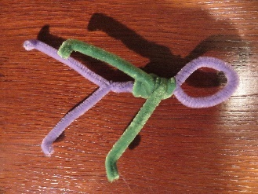
On the plate, build a clay wall with a window in it, with the window sill wide enough to sit a person on. Remember to keep your hands and the clay damp as you are working.
Bend one pipe-cleaner in half, make a loop at the bend, and then twist the two halves together for about half the length of what is below the loop. Bend the second pipe-cleaner lightly in thirds. Twist the middle third of the pipe-cleaner several times around the body you have already made, so that the ends stick out to make the arms. Bend the ends of the legs to make feet. When the clay is dry, sit the man in the window.
  - Ice cream wafers and jelly babies
You will need: a paper plate, four ice cream wafers, some squirty icing, and some jelly babies.
In one of the wafers, towards one end, carefully cut out a window (you can cut out a door in one of the other three – remember where the ground level is!). Then stick all four wafers together, standing them on their short ends (the house had two stories). Lie one of the jelly babies on the plate below the window, as if he has just fallen down. Put another two jelly babies standing beside him.
Talk about: learning to do things differently. What happens when you have learned one way of doing something, and you discover that there is another way? Do you refuse to learn a new way, or do you try it and see?

Celebration

Pentecost is on the 8th June, which is just before our next Messy Church. We think of it as the Birthday of the Church, because that is the day when the Apostles went out and started talking about Jesus. Lots of things happened after that, some odd, some amusing, some frightening, as the church grew and more and more people started to follow Jesus.

We’ll sing Spirit of God, unseen as the wind https://youtu.be/ozWAspk5Zcg?si=KLL-2O4oFWQ_-Coo

Pentecost was a Jewish celebration 50 days from Passover. On that day the disciples were all in the Upper Room when the Holy Spirit came on them. They saw what looked like flames, and heard what sounded like a strong wind, but they didn’t see the Holy Spirit. They did feel the experience, and they went out to the Temple and started talking about Jesus. Up till then they’d been too frightened to, but now they had the courage. 3,000 people decided to follow Jesus that day. After that the disciples stopped hiding. Peter and John went out and when a lame man asked them for money, they healed him “In Jesus name.” The authorities wanted them to be quiet, but they wouldn’t be. They stopped being afraid, even after one of the followers, Stephen, was killed. The person who took responsibility for Stephen’s death was called Saul.

Stephen was one of seven people chosen to help distribute food to Christians in Jerusalem. Another one of the seven was called Phillip (not to be confused with Phillip the disciple!) When the church was persecuted in Jerusalem, Phillip went to Samaria. He met an Ethiopian official who was riding in a chariot and who was reading the scriptures. Phillip told him about Jesus, and he became a believer. Christianity is strong in Ethiopia still.

Meanwhile back to Saul. He saw a vision of Jesus while he was going to Damascus to persecute Christians there. He couldn’t see after that, until Ananias came to him. Then he followed Jesus, his Christian name was Paul. People who had hoped Paul would get rid of Christians now were annoyed with him and wanted to kill him. He had to escape from Damascus by being lowered down the wall in a basket.

We’ll make a basket.

Song Our God is a great big God https://youtu.be/0K3TUFFpmhA?si=qiRAK48jnFYIMNmJ

Peter meanwhile went to Joppa. While he was there he had a vision of a sheet full of animals. This was to tell him that God was widening his world. Someone came to see him to ask him to visit a Roman centurion called Cornelius. Before the vision, Peter wouldn’t have wanted to meet a Roman, but now he knew he had to. Cornelius accepted Jesus, and received the Holy Spirit which proved to Peter that visiting him had been right.

We’ll colour in a picture of a Roman soldier.

Back to Paul. Not everything worked out perfectly for him. Have you ever gone to sleep during a sermon in church? Well, Eutychus did when Paul was preaching, and he fell out of a window!

We are going to sing Be bold, be strong https://youtu.be/OdQYmGTsKmE?si=QuV59B1m_AwYLdZW

Let’s pray.

Dear God,
Your first followers gained the courage to tell other people about Jesus, and the church grew. Give us the same courage, and also the courage to make space for new people as the Church grows.

Amen

Next Messy Church is 21st June 2025. See you then.

Enjoy our celebration on the Harlington Methodist Church YouTube channel at https://www.youtube.com/channel/UCTMWR_QCxujkh1zHjTFcoJw

Then have tea or a treat if it isn’t tea time!

If you send me pictures of anything you do, I can share them on the Church Facebook page or in the Church Monthly (if you want to send pictures that you don’t want shared, just tell me. I’ll only share the one’s you’re happy to share.)

Harlington Messy Church Team

We’ll have a Zoom meeting open for those who can’t come to the church. Our end of Zoom will go on YouTube during the celebration, but we won’t put pictures from your end on. Contact me if you want the link for Zoom. Look out for the broadcast on the Harlington Methodist Church YouTube Channel. https://www.youtube.com/channel/UCTMWR_QCxujkh1zHjTFcoJw/videos

