Messy Church – 16th November 2024
John Bunyan and Pilgrim’s Progress

The activities are:

- John Bunyan – the man
  - Soldier – card sword
  - Tinker – make a saucepan (playdoh, clay, cooking foil)
  - Preacher – tree with pipe cleaner man
  - Author – quill pen – in the Celebration
- Pilgrim’s Progress
  - Slough of Despond – chocolate angel delight
  - Wicket gate – lolly sticks – in the Celebration
  - Vanity Fair – pompom ladies in bright colours
  - City of Gold – on black or dark blue, decoupaged for older children
- Preparation for Christmas
  - Advent rings

Stories and Activities
John Bunyan, who wrote the book Pilgrim’s Progress, was born in Bedford in 1628 – nearly four hundred years ago. In 1644, when he was 16, and the country was at war, the King against Parliament, which is called the Civil War, John joined the army. He doesn’t seem to have done any fighting, and after three years, he left and went home to Elstow, just outside Bedford. In about 1649, John got married, and started to go to church with his wife. He was a tinker, a man who walked around the area, mending pots and pans (metal things) for householders.
While doing this, he met some members of the Bedford Meeting (a non-conformist church – any protestant denomination, rather than the Anglican Church). He changed his church, and began to study his faith, and then to preach. At this time, Parliament ruled the country, rather than the King, and many of them were also non-conformists, and so a level of religious tolerance was in operation – before this time, people, by law, had to go to the Anglican Church, and there was very little freedom for people who wanted to be Catholics or non-conformist (the name means they didn’t want to “conform” to the state church).
By 1660, John Bunyan was preaching all over Bedfordshire, in people’s houses, in the open air. When he came to Harlington, in good weather, he preached in the fields to the east of the village, perched in an oak tree, while the people who listened stood or sat on the hill side.
However, in May 1660, King Charles II was invited back as King of England and Scotland, and then religious affairs started to go back to the pre-Civil War ways. Field preaching was now frowned on, and in November, when John Bunyan came to the farm at Lower Sampshill, in the parish of Harlington, he was arrested, and taken to Harlington Manor, where the local magistrate lived. On the Monday following, he was taken to Bedford Jail, where he stayed for 12 years. There, he started to write – hymns, prayers, sermons, and his own thoughts. One of his famous books, called “Grace Abounding” was published in 1666, while he was still in prison, and he started writing the book we will be learning about as well, “The Pilgrim’s Progress”. This book was finished while he was in prison again, in late 1676, for about 6 months. It was published in 1678. John Bunyan died in London in 1688.
There are four activities to illustrate some of the things John Bunyan did in his life.
- John Bunyan – the man
  - Soldier – card sword
You will need: a piece of card, some cooking foil, scissors, pencils or felt tip pens. Optional – stick on jewels
Draw the shape of a sword on the card, and cut it out. Cover the blade tightly with cooking foil, and colour the hilt. If you have them, you could use stick on jewels on the hilt – but remember that each soldier had to provide their own sword, and you would have to be rich to have jewels. John Bunyan was a working man, but he would be unlikely to have the money for a fancy sword.
  - Tinker – make a saucepan out of clay, playdoh or sturdy cooking foil
You will need: the material of your choice, a paper plate to put it on. If you are using clay, some water to keep the clay and your hands damp.
With clay or playdoh, shape a saucepan, with a handle, and put it on the plate. With cooking foil, fold a piece into a square, so that it has several layers, and scrunch them up a little, so that the layers are firmly together (not too tight), and then unfold it carefully, shaping it into a saucepan. (You wouldn’t be able to make it into a sturdy shape with only one layer.) See if you can make a handle, by unfolding part it a little more.
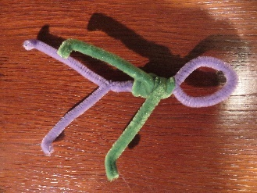
- Preacher – tree with pipe cleaner man
You will need: a sturdy piece of wood, two pipe cleaners, scraps of fabric (optional)
Make a man: fold one pipe cleaner in half, making a loop at the fold, and twisting the two sides together to make the body. Separate the bottom ends, and tip the very ends up to make feet. Twist the second pipe cleaner around the upper body several times, leaving the ends free to make arms. You could use scraps of fabric to dress the man.
John Bunyan, when he came to Harlington, spoke to crowds in the fields on the eastern side of the village. There was a hollow oak tree there, and he stood inside it. Use a sturdy piece of wood, or card, to make a base for your man. You could make a rim for it, if you like.
- Author – quill pen – in the Celebration
The sort of pens we use didn’t exist in John Bunyan’s day. People wrote with a goose quill pen, dipped in ink. A quill is a wing feather – the shaft of the feather is hollow, and will hold ink (but you have to dip it in the bottle quite often), and it is also sturdy. Other feathers may be hollow, but they are often not strong. Wing feathers need to be strong to take the strain of the weight of the bird, holding it against the air.
You will need: a piece of card, scissors, pencil or felt tip pen

Cut out the shape below, and colour the sides – it doesn’t have to be solidly coloured, just to give the effect of the feathery sides. Fold the whole thing in half, down the length of the shape, and then fold the feathery edges back on themselves, so that the pointed end looks like the quill end to dip in ink.
Talk about:
Lots of things happened in John Bunyan’s life that made him into the person he was. Some of them were good things, others less so. He followed what he believed in, and wasn’t put off by being arrested. Eventually, when he was in prison a second time, he wrote. How do you use what happens to you?

2. Pilgrim’s Progress
The book tells the story of a man called Christian, who lived in a town which he began to think of as a bad place. He wanted to live somewhere good, and he met a man who told him to find the way to such a place, called the City of Gold. The man gave him a book to read on the way, and from the stories that Christian reads in it on his way, it must have been a Bible. Pilgrim’s Progress is the story of how Christian gets to the City of Gold – the things that go wrong, the things that go right for him. He meets lots of people, some good and some not so good, and some actually bad. All the places he goes are based on places around Bedford, some of them still there to see.
- Slough of Despond – chocolate angel delight
A slough is a bog! This one is based on the boggy areas south of Bedford, where John Bunyan grew up. The bogs possibly don’t now exist in the same way – but if you look at a map of the land south of the A421, it is full of lakes, where sand, gravel and brick clay have been removed, and the holes have filled with water, so it is easy to imagine that the land was boggy before.
You will need: a packet of angel delight, and some milk, a bowl to mix in, small bowls to put the angel delight in, a fork or whisk to mix, and a measuring jug to get the right amount of milk. You could just use the measuring jug to make the angel delight in, rather than another large bowl!
Make the dessert as given on the packet, and pour it into small bowls to set.
- Wicket gate – lolly or craft sticks – in the Celebration
A wicket gate is a gate, usually made of wood, in a fence or hedge, just people sized. This could have been a churchyard gate – today these are often made of metal, rather than wood – look at the side gate, called the “Vicar’s Gate” to St Mary’s, in Harlington.
You will need: a number of lolly or craft sticks, about 10 to be sure of having enough, some glue that will secure wood. A working surface that will clean – so not wood!
Put five sticks side by side with small gaps between them. Put three sticks across these from side to side, one towards the top, one towards the bottom, and one in the middle. Put another one or two diagonally (you may need to cut these) between the side to side ones, to stop the shape from distorting.
- Vanity Fair – pompom ladies in bright colours
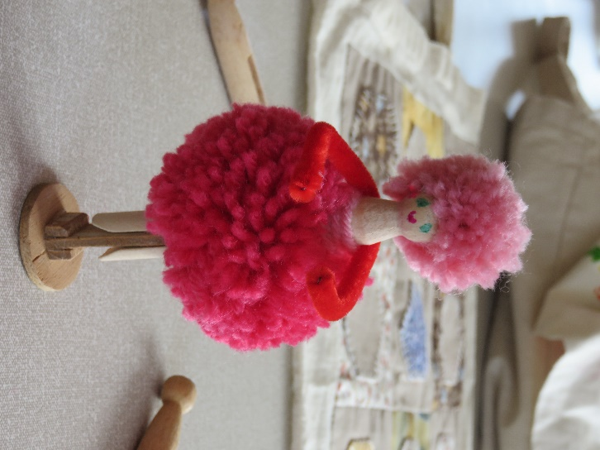
We don’t know which fair John Bunyan modelled this one on – but to puritans, who were of a serious turn of mind, the market fairs of the Restoration period, when bright colours of clothing, and lots of frivolous things were on sale, any fair might have been the target. Bedford and Leighton Buzzard were two towns which held regular markets.
You will need: two sizes of pompom maker, a dolly peg, a pipe cleaner, felt tip pens to draw the face, and yarn in bright colours.
Make the pompom in the usual way, but before you cut round the maker, put the dolly peg in the middle of the maker. Cut round the yarn, and tie a length of yarn round the pompom, pulling the whole thing tight against the body of the peg. Fasten off the tie tightly.
With a little glue on the body above the skirt, stick the pipe-cleaner to the body. Draw the face, making sure that the face is above the dividing point for the legs, rather than having one leg at the front and one at the back! For the hair, either make a smaller pompom and stick that to the head, or stick some strands of yarn to the head.
You could use larger pompom makers than were used for the illustration, which would give you a longer skirt, and longer hair.
- City of Gold – on black or dark blue paper, decoupaged for older children
The City of Gold was the heavenly city in the book of Revelation, the last book in the Bible. Chapter 21 says, among other things, that the city was golden.
You will need: dark blue or black paper for the background, light weight card, either gold (or bright yellow) paint, or gold paper to stick to the card, the city outline supplied, scissors, glue, and if making a decoupage image, some sticky fixers (double sided sticky pads)
Paint and cut out the city outline, or cut it out and stick gold paper to the card. (If making the decoupage version, cut out several copies, making each one slightly different, to give a 3D image when finished).
Stick the city to the dark paper. For the decoupage version, stick the layers together with the sticky pads.
Talk about:
Pilgrim’s Progress is an allegory, a story where each part represents something. (Some of Jesus’ parables, particularly the parable of the sower, are allegories.) Talk about what is represented by the different parts. Could any of these apply to you?

3. Preparation for Christmas
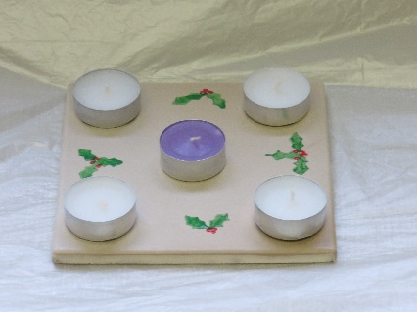
You will need: a bathroom tile or a piece of very heavy card, or wood, tin foil (to cover wood or card), blue tac, night lights – we will use battery lights, not the candle versions in the picture. If you are using a tile, you might like to paint the tile, so you will need paint, paintbrushes, pencil for marking up the tile if wanted, picture to see what it could look like.
If it helps, work out where the night lights will go, and draw round them. Decorate the rest of the tile. Use blue tac to attach the night lights, so that they can be replaced if they burn out. (If you are using battery lights, the switches are on the underneath, so you will still need blue tac.

Never leave the advent ring candles lit if you leave the room!

If you are using candle lights, and tin foil covered card, stand the card on a heatproof surface before lighting any of the night lights!

Talk about:
Getting ready for things, in this case Christmas. What do you need to prepare?

Celebration
We’ll sing Our God is a Great Big God https://youtu.be/0K3TUFFpmhA?si=MKkiCEpL9oqQnb4R

John Bunyan was born in Elstow nearly 400 years ago. At the time, there was a lot of arguments going on about how people should live and who should be in charge. The politics was about power between the king and Parliament. There was also argument about how Christianity should be practiced. One side wanted everyone to be very high church, the other side wanted everything very simple and plain – they thought of it as pure, hence Puritans. The high church sided with the king and the Puritans sided with Parliament. When Bunyan was a young man, this became a Civil War. Bunyan joined the Parliamentary army.

Parliament won the war, executed the king (Charles I), and appointed one of their leaders, Oliver Cromwell, as Lord Protector. This period was called the Commonwealth. After Cromwell died people decided they preferred a king and invited the dead king’s son back (Charles II). However, the new king was worried that people would rebel again and so laws were passed saying you couldn’t worship anywhere except in the Parish Church.

Bunyan’s dad had been a tinker, that is someone who made and repaired pots and pans. During the Commonwealth Bunyan returned to this trade. However, he married and under his wife’s influence became a Christian. He started preaching, which was OK in the Commonwealth but after the restoration wasn’t allowed. This didn’t stop him, and he was arrested, just outside Harlington, in Upper Sampshill and brought to Harlington Manor, to the Magistrate. He spent 12 years in prison. When he was freed, he started preaching again. At first this was allowed, then he was arrested again. It was during this time he finished writing Pilgrim’s Progress.

We’ll make a quill which is what he would have used to write.

We’ll sing When the road is rough and steep https://youtu.be/UF7xgQwKlpc?si=kOssBBUHygAZ305L

In Pilgrim’s Progress, Christian decides that where he lives is bad, and he wants to get to a better place. So he starts out walking. He’s heading for the Wicket Gate, but he falls into a bog, the Slough of Despond. That’s the start of his adventures.

We’ll make a gate to represent the Wicket Gate.

In the course of his travels, Christian meets people who try to help him, and people and things that distract him or actively try to stop him. Sometimes he does the right thing, but often he does wrong things. One thread of the story is that he is carrying a burden, which he finally realises he can let go of.

Eventually he gets to the Heavenly City.

The story is intended to show that you can follow Jesus, but it will not always be easy. However, if you persevere, you can make it because Jesus will help you.

Sing Who would true valour see
https://youtu.be/ydPn31WCkNs?si=4PXraq39f4o2veiN

This hymn was written by John Bunyan, and if you live in Harlington, it’s practically compulsory to learn it.

Let’s pray.

Dear God,
Help us to follow you. Let us not be distracted, or persuaded to do the wrong things, but help us to listen to you.

Amen

Next Messy Church is 21st December. See you then.

Enjoy our celebration on the Harlington Methodist Church YouTube channel at https://www.youtube.com/channel/UCTMWR_QCxujkh1zHjTFcoJw

Then have tea or a treat if it isn’t tea time!

If you send me pictures of anything you do, I can share them on the Church Facebook page or in the Church Monthly (if you want to send pictures that you don’t want shared, just tell me. I’ll only share the one’s you’re happy to share.)

Harlington Messy Church Team

We’ll have a Zoom meeting open for those who can’t come to the church. Our end of Zoom will go on YouTube during the celebration, but we won’t put pictures from your end on. Contact me if you want the link for Zoom. Look out for the broadcast on the Harlington Methodist Church YouTube Channel. https://www.youtube.com/channel/UCTMWR_QCxujkh1zHjTFcoJw/videos

