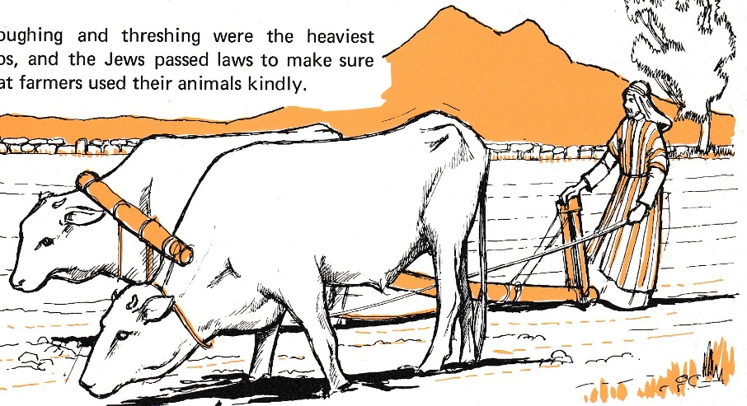
Growing a grain crop – wheat or barley
Ploughing with a pair of oxen

Ploughing might be done before the grain was sown, if the ground had not been used before, or if it were stony.

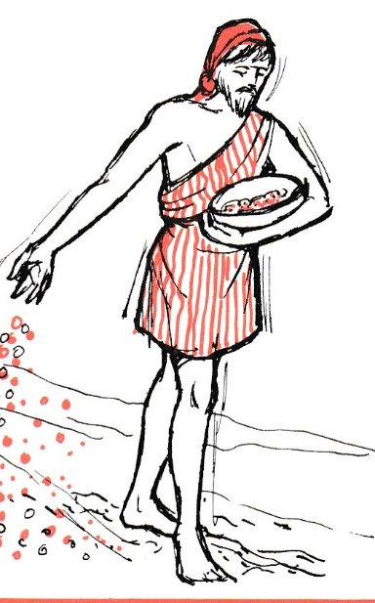
Otherwise, it would be sown and then ploughed, to cover the seed, so the birds didn’t take so much
Man sowing the grain – from a basket.

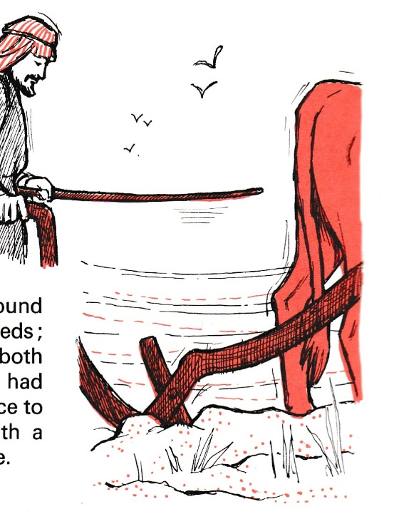
This is what a plough might look like behind a single ox.

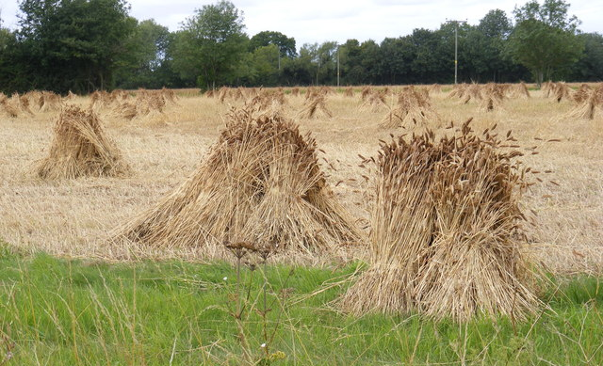

These are stooks of corn, drying in a field.
When the corn is dry, it is threshed – the corn grains are beaten out of the husks – if there is only a small amount of grain, it could be done by hand, but for a field full, a threshing sledge and oxen would be used. (see below)

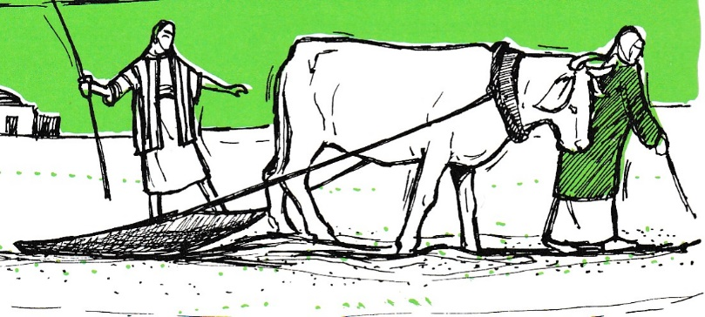
The books of the Law say that such oxen should not be muzzled to prevent them eating the grain!
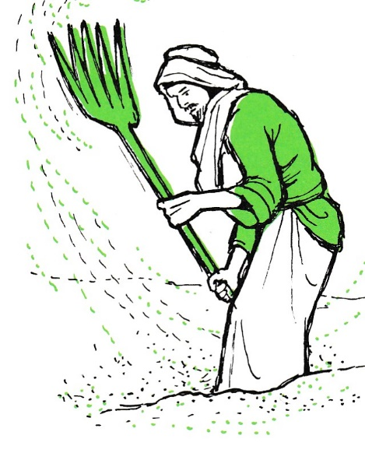

Winnowing the corn, to get rid of the bits – the husks and the stalks – so just the good grain was left.

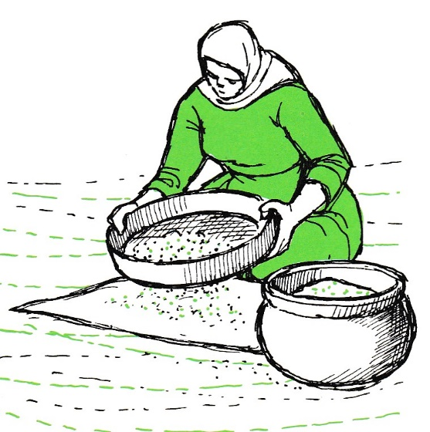
Sieving the grain, to be sure that all the bits of husk are gone – they are not good to find in a loaf of bread! And since the threshing and winnowing are done on a bare patch of ground, the sieving makes sure there are no little stones, or soil in with the grain.

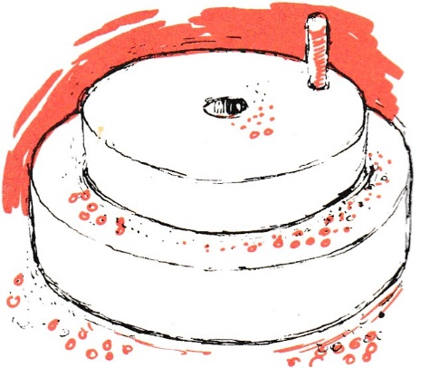
These are the grinding stones, which Palestinian women would use to prepare the flour they needed for bread each day. The hole in the top stone has two uses – it fits over a small peg in the bottom stone, so the stones stay in the same relationship to each other, and it also allows the woman to feed grain into the stones. When she then turned the handle, the top stone would rotate on the bottom one, grinding the grain that was between them. The stones would be put on a piece of cloth, which would catch the flour, which could then be scooped up and prepared to make bread.

