Peter is sinking!
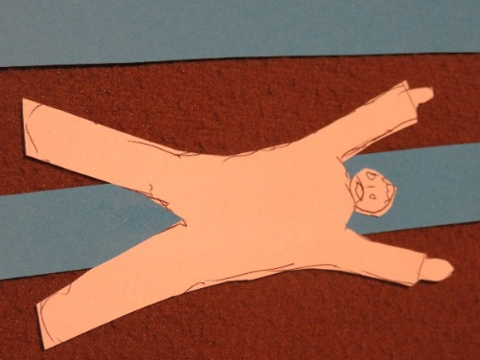
1 Draw and cut out a man with his arms in the air, as if he were sinking, waving his arms, from a piece of scrap paper. This is Peter.
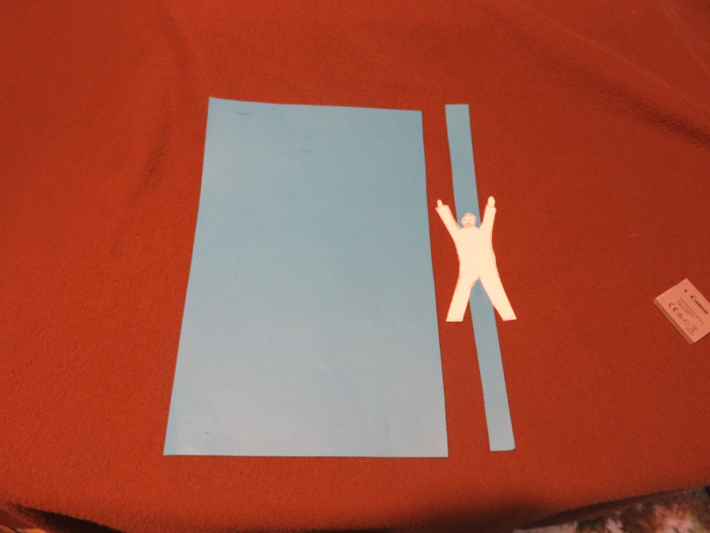
2 Cut a strip from a long side of your darker blue sheet of paper, and stick Peter in the middle of the strip, lengthwise, so that the strip goes above his head and below his feet.
3 Holding the dark blue paper with the long sides at the top and bottom, cut two slits in the paper, one in the top half of the paper, and the other in the bottom half. Make the slits wide enough to thread the strip with Peter on through.
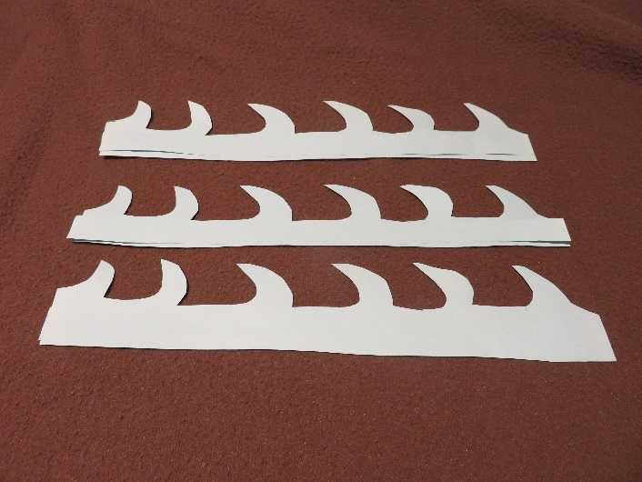
4 Either: with the rest of the dark blue paper, with the long sides at the top and bottom, paint waves so that they come at least half way up the paper. The waves should come past the bottom slit.
Or: draw and cut out waves from the lighter blue piece of paper, (use the paper with the long sides at the top and bottom) and stick them onto the dark blue piece, sticking only the ends of the paper down, so that Peter can slide down behind the waves. Make sure the waves come at least half way up the paper.
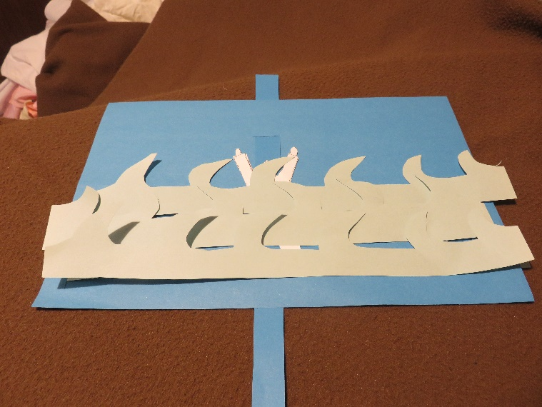
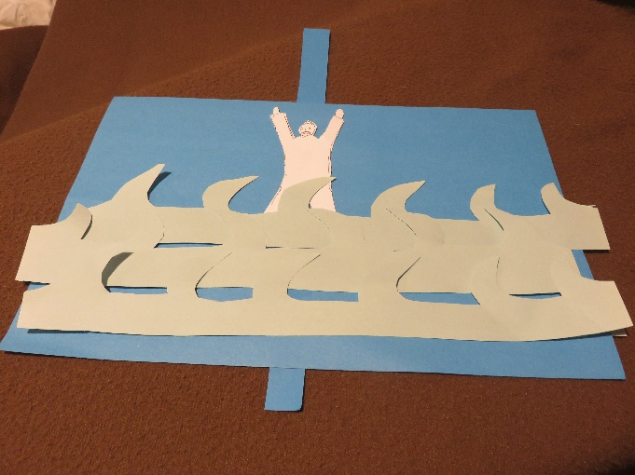
Or: if you want to be really complicated, cut slits in the sides of the dark blue piece of paper, stick additional strips of paper on the back of your waves, so that the ends are loose, and thread the ends through, so that you can move the waves, as well as moving Peter! If you use multiple moving strips of waves, offset your side slits, and reverse some of your waves, so that the waves don’t get tangled up together.

