Messy Church – 18th July 2026
Holidays: 7th day of creation

The activities are:

- Paper plate aquarium
- Surfboard on a paper spring
- Pipe cleaner people
- Climbing on a rock face
- Lighthouse (Celebration)
- Picture (Celebration)
- Microwave meringues

Stories and Activities
In the story of creation, right at the very beginning of the bible, in Genesis chapter 1, the creation of the universe takes God six days. Then, in chapter 2, the first three verses say “And so the whole universe was completed. By the seventh day God finished what he had been doing and stopped working. He blessed the seventh day and set it apart as a special day, because by that day he had completed his creation and stopped working.”
The important word here is “stopped”, because in Hebrew, the language the Old Testament was originally written in, that word is “sabat” – which is the root of the word “Sabbath”, which is what the seventh day became.
In Exodus, which is the second book of the bible, God gives his people, the Hebrews, or Israelites (after Jacob, whose other name was Israel), a set of laws to follow. There are ten of them – the Ten Commandments – which have to do with people’s behaviour to God and to each other. The fourth of these commandments says “Observe the Sabbath day and keep it holy. You have six days in which to do your work, but the seventh day is a day of rest dedicated to me. On that day no-one is to work – not you, your children, your slaves, your animals, or the foreigners who live in your country. In six days I, the Lord, made the earth, the sky, the sea and everything in them, but on the seventh day I rested. That is why I, the Lord, blessed the Sabbath and made it holy.”
So the Sabbath day became a day dedicated to worship for the Israelites, and they did no work. Their Sabbath dinner was cooked, if it needed to be, the day before.
Of course, which day is the seventh depends on which day you start counting. The Hebrews, or the Jews, as the national name became, started counting on the day we call Sunday, so their Sabbath was, and is, Saturday. However, because Jesus rose to live again after his crucifixion on the Sunday, the early church changed their day of praise to God and rest to Sunday.
Holy days were extra days for Jews when they focussed on God and the things he had done for them – like a good harvest, or rescuing them from Egypt, and they did no work on those days either. Christians adopted this policy, and so churches have holy days as well – like Good Friday, and Christmas Day – although for Christians in this country, most holy days are Sundays, and we have a tradition of weekends, which means we work only five days.
“Holiday” is a word which is derived from Holy Day – and just means people don’t have to go to work!
Everyone looks forwards to holidays, whether they are religious, or just fun!

Talk about: what you do to relax, and the difference between relaxing and working – some things are work for one person and relaxing for another!
Think about: people who can’t go on holiday - because they can’t afford it, or because they can’t leave animals or family members who cannot travel.

1 paper plate aquarium
You will need: a paper plate (if you don’t have a paper plate, you could use blue paper), paint, glue, sand, small pebbles, tissue or crepe paper in green, pink and orange, sea shells, googly eyes, black felt tip pen, the picture also on the website. If you don’t have sand, pebbles or sea shells, improvise! Look at the pictures, and think how you could make the shapes in other ways – for example, for the sea shells, you could finely pleat paper, cut it in a curve, and fan it out from one end.
Paint two thirds of the top of a paper plate blue using acrylic paint. Leave to dry.
Cover the bottom third with PVA glue then cover the glue with yellow sand. Leave for a minute, then shake off the excess sand. Leave to dry. (you could use yellow paint here if you don’t have sand!)
Choose two mini scallop shells to create the fish. Paint the triangular base ends of the shells with a bright colour acrylic paint to create the fish tails. Leave to dry.
Select two pebbles to use as a fin on each fish. Paint the pebbles the same colours as the tails. Leave to dry. (could you use pieces of egg box here?)
Glue a painted pebble onto the middle of one of the fish shell. Leave to dry. Repeat with the second pebble on the other shell. Leave to dry.
Stick a googly eye onto each fish. Draw a mouth on each fish using a thin black pen.
Place a line of glue around the underneath edge of one of the fish and stick to the plate. Leave to dry. Repeat this step with the other fish.
To make the seaweed, take some green tissue paper and cut into lots of strips roughly 10cm long, and twist together at one end. Glue the tissue paper bunch to the bottom of the plate on the sandy section. Create another tissue paper bunch and glue it on. Leave to dry.
To make the coral, take some pink and orange tissue paper and cut into lots of strips roughly 6cm long. Twist the strips into sausage shapes and glue to the sand on the plate. Leave to dry.
Stick pebbles at the base of the seaweed and coral, to add detail to the sea bed. Leave to dry. Paint small white circles onto the plate by the mouths of the fish to create bubbles. Leave to dry.
If you want to make your picture more like a coral reef than an aquarium, make more coral and less seaweed, and you won’t need so many pebbles either.
If you want to make your picture more like a rock pool, you might want to paint the bottom part of the plate a dark brown, and perhaps use more pebbles, and no coral.

2 Surfboard on a paper spring
How to make a paper spring
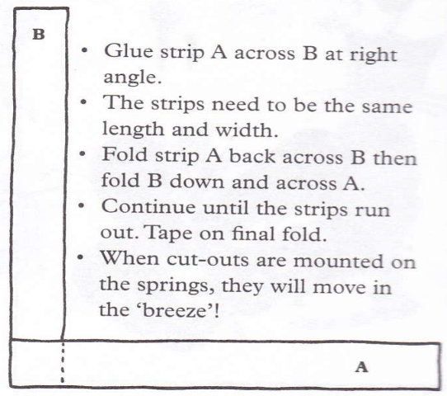
To make the paper spring, cut two strips of paper the width of a piece of A4 paper, about a cm wide. Stick them together in a right angle, as shown on the first picture. Follow the instructions on the picture, gluing the last two layers together.
You will need: a paper spring, card, felt tip pens, a piece of blue paper, scissors, glue, the pictures on the “Surfing” page with this booklet.
Surfing is done standing up, and body-boarding is done lying down, and the boards for each activity are a little different, although the waves may be the same!
Draw and cut out a surfboard in card, and colour it to your satisfaction. A surfboard is curved more than a body board, at the front end. Draw some waves to ride on on the piece of paper.
Glue one end of the paper spring to the centre of the board, and the other end to the appropriate place on your “sea”.
If you want to put a figure on your board, look for the pipecleaner people activity. Make your figure the right size for the board.

3 Pipe cleaner people
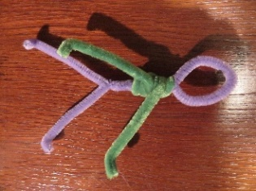
You will need: two pipe cleaners for a full size man, for a smaller one, one pipecleaner, tin snips and an adult to use them
Make a man: fold one pipe cleaner in half, making a loop at the fold, and twisting the two sides together to make the body. Separate the bottom ends, and tip the very ends up to make feet. Twist the second pipe cleaner around the upper body several times, leaving the ends free to make arms. If you are making the small version, cut the pipe cleaner in half, and follow the instructions as if the halves were the whole pipe cleaner.

4 Climbing on a rock face
You will need: a very large stone, pipe cleaner people, thread, scissors, glue,
Tie thread around the waists of your people, and glue the other ends of the thread to the rock, so that the people hang down the side of the rock, as if they are climbing using rope. You could bend the figures to look as if they are climbing, not just hanging loosely, and then glue hands and/or feet to the rock.

5 Lighthouse
You will need: a paper cup, a clear plastic cup, pens or paint, to make the paper cup red and white striped, black marker pen and black paint for the clear plastic cup, a battery tealight
Paint the paper cup in red and white stripes (about 1 cm wide for each stripe.
When the paint is dry, use the black marker pen to draw a door and windows.
Turn the paper cup upside down. Put the clear plastic cup on the top of the paper cup. Where the top of the paper cup meets the clear plastic cup, draw a black line on the clear cup, and use this as the base of a railing drawn on the clear cup.
Paint the top of the clear cup black.
Take the clear cup off the paper cup, and put the battery tealight on the top of the paper cup. Switch it on, and put the clear cup back on top.
If it is dark outside, turn the lights in your room off so you can see the lighthouse light.

6 Microwave meringues
You will need: egg white, icing sugar, plates to cook on, microwave cookers, whisk and/or fork, teaspoon, greaseproof paper, cooling racks, recipe (see separate sheet)
- Using the fork or whisk, mix enough icing sugar into the egg white to make a stiff mixture which can be handled.
- Roll the mixture into small balls the size of a marble
- Arrange the balls, four at a time, on the greaseproof paper lined plates (make sure they are well spread out)
- Microwave on high for about 1¼ minutes
- Transfer the greaseproof paper to a cooling rack

Celebration
Song My God is so big, so strong and so mighty https://youtu.be/Aq1ZIC4lsEw
At the very beginning of the Bible there is the story of God making the world. One of the things we can learn from that story is that after God did all the work, he took a day off to rest. Rest is very important to people. The Jews used this seventh day, the Sabbath, as their day to spend just on worshipping God and very much not working. The Sabbath was to be a Holy Day, which is where our word “Holiday” comes from. We all need holidays. Tina and I are going on holiday soon. We are going to the seaside. One thing you may see at the coast is a lighthouse. Sometimes you may see the light from one at night. It seems to blink on and off, but really the beam is rotating.
Song My Lighthouse https://youtu.be/5J32hCTVAlQ?si=XMbNMI1bFai1xCni
By Jesus’ day, some people had got to thinking that the Sabbath was so important that it had to have a whole lot of rules to protect it and stop people working on it. Some of the rules were quite weird. Jesus got into trouble because he healed someone on the Sabbath, and he said, “The Sabbath was made for people, not people for the Sabbath!” He knew that people needed rest, but that people also needed healing. What do you do on your holiday? Do you walk, swim, cycle, climb, sunbathe, build sandcastles, play games, fly kites? Draw a picture of your favourite holiday thing(s).
Prayer
Dear God, thank you for giving us time to rest and relax.
Amen
Song Jesus’ love is very wonderful https://youtu.be/WcgplHIntJc

Enjoy our celebration.
Then have tea or a treat if it isn’t tea time!

If you send me pictures of anything you do, I will share them on the Church Facebook page (if you want to send pictures that you don’t want shared, just tell me. I’ll only share the ones you’re happy to share.)
Next meeting 19th September 2026 (No August meeting)
Harlington Messy Church Team
We’ll have a Zoom meeting open for those who can’t come to the church. Our end of Zoom will go on YouTube during the celebration, but we won’t put pictures from your end on. Contact me if you want the link for Zoom. Look out for the broadcast on the Harlington Methodist Church YouTube Channel. https://www.youtube.com/channel/UCTMWR_QCxujkh1zHjTFcoJw/videos

