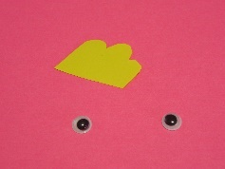
Simple Origami Cockerel/Rooster
You will need: a square of yellow paper (I have worked with a pink square, because the yellow paper I had did not show up well), a scrap of red paper for the comb (I have used yellow), and two small wiggly eyes, plus a little glue.
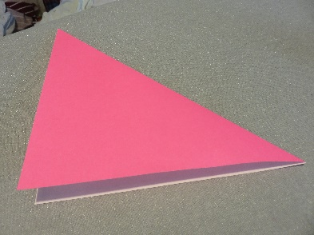
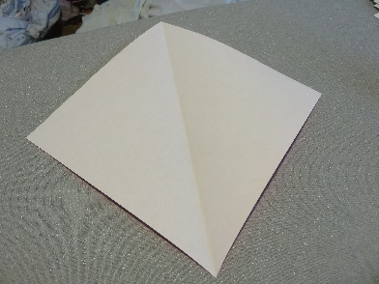
- Fold the paper in half along the diagonal, and press the fold down firmly – you will need to use it later.
- Unfold it again, so you can see the fold line.
- Fold both sides to meet at the fold line.
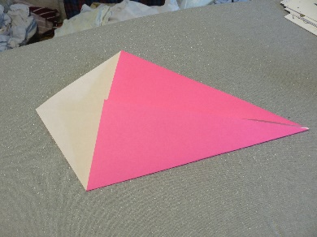
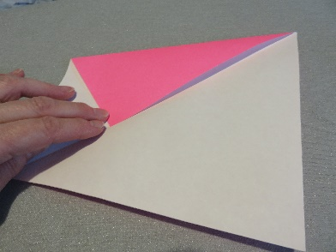

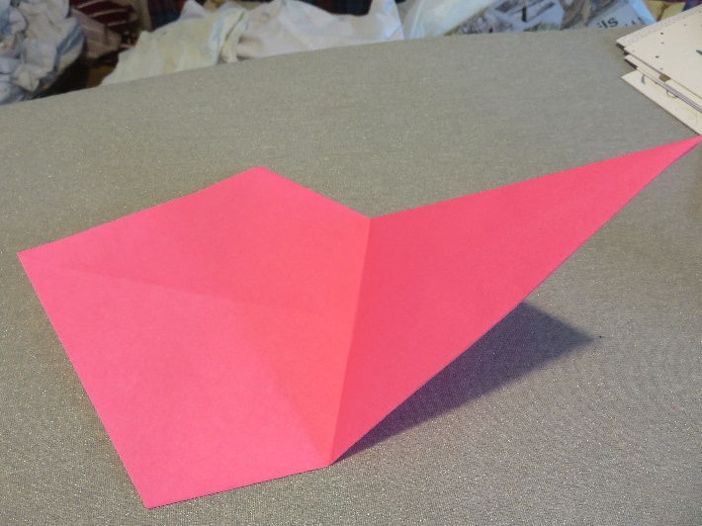
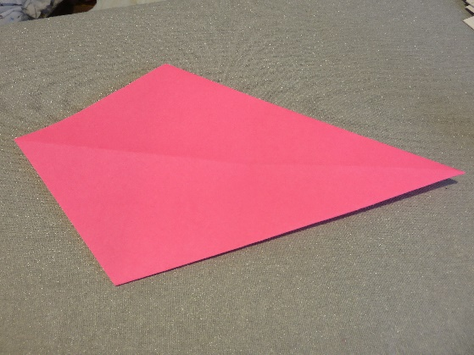
- Turn the paper over.
- Fold the narrow point up to meet the wide point.

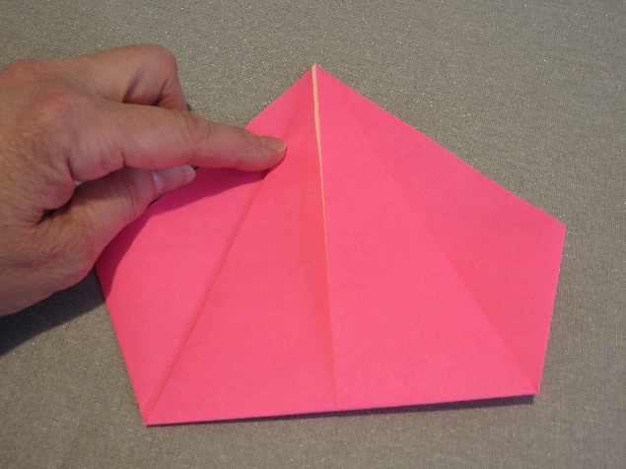

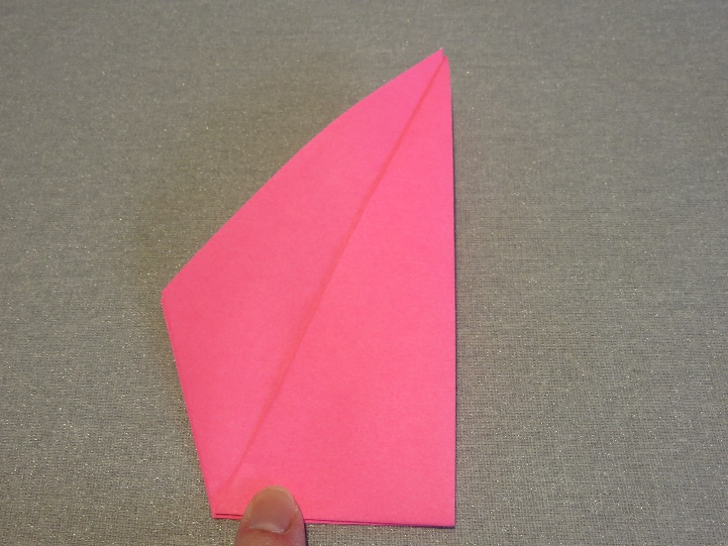

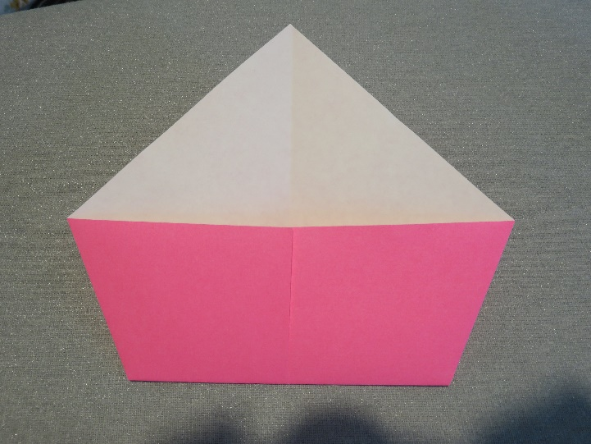
- Turn the paper over again.
- See the fold line down the middle? Fold the whole thing on that line.

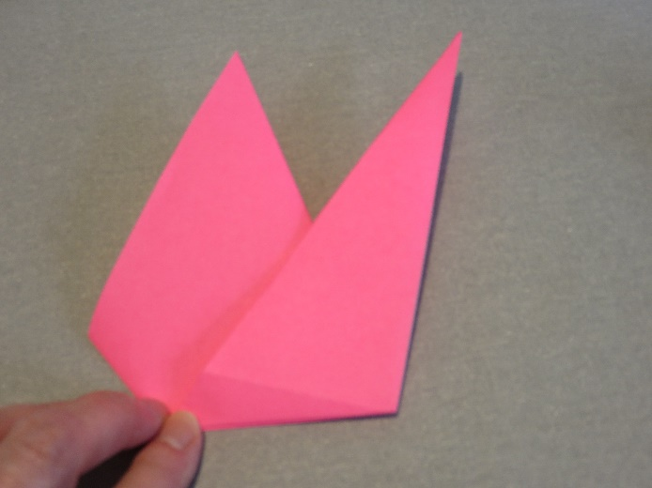
- Pull the narrow point on the right hand side outwards, to make the cockerel’s tail, and press the new fold into place. The cockerel will now stand up, if you want.
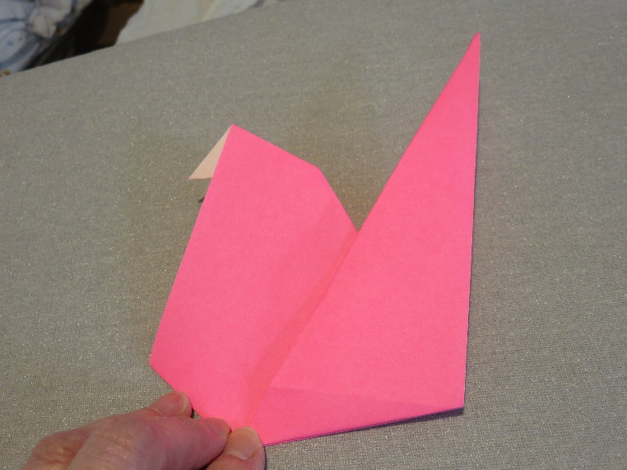
- Open the other point up, and fold it inwards on the same fold, to make the beak.

- Cut a piece of red paper, and glue it into the fold above the beak. Glue wiggly eyes on each side. Finished!!
