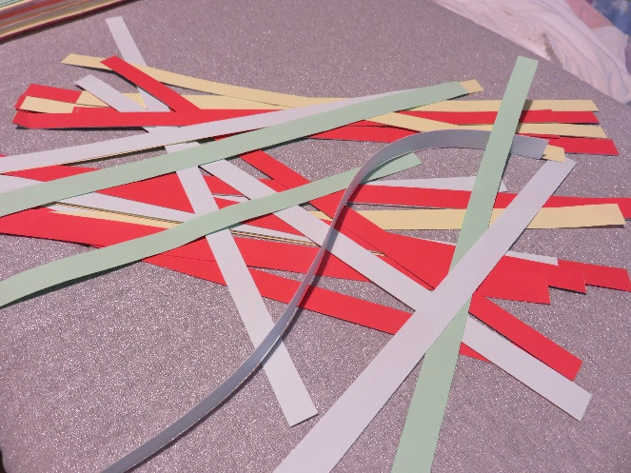
How to make a woven paper basket
- Cut strips of paper – the ones in the picture are about ½ a centimetre wide, and I used 4 colours – enough to make the basket. I used 10 strips for the base and four around the sides.

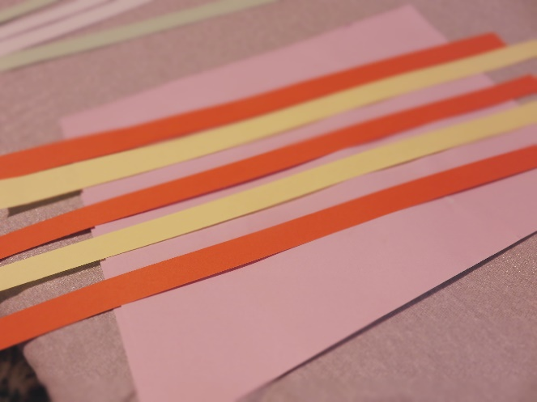

- Lay out the strips for the base of the basket – I used 5 each way. Start with the strips that go one way.
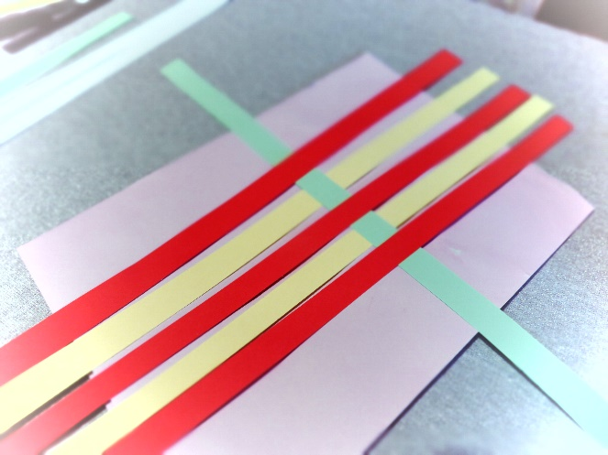

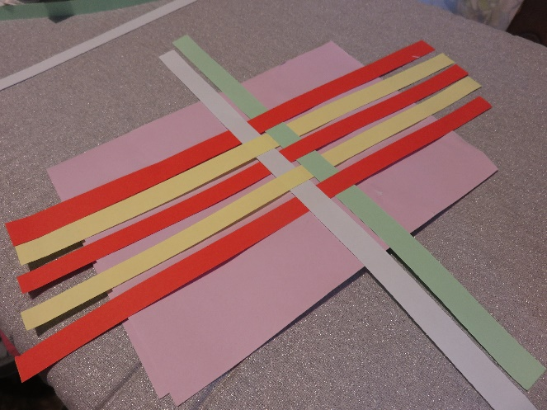
- Then interweave the strips that go the other way. Make sure the strips of paper are as close together as you can get them, and in the centre of the lengths.

- Use a little glue on some of the strips, where they cross, to make sure they don’t move as you make the rest of the box.
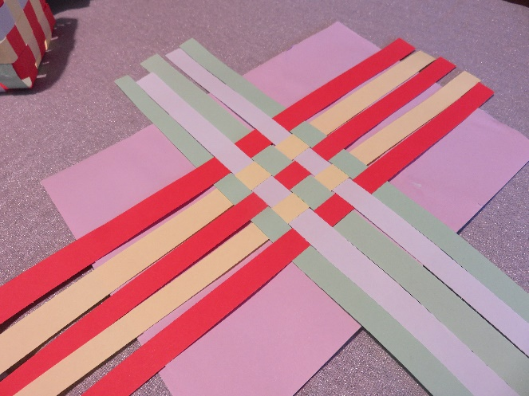

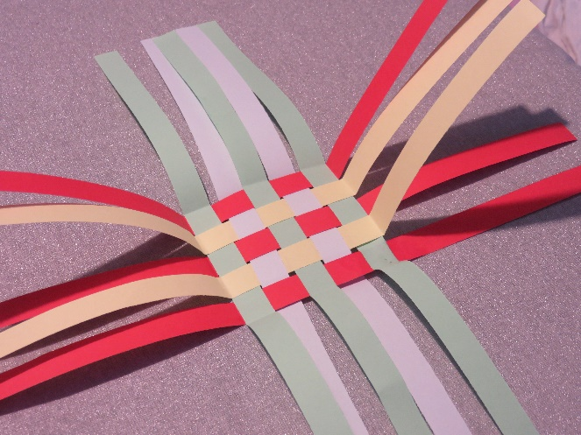

- Fold up the ends of all the strips, to make the sides of the box.

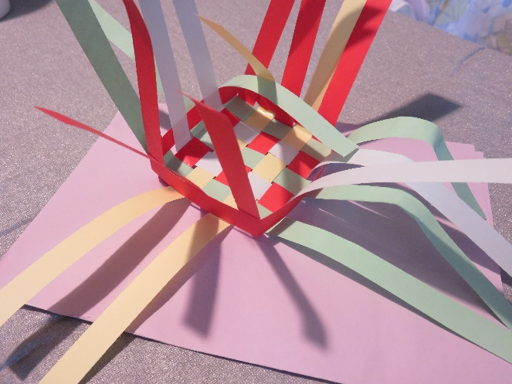
- Weave the next strips around the upright strips, to build up the sides.

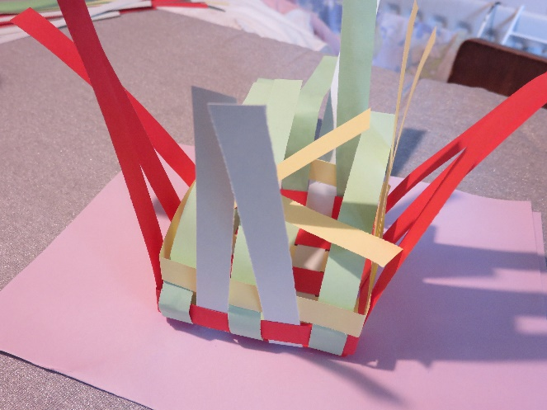

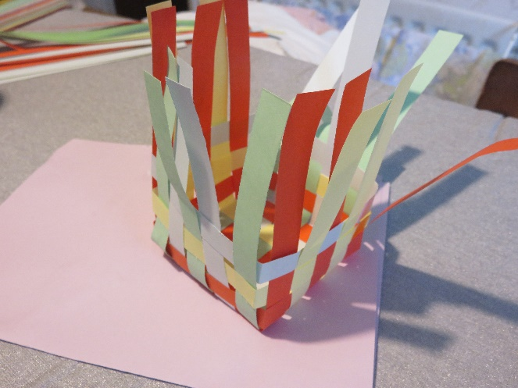

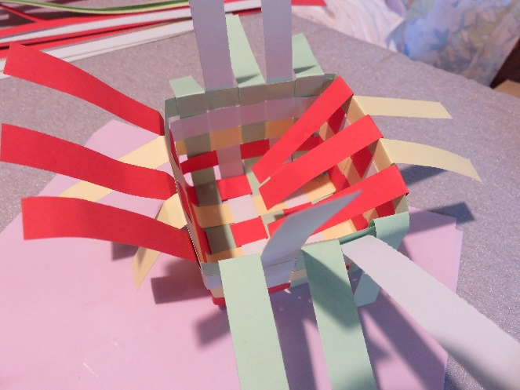

- When you have the sides as high as you want them, fold the tops of the remaining upright strips down over the last horizontal row – so that the strips which were inside on the last row are folded outwards, and those which were outside are folded inside.
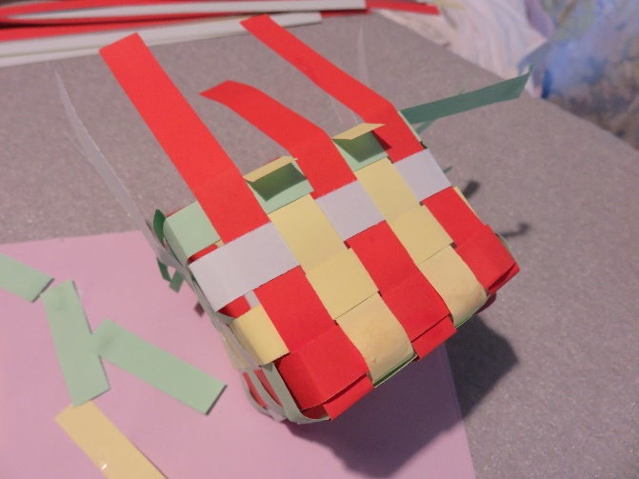

- Trim the length of the strips and stick them to the last row, on all the sides.

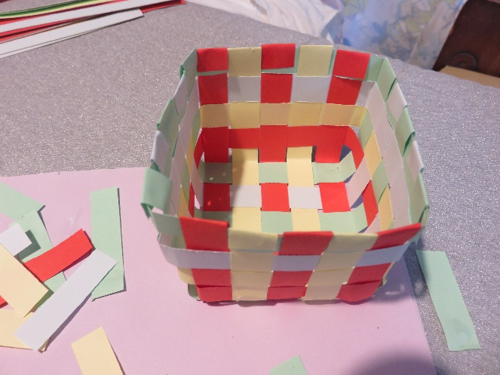

- Your basket is complete!

