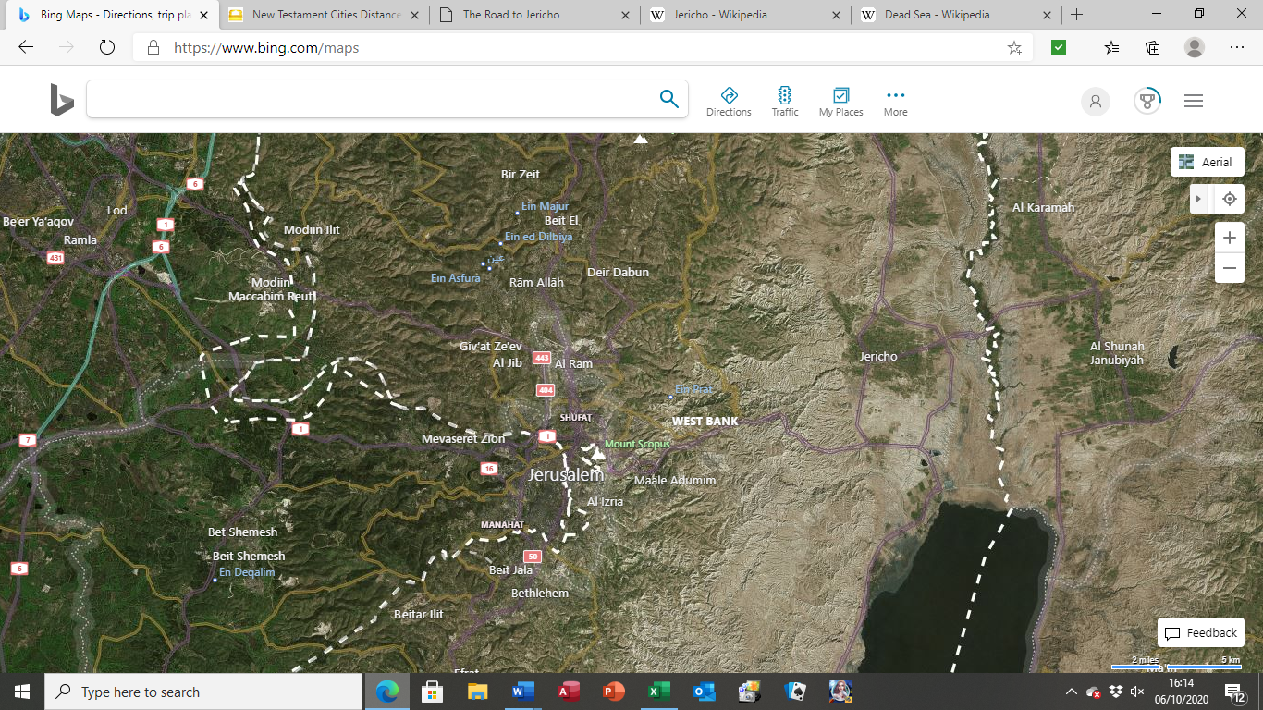

In Jesus’ time the 25 km-long Jericho-Jerusalem road was notorious for its danger and difficulty. The road is best known for its appearance in the parable of the Good Samaritan (Luke 10:25-37), which is remembered today by a building known as the Good Samaritan Inn, or Khan al-Ahmar. This is the latest building in a long line that goes back to before Jesus’ day, all built on the same site. It functioned as a way station for travellers, which it has remained through the Roman Empire, Byzantine era, the Crusades, and the Ottoman era, and still does today. The red dot on the map shows the approximate position of the inn.

Three kilometres east of the Good Samaritan Inn, a narrow path to the left leads to the Wadi Qelt (the “valley of darkness,” Ps 23), a natural rift in the hills between Jerusalem and Jericho. Along the route can still be seen the aqueduct and water system of the Hellenistic-Roman period.

The modern road from Jerusalem to Jericho is a lot further than the original road. The modern road on this map is marked in purple. Where the road bends sharply to the right, where the black arrow points, the original road went a little left and then down the valley, where the orange arrow is. It was shorter and much more direct – if you look at the map, the lines of the valley point directly at Jericho from the corner of the modern road – but it was a lot more dangerous!