**Messy Church – July 2021**

**Feeding the 5000: John chapter 6, verses 1 – 13**

We are using the version of the story from the Gospel of St John, but the story is also told in the other three gospels, with the difference that in the others, although they all tell about five small loaves and two fish, none of the others mention the little boy that John talks about, and Philip is not mentioned by name.

The activities are:

1. **The crowd following Jesus** – John 6, 1 – 3

zig-zag people

1. **The disciples** – John 6, 5 – 8, 10,
   1. Peg doll people
   2. Cardboard roll people
2. **The little boy** – John 6, 9
3. mosaic fish
4. bread rolls
5. **The miracle** – John 6, 11

Cutting up a slice of bread

1. **The leftovers** – John 6, 12 – 13

Paper strip baskets

**Stories and Activities**

1. **The crowd following Jesus** **– zig zag people**

**You will need:** a piece of paper, scissors, the picture of the final product, colouring pencils if you want to colour your people.



Hold your piece of paper so that it is wider than it is tall, then fold it up in zig-zags, like a fan – you should have four or five layers. Make sure they are the same width. Draw a person on the top fold, so that the feet and the arms reach the fold. (The picture just shows the hands touching.) Cut round your person, through all the layers of paper, and carefully unfold the layers, so you have a chain of people. You can colour them in if you want.

Jesus had been in Jerusalem with his friends, teaching them and healing people who came to him, or who he met. Then he went back to Galilee, where he had been brought up. (The |John’s gospel doesn’t actually say this. Chapter 5 tells stories about what happened in Jerusalem, and then chapter 6 starts, “After this, Jesus went across Lake Galilee …)

John says that a large crowd followed him, because they had seen miracles of healing. He was sitting down on a hillside, teaching his disciples. When he saw the crowd of people, he knew they would have to be fed, and he asked Philip what he would do to feed them. Philip said they would have to spend a lot of money to buy bread for everyone, and Andrew said there was a boy in the crowd who had a little food – five small loaves of bread and two fish, but they wouldn’t feed everyone.

**Talk about:** how much food – and what food – you would take for a picnic, or for a pack lunch at school.

**2 The disciples**

* 1. **Peg doll people**

**You will need:** “dolly” pegs (one for each character), pipecleaners (one for each character (half if they are craft pipecleaners), pieces of fabric, or crepe or tissue paper, scissors, thread, fine felt tip pens for the face

Draw a face on the knob at the top of the peg – make sure you have the peg with the legs in the right place! Wrap a pipecleaner around the peg, below the “shoulder” of the peg, to make the arms. Dress your peg person with fabric or paper pieces.

* 1. **Cardboard roll people**

**You will need:** inner tubes from kitchen towel rolls, or similar. You might want to have them in different sizes, if you are going to make more than one. Crepe or tissue paper in different colours, or fabric scraps, for clothes, crayons or felt tip pens to draw faces, pipe-cleaners for arms (optional)

Draw a face at the top of the tube, and then wrap the coloured paper or fabric scraps around the lower part of the tube for clothing. If you are feeling really clever, you can make a hole on each side of the body, below the face, and thread a pipe-cleaner through, to make arms, and then make sleeves in the clothing.

There are three friends actually mentioned in John’s version of the story – Philip, Andrew, and Simon Peter – but there were twelve friends all together, and probably it would have needed all of them to get everyone sitting down and fed, not to mention clearing up at the end.

Philip was the first one mentioned – Jesus asked him how he would feed all these people. Andrew found the boy with the picnic, but thought it wouldn’t go far in all this crowd, and then Jesus told them to get everyone to sit down. He broke the bread up, asking a blessing from God, and then John says he, presumably Jesus, distributed it. I think that he gave the bits to his friends, and they passed it around the crowd. Then the same thing happened to the fish – blessing, then breaking, then sharing it out.

**Talk about:** sharing. What can you share? Who do you share with? Could you share other things with other people? Is sharing a good thing?

**3 The little boy**

1. **mosaic fish**

**You will need:** paper – plain to cut out, and coloured – different colours if you like – this can be crepe, tissue or just coloured paper, glue, scissors

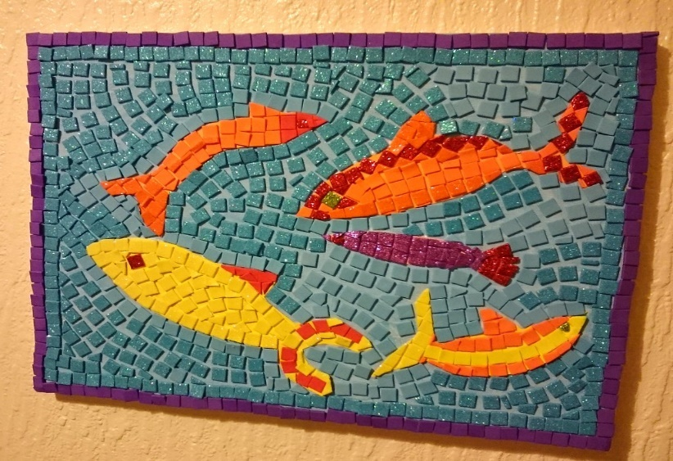Draw a fish shape on the plain paper. Cut it out. Cut your coloured paper into squares about 1 cm across – they don’t have to be exact. Glue the squares onto your fish shape, so that it is all covered in colours, like a Roman mosaic

1. **bread rolls**

**You will need:** a packet of bread mix – usually sold by supermarkets as their own brand, or Wright’s – they come in white or wholemeal, or other varieties. The packet usually has instructions on it, but you can watch the video as well if you want. Using a bread mix is quicker than starting with flour and yeast, and takes me just over an hour when making loaves. Rolls will cook quicker than a loaf!

We don’t know anything about this boy – whether he had set out to do errands for his parents, with a picnic lunch in case it took him a long time, or whether he was with his family, and Andrew just happened to find him, rather than the adults. All we know is that he had five loaves of bread – probably quite small loaves, like our rolls – and two fish. And we know that he was prepared to let Jesus have the food, which was very important.

**Talk about:** whether you would share your food under these conditions, or whether you might be scared you wouldn’t get any. Can you think of anyone you would trust as this boy trusted Jesus?

**4 The miracle – cutting up a slice of bread**

**You will need:** a slice of bread, a sharp knife, a plate or cutting board, an adult!

Put your slice of bread onto a plate or cutting board. Cut it in half. Cut each half in half, and then in half again. If you are very careful, how many pieces can you make before it becomes just crumbs?

Jesus blessed the bread, broke it up into pieces, and his friends passed it out to the crowd. St John says that there were about 5,000 men there. St Matthew’s gospel says that count didn’t include the women and children. I think everyone would have been surprised – all the friends, the boy and all the other people who were there – that everyone had enough to feel fed. The only person who would not have been surprised would be Jesus. For 2000 years, inside and outside the church people have tried to make sense of this story, from the idea that lots of people had brought food with them, and when they saw Jesus sharing some out, they shared what they had brought, to the idea that the Gospel writers told exactly what happened. No-one knows, but whatever happened, people remembered the day, and went on talking about it.

**Talk about:** what you might have done, if you had had some food with you; or what you might have felt, if you hadn’t taken any with you, but someone had shared with you.

1. **The leftovers – Paper strip baskets**

**You will need:** a couple of pieces of paper, preferably in different colours, to make it easier to see what you are doing, scissors, glue, the detailed instructions on the separate piece of paper.

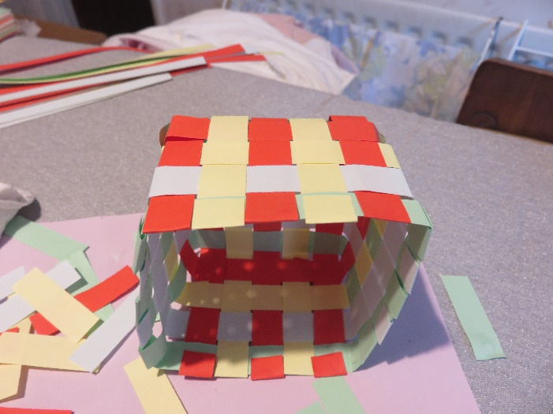

John’s gospel says that after everyone had eaten enough, the friends of Jesus gathered up twelve baskets of leftover bits.

**Talk about:** clearing up after a picnic. In Jesus’ day, they didn’t have rubbish bins around, but they obviously cared enough to tidy up after themselves, even things that would have been eaten by the wildlife. Do we care enough to take our rubbish home?

**Celebration**

We have made a video for today, which you may want to pause from time to time while you do activities. You will also need to switch to the songs and then come back to the video. You can find the video at <https://youtu.be/tMPQMD568NE>

We start with a song. My God is so big, so strong and so mighty. <https://youtu.be/yiWYtwFt9Jc>

The story for today is one that must have really stuck in the minds of the disciples, because it’s one of the few stories of its type that appears in all four Gospels. Most stories like this don’t. This means we have four versions of the story, all slightly different, which is just what happens when four different people all try to tell you about the same event.

You see, Jesus and the disciples had been very busy. Mark says that Jesus had sent the disciples out to tell people about him, and when they came back, they wanted to tell him about all the things that they’d seen and done. But so many people were coming to see Jesus that they didn’t even have time to eat!

“I know,” said Jesus, “let’s get into one of the fishing boats and go across the lake to one of the quiet places. We’ll be on our own and you’ll be able to rest there.” “Good idea,” said the disciples who were mostly fishermen, and so were used to sailing across the lake. So they all piled into a boat and set out across the lake.

Now the lake, which we know as the Sea of Galilee, isn’t very big, and unfortunately a lot of people saw them leave in the boat. What do you think the people did? Did they get into boats? No! Did they swim after the boat? Definitely not! They ran around the lake on land, and by the time Jesus had crossed the lake in the boat there was a whole crowd of people waiting. Lots and lots of people. One thousand, two thousand, three thousand, four thousand, five thousand. Five thousand people had run round the lake.

You might want to take a break here, and see if you can make a big crowd of people. We’ll cut some out of paper, or you can make cardboard tube figures to represent the disciples.

Poor Jesus. Poor disciples. They had crossed the lake for a bit of peace and quiet and there were five thousand people waiting for them. What did Jesus do? Did he tell them to, “Go away!”? He might have felt like it, but he looked at them, and he was sorry for them. Why was he sorry? He was sorry because he understood why they had come out. He knew that the crowd knew that they were missing something in their lives, and that they didn’t know what they were missing or where to find it. Jesus thought that they were just like a flock of sheep, but a flock without a shepherd to show them where to go for food and water.

So Jesus spoke to the crowd. He told them a lot of things to help them understand about God. He spoke for a long time, and eventually the disciples came to him and said, “it’s getting late. You need to send the crowd home. This is a lonely place, and they need to get food. If you send them away now they could go to the local farms and buy something.” “You give them something,” Jesus said. The disciples were flabbergasted. “Us?” they said. “It’ll cost a fortune to just buy bread for this lot. It’ll cost what one of us would take more than six months to earn.” “How much bread have you got?” said Jesus. “Go and see.”

Well, the disciples went and they asked people, and they found a boy, the only one who admitted to having any food. He still had his lunch, five bread rolls and a couple of fish. “Tell the people to sit down,” said Jesus. The disciples got the crowd to sit in groups of fifty or a hundred people. Then Jesus took the bread and the fish and prayed, and then he broke them into pieces and gave them to the disciples to pass round. I don’t know what the disciples thought would happen, but everyone there ate and had enough!

If you want to try making bread rolls, at the end of this video there is a bit that shows you how to do it with a bread mix, but you will have to pause the video a few times while you do it. You might want to finish this bit of the celebration first, then have hot bread rolls for tea!

Afterwards the disciples went round with baskets to pick up what was left, and you know what? They picked up twelve baskets of food left over. Twelve! That was a basket each.

You can make a basket from paper following the instructions on the separate sheet.

Do you like picnics when you’re on holiday? Would you like it if your picnic became large enough to feed five thousand people? Mind you, it might not be so good if there were that number of people around to be fed.

Let’s say a prayer, and then we’ll sing again.

Payer

Lord God, thank you for holidays, for picnics and for sharing. Thank you for days out and for times when we can learn about you. Be with us where ever we are and help us to learn and to share.

Amen

We’ll sing “You shall go out with joy”. <https://youtu.be/vMkWGtkbMFU>

Now if you want watch the bit about bread rolls!

Next Messy Church is 18th September. We hope to see you then, but this month we’ll say goodbye.

Enjoy our celebration on the Harlington Methodist Church YouTube channel at <https://www.youtube.com/channel/UCTMWR_QCxujkh1zHjTFcoJw>

Then have tea or a treat if it isn’t tea time!

If you send me pictures of anything you do, I will share them on the Church Facebook page (if you want to send pictures that you don’t want shared, just tell me. I’ll only share the one’s you’re happy to share.)

Harlington Messy Church Team