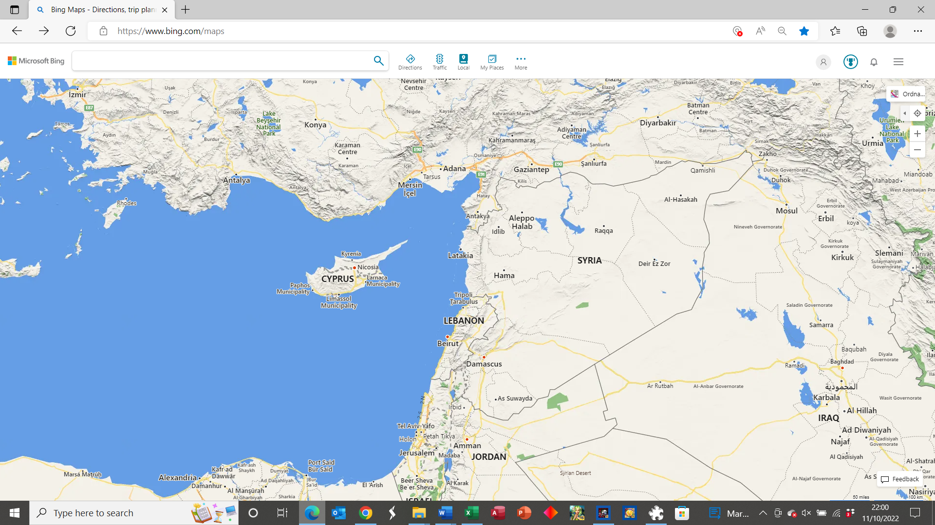
It is over 600 miles from Tarsus to Jerusalem by road – but Saul might have travelled by boat with his parents.
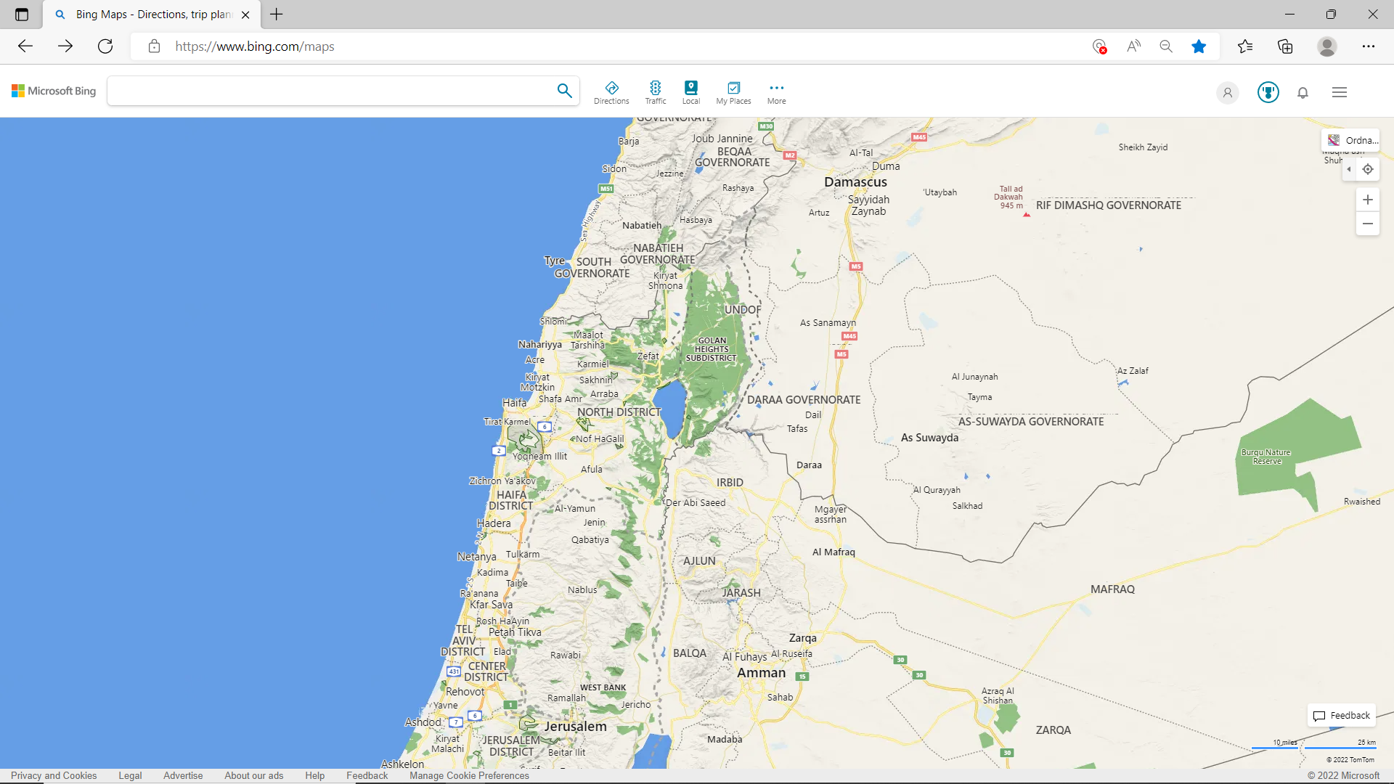

It is 135 miles from Jerusalem to Damascus, in a straight line. This is not the way Saul would have walked!

