**Miniature bird cages**

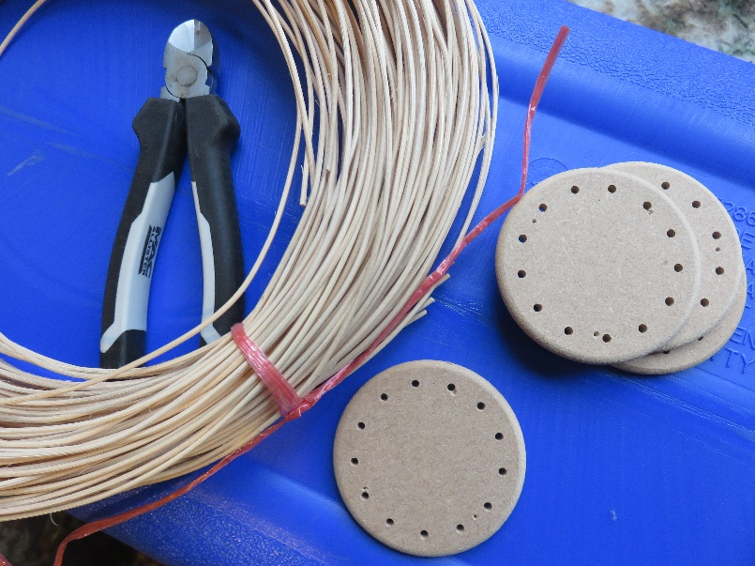**1**  Cut 13 base stakes of cane to length – this cage is about 6 inches high, so the base stakes need to be about 15 inches long (38 cm). Soak these canes in a bowl of warm (because your hands will like it better!) water, for about 15 minutes. The cane is more pliable when damp, and if it gets dry while you are working, it is more likely to break, so keep the cane moist.

**1a** Have two full lengths of cane ready to put in the water as you take out the base stakes, so that they are damp and ready to go when you have finished the base.

**2** Thread each cane through a hole in the base plate, leaving about 3 inches (8 cm) below the plate. Working with the bottom up, weave each cane round the outside of the cane next to it (it doesn’t matter whether you work from right to left or left to right, as long as you are consistent), and then tuck the end behind the next cane. If there is too much cane to do this, pull a little of the length back to the top of the base. Keep all the canes a little away from the base until you have completed the circle, as the last cane will need to be threaded carefully under the first. When the circle is complete, gently pull the canes from the top of the base, to pull the spare length through.

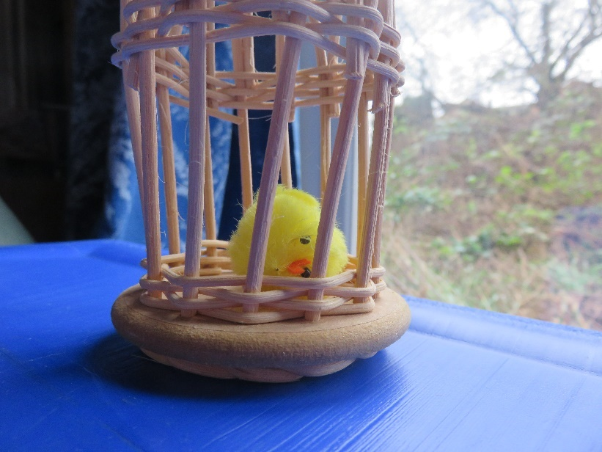

**3**  Take one of the soaked long lengths of cane, and tuck one end between two of the stakes, so that it rests on the inside of one stake, and comes out to the outside. Then weave the length round all the stakes for three rows – look at the picture. The cane should go alternately outside and inside the stakes on each row, and each row should be the opposite of the row below.

Snip the end of the cane off so that it is on the inside of the cage, held behind the next stake in the circle.

**4** Repeat this process about 2 inches (5 cm) from the base – start a new cane for this, if you have used more than half the previous one.

Again, make sure the ends are tucked in on the inside, resting against the stakes so that they cannot slip.

**5** This is the point at which you will need to put your cage into the water again. The uprights will have started to dry out, so put the cage into your bowl upside down, so that the top ends of the stakes are in the water, preferably down to the upper weaving. Soak it for about 10 minutes. While this is happening, find or make a small bird.

**6** Take the cage out of the water and turn it the right side up.

Put the bird in the cage – once you have finished the cage, you won’t be able to put it in.

Bend each stake over, carefully, and poke the end through the upper weaving beside an upright stake on the opposite side of the cage – you can see this detail in the picture. There should be enough length on each stake to achieve this, even if they are not all the same length.

When the cane is dry, it will be quite firm, and won’t come undone.

**7** When you have completed the cage, turn it over and look at the base ring. Trim any long ends that are left, carefully. As you can see from this last image, one of these canes has been trimmed too close, and will not stay in place.