Model swing
You will need: 4 – 6 bamboo skewers, a pair of wire cutters or snips, quick drying glue (Clive used a cool melt glue gun – a hot glue gun would also work – be very careful, and get a grown up to help if you are using a hot glue gun), a piece of sturdy cardboard for a base (about A5 size), and some off cuts of card, a needle and thread, and a piece of paper to draw on. You might also find a little blu tac or play doh useful.
- Draw a template – a tall triangle, with a cross bar (you don’t need a bar at the bottom)
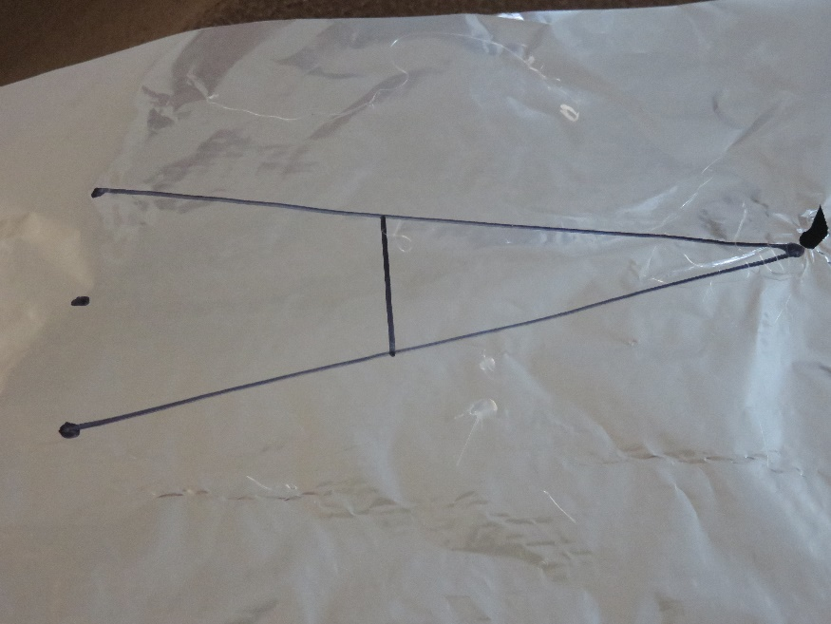
- Cut the sharp ends off three of the skewers, and then cut them in half. (Measure before you cut!) These are the legs of the swing frame.
- Take a 4th skewer, and cut two pieces long enough to make the cross pieces on your swing frame.
- Lay the pieces – two legs and a cross piece – over the template, and glue the pieces together. Then repeat with the other set.
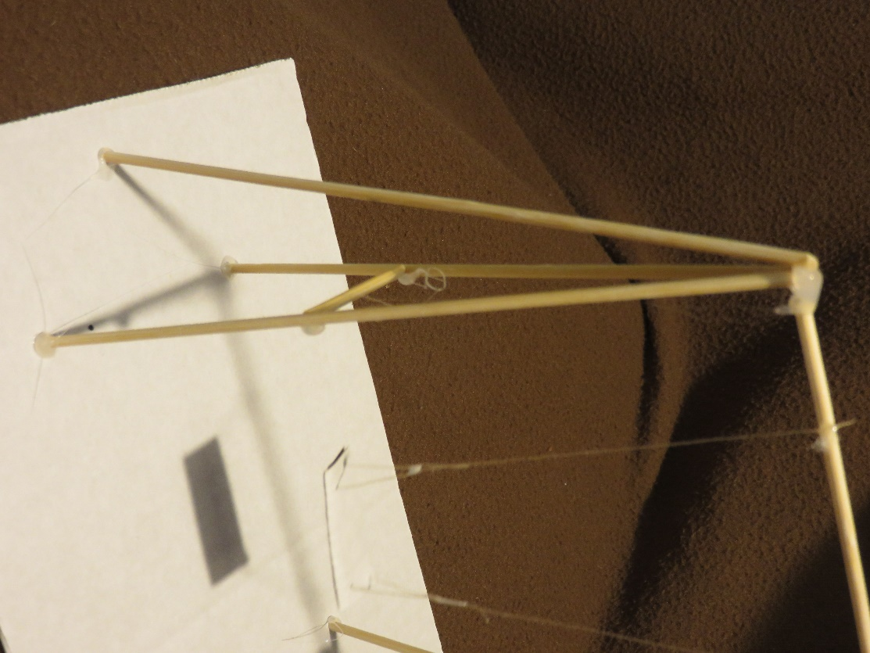
- Stand each pair of legs upright on the base board, using a little play doh or blu tac to hold them, making sure that they are vertical and glue the third leg at the top of each pair to make a brace at each side – look at the picture.
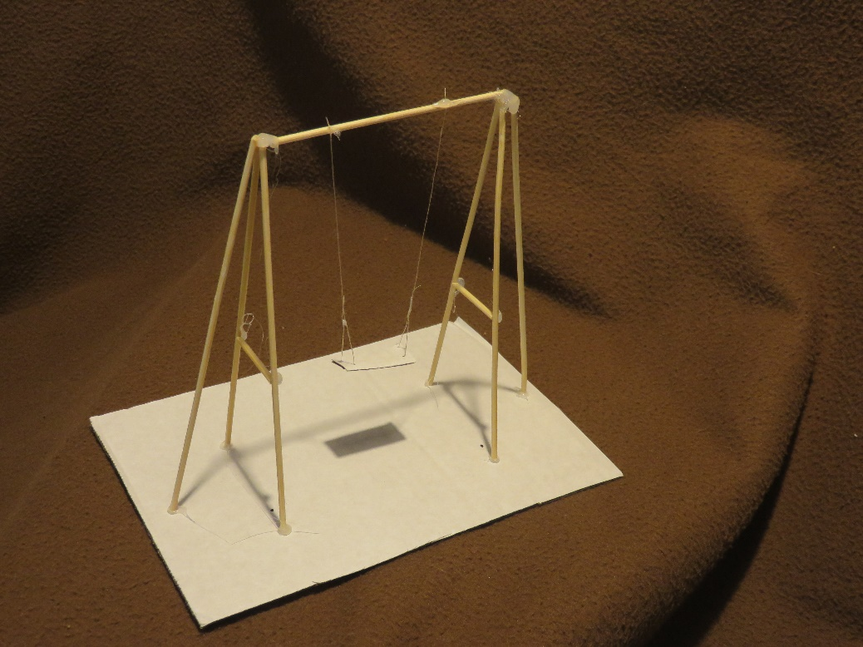
- Now remove the blu tac and glue the legs and braces to the base board, making sure that all three legs are on the board.
- Cut a piece of skewer long enough to go across the top from one set of legs to the other, and glue it in place.
- Cut a small piece of card for the seat.
- Thread the needle with enough thread to go at least from the top of the frame to the base (look at the picture – the thread needs to go through the seat twice, and be fastened to itself!)
- Push the threaded needle through one corner of the seat (from the top) and then back through the second corner at the same end. Fasten the end of the thread part way up, making a small triangle (you can glue it, or tie it). Take the thread up to the top of the frame, about a quarter of the way across from one side, and fasten the thread to the top rail (again, glue or tie it). Cut the excess thread off.
- Repeat steps 9 and 10 with the other end of the seat.
- Your swing is complete!

