Messy Church – 15th November 2025
Elisha

The activities are:

- The Shunamite woman: two-storey house – 2 Kings 4: 8 – 37
- Two food miracles: iced biscuits for other people – 2 Kings 4: 38 – 44 – in the Celebration
- Naaman: 2 Kings 5: 1 – 19
  - Collage
  - picture
- Floating axe head: model axe – 2 Kings 6: 1 – 7
  - with icing
  - with card
- Christmas preparation: advent rings – in the Celebration

Stories and Activities
1 Kings 19: 19 – 21 Elisha met Elijah when the prophet, leaving Mount Sinia, found Elisha, ploughing his father’s fields with a team of oxen. When Elijah invited him to come and be his disciple (follower), Elisha sacrificed the oxen and cooked them, using the wood of the plough for fire. He fed the meat to his village, as a farewell feast, and then followed Elijah.
Elijah went on being the main prophet of the nation of Israel for some years and during this time, Elisha travelled about with Elijah, learning his way around the country, meeting the other prophets, and listening to God for himself.
2 Kings 2: 1 – 15 Then came the time when the elderly Elijah knew he wouldn’t live much longer, and Elisha knew it too. Elijah kept trying to leave Elisha behind on this last journey, but Elisha insisted on going with him. Various people – groups of prophets living in the various towns they went through – kept telling Elisha that Elijah was going to God today. Each time, Elisha said he knew that, but he didn’t want to talk about it!
Eventually, they arrived at the river Jordan (followed by a number of the prophets who Elisha had spoken to). Elijah again tried to leave Elisha behind, but that was not going to happen. Elijah rolled his cloak up, and struck the waters of the river with it, and the water divided. Elijah and Elisha crossed over to the east side of the Jordan, and then Elijah asked Elisha what he would like as a legacy (a gift in someone’s will) from Elijah. Elisha asked for the power that would enable him to be regarded as Elijah’s successor. Elijah said he would have it, if he saw Elijah being taken away.
As they talked, they were walking away from the river. Suddenly, a chariot of fire, pulled by horses of fire, came between the pair of them, and horses, chariot and Elijah were swept up in a whirlwind. Elijah had dropped his cloak as he went, and Elisha picked it up, shouting “My father, my father, you are gone!” Then he tore his own cloak in two and went back to the river Jordan. There he struck the water with Elijah’s cloak, it divided, and he went back across, where the prophets who had been waiting said “Elijah’s power is in Elisha!”
2 Kings 2: 15 – 25 When Elisha had crossed the Jordan, back to the land of Israel, he went to the nearby town of Jericho. There, the people told him that the spring which served the town for drinking, and for watering the fields didn’t have good water, and people and plants were suffering from diseases. Elisha asked them to bring him a new bowl full of salt. When they did, he threw it into the spring, and said that God promised that from now on, neither death nor miscarriage would come from the water (which came true, according to the writer). Then Elisha set out to go to Bethel. On his way, some boys (age unknown) came out of the city and called him “Baldy” and told him to go away. Elisha cursed them, and they were attacked by bears.
2 Kings 3: 4 – 20 The nation of Israel, together with Judah and Edom, were at war with Moab, but they had run out of water for men and animals. The king of Judah asked for a prophet, and Elisha came to them. They asked for God’s help, and Elisha wanted music while he prayed. They provided a musician, and God told Elisha that he would provide water for the army and its animals.
2 Kings 4: 1 – 7 The widow of an Israelite prophet came to Elisha for help. Having no money after her husband’s death, people to whom he owed money were threatening to take her children to sell as slaves to pay the debt. Elisha asked what she had, and she said she had a jar of oil. He told her to ask all her neighbours for empty jars and bottles – lots of them. Then he told her to pour oil into these jars and bottles – and sell the full jars for money to pay her husband’s debts.
- The Shunamite woman: two-storey house – 2 Kings 4: 8 – 37
Elisha was travelling, and he came to the city of Shunem, and a rich woman offered him a meal. It was a regular trip for Elisha, and every time he arrived in Shunem, he would be offered a meal. After some time, the woman suggested to her husband that they should build a room on their flat roof, and furnish it for Elisha, so that he would have somewhere to stay when he came. So it was done.
One time when Elisha was staying there, he asked the woman if there was anything he could do for her, since she had done so much for him. She said she needed nothing, but when she had gone downstairs, his servant Gehazi said that she had no children, though she had been married for some years. So Elisha told her she would have a son. She told him not to get her hopes up – she would be OK without a son, but Elisha insisted, and the son duly arrived.
When the boy was older, he was with his father in the fields at harvest time, but he collapsed. He was carried back to the house, but he died. His mother put him upstairs on Elisha’s bed, and set off by donkey, and went to find Elisha at Mount Carmel.
He came back with her, and revived the boy.
You will need: card – enough to make a house, and a room on the roof (see picture sent separately for the basic design of the house), scissors, glue, pencil if you want to draw the pieces out first
Cut out and make a house (a basic box will be fine), then make a smaller box to go on the roof of the house. If you want to be complicated, you can make stairs up the outside of the house to the roof, and a small wall around the top of the house, so that the roof has a rim.
Talk about: making room in your house for someone else – do you have to share a bedroom if someone else is sleeping in yours, for example. What other arrangements do you have to make – cooking more food, doing more washing

2. Two food miracles: iced biscuits for other people – 2 Kings 4: 38 – 44
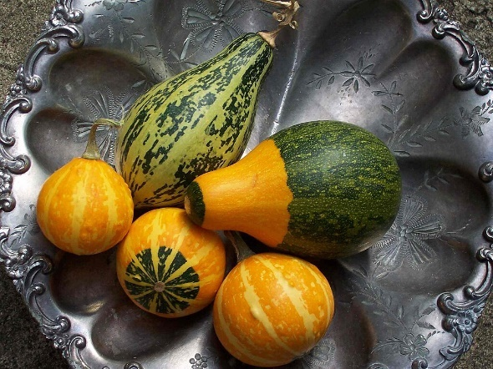
On his travels, Elisha went to Gilgal. On one occasion, when he arrived, there was a famine, and not enough food. Elisha said the prophets who he had come to see should make a stew from what they had, and what they could find in the fields. Unfortunately, someone in the group picked some wild gourds which were not good to eat (look at the picture – they look just like some vegetables), and put them in the pot of stew. When the stew was served, they discovered that it made them feel ill. They told Elisha, who made them put some flour in the pot – and then the stew was fit to eat.
On another occasion, a man came to Elisha, bringing some of the first fruits of his farm to Elisha – twenty barley loaves and some fresh grain. Elisha told his servant to share it out among the other people there. The servant said that no way would there be enough for the hundred people who were there. Elisha told him to do as he was told – there would be enough and to spare – and there was!
You will need: plain biscuits – enough for every one who is going to share the meal, squirty icing, plate to put the biscuits on (not individual plates!)
Decorate the biscuits, putting the finished ones on a plate
Talk about: sharing food – or keeping it to yourself! How much fun is sharing food – especially if everyone has brought something different?

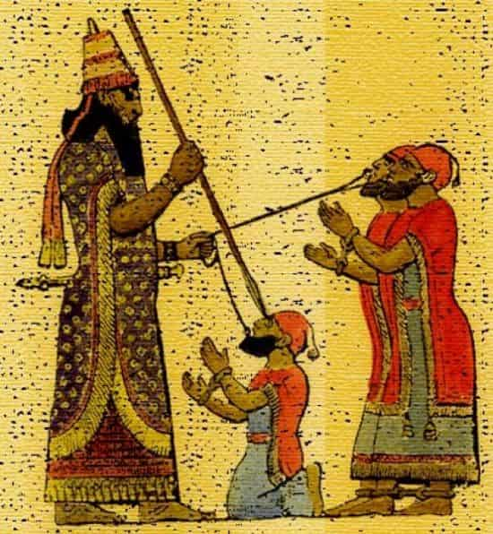
3. Naaman: picture – 2 Kings 5: 1 - 19
Naaman was a Syrian – an important Syrian: he was the general in charge of the Syrian army. Because Syria and Israel were often at war, he must have been a good general, as the Syrians saw it, since he had Israelite slaves in his house.
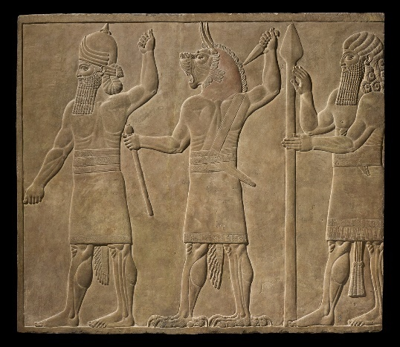
Unfortunately for him, Naaman had caught leprosy – which is still catching, although these days it is curable. The standard treatment for leprosy in Elisha’s time was to exclude the person with the disease from the community, so they couldn’t pass it to others. Their families would have to feed them at a distance – taking food and leaving it where they could get it, after everyone else had gone away again. If everyone discovered that Naaman had leprosy, this would happen to him, never mind how good a general he was.
Naaman had a Israelite slave girl in his house, who told Naaman’s wife that if he lived in Israel, the prophet there could cure him.
Naaman’s wife told this to Naaman – who went to his king and reported it. The Syrian king sent him with a letter to the king of Israel, along with some treasure, to pay for the cure. When Naaman got to Samaria and presented his letter, king Jehoram was very upset, thinking that the king of Syria was trying to tempt him into yet another war – after all, he couldn’t cure leprosy. When Elisha heard what was going on, he sent a message to Jehoram to tell him to send Naaman to him, Elisha.
When Naaman arrived at Elisha’s house, Elisha sent Gehazi, his servant, to tell Naaman to go and bathe seven times in the river Jordan. This made Naaman angry – to be told by a servant, and to be told just to bathe in the local river. He thought that Elisha should come himself, and pray over him publicly. He refused to bathe in the Jordan, saying that the rivers of Damascus, where he came from, would be better, and threatened to go home, just as he was. His soldiers (or servants) were worried, and asked him if he would have done something difficult, if the prophet had asked it.
Naaman said that he would have done – and so he went to the Jordan, and dipped himself in it seven times – and when he came out the seventh time, his skin was normal again, no sign of leprosy. He went back to Elisha, and tried to give him the treasure he had brought with him. Elisha said no thank you, not at all, and then Naaman asked to be allowed to take home two sacks of soil, so that he could spread them in his garden and worship Elisha’s god there (believing that Elisha’s god was tied to the soil of Elisha’s country). He asked if God would forgive him when he had to go to the temple of the god of Syria with his king, and Elisha said “go in peace”, meaning that God would forgive this.
When Naaman had started to go home to Syria, Gehazi thought he could benefit from these riches that Naaman was taking home with him, so he ran after the men. He told Naaman that Elisha had unexpected, important visitors, and asked for some money and some new clothes for them. Naaman gave him what he asked, and two servants to help him carry it back to Elisha’s. Gehazi hid what he had acquired, and then went into the house to do his work. Elisha asked him what he had done, and Gehazi said he had done nothing. Elisha said that he knew he had taken money and clothing from Naaman – and now he would have Naaman’s leprosy as well!
There are two activities in this section: - you can use the pictures in the booklet for ideas
3a. a collage of Naaman, dressed up as the general
You will need: a piece of paper, colouring pencils or felt tip pens, fabric, cooking foil to make a sword or spear point, glue and scissors
Draw the outline of Naaman, and use fabric for his clothing, colouring in face, hands, etc for what you cannot use fabric for. Give him a sword or a spear, using cooking foil for blades.
3b. a picture of Naaman, bathing in the river Jordan
You will need: a piece of paper, colouring pencils or felt tip pens
Draw a picture of Naaman bathing in the river Jordan – you could draw his soldiers watching if you have time and space

- Floating axe head: model axe – 2 Kings 6: 1 – 7
The prophets who lived near Elisha, to benefit from his teaching and understanding of God, decided that they needed more living space, so they collected wood to build some more space by going to the Jordan river (which was not far away) to cut down some trees. Elisha went with them, at their invitation. As they were cutting the trees down, the head of one man’s axe fell off the handle, and into the river. While axe handles were easy to make, from a piece of wood, axe heads were difficult, and expensive to buy, as they were made of iron. Usually they had to be bought from other nations, as there was no iron in Israel, and therefore no-one with the skills to work it. The man who was using the axe was very upset, because, as he told Elisha, he had borrowed the axe from someone else!
Elisha asked where the axe head had fallen, and then he threw a stick of wood into the river there. The axe head, which had sunk (iron is much too heavy to float), then DID float. Elisha told the man to pick it out of the river.
Again, there are two activities in this section. Both are to make an axe, but out of different materials.
3a. using icing
You will need: ready-to-roll icing, a paper plate to work on, food colouring

Shape the icing to make a handle and a blade separately (see the picture). Paint the handle with food colouring, and then press the two parts together.
3b. using card
You will need: card for the handle, colouring pencils or felt tip pens, card for the blade, cooking foil to cover the blade, scissors, glue
Cut out the shapes of the handle and the blade. Cover the blade with cooking foil (if you smooth it down carefully on both sides, you won’t need glue at this stage. Colour the handle to look like wood. Stick the two parts together.
Talk about: looking after other people’s property. What would happen if we lost or damaged something valuable which belonged to someone else? How would we feel – or how would we feel if someone lost or damaged something of ours?

5. Christmas preparation: Advent rings (in the Celebration)
Lots of churches, and some homes, use Advent Rings to help them think about preparing for Christmas. In church, we light one candle on the first Sunday in Advent – this year it will be 28th November – two candles on the second Sunday, three candles on the third, and four candles on the fourth. On Christmas day we light all five. Each Sunday candle represents one of the following: the Second Coming, the prophets, John the Baptist, and Mary. In some years, instead of the Second Coming, we think about the people of God – all the people who go to church anywhere.

You will need: a bathroom tile or a piece of very heavy card, or wood, cooking foil (to cover wood or card), blue tack, night lights – four white and one red or purple, (or one white, three pink and a purple, depending on what you have or can get), or you can use electric night lights – we will be doing that. If you are using a tile, you might like to paint the tile, so you will need paint, paintbrushes, pencil for marking up the tile if wanted, picture to see what it could look like. We will be using Christmas stickers of holly leaves, etc – you could do that as well.
If you are using candle night lights, the white night lights go round the outside of the tile, and the red or purple one goes in the middle. (With the other colour scheme, one white in the middle, three pink and a purple in the corners.) If it helps, work out where the night lights will go, and draw round them. Decorate the rest of the tile. Use blu tac to attach the night lights, so that they can be replaced if they burn out.
We will be using electric night lights – they also need to be attached with blu tac, so that they can be switched on and off!
Never leave candle advent rings lit if you leave the room!
If you are using cooking foil covered card, stand the card on a heatproof surface before lighting any of the night lights!
Younger children may need a lot of help with this – make sure they wear an overall if they are painting!

Celebration

Sing Our God is a great big God https://youtu.be/0K3TUFFpmhA?si=KOcZtPqH5t9h18yW

Do you ever call people by the wrong name? Do you ever get called the wrong name? Elijah and Elisha often get confused. Because they lived at the same time, and were dealing with the same problems they had similar things happening to them as well as some different things.

Elisha had to follow Elijah as the main Prophet in Israel. When Elijah first approached him, he was a young man, working for his father. He was with Elijah for a number of years, learning what he had to do. Last time we learned about Elijah, and how he went up to heaven in a fiery chariot.

Elisha had to take over from him. There are a number of stories in the Bible about people who took over from someone else. It can be a very hard thing to do. There are a number of issues. Do you do the job the same as the previous person? Often people see someone who has done a job for a time and think, “I couldn’t do it like they do.” The good news is that, in the church, you don’t have to. Of course there are some bits of some jobs that have to be done the same, but if you’re called to do a job it’s because you are you. You may well have new things to offer and few of us can be exactly the same as someone else. Of course there are always people who look back to the previous person, particularly if they were good, but there is often need for a new angle.

Another issue is, are you really called? All through the Bible successors ask God to show them something so that they will know. In one story Elijah hits a stream with his rolled up cloak and the stream splits to let him cross. After he goes to Heaven Elisha tries it, and a stream divides for him, too. This helps him know that God is with him.

Sing There are hundreds of sparrows, thousands, millions. https://youtu.be/sIkcJGUxDrc?si=oGAe9iCeVpM373C9

Elisha did a number of miracles. Some of them involved food, sharing food. One was a time when he made food that had had the wrong things put in it, be healthy and tasty, and another was a bit like Jesus feeding the five thousand.

We are going to ice some biscuits that we would share with another person, so we have to ice them well.

Advent Sunday will happen before our next Messy Church, so we are going to make Advent rings ready to start using them on Advent Sunday, which is in two week’s time. We will use electric tea lights because they are safer.

Let’s pray.

Dear God,
Thank you that you call us to take jobs, and that you help us do them. Thank you that we can be different.

Thank you as well for planning for Advent and Christmas. Help us to take time to think about everything it really means.

Amen

Songs O Lord all the world belongs to you. https://youtu.be/jJMaNZ84xsw?si=SO4wxs7WBnYidWy-

Next Messy Church is 20th December 2025. See you then.

Enjoy our celebration on the Harlington Methodist Church YouTube channel at https://www.youtube.com/channel/UCTMWR_QCxujkh1zHjTFcoJw

Then have tea or a treat if it isn’t tea time!

If you send me pictures of anything you do, I can share them on the Church Facebook page or in the Church Monthly (if you want to send pictures that you don’t want shared, just tell me. I’ll only share the one’s you’re happy to share.)

Harlington Messy Church Team

We’ll have a Zoom meeting open for those who can’t come to the church. We’re also on YouTube during the celebration. Contact me if you want the link for Zoom. Look out for the broadcast on the Harlington Methodist Church YouTube Channel. https://www.youtube.com/channel/UCTMWR_QCxujkh1zHjTFcoJw/videos

